Supporting Information
Gradient Phosphatized Interphase for Ultra-Stable and Low-Temperature Zinc Metal Batteries

Wei Wang¹, Shan Chen¹, Xuelong Liao¹, Rong Huang¹, Jialei Chen¹, Yaxin Wang¹, Fei Wang³*, Huan Wang^{1,2}*
¹Key Laboratory of Advanced Energy Materials Chemistry (Ministry of Education), Renewable Energy Conversion and Storage Center (RECAST), College of Chemistry, Nankai University, Tianjin 300071, China
²Haihe Laboratory of Sustainable Chemical Transformations, Tianjin 300192, China
³Department of Materials Science, Fudan University, Shanghai 200438, China
*E-mail: huan.wang0520@nankai.edu.cn; feiw@fudan.edu.cn
Keywords: Zn metal anodes, Gradient phosphatized SEI, Low temperature, Rapid interfacial kinetics, Long-term stability, Aqueous Zn batteries

Supplementary Figure 1. Differential scanning calorimetry (DSC) curves of TMP–5 and TMP–10 electrolytes.

Supplementary Figure 2. Ionic conductivity of TMP–5 and TMP–10 electrolytes at different temperatures.

Supplementary Figure 3. Raman spectra of O–H stretching vibration in TMP–5 and TMP–10 electrolytes.
Supplementary Figure 4. The fitted H-bonds in various hybrids of electrolytes.

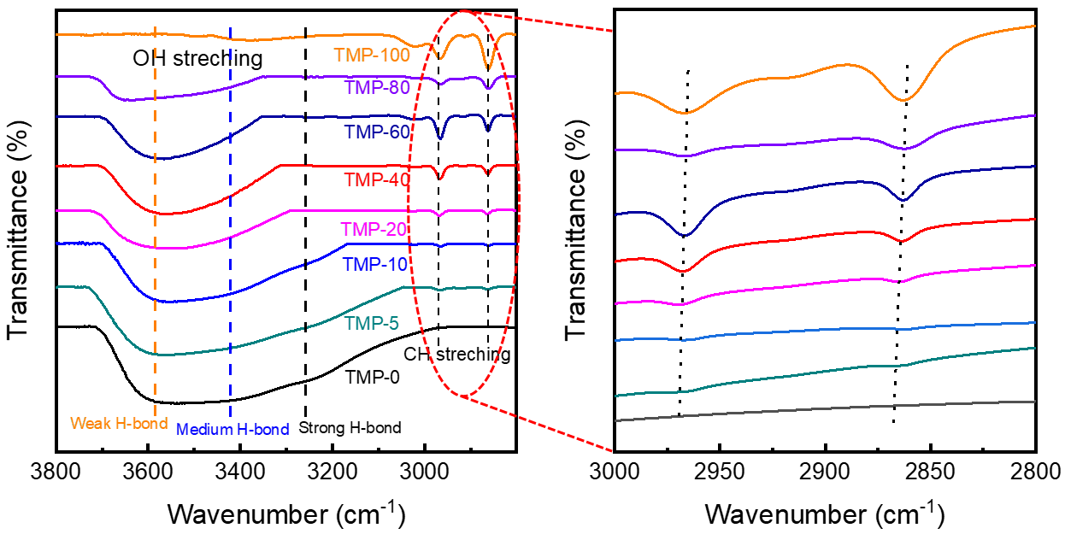
Supplementary Figure 5. FTIR analysis of different hybrid electrolytes. Right: the enlarged view.

Supplementary Figure 6. ¹H NMR spectra of TMP–5 and TMP–10 electrolytes.

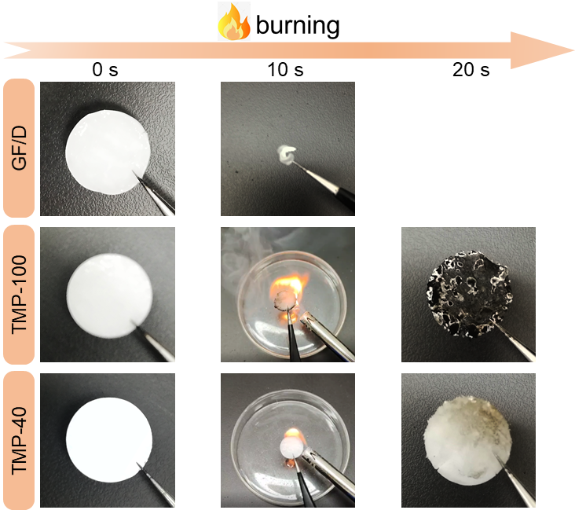
Supplementary Figure 7. Photographs of the combustion tests of pure glass fiber (GF/D) (top), TMP–100 (middle) and TMP–40 (bottom).

Supplementary Figure 8. Raman spectra to reveal the –SO₃ stretching mode in TMP–5 and TMP–10 electrolytes.
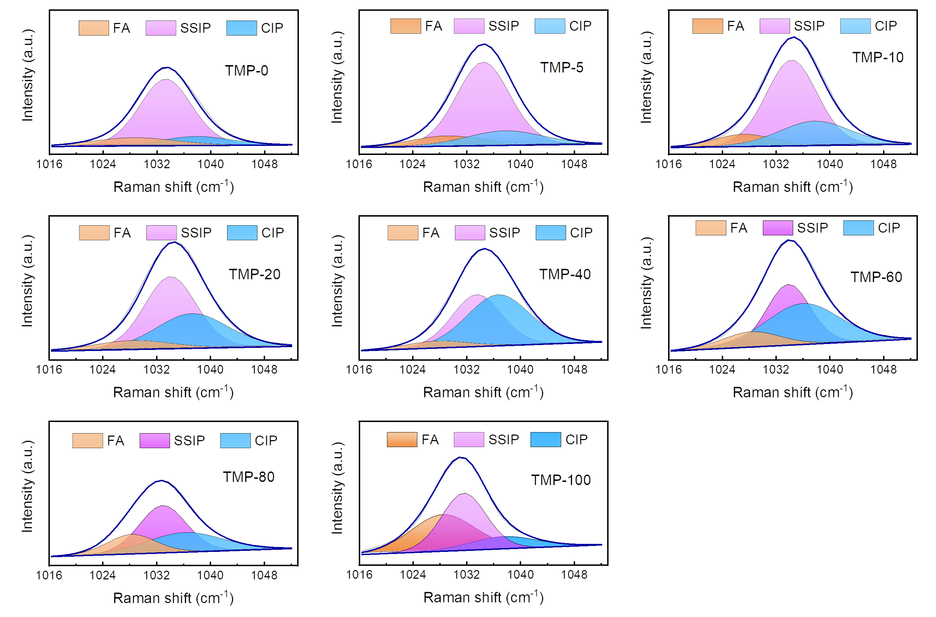
Supplementary Figure 9. The fitted –SO₃ stretching vibration in various kinds of hybrid electrolytes.

Supplementary Figure 10. The FA and CIP ratios with TMP content.

Supplementary Figure 11. Raman spectra to reveal the P–O–(C) symmetric stretching vibration mode in TMP–5 and TMP–10 electrolytes.

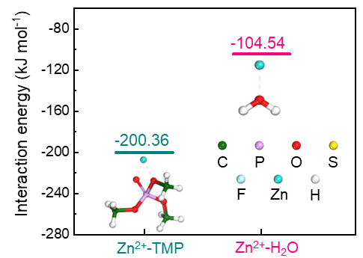
Supplementary Figure 12. The binding energy of Zn²⁺–TMP and Zn²⁺–water obtained from DFT calculations.

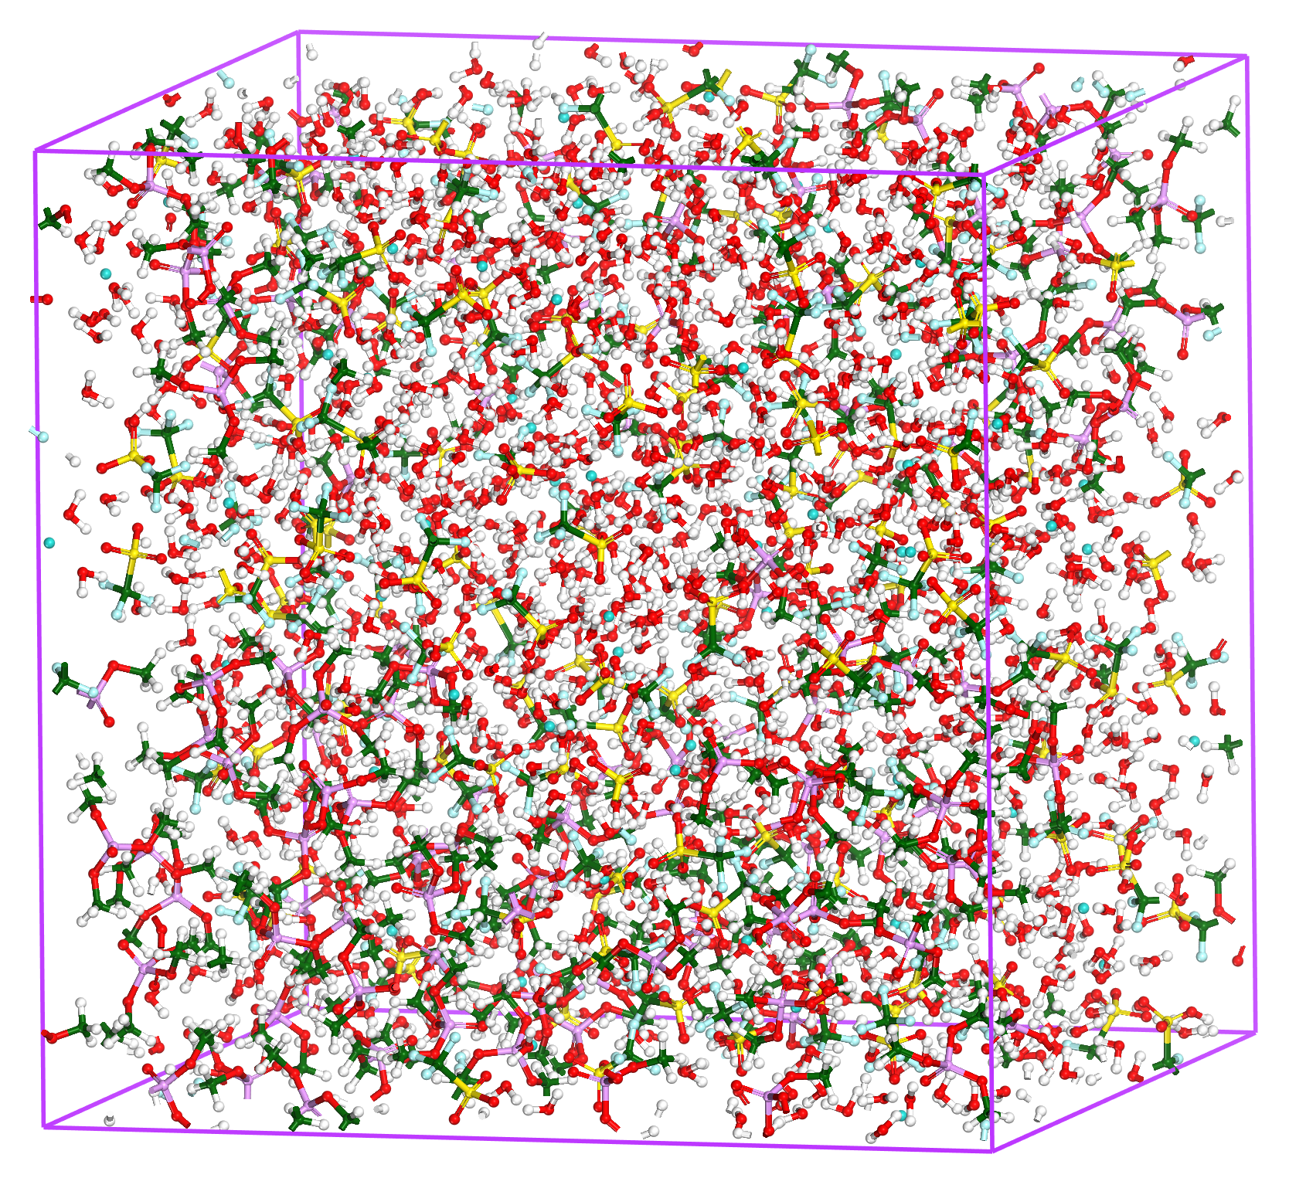
Supplementary Figure 13. Snapshot of the MD simulation cell for the TMP–40 electrolyte.

Supplementary Figure 14. Solvation structure model of TMP–0 and TMP–40 electrolytes.

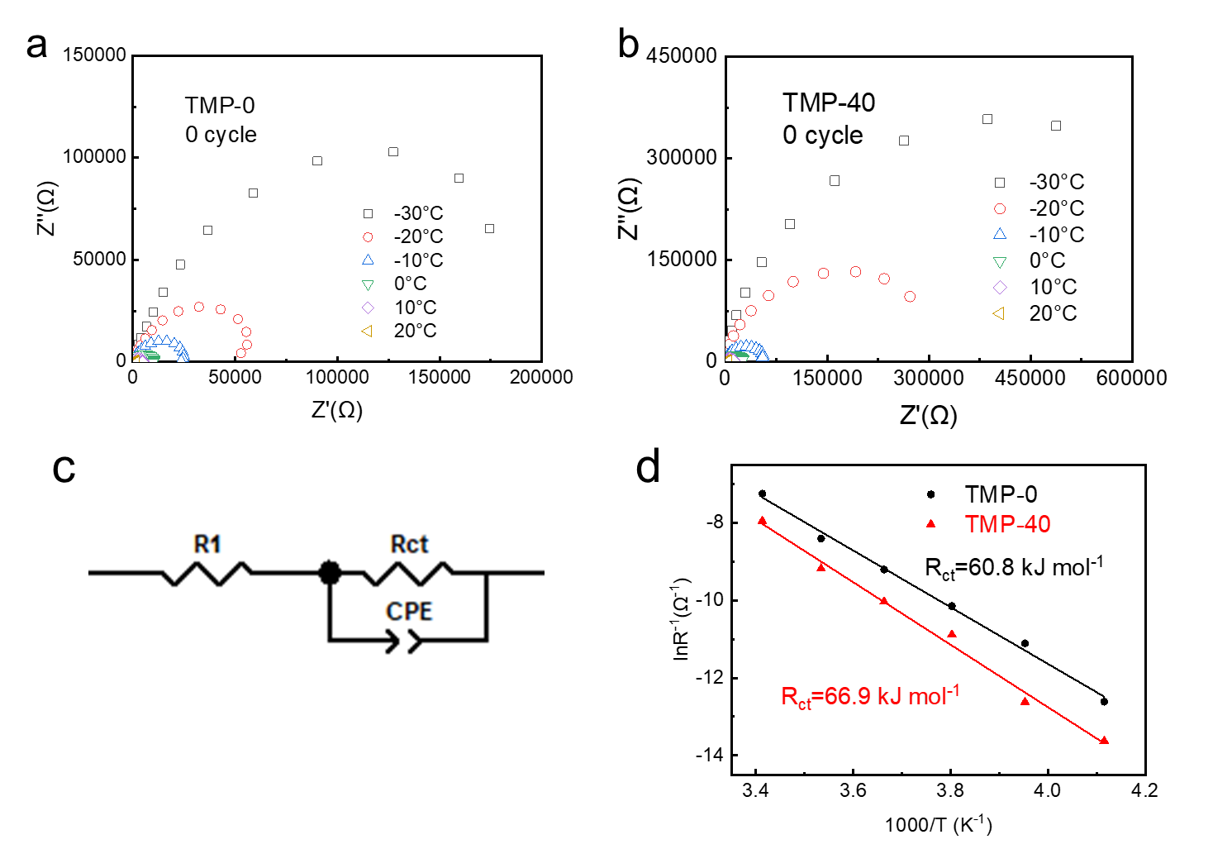
The fitting results corresponding to R_{ct} are as follows:
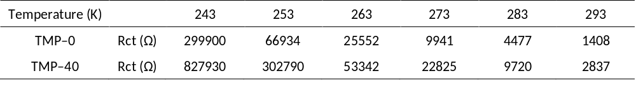
Supplementary Figure 15. Comparison of desolvation energy between TMP–0 and TMP–40 electrolytes. Temperature-dependent electrochemical impedance spectra of Zn||Zn symmetric cells with (a) TMP–0 or (b) TMP–40 electrolyte. (c) The equivalent circuit model. (d) Arrhenius fitting of R_{ct} derived from the Nyquist plots of the Zn||Zn symmetric cells with TMP–0 and TMP–40 electrolytes.

Supplementary Figure 16. Polarization curves of TMP–0 and TMP–40 electrolytes.

Supplementary Figure 17. Comparison of electrochemical stability windows of TMP–0 and TMP–40 electrolytes. LSV curves of TMP–0 and TMP–40 electrolytes to reveal the electrochemical stability in the voltage of (a) −0.2~0.5 V and (b) 1.75~2.75 V.

Supplementary Figure 18. LSV curves of Ti||Zn asymmetric cells before and after cycling in the TMP–40 electrolyte.
As shown in the Supplementary Fig. 18, the peak current density of Ti||Zn asymmetric cell at ~0.1 V disappears after 5 cycles, and the hydrogen evolution reaction is suppressed, indicating the generation of SEI.

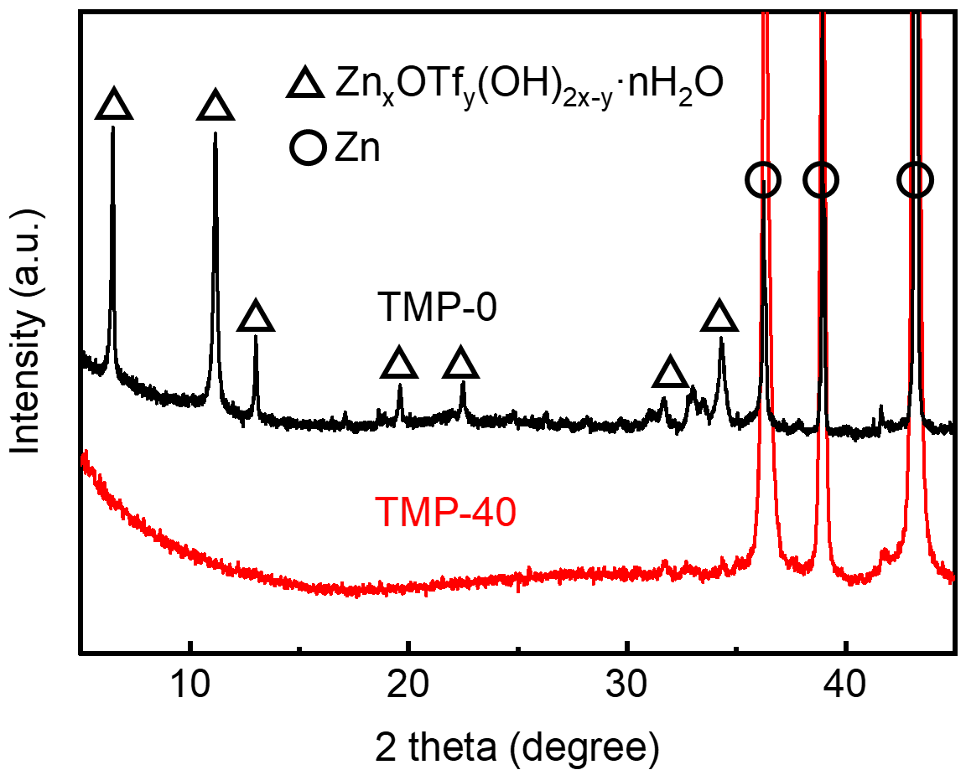
Supplementary Figure 19. XRD patterns of Zn anodes in TMP–0 and TMP–40 electrolytes after 40 cycles.

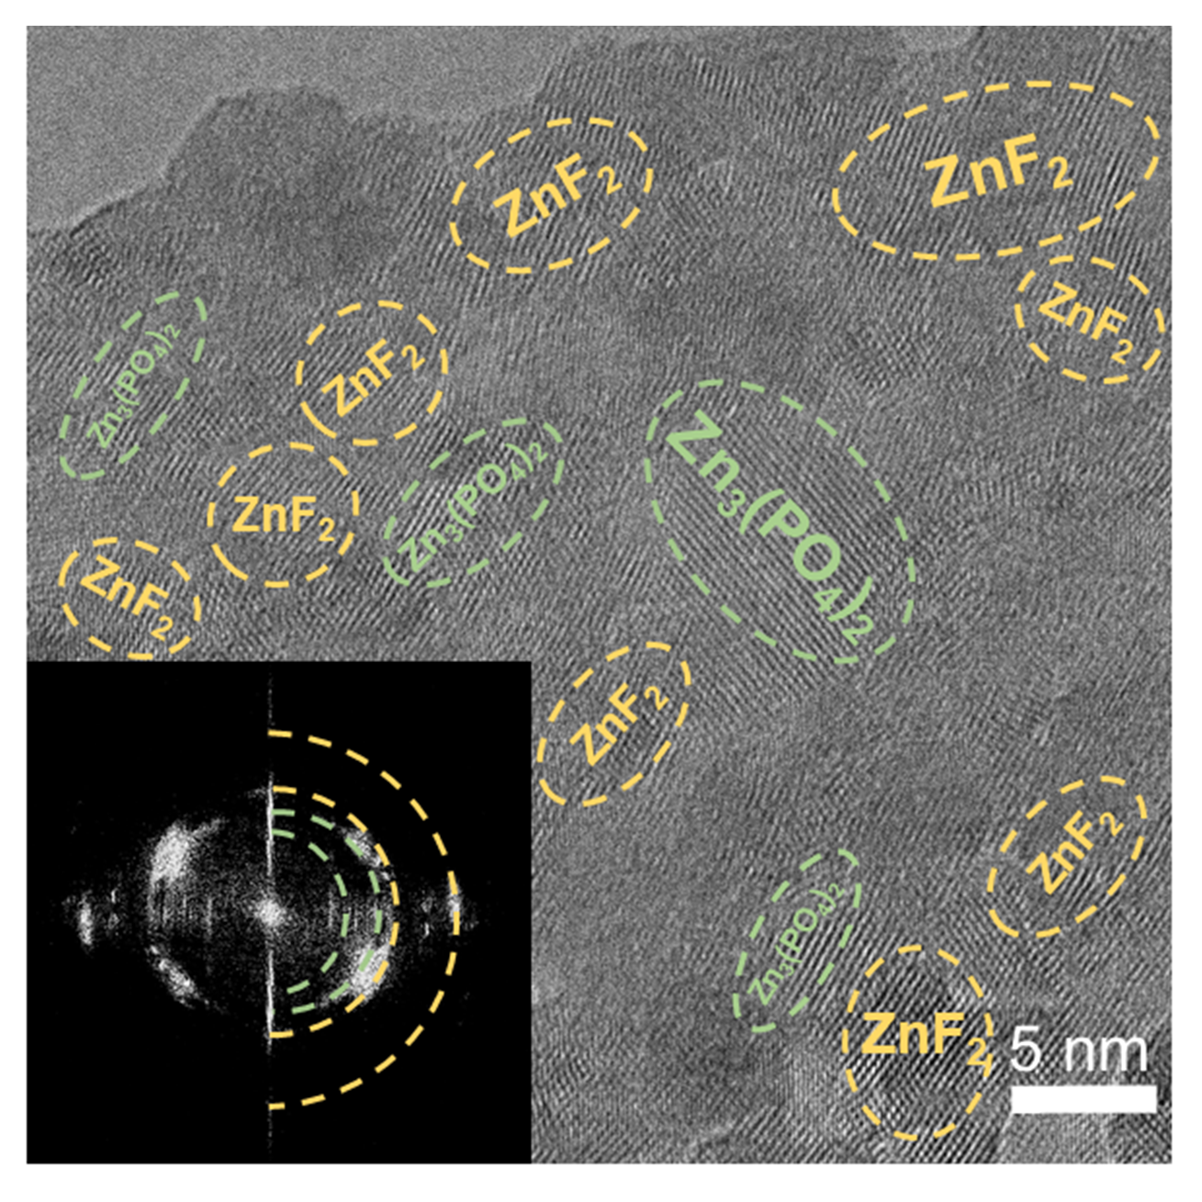
Supplementary Figure 20. HRTEM images of Zn surface after cycling by Zn||Zn symmetric cells with TMP–40 electrolyte. Inset: the corresponding SAED pattern.

Supplementary Figure 21. The content ratio of Zn₃(PO₄)₂ to ZnF₂ with the sputtering depth.

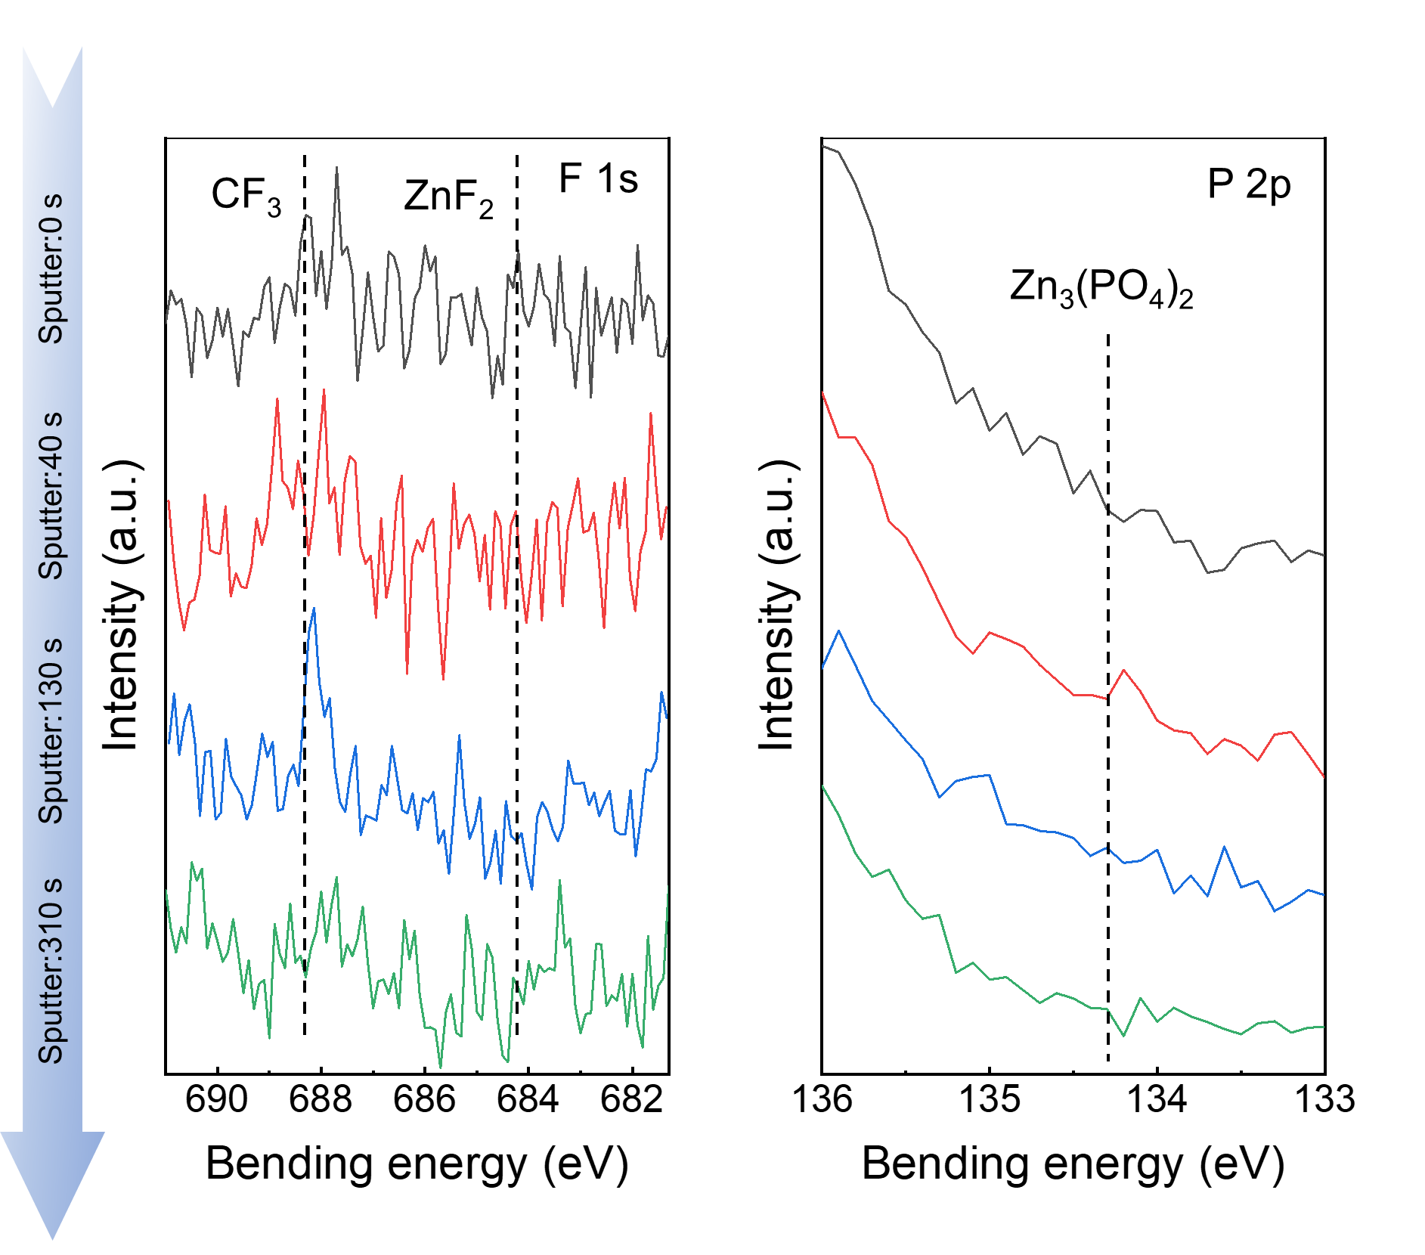
Supplementary Figure 22. XPS spectra of (a) F 1s and (b) P 2p on the Zn surface in the TMP–0 electrolyte.

The fitting results corresponding to R_{ct} and R_{SEI} are as follows:
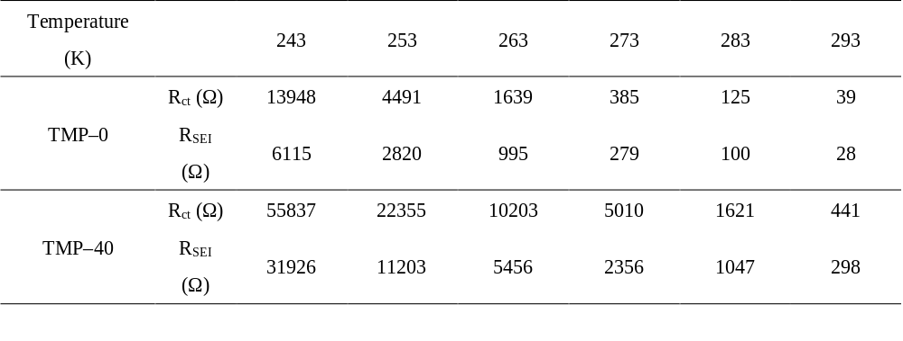Supplementary Figure 23. Temperature-dependent electrochemical impedance spectra of Zn||Zn symmetric cells after 40 cycles with (a) TMP–0 and (b)TMP–40 electrolyte. (c) The equivalent circuit model.

The fitting results corresponding to R_{ct} and R_{SEI} are as follows:
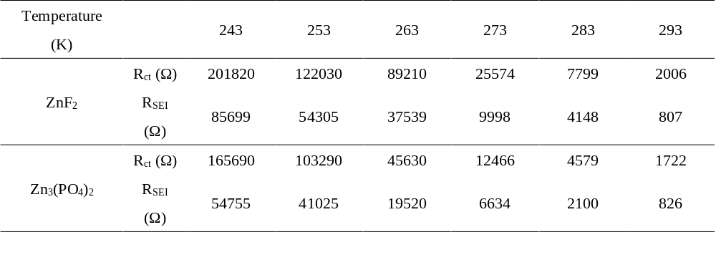
Supplementary Figure 24. Temperature-dependent electrochemical impedance spectra of (a) ZnF₂@Zn||ZnF₂@Zn and (b) Zn₃(PO₄)₂@Zn||Zn₃(PO₄)₂@Zn. (c) The equivalent circuit model. Arrhenius fitting of (d) R_{ct} and (e) R_{SEI} derived from the Nyquist plots of the ZnF₂@Zn||ZnF₂@Zn cells and Zn₃(PO₄)₂@Zn||Zn₃(PO₄)₂@Zn cells.
As shown in Supplementary Fig. 24d, e, compared with ZnF₂ SEI (E_{a,ct}=54.3 KJ mol⁻¹ and E_{a,SEI}=54.0 KJ mol⁻¹), Zn₃(PO₄)₂ SEI exhibits higher Zn²⁺–desolvation energy (E_{a,ct}=56.2 KJ mol⁻¹) and lower migration energy barrier of Zn²⁺ (E_{a,ct}=51.9 KJ mol⁻¹).This further confirms the superiority of gradient ZnF₂–Zn₃(PO₄)₂ SEI formed by TMP–40 electrolyte.

Supplementary Figure 25. Surface morphology after 50 mAh cm⁻² of deposited Zn in the electrolyte of (a) TMP–0 and (b) TMP–40.

Supplementary Figure 26. Stability of Zn plating/stripping in Zn||Zn symmetrical cells with various electrolytes at 45 °C.

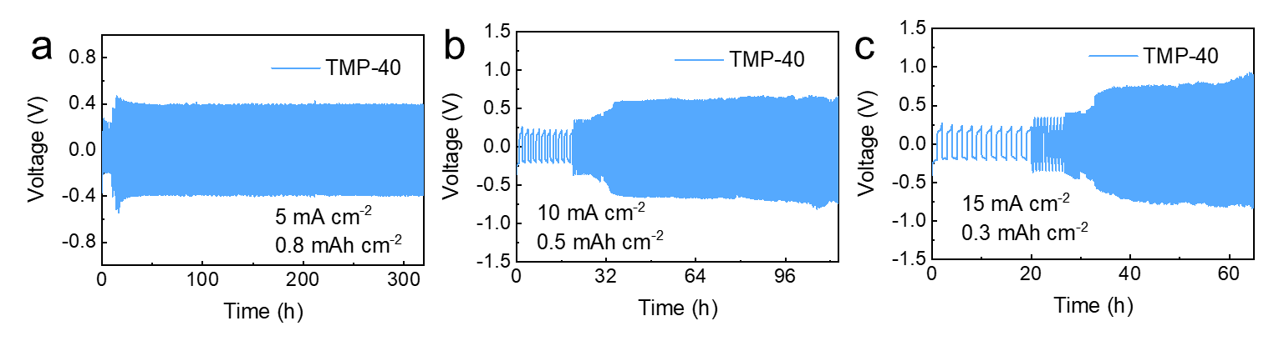
Supplementary Figure 27. Stability of Zn plating/stripping in Zn||Zn symmetrical cells with TMP–40 electrolyte at high currents under −30 °C.

Supplementary Figure 28. Galvanostatic cycling stability of symmetrical Zn cells with TMP–40 electrolyte at 0.1 mA cm⁻² and 1 mAh cm⁻² at −50 °C.

Supplementary Figure 29. Voltage profiles of Zn deposition on to Ti substrates at a current density of 1 mA cm⁻² and a capacity of 0.5 mAh cm⁻² after different cycles at −30 °C.

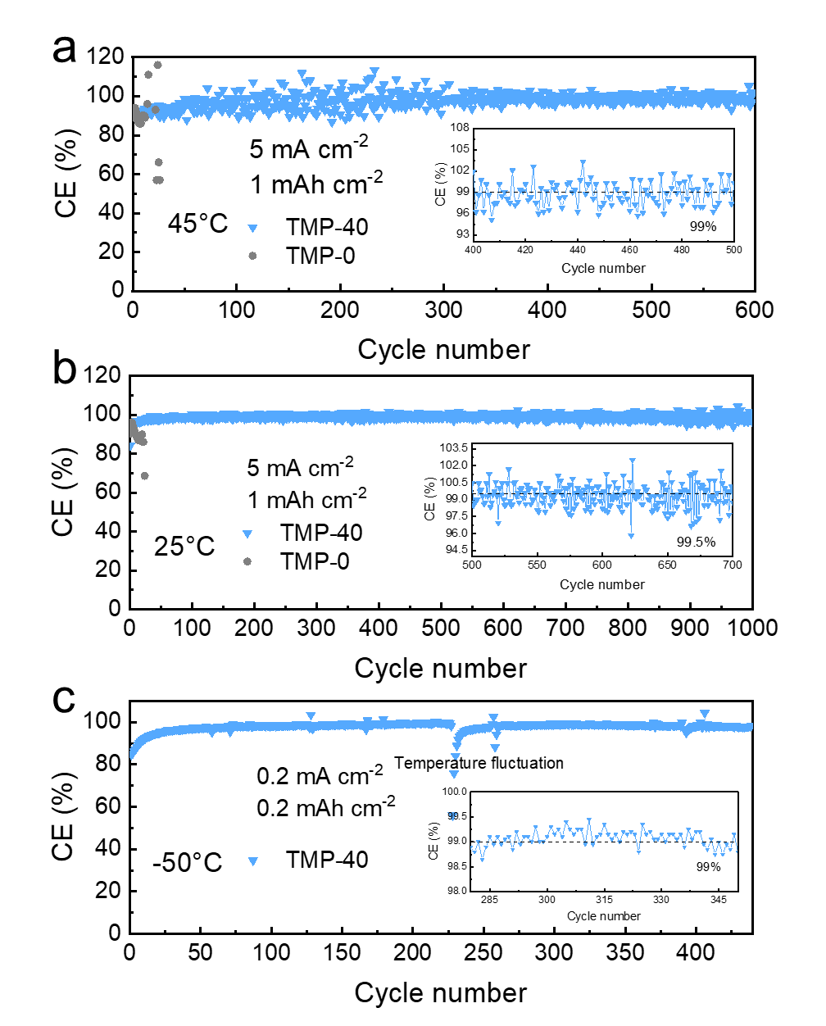
Supplementary Figure 30. Long-term Zn plating/stripping Coulombic efficiency with TMP–40 and TMP–0 electrolytes at (a) 45 °C, (b) 25 °C and (c) −50 °C.

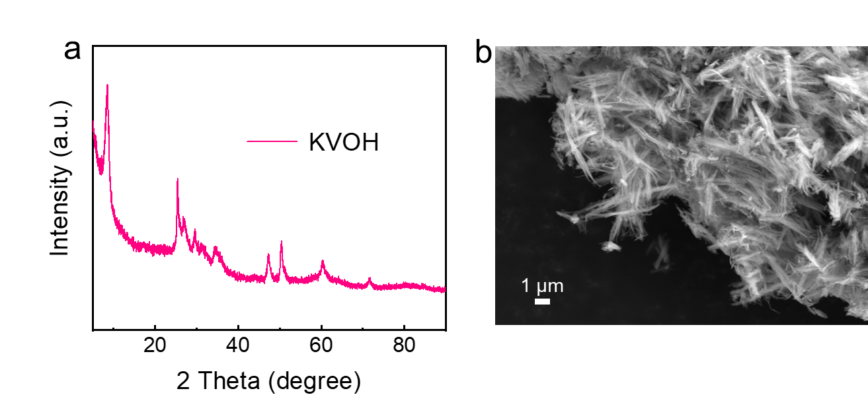
Supplementary Figure 31. (a) XRD pattern and (b) SEM image of KVOH.

Supplementary Figure 32. Comparison of charge–discharge curves with different cycles using (a) TMP–0 electrolyte and (b) TMP–40 electrolyte.

Supplementary Figure 33. The cycling performance of Zn–KVOH full cell in the TMP–40 electrolyte with different cathode loadings.

Supplementary Figure 34. The cycling performance of Zn–KVOH full cell with a rate of (a) 1A g⁻¹, (b) 2 A g⁻¹ and (c) 10 A g⁻¹ at 25 °C.

Supplementary Figure 35. The cycling performance of Zn–KVOH full cell with TMP–40 and TMP–0 electrolyte at 45 °C.

Supplementary Figure 36. The cycling performance of Zn–KVOH full cell with a rate of (a) 1A g⁻¹, (b) 2 A g⁻¹ and (c) 5 A g⁻¹ at −30 °C.

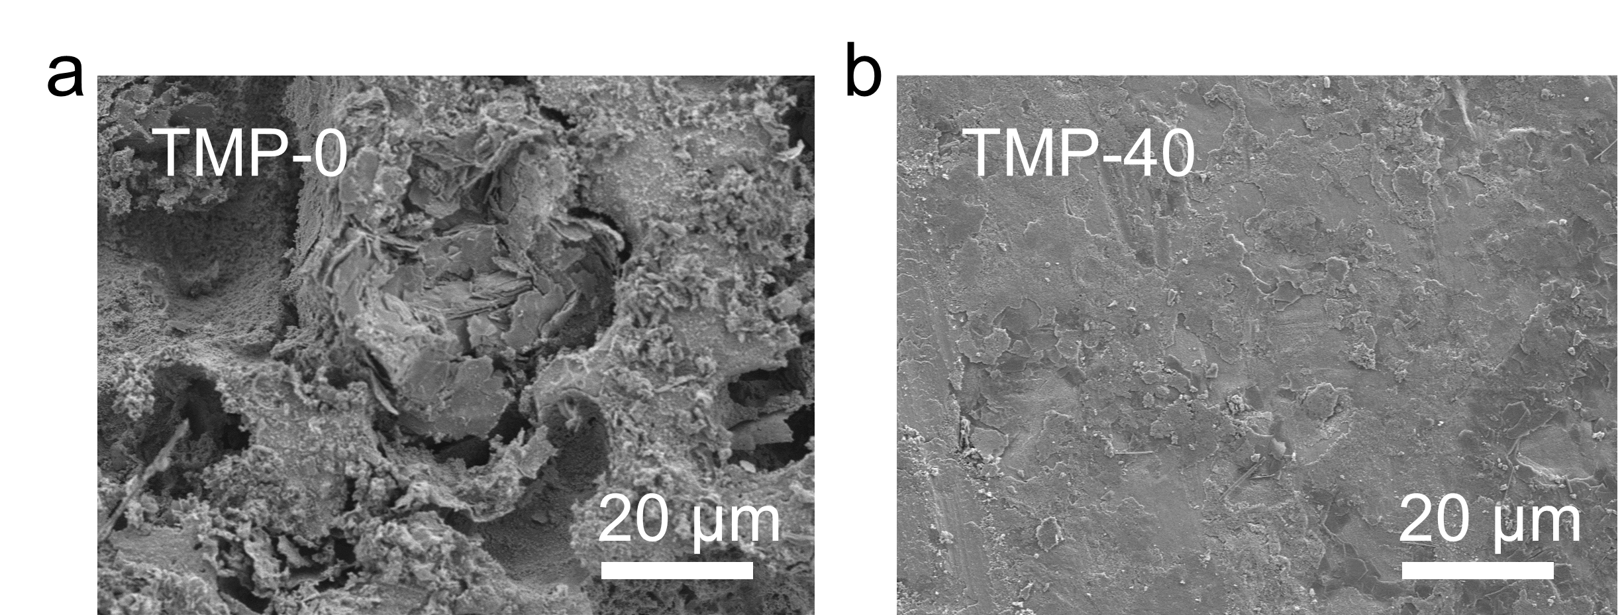
Supplementary Figure 37. Surface morphology of Zn anode after 1000 cycling in the electrolyte of (a) TMP–0 and (b) TMP–40.

Supplementary Figure 38. Cycling performance of Zn–KVOH pouch cell in the TMP–40 electrolyte at −50 °C.

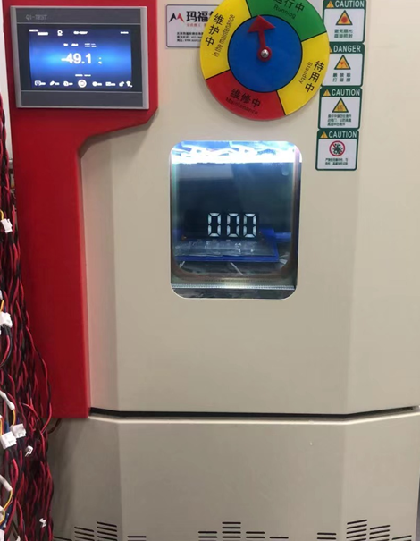
Supplementary Figure 39. Photograph of the pouch cells in the cryostat at −50 °C.

Supplementary Table 1. The ionic conductivities of different electrolytes at various temperatures.
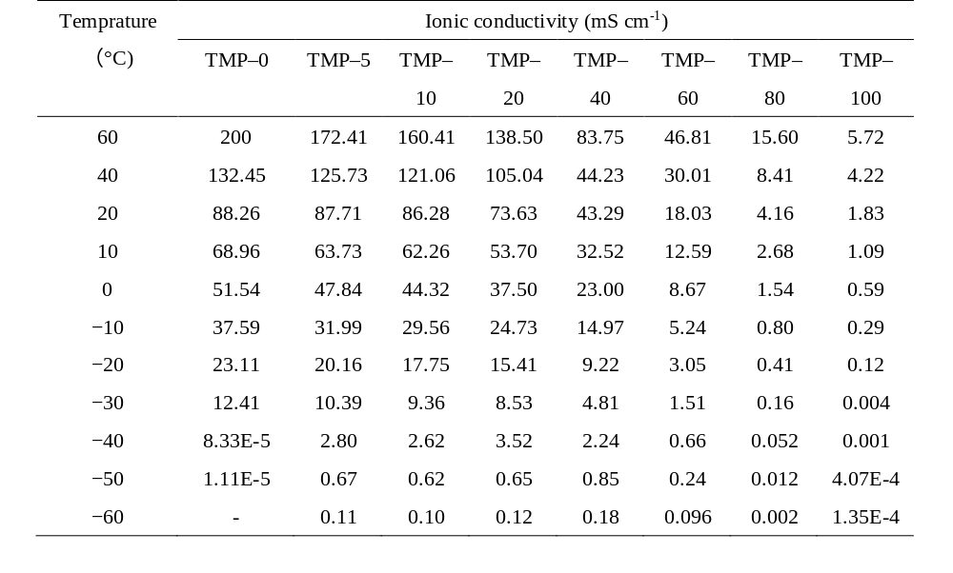
Supplementary Table 2. Numbers of ions and solvent molecules in the investigated simulation systems.
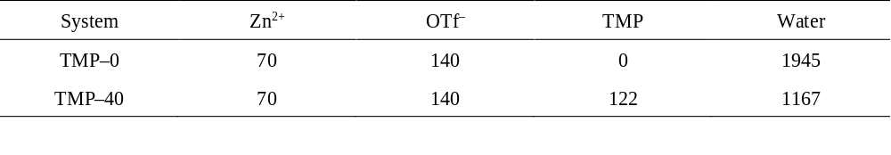

Supplementary Table 3. The summary of cumulative capacity of different reports under wide temperature range.
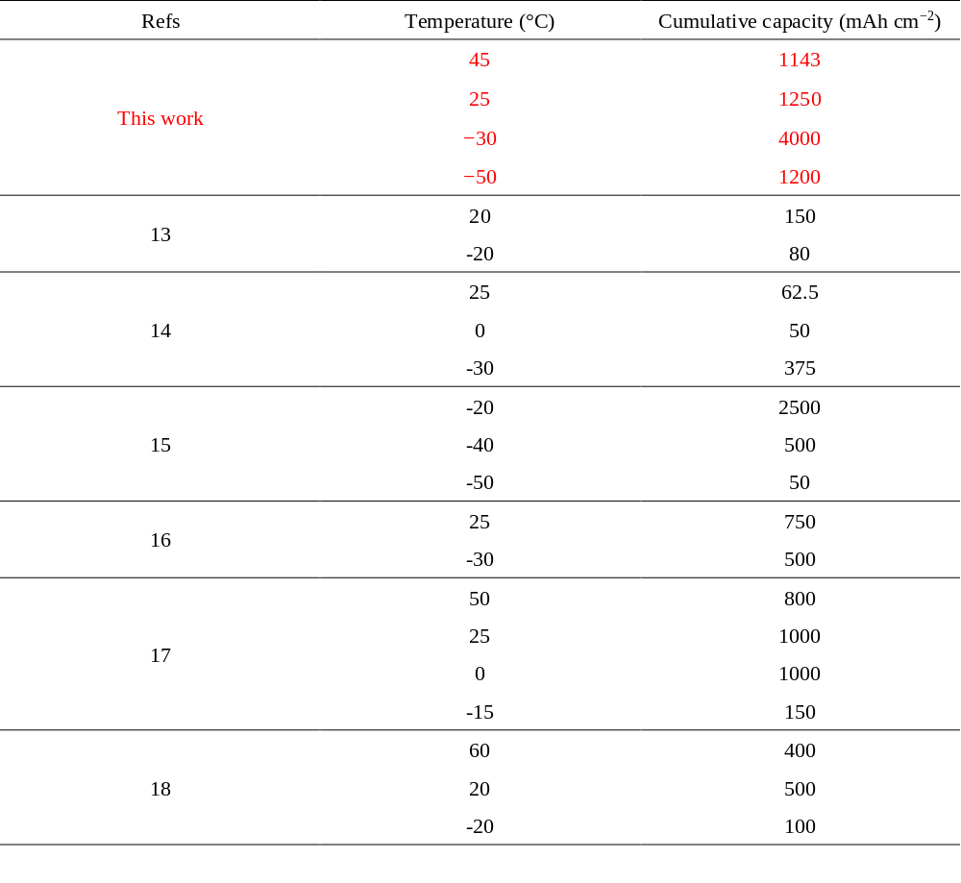

Supplementary Table 4. Summary of the cycling performance of the full cells with TMP–0 or TMP–40 electrolyte at different temperatures.
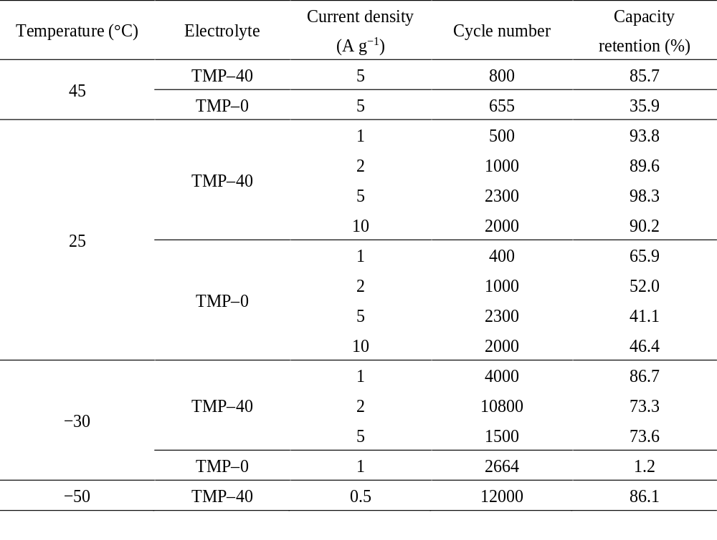

Supplementary Table 5. Summary of the cycle performance of the full cells with TMP–0 or TMP–40 electrolyte at different temperatures.
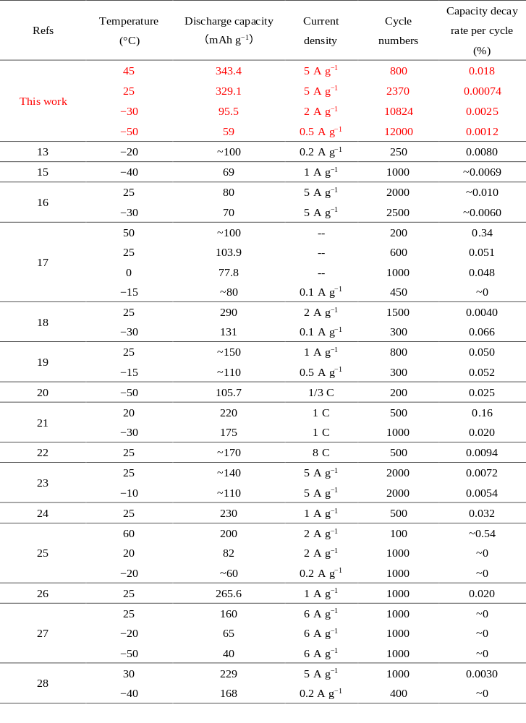

References
1. Tian, M. et al. Structural engineering of hydrated vanadium oxide cathode by K⁺ incorporation for high-capacity and long-cycling aqueous zinc ion batteries. Energy Storage Mater. 29, 9–16 (2020).
2. Chu, Y. Z. et al. In situ built interphase with high interface energy and fast kinetics for high performance Zn metal anodes. Energy Environ. Sci. 14, 3609–3620 (2021).
3. Martínez, L., Andrade, R., Birgin, E. G. & Martínez, J. M. Packmol: A package for building initial configurations for molecular dynamics simulations. J. Comput. Chem. 30, 2157–2164 (2009).
4. Plimpton, S. J. Fast parallel algorithms for short-range molecular dynamics. J. Comput. Phys. 117, 1–19 (1995).
5. Heinz, H., Vaia, R. A., Farmer, B. L. & Naik, R. R. Accurate simulation of surfaces and interfaces of face-centered cubic metals using 12-6 and 9-6 lennard-jones potentials. J. Phys. Chem. C 112, 17281–17290 (2008).
6. Nose, S. Constant temperature molecular dynamics methods. Prog. Theor. Phys. Supp. 103, 1–46 (1991).
7. Becke, A. D. Density-functional thermochemistry. I. The effect of the exchange-only gradient correction. J. Chem. Phys. 96, 2155–2160 (1992).
8. Stephens, P. J., Devlin, F. J., Chabalowski, C. F. & Frisch, M. J. Ab initio calculation of vibrational absorption and circular dichroism spectra using density functional force fields. J. Phys. Chem. 98, 11623–11627 (1994).
9. Kresse, G. & Furthmüller, J. Efficiency of ab-initio total energy calculations for metals and semiconductors using a plane-wave basis set. Comp. Mater. Sci. 6, 15–50 (1996).
10. Kresse, G. & Furthmüller, J. Efficient iterative schemes for ab initio total-energy calculations using a plane-wave basis set. Phys. Rev. B. 54, 11169–1186 (1996).
11. Blöchl, P. E. Projector augmented-wave method. Phys. Rev. B. 50, 17953–17979 (1994).
12. Perdew, J. P., Burke, K. & Ernzerhof, M. Generalized gradient approximation made simple. Phys. Rev. Lett. 77, 3865–3868 (1996).
13. Chang, N. N. et al. An aqueous hybrid electrolyte for low-temperature zinc-based energy storage devices. Energy Environ. Sci. 13, 3527–3535 (2020).
14. Sun, T. J. et al. An ultralow-temperature aqueous zinc-ion battery. J. Mater. Chem. A 9, 7042–7047 (2021).
15. Wang, J. W. et al. Low-temperature and high-rate Zn metal batteries enabled by mitigating Zn²⁺ concentration polarization. Chem. Eng. J. 433, 134589 (2022).
16. Huang, S. W. et al. Antifreezing hydrogel electrolyte with ternary hydrogen bonding for high-performance zinc-ion batteries. Adv. Mater. 34, 2110140 (2022).
17. Hou, Z., Lu, Z. H., Chen, Q. W. & Zhang, B. Realizing wide-temperature Zn metal anodes through concurrent interface stability regulation and solvation structure modulation. Energy Storage Mater. 42, 517–525 (2021).
18. Zhou, J. et al. Highly Reversible and Stable Zn Metal Anode under Wide Temperature Conditions Enabled by Modulating Electrolyte Chemistry. Chem. Eng. J. 442, 136218 (2022).
19. Han, D. L. et al. A non-flammable hydrous organic electrolyte for sustainable zinc batteries. Nat. Sustain. 5, 205–213 (2022).
20. Cao, L. S. et al. Highly reversible aqueous zinc batteries enabled by zincophilic–zincophobic interfacial layers and interrupted hydrogen-bond electrolytes. Angew. Chem. Int. Ed. 60, 18845–18851 (2021).
21. Gao, S. Y. et al. High energy and stable subfreezing aqueous Zn-MnO₂ batteries with selective and pseudocapacitive Zn-ion insertion in MnO₂. Adv. Mater. 34, 2201510 (2022).
22. Cao, L. S. et al. Solvation structure design for aqueous Zn metal batteries. J. Am. Chem. Soc. 142, 21404–21409 (2020).
23. Hao, J. N. et al. Boosting zinc electrode reversibility in aqueous electrolytes by using low-cost antisolvents. Angew. Chem. Int. Ed. 60, 7366–7375 (2021).
24. Han, D. L. et al. A self-regulated interface toward highly reversible aqueous zinc batteries. Adv. Energy Mater. 12, 2102982 (2022).
25. Du, H. H. et al. Improving zinc anode reversibility by hydrogen bond in hybrid aqueous electrolyte. Chem. Eng. J. 427, 131705 (2022).
26. Sun, P. et al. Simultaneous Regulation on Solvation Shell and Electrode Interface for Dendrite-free Zn ion batteries achieved by a low-cost glucose additive. Angew. Chem. Int. Ed. 60, 18247–18255 (2021).
27. Yang, G. S. et al. An aqueous zinc-ion battery working at −50 °C enabled by low-concentration perchlorate-based chaotropic salt electrolyte. Ecomat 4, e12165 (2022).
28. Liu, D. S. et al. Regulating the electrolyte solvation structure enables ultralong lifespan Vanadium-based cathodes with excellent low-temperature Performance. Adv. Funct. Mater. 32, 2111714 (2022).

