Supplementary Data
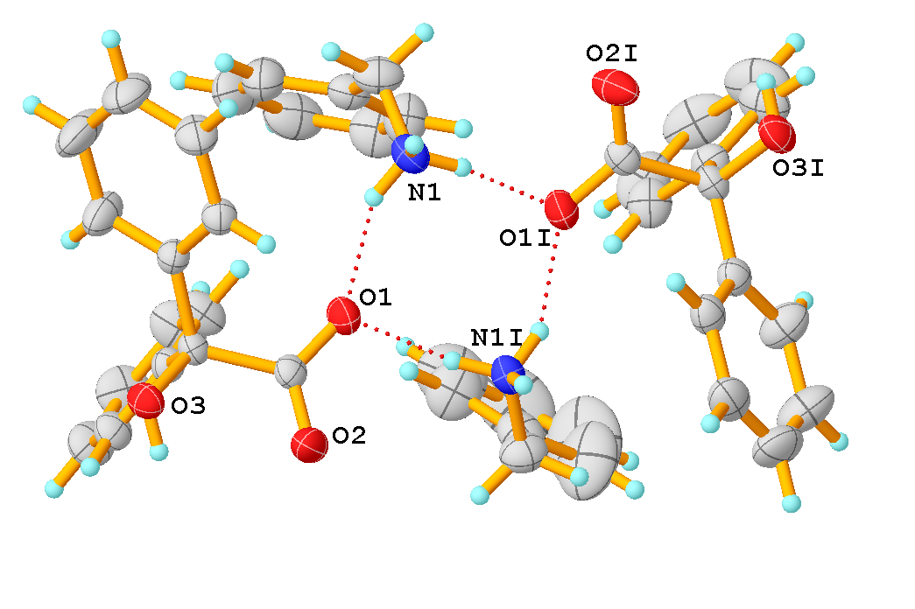
Fig.S1 Dimer formed by BABA molecule related by inversion centre.

