Thermophilic Dehalococcoidia with unusual traits shed light on an unexpected past
Marike Palmer, Jonathan K. Covington, En-Min Zhou, Scott C. Thomas, Neeli Habib, Cale O. Seymour, Dengxun Lai, Juliet Johnston, Ameena Hashimi, Jian-Yu Jiao, Alise R. Muok, Lan Liu, Wen-Dong Xian, Xiao-Yang Zhi, Meng-Meng Li, Leslie P. Silva, Benjamin P. Bowen, Katherine Louie, Ariane Briegel, Jennifer Pett-Ridge, Peter K. Weber, Elitza I. Tocheva, Tanja Woyke, Trent R. Northen, Xavier Mayali, Wen-Jun Li, Brian P. Hedlund

Supplementary Tables
- Table S1. High-quality Chloroflexota genomes used in this study
- Table S2. High-quality Dehalococcoidia genomes used in this study
- Table S3. EMP data for the Tepidiformaceae and Tepidiforma
- Table S4. Prevalence of Tepidiformaceae and Tepidiforma in EMP datasets
- Table S5. Core genome of the Tepidiformales
- Table S6. Genome annotations for YIM 72310^{T}
- Table S7. Genome annotations for G233^{T}
- Table S8. Anaerobic growth experiments
- Table S9. Sole carbon source experiments
- Table S10. Medium drop-out experiments
- Table S11. Growth stimulation experiments
- Table S12. Exometabolomics data for YIM 72310^{T}
- Table S13. Exometabolomics data for G233^{T}
- Table S14. Summary of metabolite identification in negative mode
- Table S15. Summary of compound metadata in negative mode
- Table S16. Summary of metabolite identification in positive mode
- Table S17. Summary of compound metadata in positive mode
- Table S18. CAZymes annotated for YIM 72310^{T}
- Table S19. CAZymes annotated for G233^{T}
- Table S20. Quantitative PCR results for detection of Tepidiforma in Great Boiling Spring
- Table S21. MIGS data for YIM 72310^{T} and G233^{T}
- Table S22. Growth at varying tungsten concentrations

Supplementary Datasets
- File S1. Flagellar gene trees
- MassIVE dataset 1. Exometabolomics for Tepidiforma spp. grown on R2A broth (https://doi.org/10.25345/C57S7HX50)
- FigShare Collection 1. Exometabolomics analysis for MassIVE dataset MSV000090480 (https://doi.org/10.6084/m9.figshare.c.6236283.v1)

Supplementary Figures
- Figure S1. Chloroflexota Bac120 phylogeny
- Figure S2. EMP distribution
- Figure S3. Growth of YIM 72310^{T} with β-lactam antibiotics
- Figure S4. Exometabolomics data
- Figure S5. Lignin ¹³CO₂ respiration and ¹³C incorporation data
- Figure S6. Aromatics degradation pathways and presence of genes

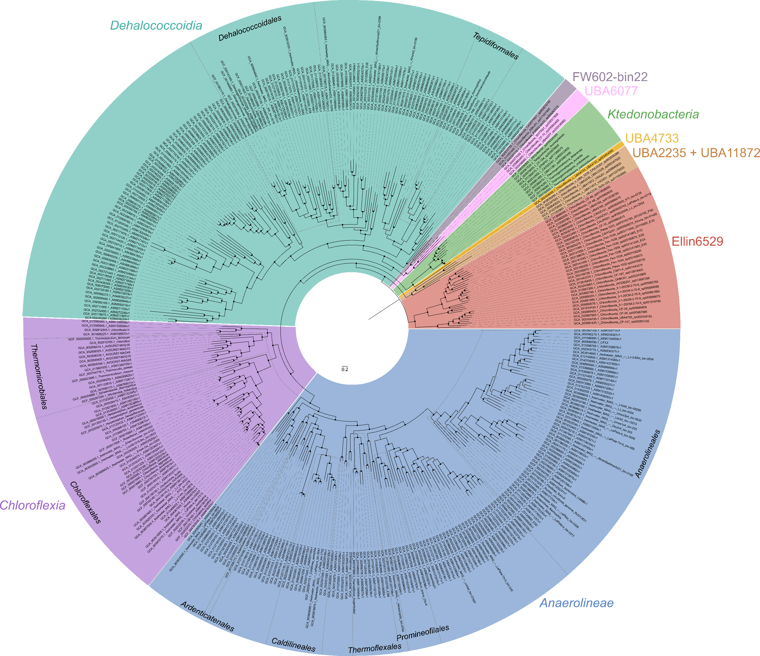
Figure S1. Chloroflexota Bac120 phylogeny. An approximate maximum-likelihood phylogeny constructed from the concatenated bacterial markers as extracted and aligned with GTDB-Tk v. 1.4.1, for all high-quality genomes representing species-groups belonging to the phylum Chloroflexota. All markers were evaluated to determine the best-fit evolutionary model with ProtTest v. 3.4 and concatenated and partitioned in FAsconCAT-G v. 1.04. Classes as identified in the Genome Taxonomy Database are represented by colored segments, and order-level groups with cultivated representatives within the phylum are indicated as wedges. Branches supported by > 0.95 support from 1,000 replications with Shimodaira-Hasegawa support are indicated as black dots at nodes.
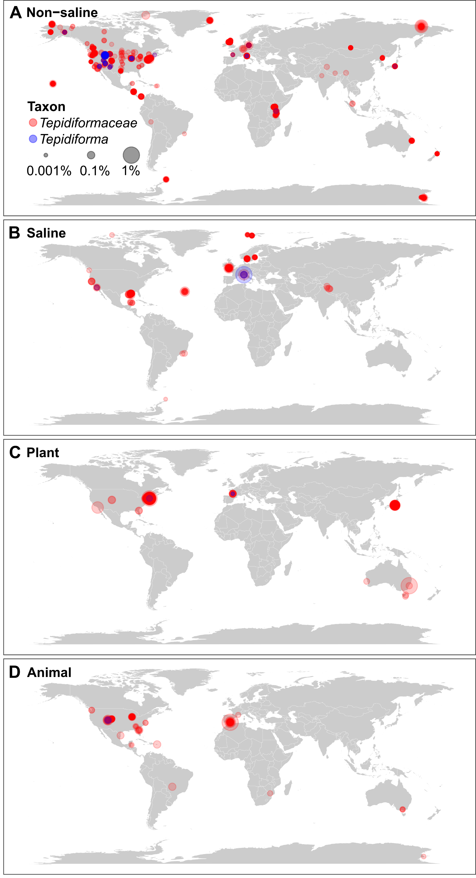
Figure S2. Earth Microbiome Project data for the Tepidiformaceae and Tepidiforma. Geographic distribution of Tepidiformaceae and Tepidiforma within the EMP Qiita database (1) across empo-level 2 biomes. Each point represents a microbial community containing the family (red) or genus (blue) based on 16S rRNA gene sequences.
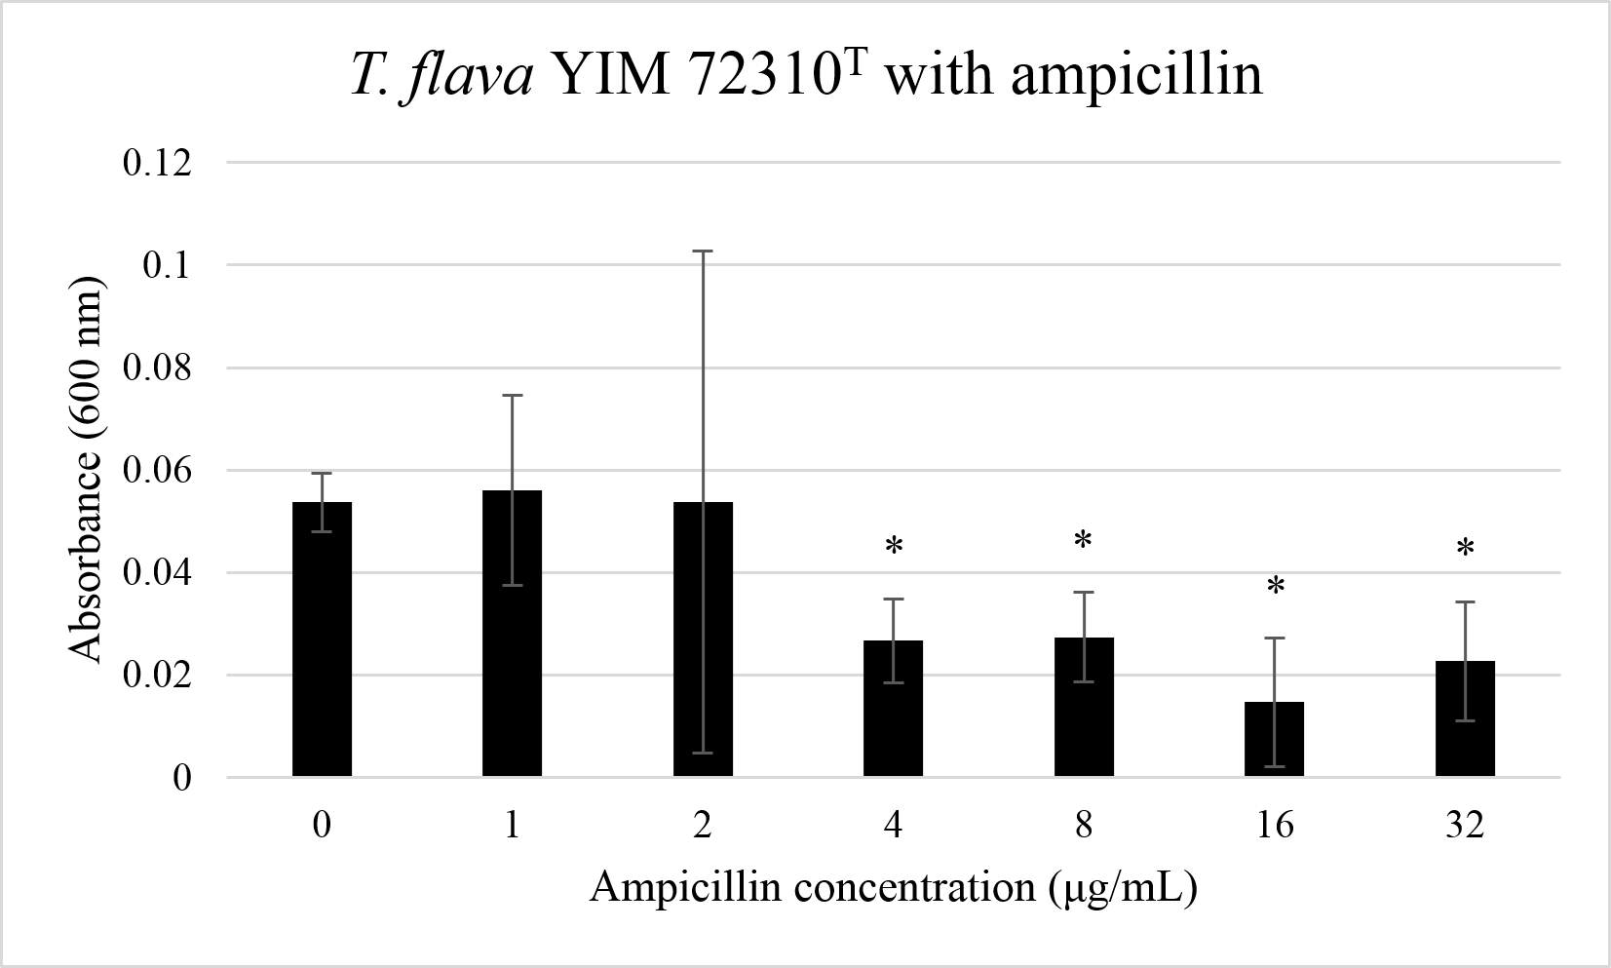
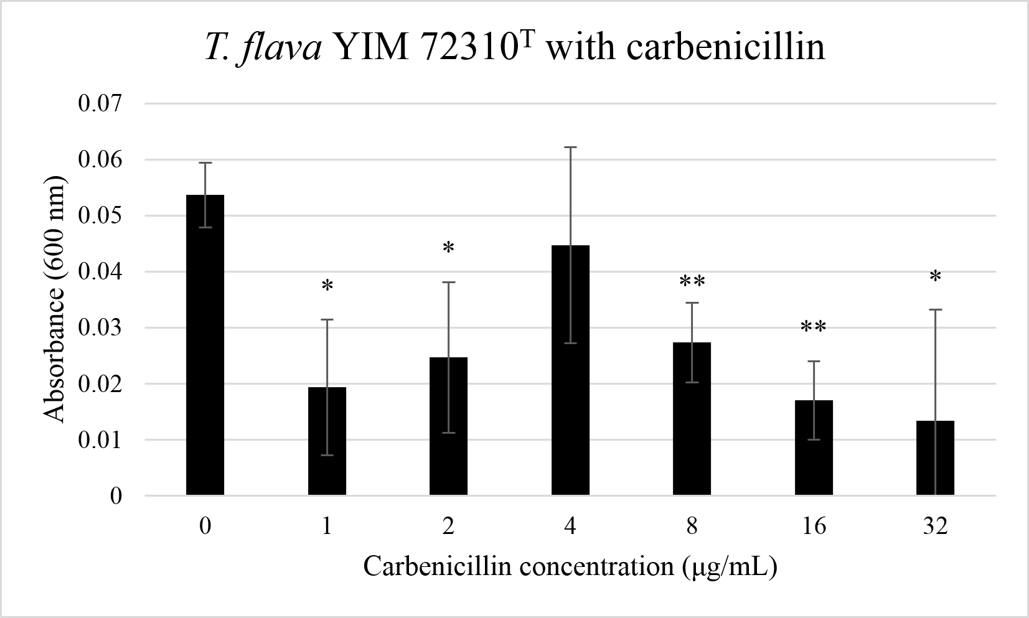

Figure S3. Growth of strain YIM 72310^{T} on 2R2AW broth containing varying concentrations of β-lactam antibiotics. Effects on growth were assessed using unpaired t-tests and were either significant (p-value < 0.05) or highly significant (p-value < 0.005) compared to the 0 μg/mL controls.

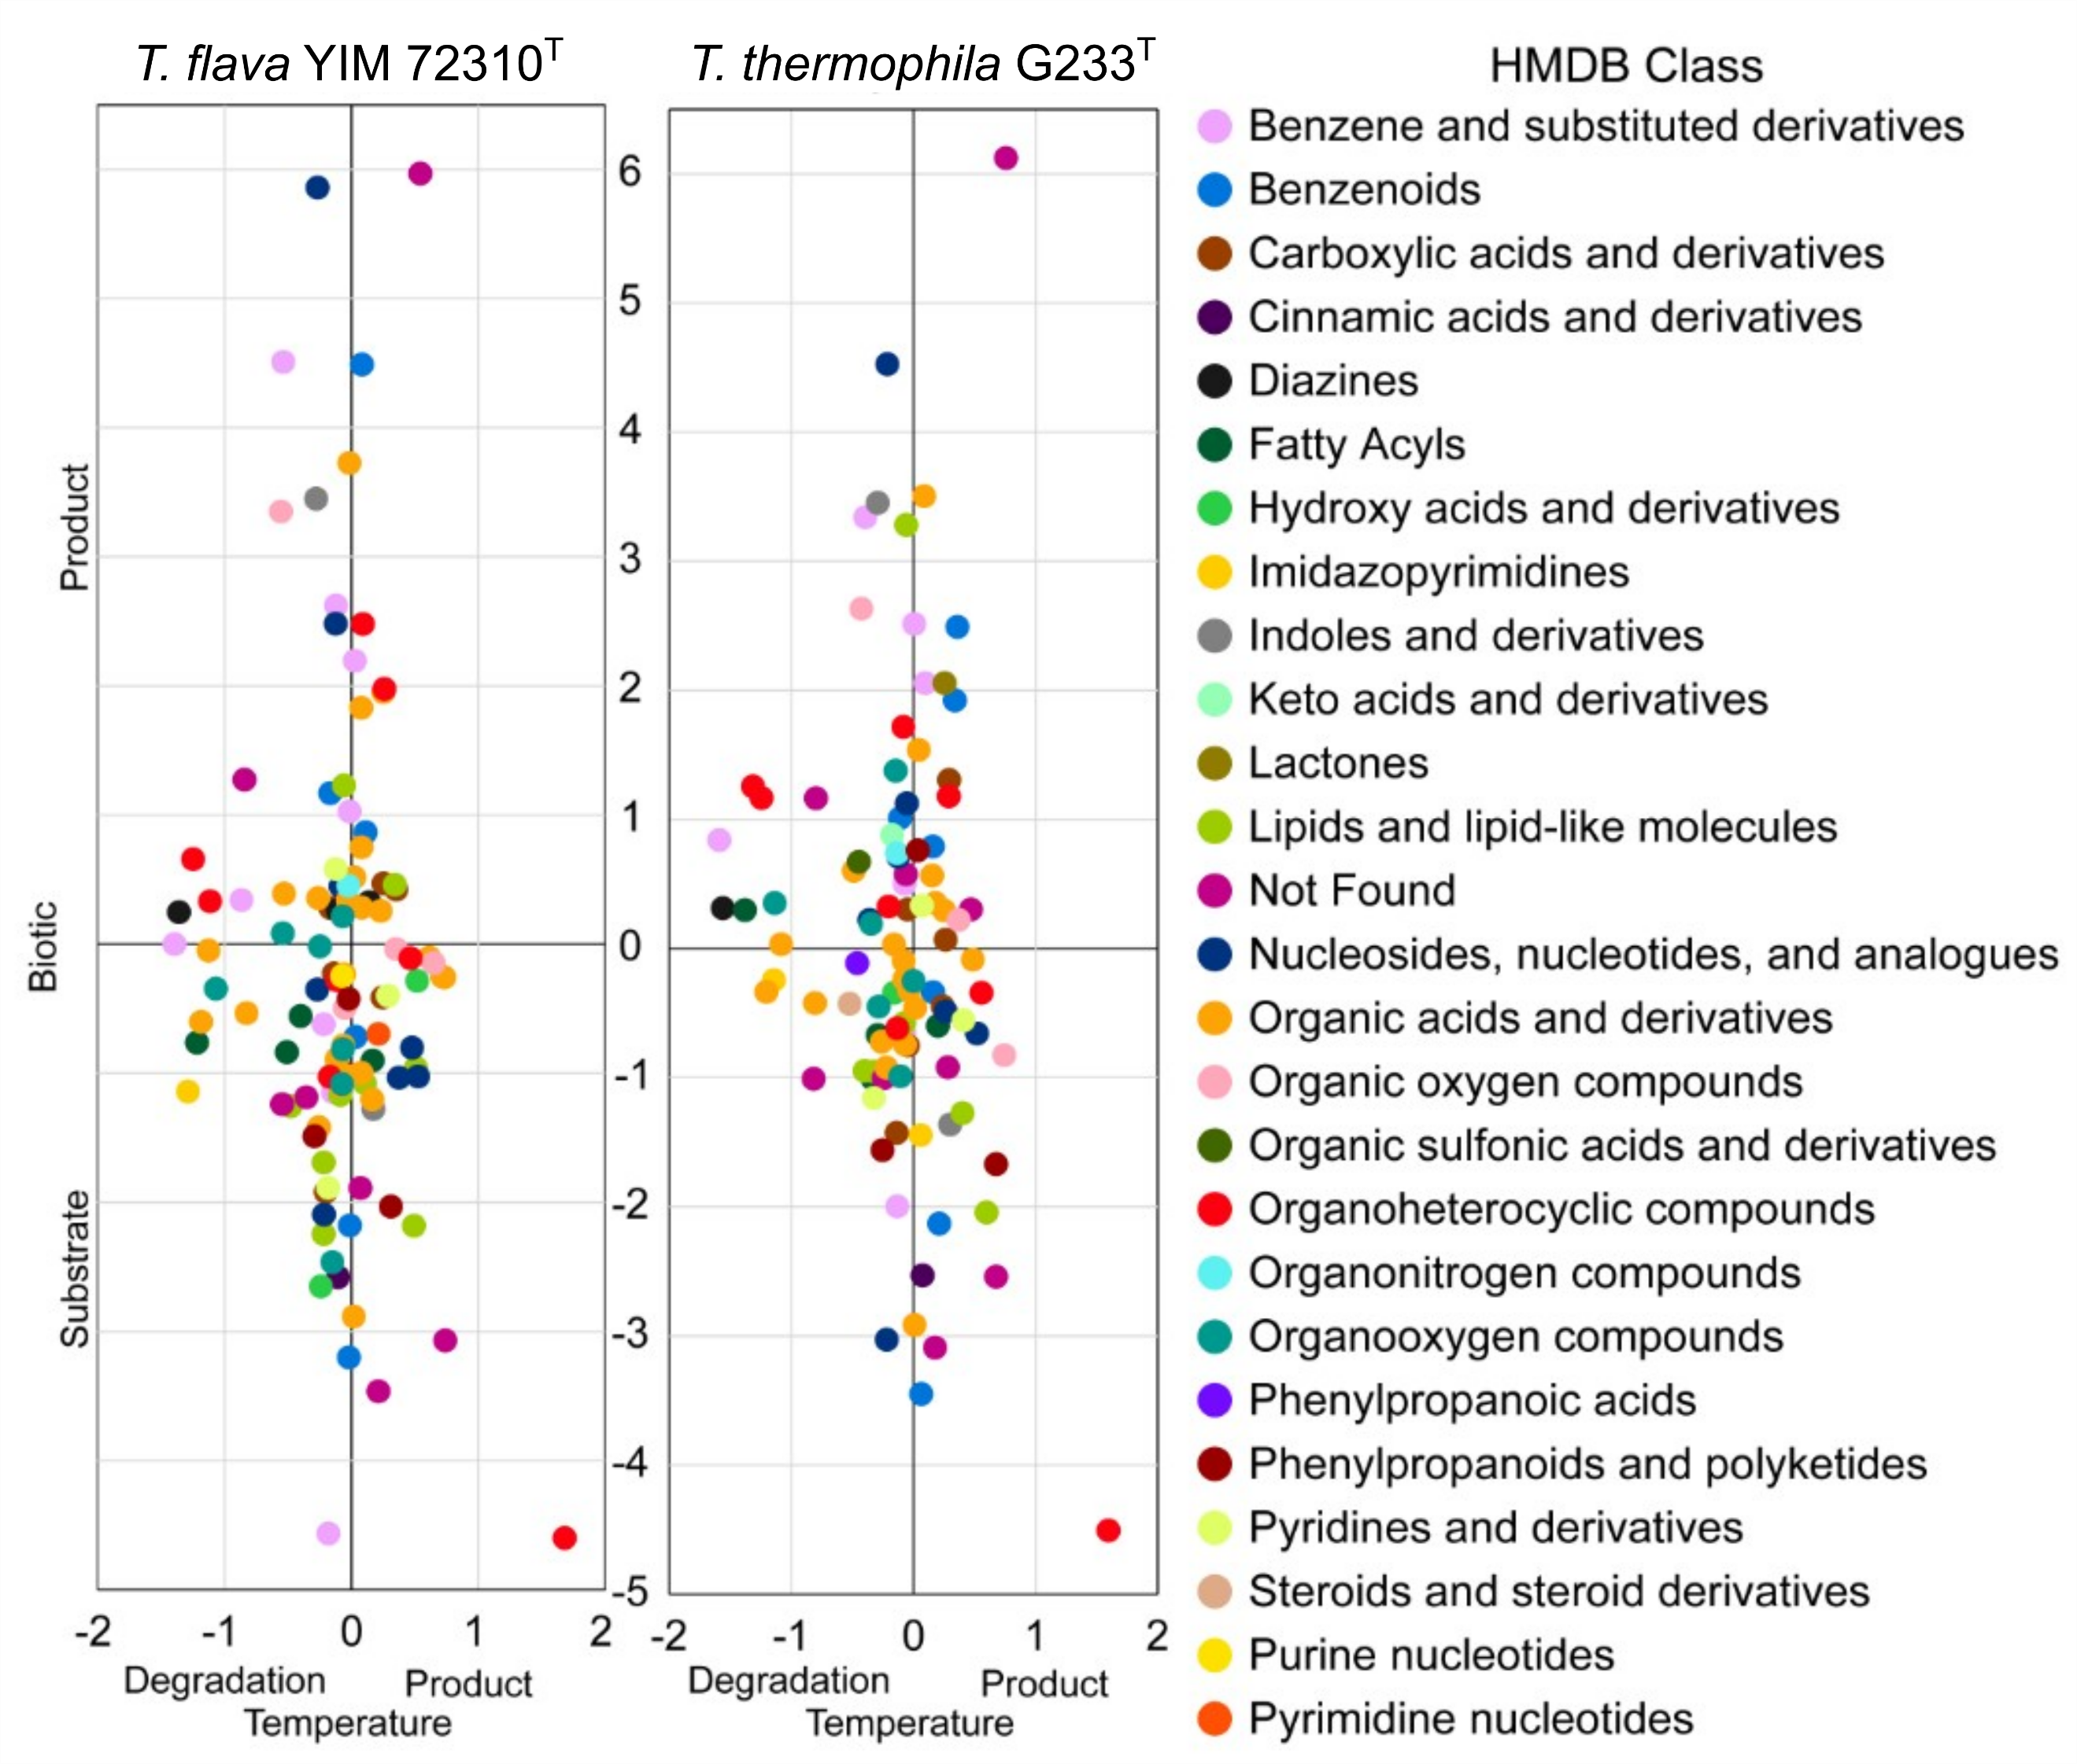

Figure S4. Exometabolomics results demonstrate metabolisms of heterocycles and lipids. Log2 fold changes in peak height for metabolites that differed significantly between treatments (p-value < 0.05 for ANOVA with Tukey’s HSD). Colors indicate the Human Metabolome Database (HMDB) metabolite Class for specific compounds. Compounds can be identified in Table S10 and S11 and are ordered vertically as shown on this graph.
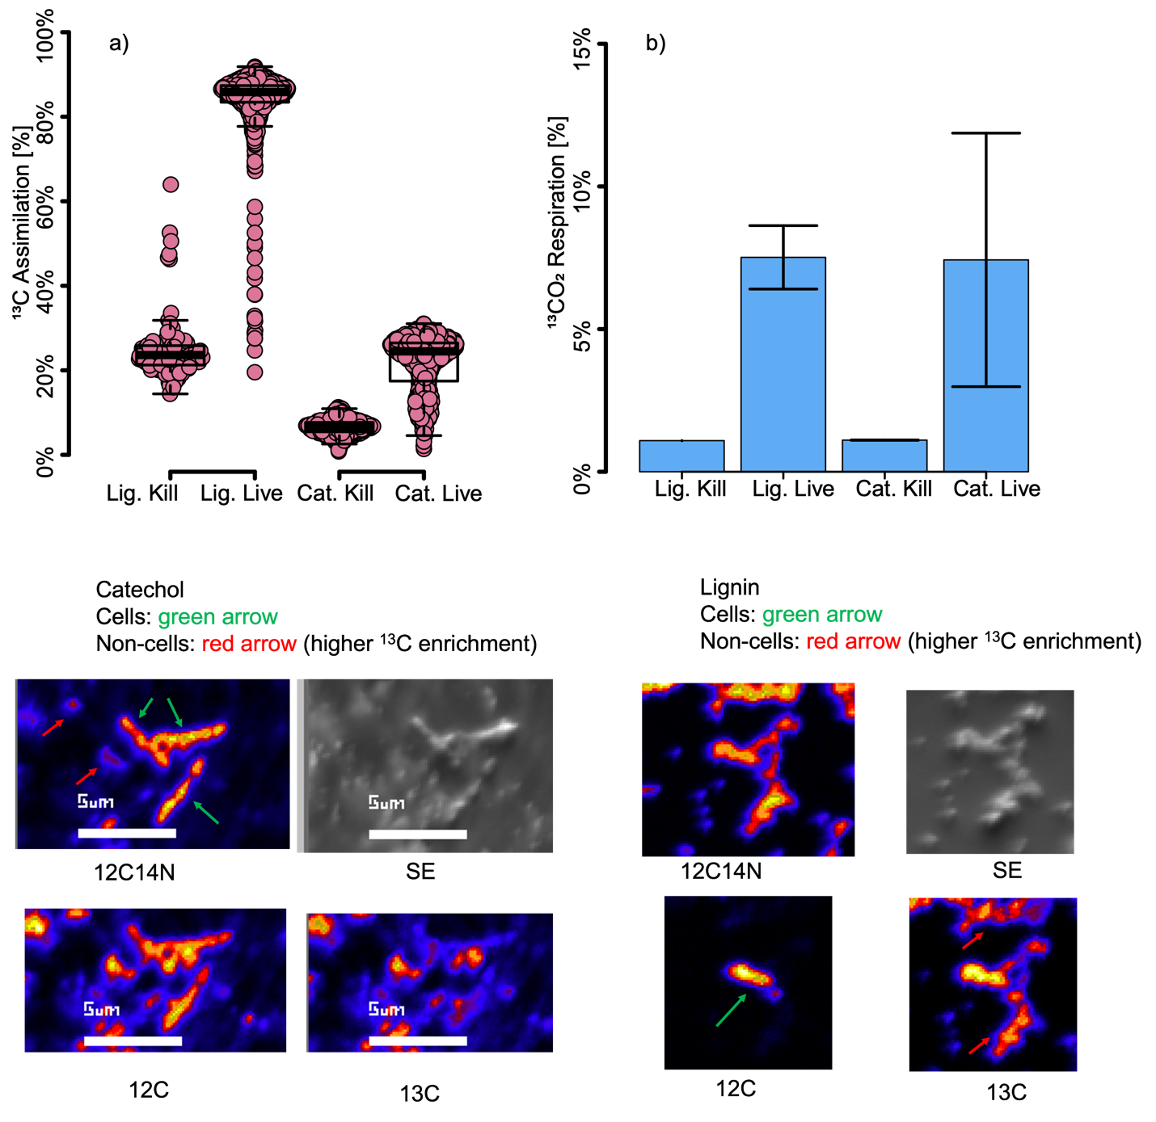

Figure S5. Single cell isotope ¹³C labeling (a) and respiration (b) of ¹³C lignin and ¹³C catechol. While the live cells were more strongly labeled than the killed cells, these data are not definitive for incorporation, as the nanoSIMS images (c, d) suggest the lignin and catechol bind to non-cellular organic material (red arrows).

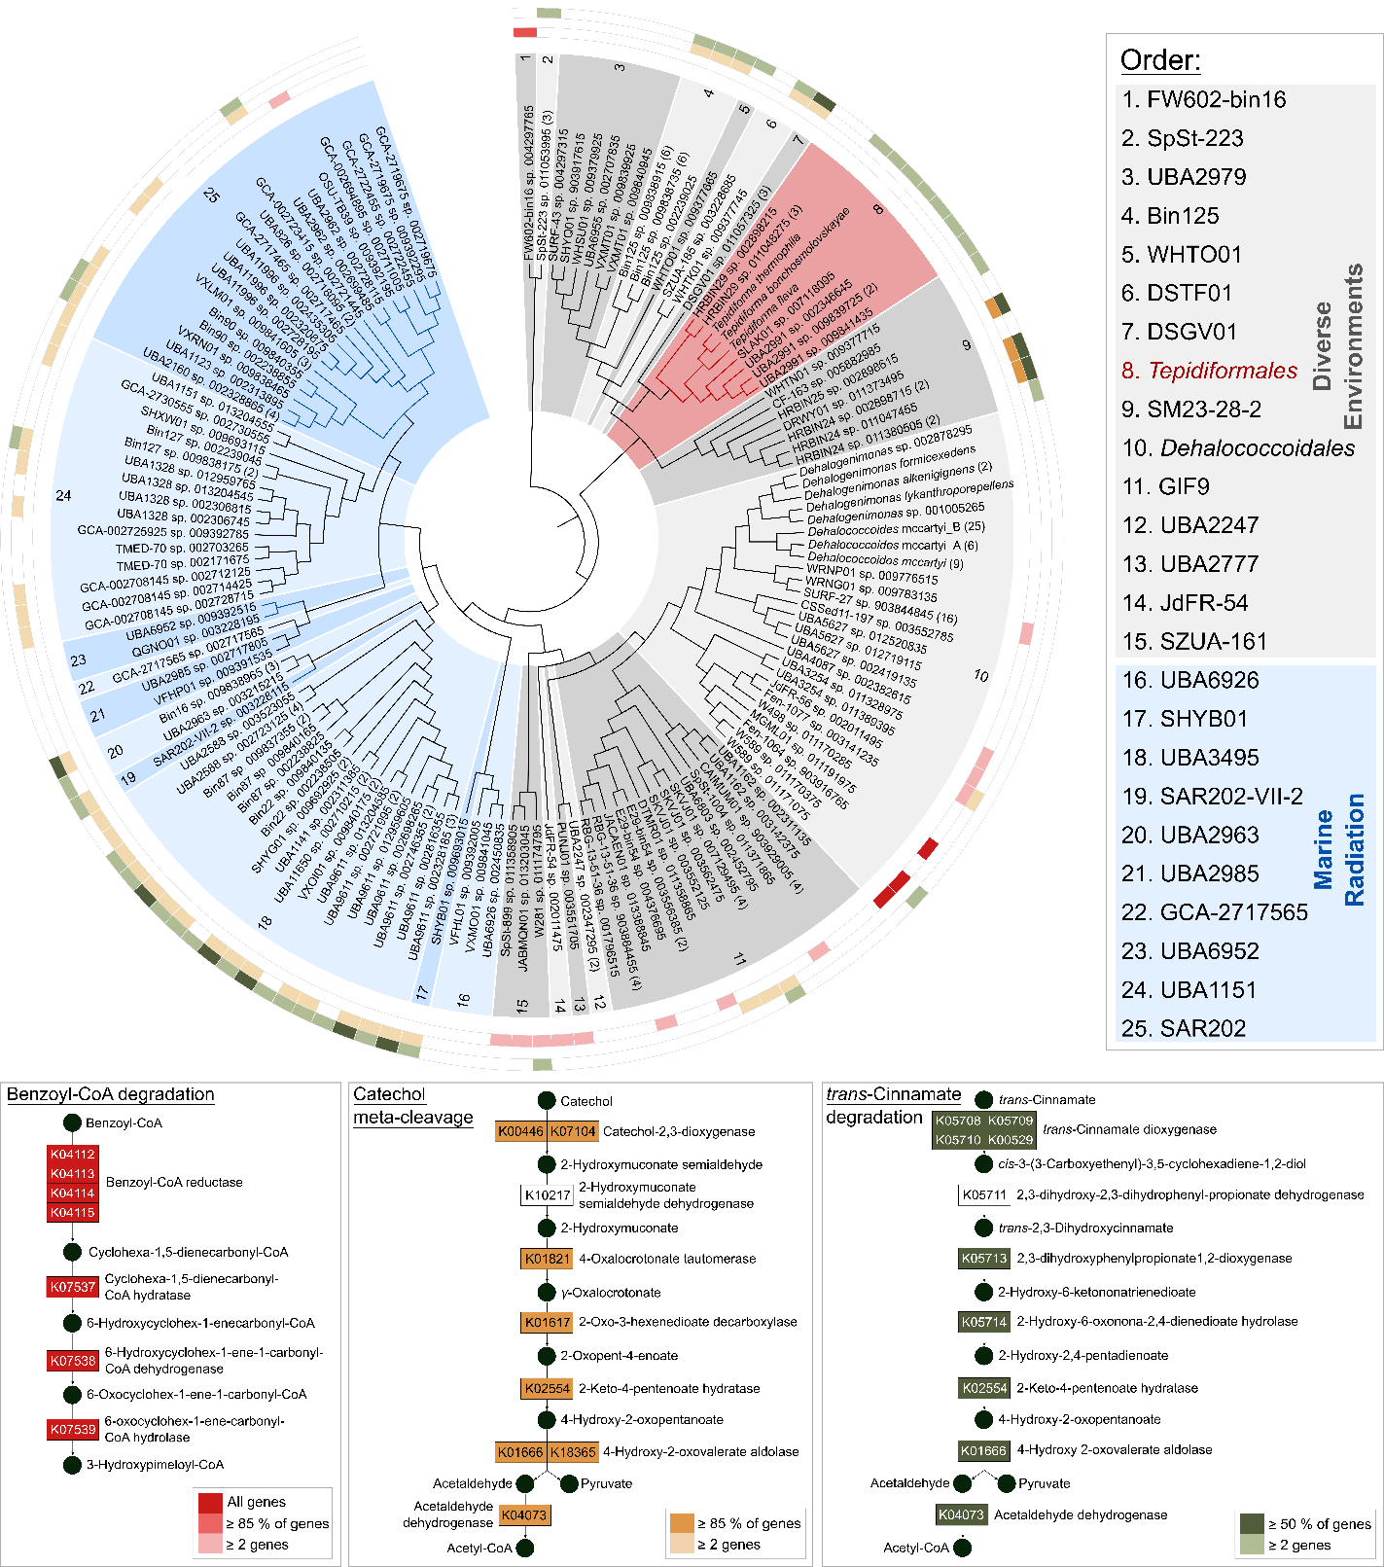
Figure S6. Distribution of genes involved in aromatics degradation pathways across the class Dehalococcoidia. Order-level groups within the class Dehalococcoidia are indicated with alternating shades of grey and indicated with numbers corresponding to the numbers indicated in the key. Several pathways for the degradation of aromatic compounds are depicted in different colors. Distribution of the genes across the class is colored according to the color of degradation pathways.

