Supporting Information

On the Metabolic Conversion of Salicortin-like Chemical Defenses (Salicortinoids) in the Lepidopteran Specialist Herbivore Cerura vinula (Notodontidae)
Florian Schnurrer, Christian Paetz*
Max-Planck-Institute for Chemical Ecology, Hans-Knöll-Straße 8, 07745 Jena, Germany

Table of Contents
Extraction of 6’-O-benzoyl-salicortinol 1
Structure of 6’-O-benzoyl-salicortinol 2
Isolation of [U-¹³C]salicortin, [U-¹³C]HCH-salicortin and [U-¹³C]tremulacin 8
Characterization of isolated ¹³C-labelled compounds 9
[U-¹³C]salicortin 9
[U-¹³C]HCH-salicortin 15
[U-¹³C]Tremulacin 21
Decomposition of 6’-O-benzoyl-salicortinol 28
Decomposition of salicortinoids at pH 7.8 32
Gut homogenate incubation experiments 35
HPLC-HR-ESI-MS Chromatogram of methanol extract of P. tremula x tremuloides leaves 44
HPLC-HR-ESI-MS Chromatogram of methanol extract of C. vinula frass after feeding on P. tremula x tremuloides leaves 44
Mechanism of DHCH transformation to salicylic acid 45

Tab. 1: Masses of fractions from coarse frass separation on HR-X resin 2
Tab. 2: Masses of MPLC fractions after drying (Biotage Isolera One/Biotage Sfär C18 Duo column) 2
Tab. 3: Mass fragments of 6'-O-benzoyl-salicortinol 7
Tab. 4: Extracted MS data used for the calculation of the ¹³C-enrichment of salicortin isotopologues (m/z) together with their signal intensities 9
Tab. 5: Extracted MS data used for the calculation of the ¹³C-enrichment of the salicortin isotopologues (m/z) together with their signal intensities 10
Table 6: Extracted MS data used for calculation of the ¹³C-enrichment of the HCH-salicortin isotopologues (m/z) together with their signal intensities 15
Tab. 7: Extracted MS data used for the calculation of ¹³C-enrichment of HCH-salicortin isotopologues (m/z) together with their signal intensities 16
Tab. 8: Extracted MS data used for the calculation of ¹³C-enrichment of tremulacin isotopologues (m/z) together with their signal intensities 22
Tab. 9: Extracted MS data used for calculation of ¹³C-enrichment of the tremulacin isotopologues (m/z) together with their signal intensities 23

Fig. 1: Structure of 6’-O-benzoyl-salicortinol as determined by NMR-spectroscopy. Chemical shift δ_{H} (mult., J_{HH}) in red, δ_{C} in blue. 7
Fig. 2: 6’-O-benzoyl-salicortinol, ¹H-NMR spectrum (MeOH-d₃) 8
Fig. 3: 6’-O-benzoyl-salicortinol, ¹H-¹³C HSQC spectrum (MeOH-d₃) 8
Fig. 4: 6’-O-benzoyl-salicortinol, ¹H-¹³C HMBC spectrum (MeOH-d₃) 9
Fig. 5: 6’-O-benzoyl-salicortinol, ¹H-¹H COSY spectrum (MeOH-d₃) 9
Fig. 6: 6’-O-benzoyl-salicortinol, ¹H-¹H TOCSY spectrum (MeOH-d₃) 10
Fig. 7: HR-ESI-MS² spectrum of 6'-O-benzoyl-salicortinol 10
Fig. 8: HR-ESI-MS² spectrum of 6'-O-benzoyl-salicortinol, main isotope peak 11
Fig. 9: [U-¹³C]salicortin, HR-ESI-MS spectrum, m/z 423.1308 [M-H]⁻ 13
Fig. 10: [U-¹³C]salicortin, structure with chemical shifts (MeOH-d₃) 15
Fig. 11: [U-¹³C]salicortin, ¹H-NMR spectrum (MeOH-d₃) 15
Fig. 12: [U-¹³C]salicortin, ¹H-NMR spectrum, ¹³C-decoupled (MeOH-d₃) 16
Fig. 13: [U-¹³C]salicortin, ¹³C-NMR spectrum (MeOH-d₃) 16
Fig. 14: [U-¹³C]salicortin, ¹H-¹³C HSQC spectrum (MeOH-d₃) 17
Fig. 15: [U-¹³C]salicortin, ¹H-¹³C HMBC spectrum (MeOH-d₃) 17
Fig. 16: [U-¹³C]salicortin, ¹³C-¹³C COSY spectrum (MeOH-d₃) 18
Fig. 17: [U-¹³C]salicortin, UV spectrum from HPLC-DAD 18
Fig. 18: [U-¹³C]HCH-salicortin, HRESIMS spectrum, m/z 561.1607 [M-H]⁻ 19
Fig. 19: [U-¹³C]HCH-salicortin, chemical structure with chemical shifts (MeOH-d₃) 21
Fig. 20: [U-¹³C]HCH-salicortin, ¹H-NMR spectrum (MeOH-d₃) 21
Fig. 21: [U-¹³C]HCH-salicortin, ¹H-NMR spectrum, ¹³C-decoupled (MeOH-d₃) 22
Fig. 22: [U-¹³C]HCH-salicortin, ¹³C-NMR spectrum (MeOH-d₃) 22
Fig. 23: [U-¹³C]HCH-salicortin, ¹H-¹³C HSQC spectrum (MeOH-d₃) 23
Fig. 24: [U-¹³C]HCH-salicortin, ¹H-¹³C HMBC spectrum (MeOH-d₃) 24
Fig. 25: [U-¹³C]HCH-salicortin, ¹³C-¹³C COSY spectrum (MeOH-d₃) 24
Fig. 26: [U-¹³C]HCH-salicortin, UV spectrum from HPLC-DAD 25
Fig. 27: [U-¹³C]tremulacin, HR-ESI-MS spectrum, m/z 527.1572 [M-H]⁻ 25
Fig. 28: [U-¹³C]tremulacin, chemical structure with chemical shifts (MeOH-d₃) 28
Fig. 29: [U-¹³C]tremulacin, ¹H-NMR spectrum (MeOH-d₃) 28
Fig. 30: [U-¹³C]tremulacin, ¹H-NMR spectrum, ¹³C-decoupled (MeOH-d₃) 29
Fig. 31: [U-¹³C]tremulacin, ¹³C-NMR spectrum (MeOH-d₃) 29
Fig. 32: [U-¹³C]tremulacin, ¹H-¹³C HSQC spectrum (MeOH-d₃) 30
Fig. 33: [U-¹³C]tremulacin, ¹H-¹³C HMBC spectrum (MeOH-d₃) 30
Fig. 34: [U-¹³C]tremulacin, ¹H-¹H COSY spectrum (MeOH-d₃) 31
Fig. 35: [U-¹³C]tremulacin, ¹³C-¹³C COSY spectrum (MeOH-d₃) 31
Fig. 36: [U-¹³C] tremulacin, UV spectrum from HPLC-DAD 32
Fig. 37: Percentage of intact 6'-O-benzoyl-salicortinol during decomposition experiment in various buffers 32
Fig. 38: Peak area of populin ([M-H+FA]⁻, C₂₁H₂₃O₁₀⁻ calc. for C₂₁H₂₃O₁₀⁻, m/z 435.1297) generated by benzylic ester cleavage from 6’-O-benzoyl-salicortinol during decomposition experiments 33
Fig. 39: Peak area of DHCH ([M-H]⁻, C₇H₉O₄⁻ calc. for C₇H₉O₄⁻, m/z 157.0506) generated by benzylic ester cleavage from 6’-O-benzoyl-salicortinol during decomposition experiments 33
Fig. 40: Peak area of salicylic acid ([M-H]⁻, C₇H₅O₃⁻ calc. for C₇H₅O₃⁻, m/z 137.0244) generated by auto-oxidation of DHCH during decomposition experiments 34
Fig. 41: Peak area of salicortinol ([M-H]⁻, C₂₀H₂₅O₁₀⁻ calc. for C₂₀H₂₅O₁₀⁻, m/z 425.1453) generated by glucosidic ester cleavage of 6’-O-benzoyl-salicortinol during decomposition experiments 34
Fig. 42: Peak area of salicin ([M-H+FA]⁻, C₁₄H₁₉O₉⁻ calc. for C₁₄H₁₉O₉⁻, m/z 331.1035) generated by benzylic ester cleavage of populin during decomposition experiments 35
Fig. 43: Percentage of intact salicortinoids during decomposition experiments (pH 7.8) 36
Fig. 44: Peak area of salicin generated by benzylic ester cleavage of salicortin HCH-salicortin (by benzylic ester cleavage), and tremulacin (by benzylic and glycosidic ester cleavage) during decomposition experiments (pH 7.8) 36
Fig. 45: Peak area of salicortin and salicortin generated by liberation from HCH-salicortin or tremulacin during decomposition experiments (pH 7.8) 37
Fig. 46: peak area of tremuloidin and populin liberated by benzylic ester cleavage from tremulacin during decomposition experiments (pH 7.8) 37
Fig. 47: Catechol concentration calibration. 38
Fig. 48: Catechol concentration during decomposition experiments (pH 7.8) 38
Fig. 49: Labelling grade of salicortin (1) during gut homogentate incubation 39
Fig. 50: Labelling grade of salicortinol (4) during gut homogenate incubation 39
Fig. 51: Labelling grade of DHCH (14) during gut homogenate incubation 40
Fig. 52: Labelling grade of salicin (10) during gut homogenate incubation 40
Fig. 53: Labelling grade of saligenin (7) during gut homogenate incubation 41
Fig. 54: Labelling grade of salicylic acid (15) during gut homogenate incubation 41
Fig. 55: Labelling grade of catechol (13) during gut homogenate incubation 42
Fig. 56: Labelling grade of tremulacinol (5) during gut homogenate incubation 42
Fig. 57: Labelling grade of tremuloidin (11) during gut homogenate incubation 42
Fig. 58: Labelling grade of populin (12) during gut homogenate incubation 43
Fig. 59: Peak area of salicortin and liberated salicortin from HCH-salicortin and tremulacin during gut homogenate incubation 43
Fig. 60: Peak area of HCH-salicortin and tremulacin during gut homogenate incubation 44
Fig. 61: Peak area of salicortinol yielded by reduction of the 6-HCH-moiety from salicortinoids and peak area of tremulacinol formed by reduction of tremulacin (gut homogenate incubation) 44
Fig. 62: Peak area of DHCH generated by reduction and cleavage of the 6-HCH moiety from salicortinoids during gut homogenate incubation 45
Fig. 63: Peak area of salicin generated from salicortinoids during gut homogenate incubation 45
Fig. 64: Peak area of saligenin generated from salicortinoids during gut homogenate incubation 46
Fig. 65: Catechol concentration during gut homogenate incubation 46
Fig. 66: Concentration of catechol in decomposition experiments (dotted graphs, only buffer pH 7.8) vs. gut homogenate incubations 47
Fig. 67: A: base peak chromatogram of P. tremula x tremuloides MeOH leaf extract, c = 1 mg/mL. B: Extracted ion chromatogram (m/z = 529.1715, calc. mass for tremulacinol and 6’-O-benzoyl-salicortinol) of P. tremula x tremuloides MeOH leaf extract 48
Fig. 68: A: Base peak chromatogram of C. vinula (5th instar) MeOH feces extract after feeding on P. tremula x tremuloides foliage, c = 1 mg/mL. B: Extracted ion chromatogram (m/z = 529.1715, calc. mass for tremulacinol and 6’-O-benzoyl-salicortinol) of C. vinula (5th instar) MeOH feces extract after feeding on P. tremula x tremuloides foliage 48
Fig. 69: Dehydration and subsequent auto-oxidation of DHCH to salicylic acid under acidic conditions and to salicylate under alkaline conditions… 49

Extraction of 6’-O-benzoyl-salicortinol

Tab. 1: Masses of fractions from coarse frass separation on HR-X resin
% solvent B (MeOH) | mass in mg
0% - I | 260.29
0% - II | 123.71
10% - I | 148.29
10% - II | 153.23
20% - I | 128.65
20% - II | 298.54
30% - I | 155.08
30% - II | 199.24
40% - I | 63.75
40% - II | 95.4
50% - I | 127.12
50% - II | 154.75
60% - I | 34.49
60% - II | 78.61
70% - I | 77.6
70% - II | 99.56
80% - I | 96.66
80% - II | 151.1
90% - I | 104.22
90% - II | 104.57
100% - I | 48.37
100% - II | 44.83
100% - III | 47.48

Tab. 2: Masses of MPLC fractions after drying (Biotage Isolera One/Biotage Sfär C18 Duo column)
Fraction | mass in mg
F1 | 0.4
F2 | 1.0
F3 | 1.4
F4 | 3.0
F5 | 13.3
F6 | 39.9
F7 | 14.3
F8 | 5.8

Structure of 6’-O-benzoyl-salicortinol

Fig. 1: Structure of 6’-O-benzoyl-salicortinol as determined by NMR-spectroscopy. Chemical shift δ_{H} (mult., J_{HH}) in red, δ_{C} in blue.
Fig. 2: 6’-O-benzoyl-salicortinol, ¹H-NMR spectrum (MeOH-d₃)
Fig. 3: 6’-O-benzoyl-salicortinol, ¹H-¹³C HSQC spectrum (MeOH-d₃)
Fig. 4: 6’-O-benzoyl-salicortinol, ¹H-¹³C HMBC spectrum (MeOH-d₃)
Fig. 5: 6’-O-benzoyl-salicortinol, ¹H-¹H COSY spectrum (MeOH-d₃)
Fig. 6: 6’-O-benzoyl-salicortinol, ¹H-¹H TOCSY spectrum (MeOH-d₃)
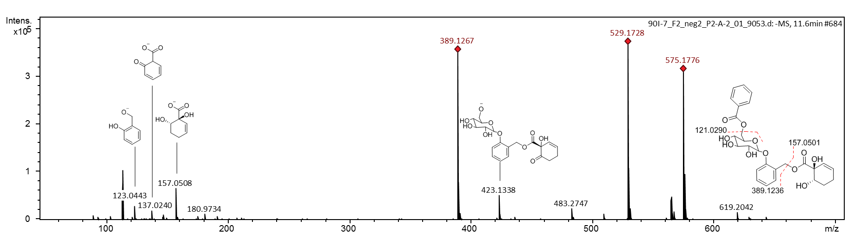
Fig. 7: HR-ESI-MS² spectrum of 6'-O-benzoyl-salicortinol
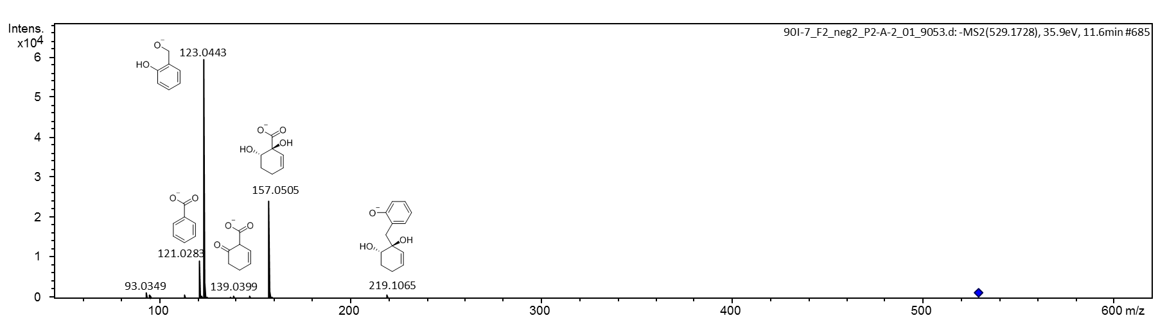
Fig. 8: HR-ESI-MS² spectrum of 6'-O-benzoyl-salicortinol, main isotope peak
Tab. 3: Mass fragments of 6'-O-benzoyl-salicortinol
fragment m/z [M-H]⁻ | sum formula | calc. fragment m/z | structure
123.0443 | C₇H₇O₂⁻ | 123.0452
121.0295 | C₇H₆O₂⁻ | 121.0295
157.0508 | C₇H₉O₄⁻ | 157.0506
389.1267 | C₂₀H₂₁O₈⁻ | 389.1242
529.1728 | C₂₇H₂₉O₁₁⁻ | 529.1715

Isolation of [U-¹³C]salicortin, [U-¹³C]HCH-salicortin and [U-¹³C]tremulacin
An extract of ¹³C-labeled P. deltoides x trichocarpa leave material, prepared as described previously, was used.* An amount of 2.19 g dried extract was used for isolation of the [U-¹³C]-title compounds. After reconstitution with MeOH, aliquots (146.19 mg ml⁻¹) were subjected to HPLC separation on a Macherey-Nagel (MN) Isis RP-18e column (250 × 4.6 mm, 5 μm particle size) utilizing the chromatographic conditions as described previously.* Salicortin eluted at R_{t} 40.2 min, trichocarpin at R_{t} 57.3 min, HCH-salicortin at 62.0 min, and tremulacin eluted at 86.3 min. For monitoring, the UV trace at 285 nm was used. The compounds were subsequently re-purified to remove traces of impurities, as described below.
A binary solvent system consisting of 0.1% formic acid in H₂O (solvent A) and 0.1% formic acid in MeOH (solvent B) was used. The respective HPLC column temperature was set to 35 °C and the flow rate was set to 0.8 ml min⁻¹.
[U-¹³C]salicortin. An aliquot solution (39.27 mg ml⁻¹) was purified using a MN π-column (250 × 4.6 mm, 5 μm particle size). The HPLC gradient started with 50% of solvent B and increased linearly to 62% in 12 min. Afterwards, the column was washed for 10 min with 100% solvent B, followed by a 10 min equilibration with 50% solvent B. The [U-¹³C]salicortin peak (λ = 285 nm) appeared at R_{t} 10.4 min. We isolated 48.19 mg of [U-¹³C]salicortin.
[U-¹³C]HCH-salicortin. An aliquot solution (56.02 mg ml⁻¹) was purified using a MN π-column (250 × 4.6 mm, 5 μm particle size). The HPLC gradient started with a concentration of 40% solvent B and increased linearly to 75% solvent B in 30 min. Afterwards, the column was washed for 15 min with 100% solvent B, followed by a 10 min equilibration with 40% solvent B. The [U-¹³C]HCH-salicortin peak (λ = 285 nm) appeared at R_{t} 25.5 min. We isolated 45.13 mg of [U-¹³C]HCH-salicortin.
[U-¹³C]tremulacin. An aliquot solution (40.12 mg ml⁻¹) was purified using a MN π-column (250 × 4.6 mm, 5 μm particle size). The HPLC gradient started with a concentration of 70% solvent B and increased linearly to 80% solvent B in 15 min. Afterwards, the column was washed for 10 min with 100% solvent B followed by an equilibration period of 10 min with 70% solvent B. The tremulacin peak (λ = 285 nm) appeared at R_{t} 10.6 min. We isolated 21.46 mg of [U-¹³C]tremulacin.
*) Feistel, F., et al., Acylated Quinic Acids Are the Main Salicortin Metabolites in the Lepidopteran Specialist Herbivore Cerura vinula. Journal of Chemical Ecology, 2018. 44(5): p. 497-509.

Characterization of isolated ¹³C-labelled compounds

[U-¹³C]salicortin

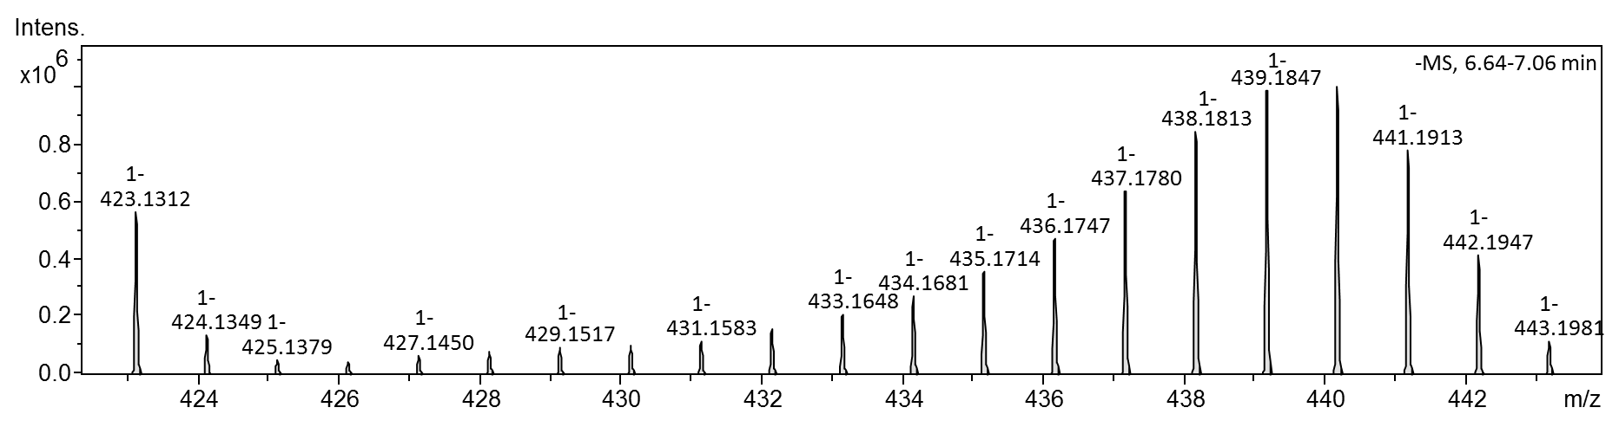
Fig. 9: [U-¹³C]salicortin, HR-ESI-MS spectrum, m/z 423.1308 [M-H]⁻

Tab. 4: Extracted MS data used for the calculation of the ¹³C-enrichment of salicortin isotopologues (m/z) together with their signal intensities
C-isotope |  | salicortin
¹²C | ¹³C | m/z | I
20 | 0 | 423.1312 | 563016
19 | 1 | 424.1349 | 138922
18 | 2 | 425.1379 | 51067
17 | 3 | 426.1417 | 49058
16 | 4 | 427.1450 | 68105
15 | 5 | 428.1484 | 84101
14 | 6 | 429.1517 | 96215
13 | 7 | 430.1550 | 102883
12 | 8 | 431.1583 | 120981
11 | 9 | 432.1615 | 161279
10 | 10 | 433.1648 | 213475
9 | 11 | 434.1681 | 274441
8 | 12 | 435.1714 | 361017
7 | 13 | 436.1747 | 476937
6 | 14 | 437.1780 | 636991
5 | 15 | 438.1813 | 845567
4 | 16 | 439.1847 | 988207
3 | 17 | 440.1879 | 1004403
2 | 18 | 441.1913 | 781973
1 | 19 | 442.1947 | 419749
0 | 20 | 443.1981 | 120096
¹³C-incorporation | ~82% | R | 0.89

Tab. 5: Extracted MS data used for the calculation of the ¹³C-enrichment of the salicortin isotopologues (m/z) together with their signal intensities
 | HCH |  |  | saligenin |  |  | salicin
 | 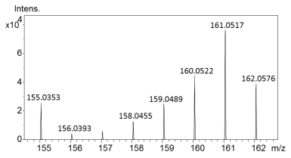 |  |  | 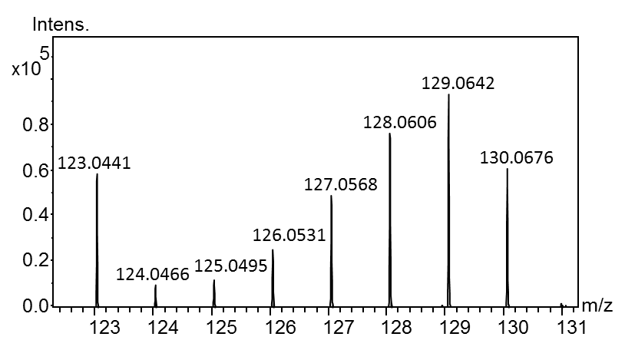 |  |  | 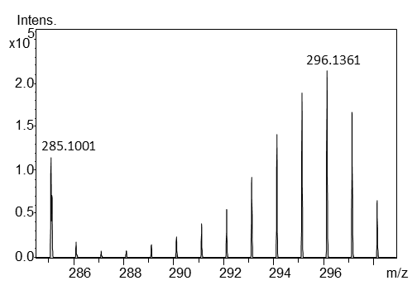
¹³C | m/z | intensity |  | m/z | intensity |  | m/z | intensity
0 | 155.0353 | 25763 |  | 123.0441 | 58980 |  | 285.1002 | 117091
1 | 156.0393 | 4418 |  | 124.0466 | 9833 |  | 286.1033 | 18886
2 | 157.0427 | 6313 |  | 125.0495 | 12312 |  | 287.1062 | 7468
3 | 158.0455 | 12927 |  | 126.0531 | 25394 |  | 288.11 | 7977
4 | 159.0489 | 25066 |  | 127.0568 | 49210 |  | 289.1134 | 12761
5 | 160.0522 | 44823 |  | 128.0606 | 76654 |  | 290.1167 | 19617
6 | 161.0517 | 76388 |  | 129.0642 | 93410 |  | 291.1201 | 29141
7 | 162.0576 | 39063 |  | 130.0676 | 60705 |  | 292.1234 | 42306
8 |  |  |  |  |  |  | 293.1268 | 64903
9 |  |  |  |  |  |  | 294.13 | 95503
10 |  |  |  |  |  |  | 295.1333 | 125788
11 |  |  |  |  |  |  | 296.1366 | 139181
12 |  |  |  |  |  |  | 297.14 | 105141
13 |  |  |  |  |  |  | 298.1435 | 42043

Fig. 10: [U-¹³C]salicortin, structure with chemical shifts (MeOH-d₃)
Fig. 11: [U-¹³C]salicortin, ¹H-NMR spectrum (MeOH-d₃)

Fig. 12: [U-¹³C]salicortin, ¹H-NMR spectrum, ¹³C-decoupled (MeOH-d₃)
Fig. 13: [U-¹³C]salicortin, ¹³C-NMR spectrum (MeOH-d₃)
Fig. 14: [U-¹³C]salicortin, ¹H-¹³C HSQC spectrum (MeOH-d₃)
Fig. 15: [U-¹³C]salicortin, ¹H-¹³C HMBC spectrum (MeOH-d₃)
Fig. 16: [U-¹³C]salicortin, ¹³C-¹³C COSY spectrum (MeOH-d₃)
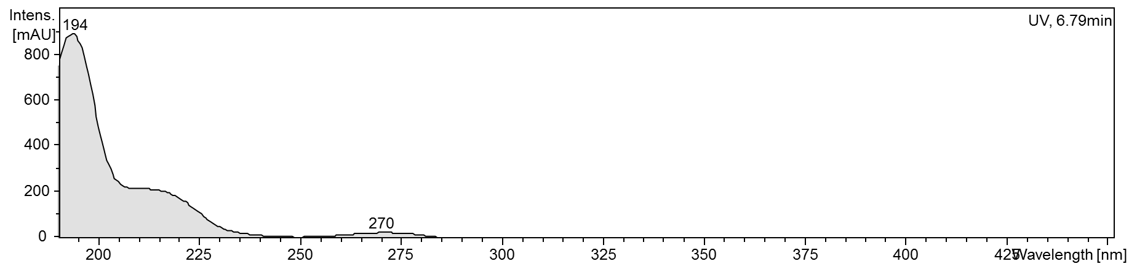
Fig. 17: [U-¹³C]salicortin, UV spectrum from HPLC-DAD

[U-¹³C]HCH-salicortin
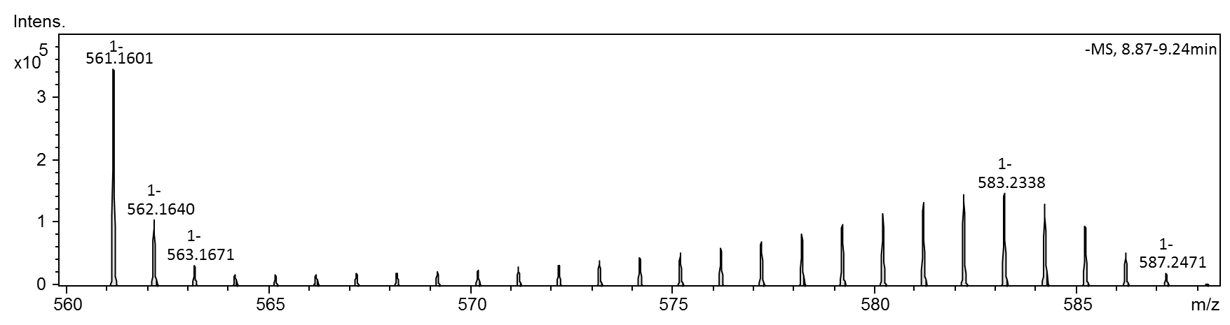
Fig. 18: [U-¹³C]HCH-salicortin, HRESIMS spectrum, m/z 561.1607 [M-H]⁻
Table 6: Extracted MS data used for calculation of the ¹³C-enrichment of the HCH-salicortin isotopologues (m/z) together with their signal intensities
C-isotope |  | HCH-salicortin
¹²C | ¹³C | m/z | intensity
27 | 0 | 561.1601 | 345519
26 | 1 | 562.164 | 106129
25 | 2 | 563.1671 | 32580
24 | 3 | 564.1709 | 18745
23 | 4 | 565.1748 | 18666
22 | 5 | 566.1778 | 19896
21 | 6 | 567.1811 | 20099
20 | 7 | 568.1845 | 20410
19 | 8 | 569.1875 | 22764
18 | 9 | 570.1909 | 25813
17 | 10 | 571.1942 | 30439
16 | 11 | 572.1973 | 34320
15 | 12 | 573.2008 | 40010
14 | 13 | 574.204 | 46564
13 | 14 | 575.2075 | 52914
12 | 15 | 576.2108 | 61142
11 | 16 | 577.2138 | 71679
10 | 17 | 578.2171 | 83471
9 | 18 | 579.2205 | 97754
8 | 19 | 580.224 | 115086
7 | 20 | 581.2273 | 132612
6 | 21 | 582.2305 | 145940
5 | 22 | 583.2338 | 148565
4 | 23 | 584.2372 | 131557
3 | 24 | 585.2406 | 96894
2 | 25 | 586.2441 | 54139
1 | 26 | 587.2471 | 21082
0 | 27 | 588.2503 | 4863
¹³C-incorporation | ~77% | R | 0.80

Tab. 7: Extracted MS data used for the calculation of ¹³C-enrichment of HCH-salicortin isotopologues (m/z) together with their signal intensities
 | HCH |  |  | saligenin |  |  | salicin
 | 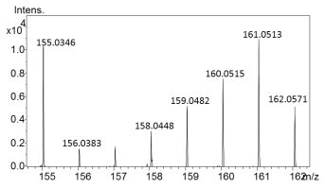 |  |  | 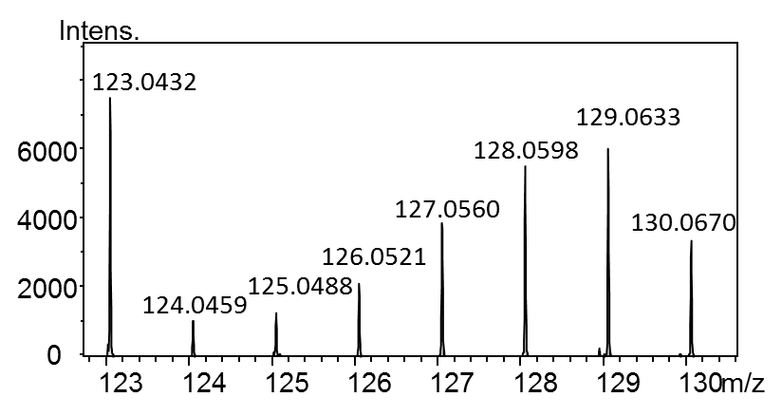 |  |  | 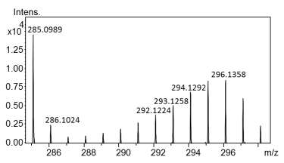
¹³C | m/z | intensity |  | m/z | intensity |  | m/z | intensity
0 | 155.0346 | 10285 |  | 7490 | 7490 |  | 285.0989 | 14497
1 | 156.0383 | 1578 |  | 1070 | 1070 |  | 286.1024 | 2435
2 | 157.0414 | 1732 |  | 1299 | 1299 |  | 287.1041 | 937
3 | 158.0448 | 3062 |  | 2138 | 2138 |  | 288.1081 | 1004
4 | 159.0482 | 5221 |  | 3888 | 3888 |  | 289.1116 | 1368
5 | 160.0515 | 7548 |  | 5484 | 5484 |  | 290.116 | 1945
6 | 161.0513 | 10896 |  | 6041 | 6041 |  | 291.1192 | 2730
7 | 162.0571 | 5169 |  | 3370 | 3370 |  | 292.1224 | 3825
8 |  |  |  |  |  |  | 293.1258 | 5143
9 |  |  |  |  |  |  | 294.1292 | 6842
10 |  |  |  |  |  |  | 295.1323 | 8367
11 |  |  |  |  |  |  | 296.1358 | 8430
12 |  |  |  |  |  |  | 297.1391 | 6080
13 |  |  |  |  |  |  | 298.1428 | 2342

Fig. 19: [U-¹³C]HCH-salicortin, chemical structure with chemical shifts (MeOH-d₃)
Fig. 20: [U-¹³C]HCH-salicortin, ¹H-NMR spectrum (MeOH-d₃)

Fig. 21: [U-¹³C]HCH-salicortin, ¹H-NMR spectrum, ¹³C-decoupled (MeOH-d₃)
Fig. 22: [U-¹³C]HCH-salicortin, ¹³C-NMR spectrum (MeOH-d₃)
Fig. 23: [U-¹³C]HCH-salicortin, ¹H-¹³C HSQC spectrum (MeOH-d₃)
Fig. 24: [U-¹³C]HCH-salicortin, ¹H-¹³C HMBC spectrum (MeOH-d₃)
Fig. 25: [U-¹³C]HCH-salicortin, ¹³C-¹³C COSY spectrum (MeOH-d₃)

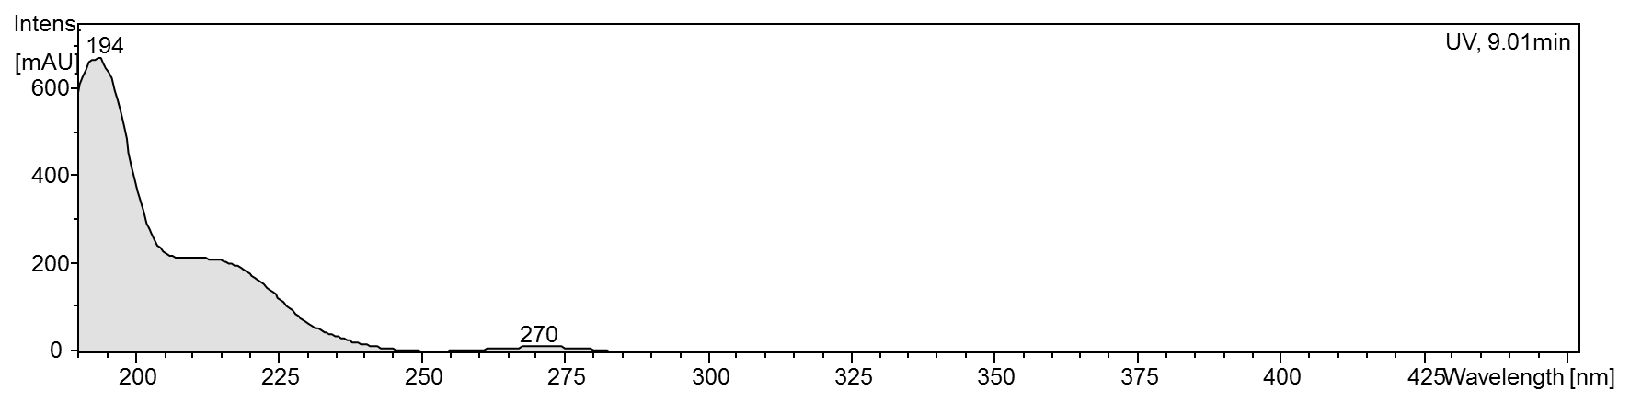
Fig. 26: [U-¹³C]HCH-salicortin, UV spectrum from HPLC-DAD

[U-¹³C]Tremulacin

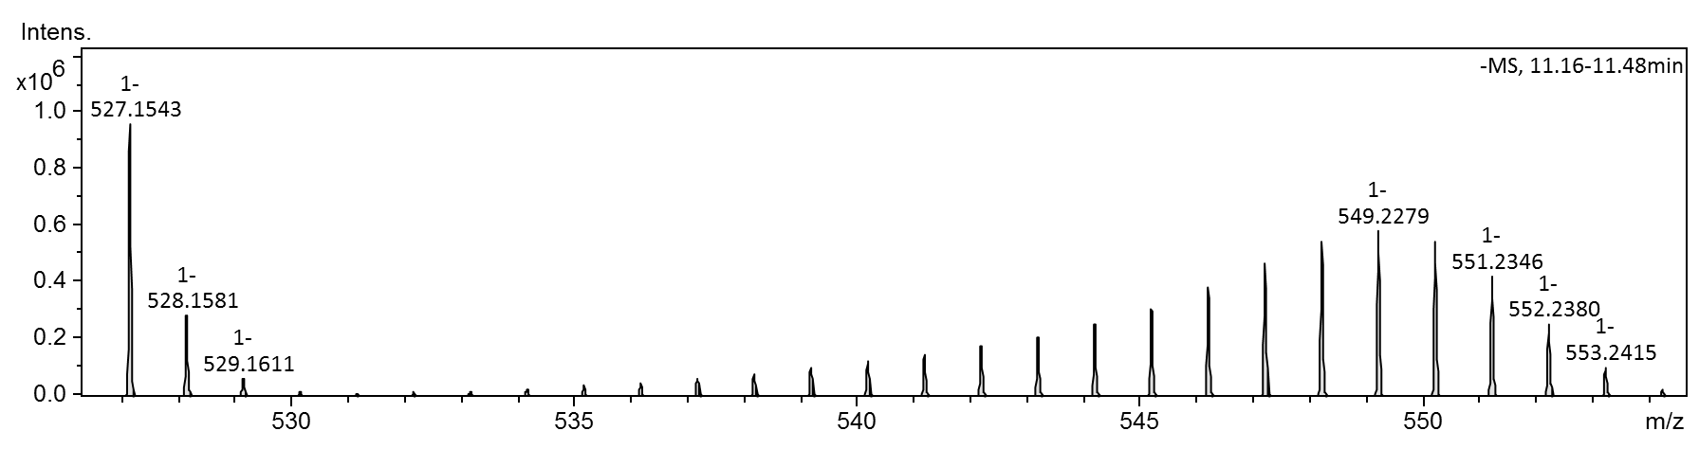
Fig. 27: [U-¹³C]tremulacin, HR-ESI-MS spectrum, m/z 527.1572 [M-H]⁻

Tab. 8: Extracted MS data used for the calculation of ¹³C-enrichment of tremulacin isotopologues (m/z) together with their signal intensities
C-isotope |  | tremulacin
¹²C | ¹³C | m/z | intensity
27 | 0 | 527.1543 | 958140
26 | 1 | 528.1581 | 289642
25 | 2 | 529.1611 | 67438
24 | 3 | 530.1648 | 18289
23 | 4 | 531.1686 | 13320
22 | 5 | 532.172 | 16560
21 | 6 | 533.1755 | 22099
20 | 7 | 534.1786 | 29738
19 | 8 | 535.1817 | 38929
18 | 9 | 536.185 | 50561
17 | 10 | 537.1885 | 65170
16 | 11 | 538.1917 | 82759
15 | 12 | 539.1949 | 101433
14 | 13 | 540.1982 | 124449
13 | 14 | 541.2015 | 148680
12 | 15 | 542.2047 | 177172
11 | 16 | 543.208 | 212284
10 | 17 | 544.2113 | 255830
9 | 18 | 545.2146 | 312113
8 | 19 | 546.2179 | 381792
7 | 20 | 547.2212 | 467183
6 | 21 | 548.2246 | 543118
5 | 22 | 549.2279 | 580236
4 | 23 | 550.2311 | 547797
3 | 24 | 551.2346 | 425374
2 | 25 | 552.238 | 253339
1 | 26 | 553.2415 | 101815
0 | 27 | 554.2447 | 23895
¹³C-incorporation | ~79% | R | 0.87

Tab. 9: Extracted MS data used for calculation of ¹³C-enrichment of the tremulacin isotopologues (m/z) together with their signal intensities
 | HCH |  |  | benzoic acid |  |  | salicin
 | 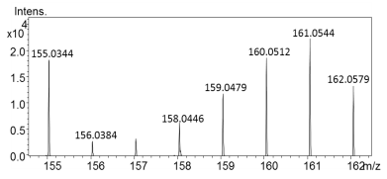 |  |  | 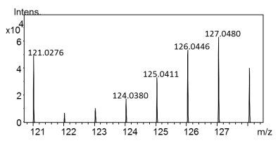 |  |  | 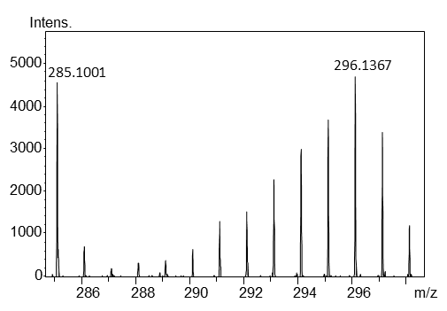
¹³C | m/z | intensity |  | m/z | intensity |  | m/z | intensity
0 | 155.0344 | 18158 |  | 121.0283 | 44931 |  | 285.0982 | 2390
1 | 156.0384 | 2801 |  | 122.0323 | 6081 |  | 286.1005 | 367
2 | 157.0415 | 3284 |  | 123.0393 | 10539 |  | 287.1027 | 175
3 | 157.9304 | 217 |  | 124.0389 | 16257 |  | 288.1076 | 196
4 | 158.0446 | 6331 |  | 125.0419 | 32067 |  | 289.1106 | 306
5 | 159.0479 | 11764 |  | 126.0455 | 49367 |  | 290.1139 | 379
6 | 160.0512 | 18492 |  | 127.0488 | 60692 |  | 291.1173 | 742
7 | 161.0544 | 22147 |  | 128.0529 | 39599 |  | 292.1209 | 854
8 |  |  |  |  |  |  | 293.1252 | 1323
9 |  |  |  |  |  |  | 294.1279 | 1731
10 |  |  |  |  |  |  | 295.1317 | 2339
11 |  |  |  |  |  |  | 296.1353 | 2488
12 |  |  |  |  |  |  | 297.1394 | 1898
13 |  |  |  |  |  |  | 298.1428 | 725

Fig. 28: [U-¹³C]tremulacin, chemical structure with chemical shifts (MeOH-d₃)

Fig. 29: [U-¹³C]tremulacin, ¹H-NMR spectrum (MeOH-d₃)

Fig. 30: [U-¹³C]tremulacin, ¹H-NMR spectrum, ¹³C-decoupled (MeOH-d₃)
Fig. 31: [U-¹³C]tremulacin, ¹³C-NMR spectrum (MeOH-d₃)
Fig. 32: [U-¹³C]tremulacin, ¹H-¹³C HSQC spectrum (MeOH-d₃)
Fig. 33: [U-¹³C]tremulacin, ¹H-¹³C HMBC spectrum (MeOH-d₃)
Fig. 34: [U-¹³C]tremulacin, ¹H-¹H COSY spectrum (MeOH-d₃)
Fig. 35: [U-¹³C]tremulacin, ¹³C-¹³C COSY spectrum (MeOH-d₃)

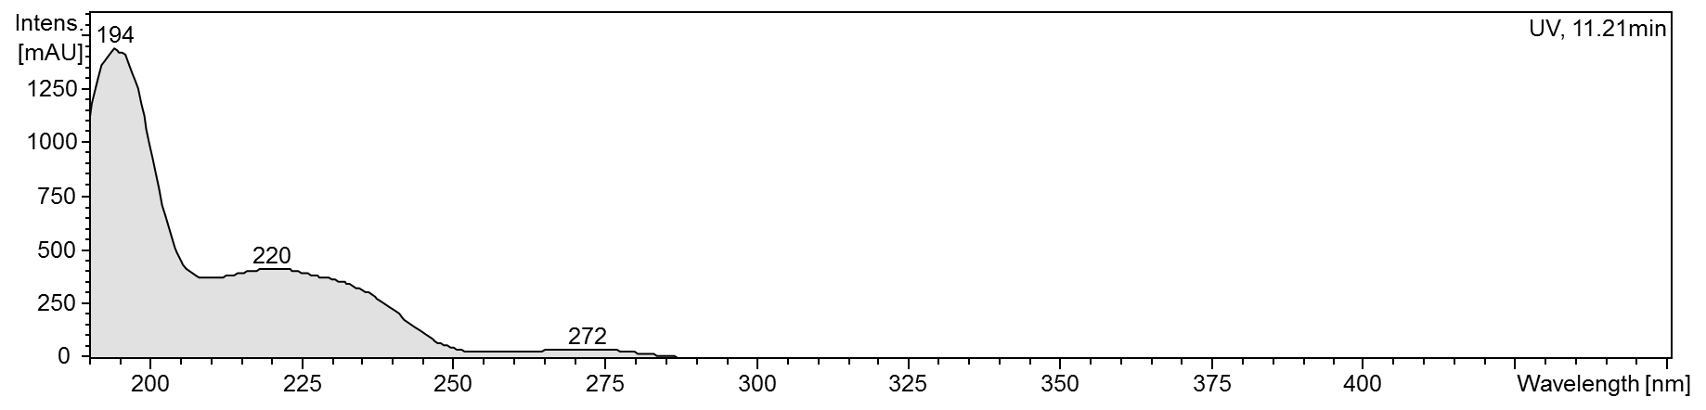
Fig. 36: [U-¹³C] tremulacin, UV spectrum from HPLC-DAD

Decomposition of 6’-O-benzoyl-salicortinol

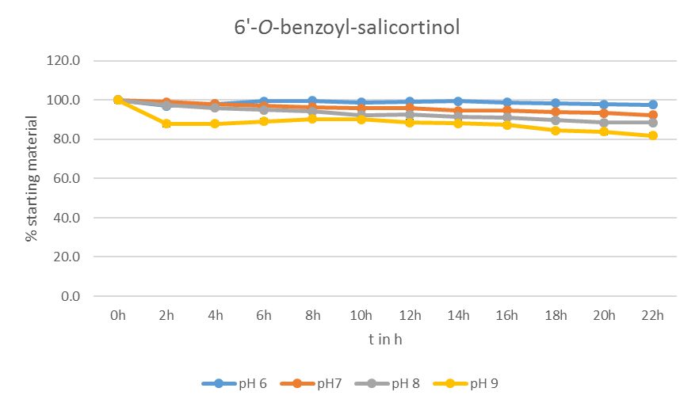
Fig. 37: Percentage of intact 6'-O-benzoyl-salicortinol during decomposition experiment
in various buffers

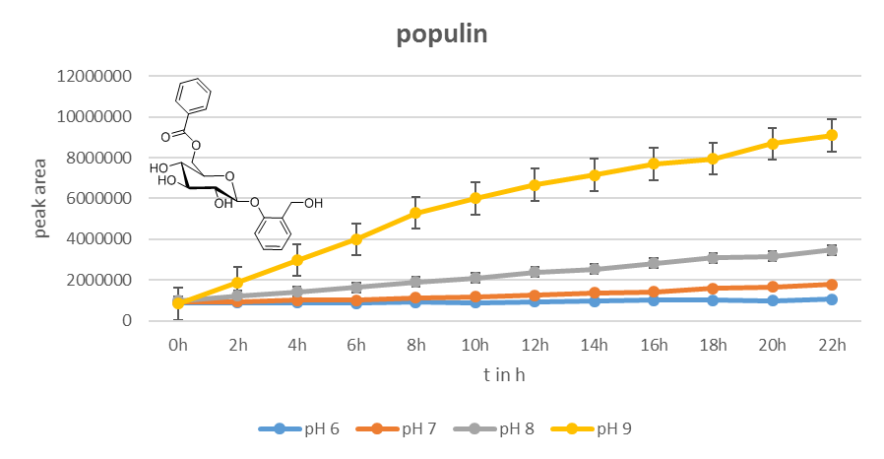
Fig. 38: Peak area of populin ([M-H+FA]⁻, C₂₁H₂₃O₁₀⁻ calc. for C₂₁H₂₃O₁₀⁻, m/z 435.1297) generated by benzylic ester cleavage from 6’-O-benzoyl-salicortinol during decomposition experiments

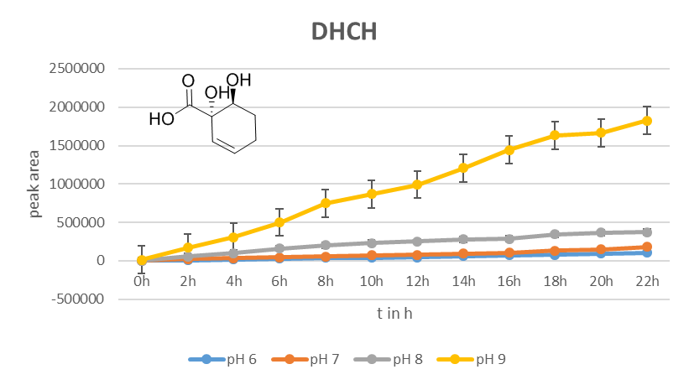
Fig. 39: Peak area of DHCH ([M-H]⁻, C₇H₉O₄⁻ calc. for C₇H₉O₄⁻, m/z 157.0506) generated by benzylic ester cleavage from 6’-O-benzoyl-salicortinol during decomposition experiments
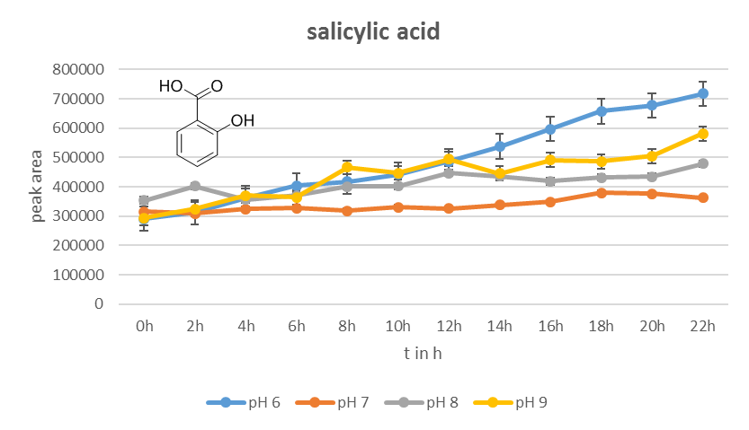
Fig. 40: Peak area of salicylic acid ([M-H]⁻, C₇H₅O₃⁻ calc. for C₇H₅O₃⁻, m/z 137.0244) generated by auto-oxidation of DHCH during decomposition experiments

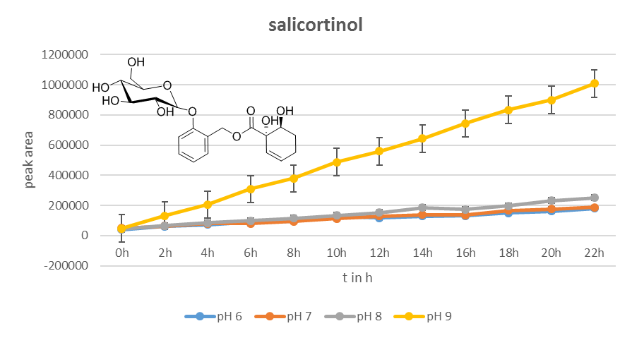
Fig. 41: Peak area of salicortinol ([M-H]⁻, C₂₀H₂₅O₁₀⁻ calc. for C₂₀H₂₅O₁₀⁻, m/z 425.1453) generated by glucosidic ester cleavage of 6’-O-benzoyl-salicortinol during decomposition experiments
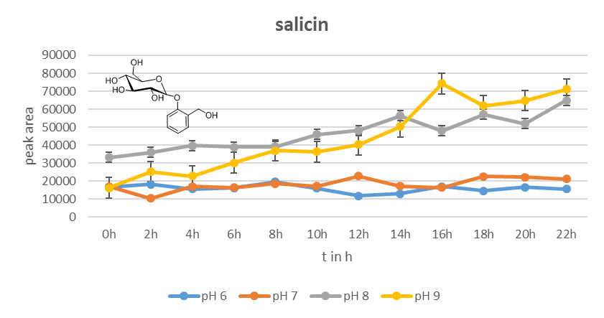
Fig. 42: Peak area of salicin ([M-H+FA]⁻, C₁₄H₁₉O₉⁻ calc. for C₁₄H₁₉O₉⁻, m/z 331.1035) generated by benzylic ester cleavage of populin during decomposition experiments

Decomposition of salicortinoids at pH 7.8

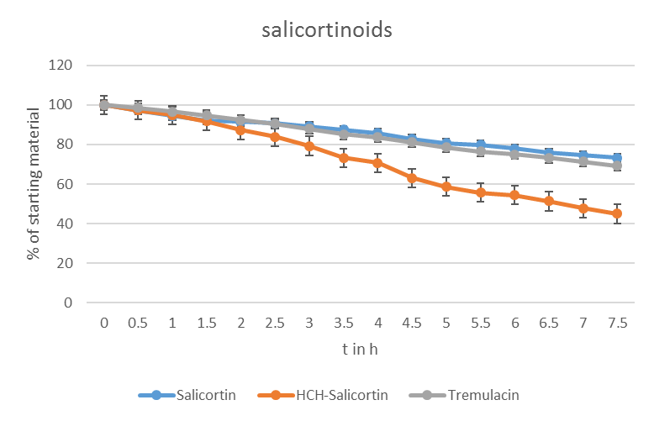
Fig. 43: Percentage of intact salicortinoids during decomposition experiments (pH 7.8)
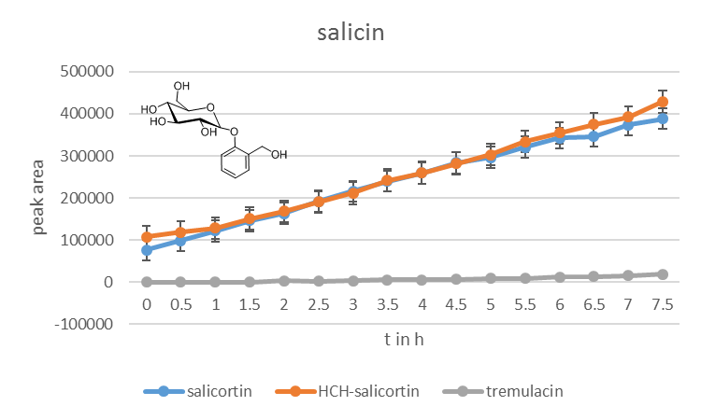
Fig. 44: Peak area of salicin generated by benzylic ester cleavage of salicortin HCH-salicortin (by benzylic ester cleavage), and tremulacin (by benzylic and glycosidic ester cleavage) during decomposition experiments (pH 7.8)

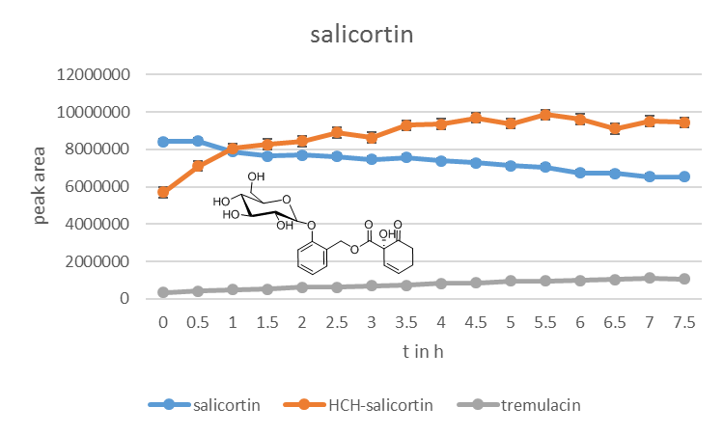
Fig. 45: Peak area of salicortin and salicortin generated by liberation from HCH-salicortin or tremulacin during decomposition experiments (pH 7.8)
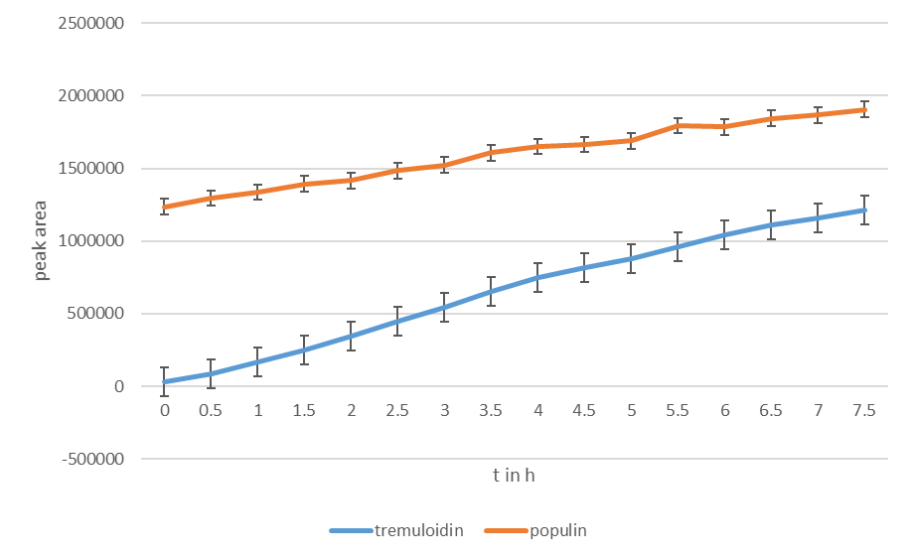
Fig. 46: peak area of tremuloidin and populin liberated by benzylic ester cleavage from tremulacin during decomposition experiments (pH 7.8)

Fig. 47: Catechol concentration calibration. The concentration of catechol was calculated as follows:
From the determination of salicortin decomposition we calculated the amount of intact salicortin based on UV data. From the difference of decomposed salicortin to intact salicortin we deduced the concentration of catechol formed. This value was correlated with the integral value of the ¹²C signal in the mass spectrum for catechol.

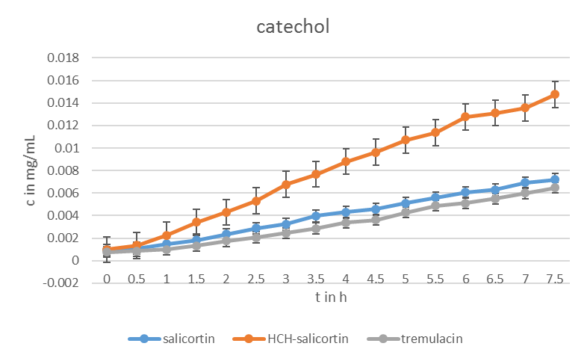
Fig. 48: Catechol concentration during decomposition experiments (pH 7.8)

Gut homogenate incubation experiments

Fig. 49: Labelling grade of salicortin (1) during gut homogentate incubation
Fig. 50: Labelling grade of salicortinol (4) during gut homogenate incubation
Fig. 51: Labelling grade of DHCH (14) during gut homogenate incubation
Fig. 52: Labelling grade of salicin (10) during gut homogenate incubation
Fig. 53: Labelling grade of saligenin (7) during gut homogenate incubation
Fig. 54: Labelling grade of salicylic acid (15) during gut homogenate incubation
Fig. 55: Labelling grade of catechol (13) during gut homogenate incubation
Fig. 56: Labelling grade of tremulacinol (5) during gut homogenate incubation
Fig. 57: Labelling grade of tremuloidin (11) during gut homogenate incubation
Fig. 58: Labelling grade of populin (12) during gut homogenate incubation
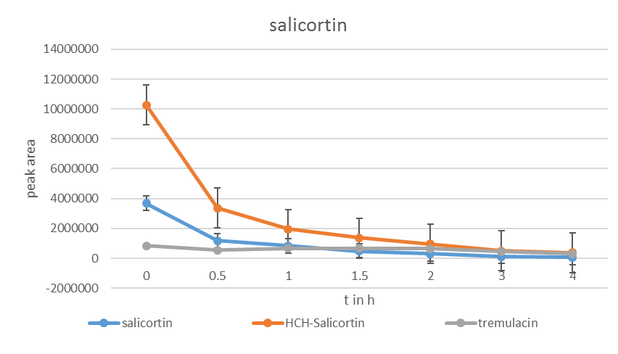
Fig. 59: Peak area of salicortin and liberated salicortin from HCH-salicortin and tremulacin during gut homogenate incubation
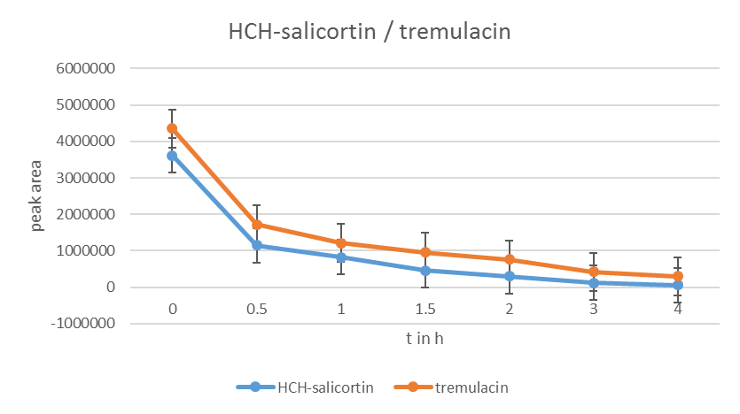
Fig. 60: Peak area of HCH-salicortin and tremulacin during gut homogenate incubation
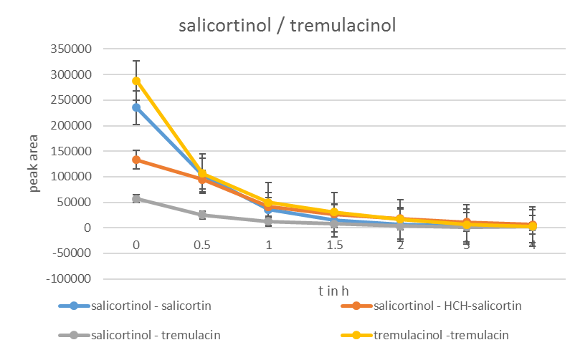
Fig. 61: Peak area of salicortinol yielded by reduction of the 6-HCH-moiety from salicortinoids and peak area of tremulacinol formed by reduction of tremulacin (gut homogenate incubation)
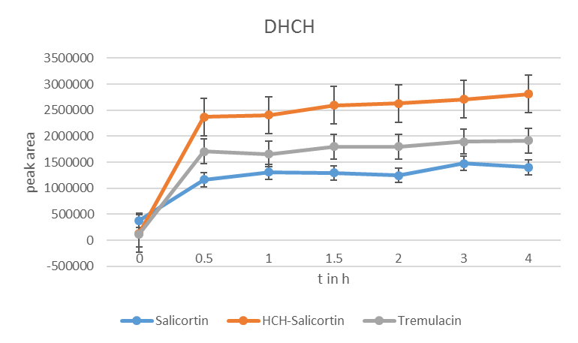
Fig. 62: Peak area of DHCH generated by reduction and cleavage of the 6-HCH moiety from salicortinoids during gut homogenate incubation 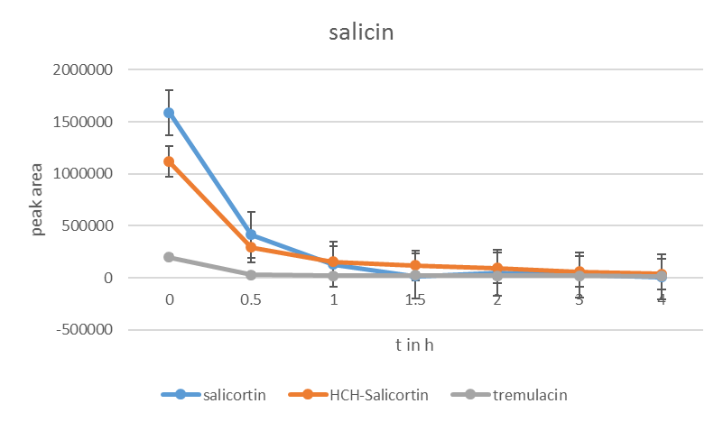
Fig. 63: Peak area of salicin generated from salicortinoids during gut homogenate incubation
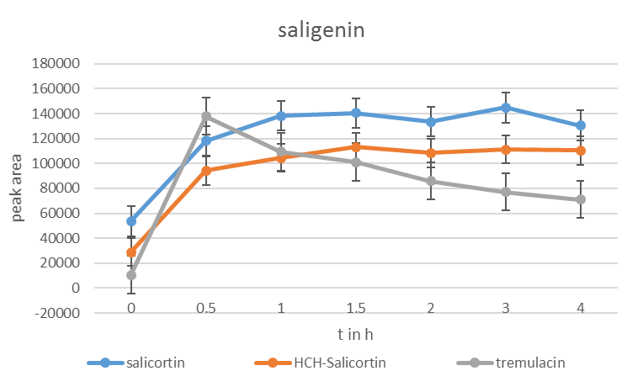
Fig. 64: Peak area of saligenin generated from salicortinoids during gut homogenate incubation
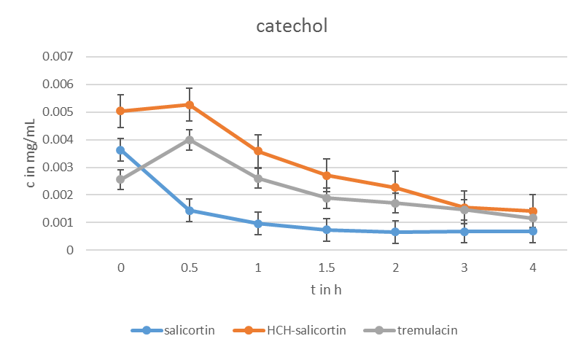
Fig. 65: Catechol concentration during gut homogenate incubation

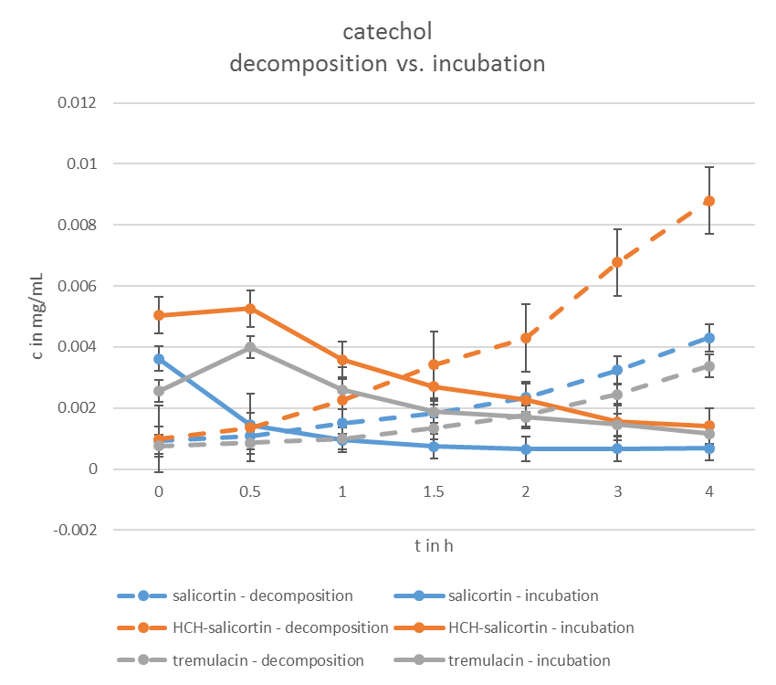
Fig. 66: Concentration of catechol in decomposition experiments (dotted graphs, only buffer pH 7.8) vs. gut homogenate incubations

HPLC-HR-ESI-MS Chromatogram of methanol extract of P. tremula x tremuloides leaves
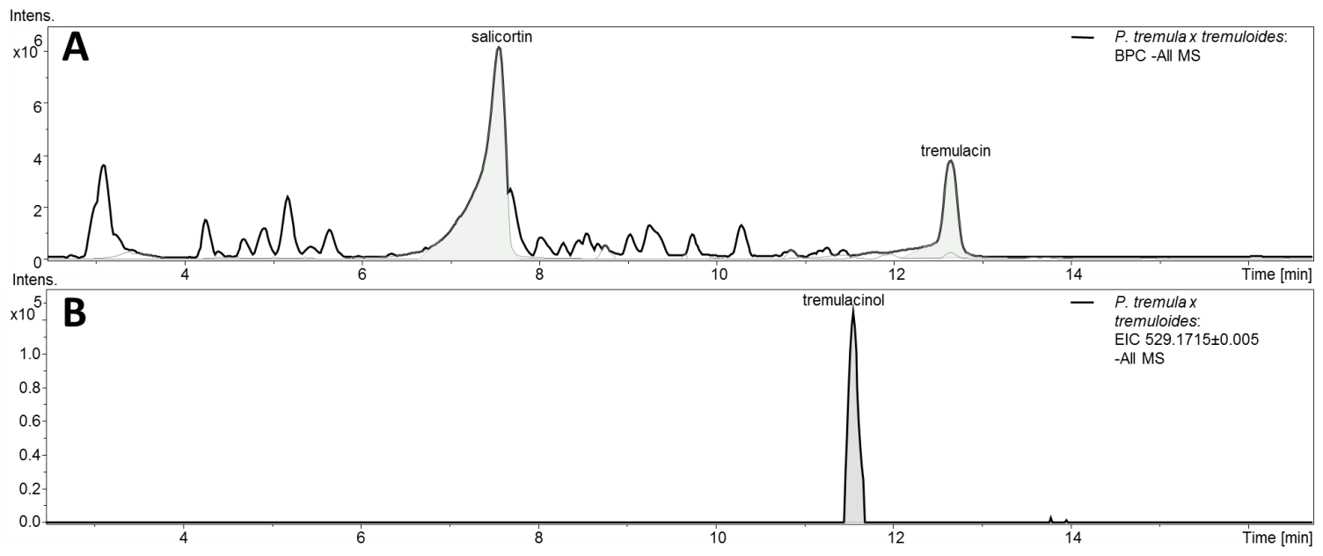
Fig. 67: A: base peak chromatogram of P. tremula x tremuloides MeOH leaf extract, c = 1 mg/mL. B: Extracted ion chromatogram (m/z = 529.1715, calc. mass for tremulacinol and 6’-O-benzoyl-salicortinol) of P. tremula x tremuloides MeOH leaf extract

HPLC-HR-ESI-MS Chromatogram of methanol extract of C. vinula frass after feeding on P. tremula x tremuloides leaves

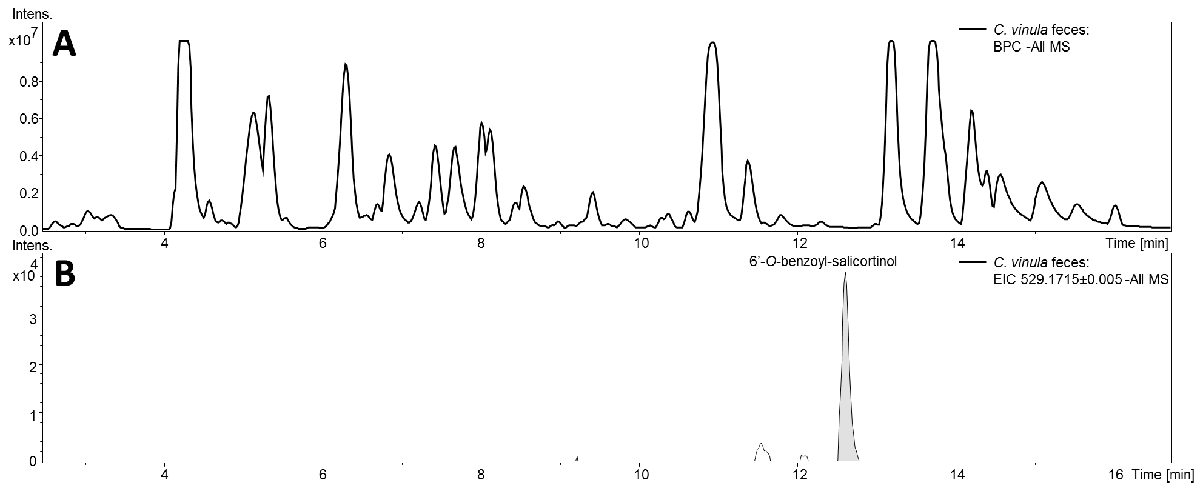
Fig. 68: A: Base peak chromatogram of C. vinula (5th instar) MeOH feces extract after feeding on P. tremula x tremuloides foliage, c = 1 mg/mL. B: Extracted ion chromatogram (m/z = 529.1715, calc. mass for tremulacinol and 6’-O-benzoyl-salicortinol) of C. vinula (5th instar) MeOH feces extract after feeding on P. tremula x tremuloides foliage

Mechanism of DHCH transformation to salicylic acid

Fig. 69: Dehydration and subsequent auto-oxidation of DHCH to salicylic acid under acidic conditions and to salicylate under alkaline conditions. In the first step, the hydroxy group at position one is protonated and subsequently dehydrated. The resulting intermediate, here represented as tautomeric structures, is further converted by auto-oxidation to form salicylic acid. Under alkaline conditions, the first step is the dissociation of the carboxylic acid. Due to the close proximity of the 2-OH group, a hydrogen bond between the carboxylate ion and the alcohol function can be formed, stabilizing the deprotonated carboxyl function. In the next step, the 1-OH group is protonated and the molecule undergoes dehydration. The resulting intermediate is then auto-oxidized to salicylate. Salicylic acid formation from DHCH is fastest in acidic media.

