Appendix

Figure A.1: Perceptions on gender norms relative to women’s role

(a) “If a woman earns more money than her husband it’s almost sure to cause problems”
(b) “Preschool child suffers with working mother”

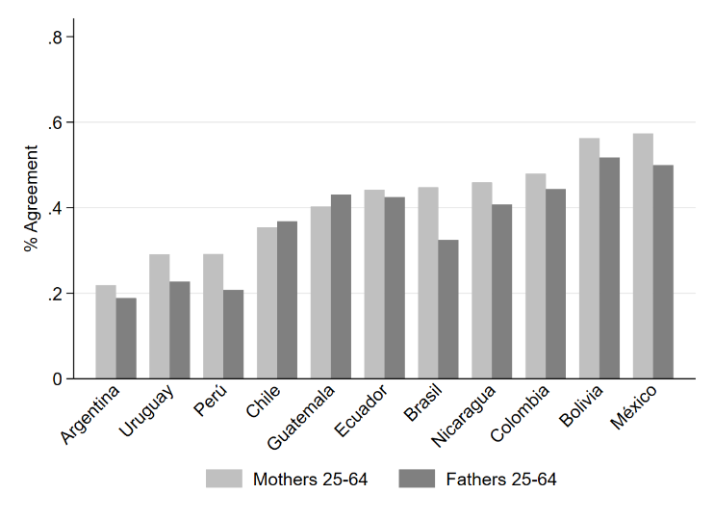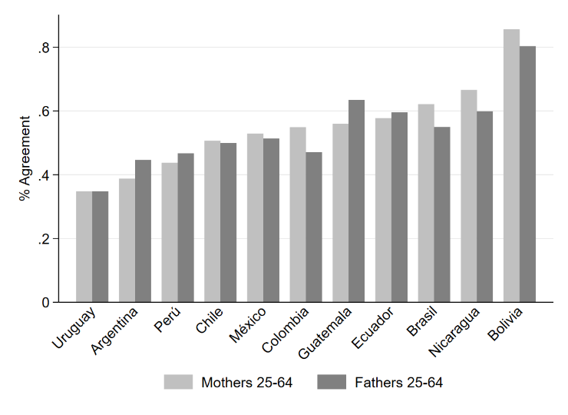

(c) “Being a housewife just as fulfilling as working for pay”
(d) “If jobs are scarce men should have more right to a job than women”

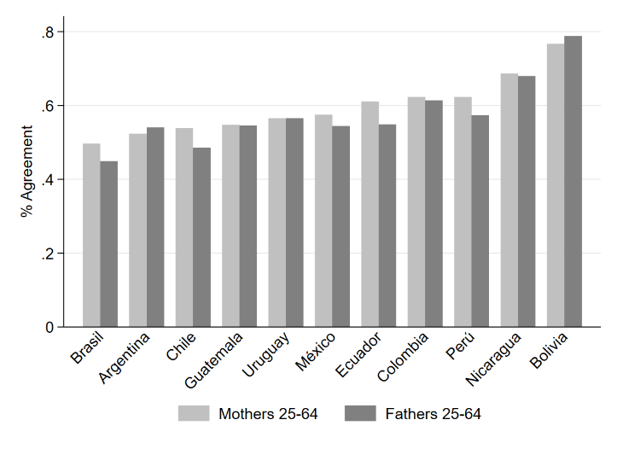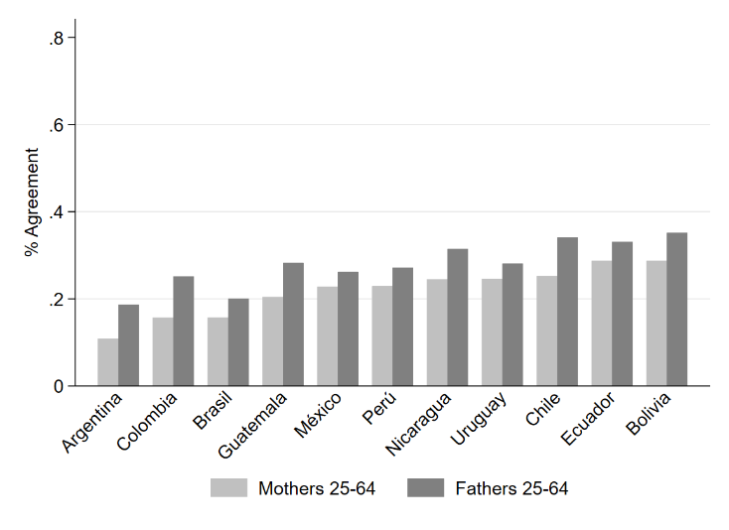

Notes: Data refers to the last wave available, which for most of the countries is 2017-2020 except for Uruguay for which we use wave 2010-2014. Data drawn from World Value Survey.

Figure A.2: Perceptions on gender norms relative to women’s role by education level

(a) “If a woman earns more money than her husband it’s almost sure to cause problems”
(b) “Preschool child suffers with working mother”

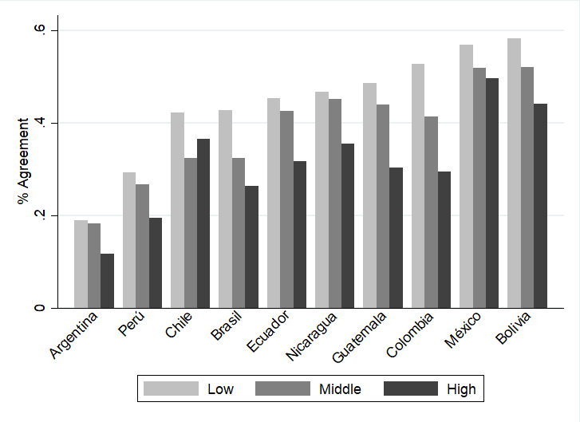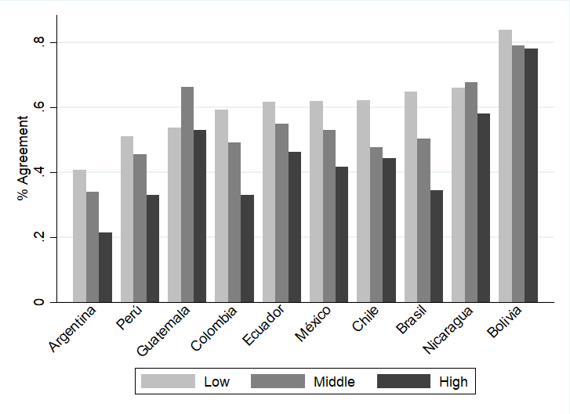

Notes: Data refers to the last wave available: 2017-2020. Source: World Value Survey.

