Supplementary Materials:
Title:
Soil enzyme activity as affected by land-use, salinity, and groundwater fluctuations in wetland soils of the prairie pothole region
Journal Name:
Wetlands
Author Names and Affiliations:
Shayeb Shahariar¹*, Bobbi Helgason¹, Raju Soolanayakanahally², Angela Bedard-Haughn¹
- Department of Soil Science, College of Agriculture and Bioresources, University of Saskatchewan, 51 Campus Drive, Saskatoon SK S7N 5A8 Canada
- Indian Head Research Farm, Agriculture and Agri-Food Canada, Indian Head SK S0G 2K0 Canada
Corresponding Author Name and Address:
Shayeb Shahariar, PhD
Department of Soil Science, College of Agriculture and Bioresources, University of Saskatchewan, 51 Campus Drive, Saskatoon SK S7N 5A8 Canada
E-mail: shayeb.shahariar@usask.ca; Phone: +1 306 966 4299

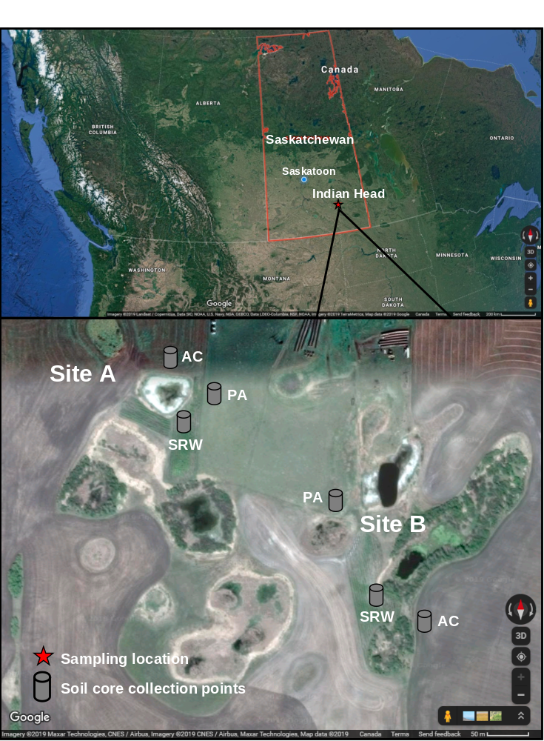
Supplementary Fig. 1 Map showing the location of study sites at Indian Head, Saskatchewan from where intact soil cores were collected under annual crop = AC, pasture = PA, and short rotation willow = SRW land-use practices (Source: Google Imagery ©2019).
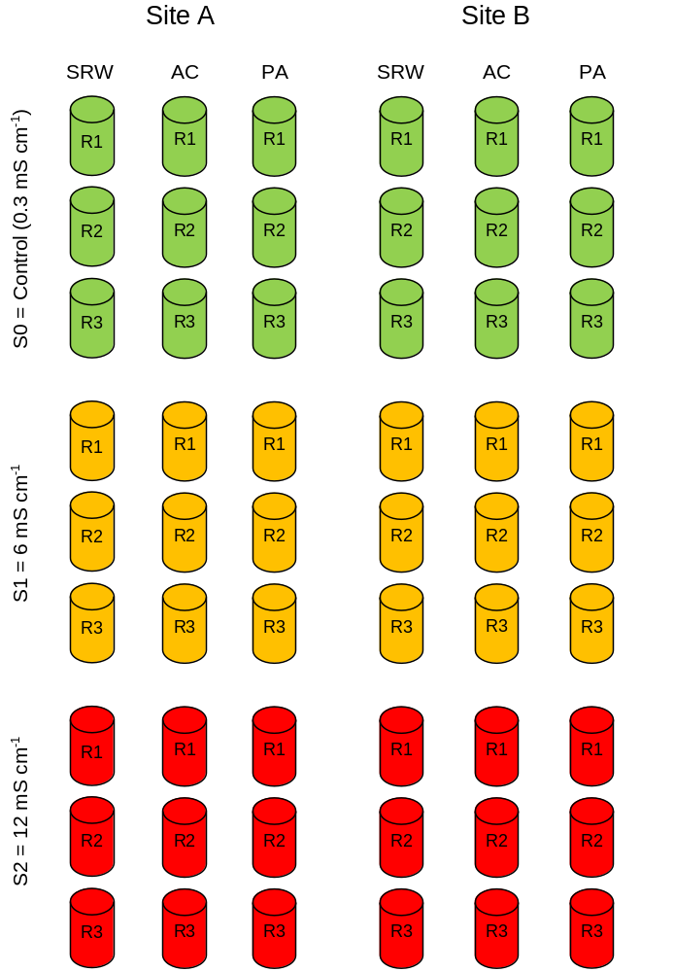
Supplementary Fig. 2 Experimental layout for microcosm incubation experiment in the greenhouse using intact soil cores using soils from annual crop (AC), pasture (PA), short rotation willow (SRW) under different salinity treatments (S) with replications (R). Note: diagram is not to scale.
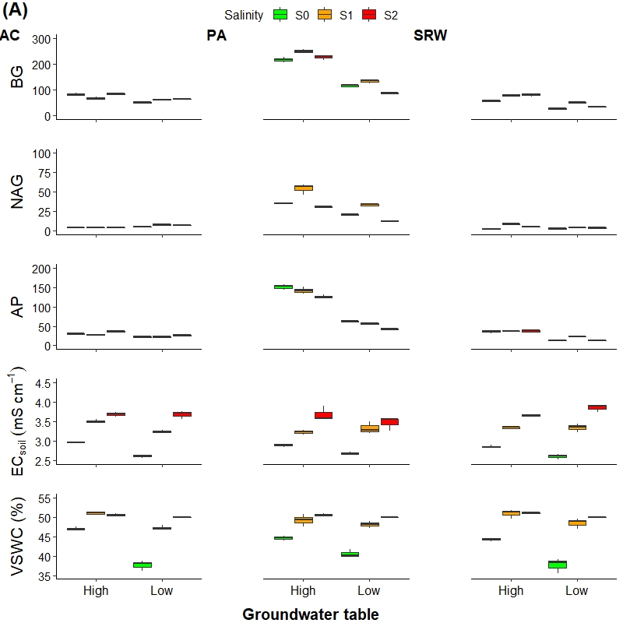

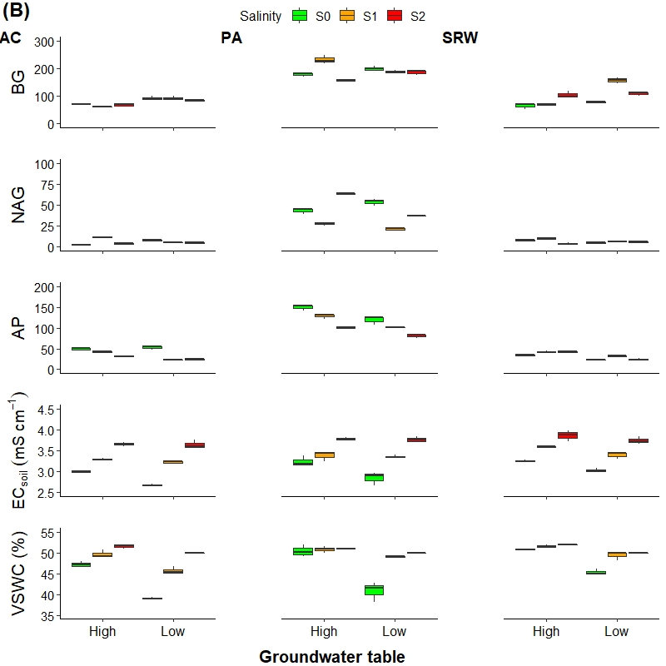
Supplementary Fig. 3 Soil β-glucosidase (BG), N-acetyl glucosaminidase (NAG), alkaline phosphatase (AP) activities (nmol activity g⁻¹ C h⁻¹), soil electrical conductivity (EC), and volumetric soil water content (VSWC) measured under different groundwater salinity treatments (e.g., S0 = control, S1 = 6 mS cm⁻¹, S2 = 12 mS cm⁻¹) and groundwater table levels in the core soils collected from annual crop (AC), pasture (PA), and short rotation willow (SRW) land-use practices from A) site A, and B) site B.
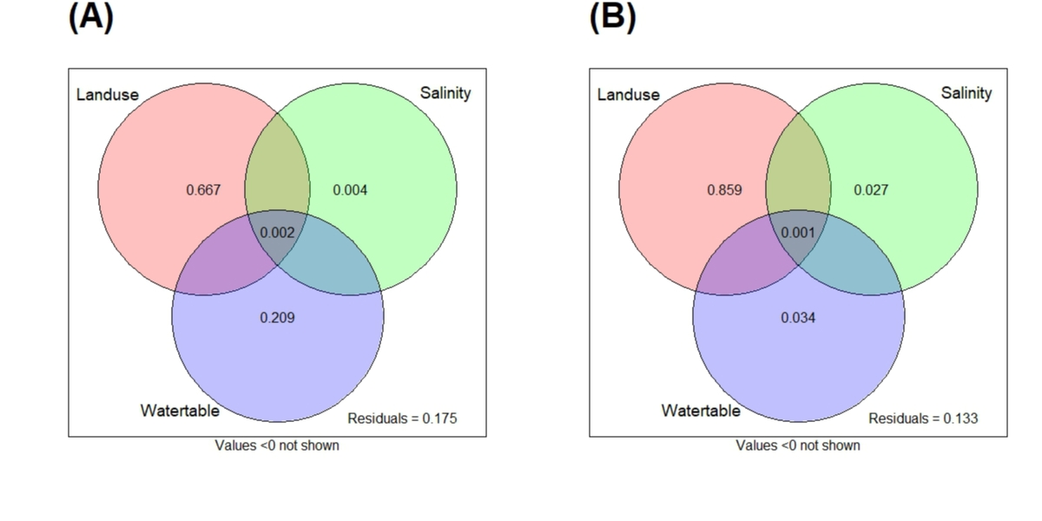
Supplementary Fig. 4 Venn’s diagram showing variation partitioning analysis (VPA) illustrates the contribution of land-use practices, salinity, and groundwater table depth to variation in soil extracellular enzyme activities from A) site A, and B) site B.
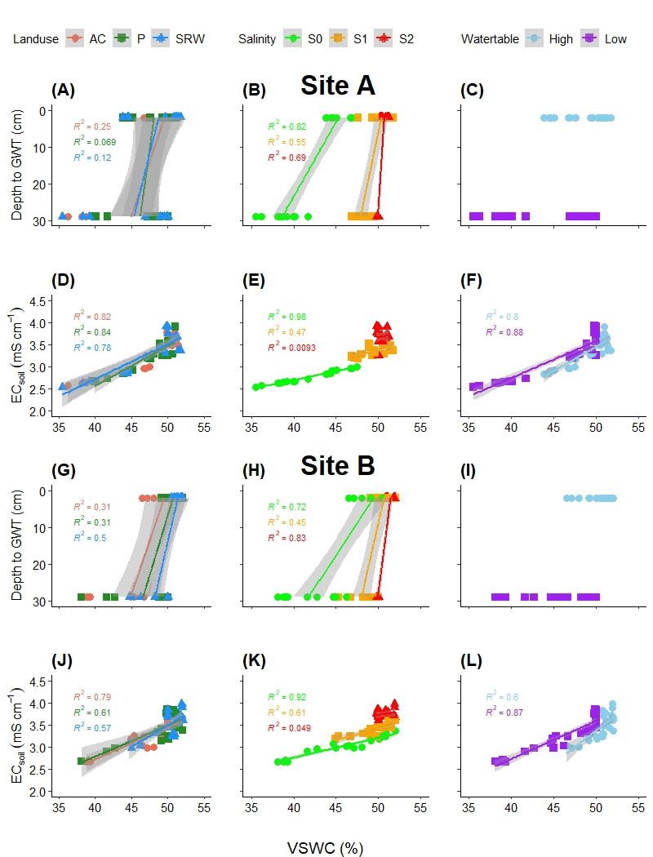
Supplementary Fig. 5 Relationship between declining groundwater table depths (GWT), volumetric soil water content (VSWC), and soil electrical conductivity (EC) in soil cores from three land-use practices (annual crop = AC, pasture = PA, short rotation willow = SRW), salinity (S0 = control, S1 = 6 mS cm⁻¹, S2 = 12 mS cm⁻¹), and groundwater table depth treatments from site A and B. The line shows linear regression of the change in VSWC and soil EC measured during the experiment against groundwater table and salinity treatments; shaded area shows 95% of confidence interval, R² gives values for individual regression lines, and p-values indicates the level of significance. p-values ≤ 0.05 indicates a significant difference, whereas p-values > 0.05 are not significantly different.

