Supplementary Information

SnP₂Se₆: A Chiral 2D Semiconductor for High-Performance Electronics and Optoelectronics

Daniel G. Chica,^{1,#} Vinod K. Sangwan,^{2,#} Ting-Ching Chu,³ Matthew Cheng,² Michael A. Quintero,¹ Shiqiang Hao,² Hyeonseon Choi,² Yukun Liu,² Eric Qian,¹ Jingyang He,⁴ Craig C. Laing,¹ Venkatraman Gopalan,⁴ Chris Wolverton,² Vinayak P. Dravid,² Lincoln J. Lauhon,² Mark C. Hersam,^{1,2,5} and Mercouri G. Kanatzidis^{1,*}

- Department of Chemistry, Northwestern University, Evanston, IL, USA 60208
- Department of Materials Science and Engineering, Northwestern University, Evanston, IL, USA 60208
- Applied Physics Graduate Program, Northwestern University, Evanston, IL, USA 60208
- Department of Materials Science and Engineering, The Pennsylvania State University, University Park, PA, USA 16802
- Department of Electrical Engineering and Computer Science, Northwestern University, Evanston, IL, USA 60208

* Email: m-kanatzidis@northwestern.edu

# These authors contributed equally to this work.

Synthesis of SnP₂Se₆
The SnP₂Se₆ material was synthesized and grown using the chemical vapor transport (CVT) method. The source material used in CVT reactions is typically the material of interest in polycrystalline form. However, since a phase pure SnP₂Se₆ could not be synthesized through the flux method, a stoichiometric amount of the elements was used as the source material. Two different transport agents were used, I₂ and SnBr₄. Iodine is typically the transport agent of choice for CVT reactions involving selenides because transport species can produce partial pressures of interest.¹ However, the reaction involving I₂ failed to produce SnP₂Se₆. The reaction using SnBr₄ as the transport agent produced both ternary phases. Blocky, millimeter-sized Sn₂P₂Se₆ crystals formed in the middle of the tube (≈ 388°C) while SnP₂Se₆ formed near the source side (≈ 325°C). At the very end of the source side, P/Se glass was deposited. Single crystals of SnP₂Se₆ were intergrown together to form florets but could be separated into individual single crystals seen in Supplementary Fig. S2. Although this CVT reaction produces two competing crystalline phases, each phase can easily be isolated via mechanical separation. Scanning electron microscopy (SEM) of the SnP₂Se₆ shows the lamellar nature of this material, as seen in Supplementary Fig. S3. The isolated crystals were ground lightly and the PXRD pattern was collected to confirm the phase purity of the material from this reaction (Supplementary Fig. S1c).
Chemical vapor transport reactions have been carried out in the Sn/P/Se [ref.²] system before targeting the Sn₂P₂Se₆ phase. These reactions utilized iodine as the transport agent and source and sink temperatures of 600 °C and 550 °C, respectively. Because these temperatures exceed the decomposition temperature of SnP₂Se₆ evidence of this phase could not be found.

Transmission electron microscopy (TEM)
High-resolution TEM (HRTEM) and selected area electron diffraction (SAED) were obtained with a JEOL ARM300 microscope at 300 kV along the [0001]-zone axis to ascertain the crystalline nature of SnP₂Se₆. Scanning transmission electron microscopy (STEM) and X-ray energy dispersive spectroscopy (XEDS) was conducted with an Oxford silicon drift detector to determine stoichiometry and chemical distribution of the SnP₂Se₆. The convergence angle of the STEM probe is 24 mrad which at 300 keV corresponds to a probe size of 0.57 Å FWHM and the solid angle of the Oxford detector is 0.98 steradian. STEM samples were prepared using mechanical exfoliation. SAED patterns were simulated with SingleCrystalTM.

Scanning electron microscopy (SEM)
A Hitachi S-3400N-II scanning electron microscope was used to collect SEM images of SnP₂Se₆ crystals. An Oxford INCAx-act electron dispersive X-ray spectroscopy (EDS) system was used to collect energy dispersive X-ray spectra on SnP₂Se₆ crystals. The accelerating voltage and probe current were set to 20 keV and 70 mA, respectively, for the collection of SEM images and EDS spectra. The EDS spectra were fitted using Aztec software, Oxford instruments.

Optical absorption spectroscopy
The transmission spectrum was collected at room temperature using a PerkinElmer LAMBDA 1050 UV/Vis spectrophotometer in the range of 250 – 1200 nm. The computer-controlled instrument is equipped with a 150 mm integrating sphere accessory and a 3-detector module consisting of a photomultiplier R6872, 3-stage wide band Peltier-cooled InGaAs, and 1-stage wide band Peltier-cooled PbS. The sample was prepared by selecting a flat flake of SnP₂Se₆ and affixing it to a beam mask sample holder using transparent Scotch tape; the baseline was collected using transparent Scotch tape on the beam mask sample holder. The percent transmission data was converted to absorption using the equation A = 2 – log(%T), then was used to generate a plot of (αhν)^{1/γ} vs. hν, for which α is the absorption coefficient of the material, h is the Planck constant, ν is the photon frequency, and γ is a factor dependent on the nature of the electronic transition (γ = 2 in this case for indirect transition).³
The UV-Vis spectrum in diffuse reflectance mode was collected on lightly grounded crystal powder of SnP₂Se₆ grown from a CVT reaction using a Cary 5000 UV-Vis-NIR double beam spectrophotometer with a monochromator. BaSO₄ powder was used for the baseline collection, whereas a mixture of SnP₂Se₆ powder with BaSO₄ was used for the data collection at room temperature. Absorbance data was converted from reflectance data in software using the Kubelka-Munk equation,⁴ α/S = (1-R)²/2R, where α and S are the absorption and scattering coefficients, respectively, and R is the reflectance.

Photoemission yield spectroscopy
An AC-2, Riken-Keiki system was used to extract the work function by measuring the valence band maximum (VBM) energy level. The CVT-grown crystal of SnP₂Se₆ was illuminated by a tunable monochromatic ultraviolet light source (UV, 4.20-6.20 eV) under dry air. The number of photoelectrons was measured by increasing the excitation energy by 0.10 eV steps. Photoelectrons are only generated when the photon energy is higher than the work function, as indicated by the onset of photoelectrons in the resulting spectra.

Raman and photoluminescence (PL) spectroscopy
Raman and PL measurements of exfoliated SnP₂Se₆ flakes were performed in a Horiba XPloRA confocal setup using a 532 nm excitation laser with a spot size of ≈ 1 um (100× objective). Raman and PL spectra were acquired using a grating of 2400 gr/mm and 600 gr/mm, respectively.

Atomic force microscopy (AFM)
AFM topographical images of SnP₂Se₆ flakes were acquired using an Asylum Cypher AFM system with a Si cantilever (resonant frequency ≈ 320−340 kHz) that was scanned in non-contact mode.

Piezo-force microscopy (PFM)
PFM was conducted on a commercial SPM system (Bruker Dimension Icon) with Pt/Ir coated Si tips under ambient conditions. PFM images were measured with a drive frequency of 360 kHz, which is near the contact resonance frequency, and a drive amplitude of 1.5 V. For DC bias sweeps, PFM responses were measured at discrete points on the sample at the same drive frequency and amplitude at DC bias offsets ranging from -2 to 2 V.

Band structure calculations
The calculations are based on density functional theory within the generalized-gradient approximation (GGA).⁵ The projector augmented wave pseudopotential are applied as implemented in the VASP package.⁶ The plane-wave basis-set cutoff energy is set to 500 eV and the convergence criterion with respect to self-consistent iterations is assumed the residual forces were less than 0.01 eV/A. A very dense k-meshes is used, which corresponds to 4000 k-points per reciprocal atom in the Brillouin zone. The spin-orbit coupling effect has been considered in the band structure calculations.

Extended discussion on photocurrent mechanism
In nanoscale devices, photothermal and photothermoelectric effects can arise from the difference in temperature and Seebeck coefficients of the metal contacts and semiconductor channel. For zero-bias photocurrent (Fig. 4), these effects can be ruled out due to the absence of localized photocurrent near and under the metal contacts.⁷ A zero-bias photocurrent can also arise from photogalvanic and photon drag effects, but they require an oblique laser beam incidence.⁸ Here, the laser beam is vertically aligned with respect to the substrate, and the planar surface of the SnP₂Se₆ nanoflake eliminates the possibility of oblique incidence. Planar nanoflakes on a flat substrate also rule out the strain-induced flexophotovoltaic effect.⁹ Another potential mechanism of short circuit current is the Dember effect where unequal electron and hole mobilities can generate electromotive forces towards opposing electrodes.^{10, 11} However, in this case, a net photovoltage can only emerge for inhomogeneous photocurrent generation due to either an asymmetry in optical illumination or intrinsic inhomogeneities in the material, such as grain boundaries. Here, the focused laser spot has a symmetric Gaussian shape and the spatially resolved photocurrent does not reveal any grain boundaries in the exfoliated flakes.
These considerations point to a combination of two mechanisms: the shift current originating from the polar symmetry of SnP₂Se₆ and asymmetric diffusion of photogenerated carriers in SnP₂Se₆.¹² BPVE has long been observed in non-centrosymmetric bulk crystals such as ferroelectric materials, with and without grain boundaries, that can be engineered to achieve voltages orders of magnitudes larger than the bandgap of the materials, albeit, without significant photocurrent.^{13, 14} Non-polar non-centrosymmetric crystal can also produce BPVE when the polarization aligns with high-symmetry axes.¹³ High photocurrent is achieved in systems either with inherent polarization within the unit cell or with spontaneous symmetry breaking in engineered systems such as nanotubes and vdW heterojunctions.^{11, 13, 15} Here, the SHG measurements (Fig. 2e) reveal symmetry breaking from vdW stacking of monolayers in as-grown SnP₂Se₆ crystals. We ruled out ferroelectricity in SnP₂Se₆ by performing piezo-force microscopy and polarization hysteresis curves (Supplementary Figs. S15 and S16). The design rules from first principles point to the importance of a low bandgap for efficient BPVE.^{12, 16} Here, the combination of high intrinsic polarization, low bandgap (compared to perovskite ferroelectrics), and high carrier mobility could result in BPVE photocurrent (Fig. 4). High mobility μ and high diffusion coefficient D (from Einstein relation D = (k_{B}T/e).μ, where k_{B} and e are Boltzmann’s constant and fundamental electronic charge, respectively) also favor the diffusion-induced photocurrent maxima in the channel.

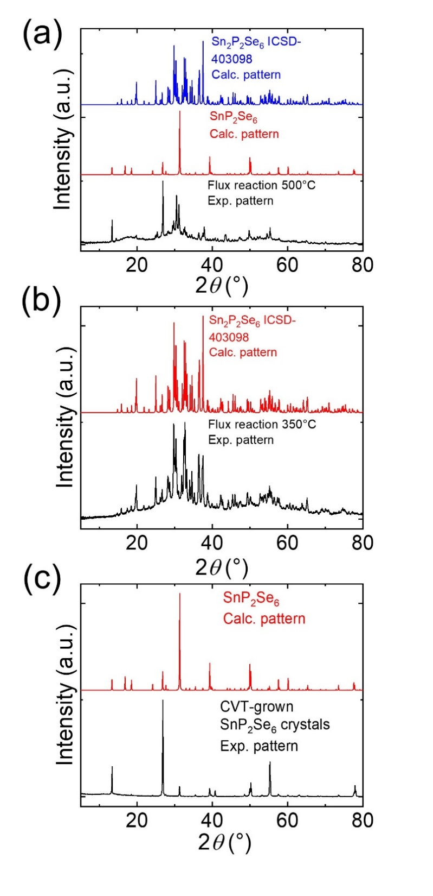
Figure S1. Powder X-ray diffraction (PXRD) patterns on ingot from (a) 500 °C and (b) 350°C flux reactions. PXRD pattern on lightly ground CVT-grown crystal of SnP₂Se₆. The calculated patterns of SnP₂Se₆ and Sn₂P₂Se₆ (ICSD – 403098) were plotted to compare with experimental patterns. The discrepancy between the peak intensities of the calculated and experimental patterns stems from preferred orientation.

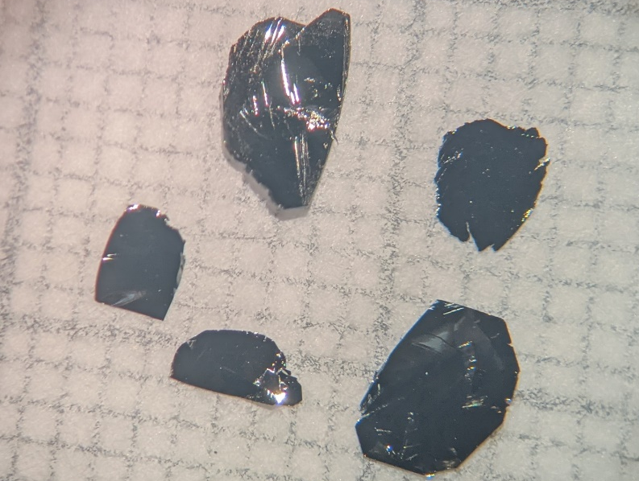
Figure S2. Images of SnP₂Se₆ single crystals grown using chemical vapor transport (CVT) with SnBr₄ as the transport agent. Each square in the background is 1×1 mm².

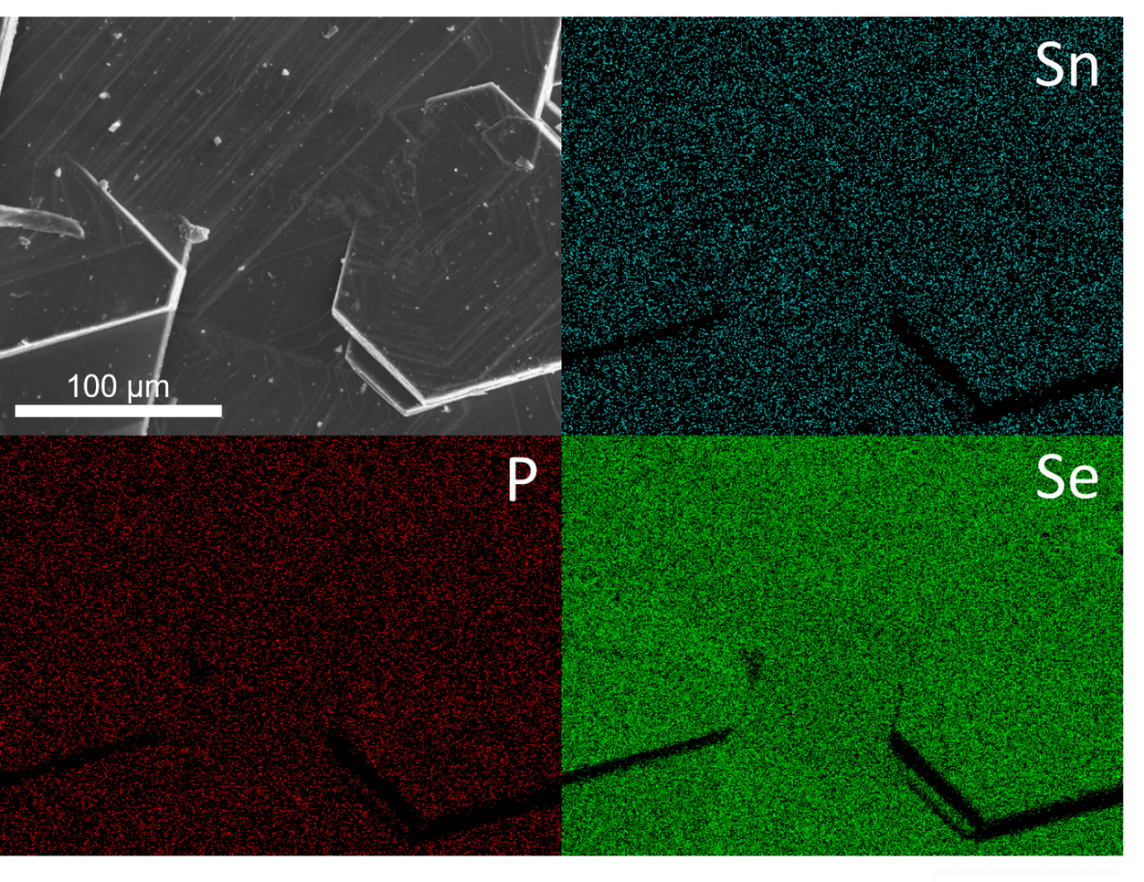
Figure S3. Scanning electron microscopy (SEM) micrograph and electron dispersive X-ray spectroscopy (EDS) mapping of elements Sn, P, and Se in the SnP₂Se₆ crystals grown from CVT reaction using SnBr₄ as the transport agent.

Table S1. Crystal data and structure refinement for SnP₂Se₆ at 293(2) K.
Empirical formula | Sn P2 Se6
Formula weight | 654.39
Temperature | 293(2) K
Wavelength | 0.56083 Å
Crystal system | Trigonal
Space group | R3
Unit cell dimensions | a = 6.3213(9) Å, α = 90°  b = 6.3213(9) Å, β = 90°  c = 19.962(4) Å, γ = 120°
Volume | 690.8(2) Å³
Z | 3
Density (calculated) | 4.719 g/cm³
Absorption coefficient | 14.109 mm⁻¹
F(000) | 852
Crystal size | 0.014 x 0.117 x 0.203 mm³
θ range for data collection | 2.415 to 27.482°
Index ranges | -10<=h<=9, -10<=k<=10, -31<=l<=32
Reflections collected | 4988
Independent reflections | 1417 [R_{int} = 0.1101]
Completeness to θ = 19.664° | 100%
Refinement method | Full-matrix least-squares on F²
Data / restraints / parameters | 1417 / 1 / 28
Goodness-of-fit | 1.055
Final R indices [I > 2σ(I)] | R_{obs} = 0.0474, wR_{obs} = 0.1201
R indices [all data] | R_{all} = 0.0501, wR_{all} = 0.1230
Extinction coefficient | N/A
Largest diff. peak and hole | 2.735 and -1.898 e·Å⁻³
R = Σ||F_{o}|-|F_{c}|| / Σ|F_{o}|, wR = {Σ[w(|F_{o}|² - |F_{c}|²)²] / Σ[w(|F_{o}|⁴)]}^{1/2} and w=1/[σ²(Fo²)+(0.0814P)²+1.5586P] where P=(Fo²+2Fc²)/3

Table S2. Atomic coordinates (x10⁴) and equivalent isotropic displacement parameters (Å²x10³) for SnP₂Se₆ at 293(2) K with estimated standard deviations in parentheses.
Label | x | y | z | Occupancy | U_{eq}*
Se(1) | 6601(2) | 6632(2) | 3121(1) | 1 | 16(1)
Se(2) | 6667(2) | 18(2) | 4849(1) | 1 | 15(1)
Sn(4) | 3333.33 | 6666.67 | 3999(2) | 1 | 14(1)
P(7) | 6666.67 | 3333.33 | 3424(2) | 1 | 12(1)
P(10) | 6666.67 | 3333.33 | 4538(3) | 1 | 11(1)
*U_{eq} is defined as one-third of the trace of the orthogonalized U_{ij} tensor.

Table S3. Anisotropic displacement parameters (Å²x10³) for SnP₂Se₆ at 293(2) K with estimated standard deviations in parentheses.
Label | U₁₁ | U₂₂ | U₃₃ | U₁₂ | U₁₃ | U₂₃
Se(1) | 18(1) | 14(1) | 19(1) | 10(1) | 5(1) | 4(1)
Se(2) | 17(1) | 12(1) | 18(1) | 8(1) | -5(1) | -1(1)
Sn(4) | 12(1) | 12(1) | 18(1) | 6(1) | 0 | 0
P(7) | 10(1) | 10(1) | 14(2) | 5(1) | 0 | 0
P(10) | 11(1) | 11(1) | 12(2) | 6(1) | 0 | 0
The anisotropic displacement factor exponent takes the form: -2π²[h²a^{*2}U₁₁ + ... + 2hka*b*U₁₂].

Table S4. Bond lengths [Å] for SnP₂Se₆ at 293(2) K with estimated standard deviations in parentheses.
Label | Distances
Se(1)-Sn(4) | 2.717(3)
Se(1)-P(7) | 2.1917(18)
Se(2)-Sn(4)#1 | 2.710(3)
Se(2)-P(10) | 2.1859(19)
P(7)-P(10) | 2.224(6)
Symmetry transformations used to generate equivalent atoms:
(1) x,y-1,z (2) -y+1,x-y+1,z (3) -x+y,-x+1,z (4) -y,x-y,z (5) -x+y+1,-x+1,z (6) x,y+1,z (7) -y+1,x-y,z
Table S5. Bond angles [°] for SnP₂Se₆ at 293(2) K with estimated standard deviations in parentheses.
Label | Angles
P(7)-Se(1)-Sn(4) | 101.86(13)
P(10)-Se(2)-Sn(4)#1 | 101.46(13)
Se(1)#2-Sn(4)-Se(1) | 82.87(11)
Se(1)#2-Sn(4)-Se(1)#3 | 82.87(11)
Se(1)#3-Sn(4)-Se(1) | 82.87(11)
Se(2)#4-Sn(4)-Se(1)#2 | 96.50(4)
Se(2)#5-Sn(4)-Se(1)#3 | 96.50(4)
Se(2)#6-Sn(4)-Se(1) | 96.50(4)
Se(2)#4-Sn(4)-Se(1) | 178.49(14)
Se(2)#5-Sn(4)-Se(1)#2 | 178.49(14)
Se(2)#6-Sn(4)-Se(1)#2 | 95.69(4)
Se(2)#4-Sn(4)-Se(1)#3 | 95.69(4)
Se(2)#6-Sn(4)-Se(1)#3 | 178.49(14)
Se(2)#5-Sn(4)-Se(1) | 95.69(4)
Se(2)#4-Sn(4)-Se(2)#6 | 84.93(11)
Se(2)#6-Sn(4)-Se(2)#5 | 84.93(11)
Se(2)#4-Sn(4)-Se(2)#5 | 84.93(11)
Se(1)#7-P(7)-Se(1) | 112.67(12)
Se(1)#5-P(7)-Se(1)#7 | 112.67(12)
Se(1)#5-P(7)-Se(1) | 112.67(12)
Se(1)-P(7)-P(10) | 106.04(14)
Se(1)#5-P(7)-P(10) | 106.04(14)
Se(1)#7-P(7)-P(10) | 106.04(14)
Se(2)-P(10)-Se(2)#7 | 112.27(12)
Se(2)-P(10)-Se(2)#5 | 112.27(12)
Se(2)#7-P(10)-Se(2)#5 | 112.27(12)
Se(2)-P(10)-P(7) | 106.50(14)
Se(2)#5-P(10)-P(7) | 106.50(14)
Se(2)#7-P(10)-P(7) | 106.50(14)
Symmetry transformations used to generate equivalent atoms:
(1) x,y-1,z (2) -y+1,x-y+1,z (3) -x+y,-x+1,z (4) -y,x-y,z (5) -x+y+1,-x+1,z (6) x,y+1,z (7) - y+1,x-y,z

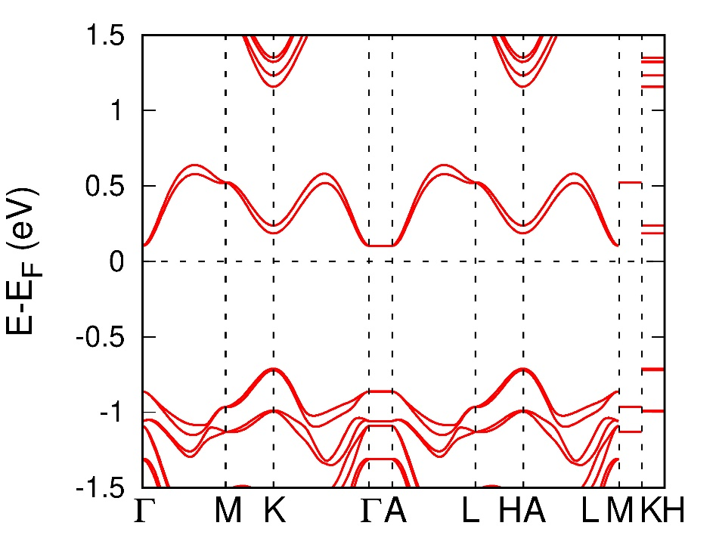
Figure S4. Band structure of a monolayer of SnP₂Se₆ calculated from density functional theory.

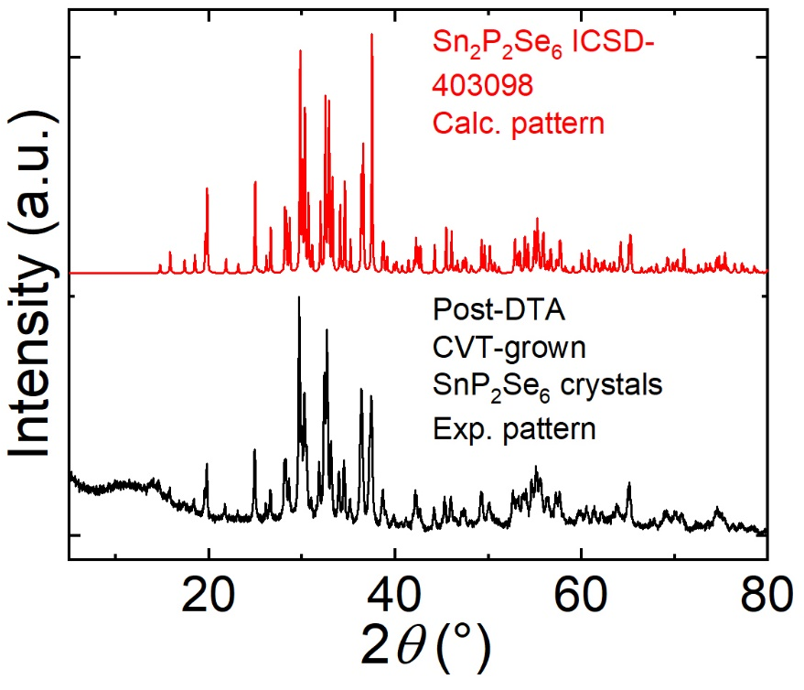
Figure S5. PXRD of SnP₂Se₆ after DTA experiment up to 600 °C compared to the calculated diffraction pattern of Sn₂P₂Se₆.

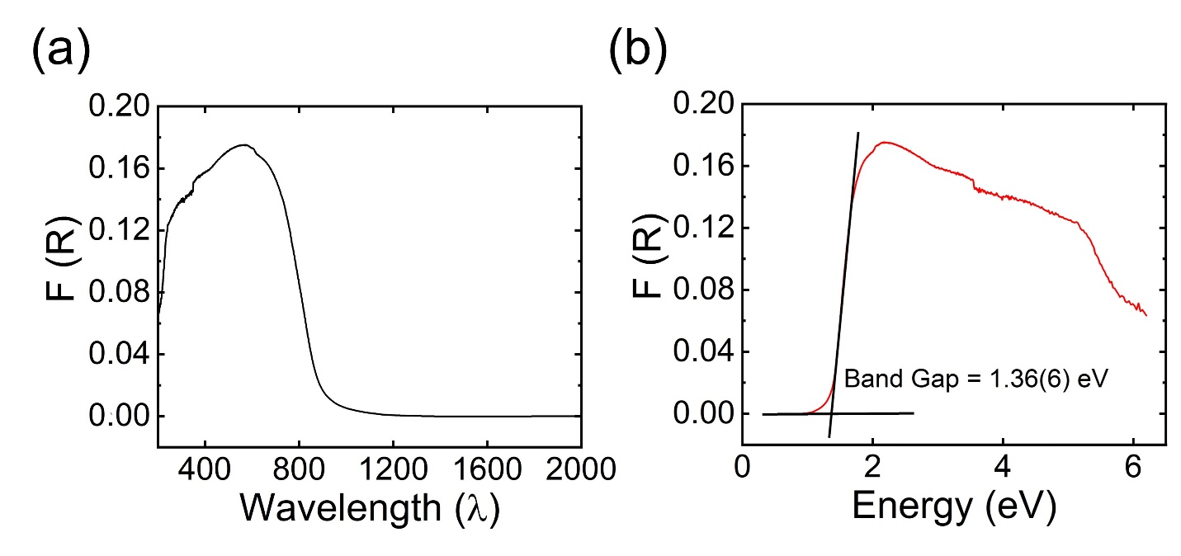
Figure S6. (a) Optical absorption spectra of a SnP₂Se₆ powder extracted from UV-Vis diffuse reflectance measurement. (b) The extracted bandgap of 1.36 matches the value from optical absorption spectra Figure 2b.

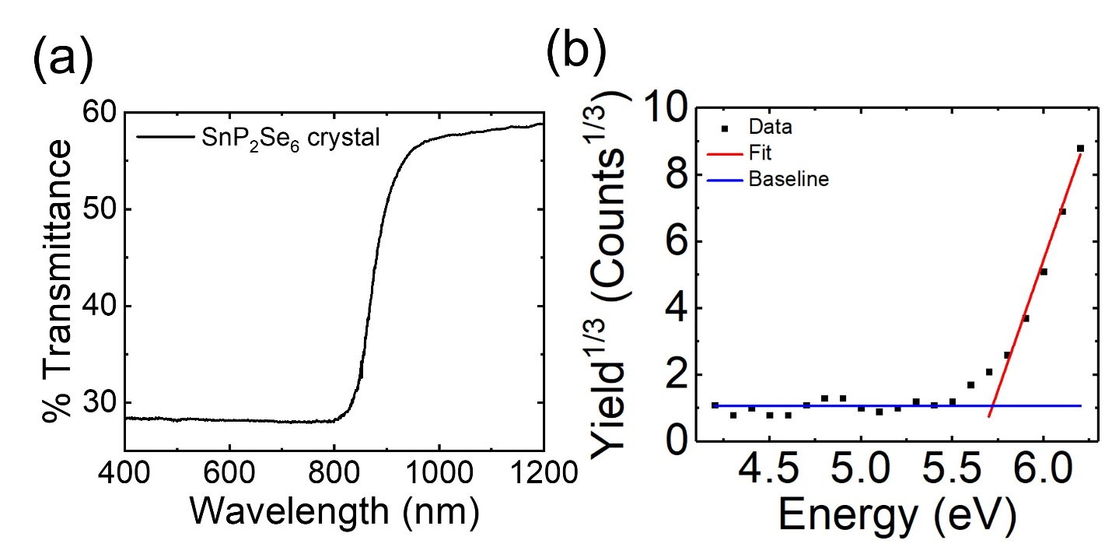
Figure S7. (a) Optical transmission spectra of a SnP₂Se₆ crystal corresponding to the Tauc plot in Figure 2b. (b) Photoemission yield spectra to extract the work-function (≈5.72(5) eV) of the SnP₂Se₆ crystal.

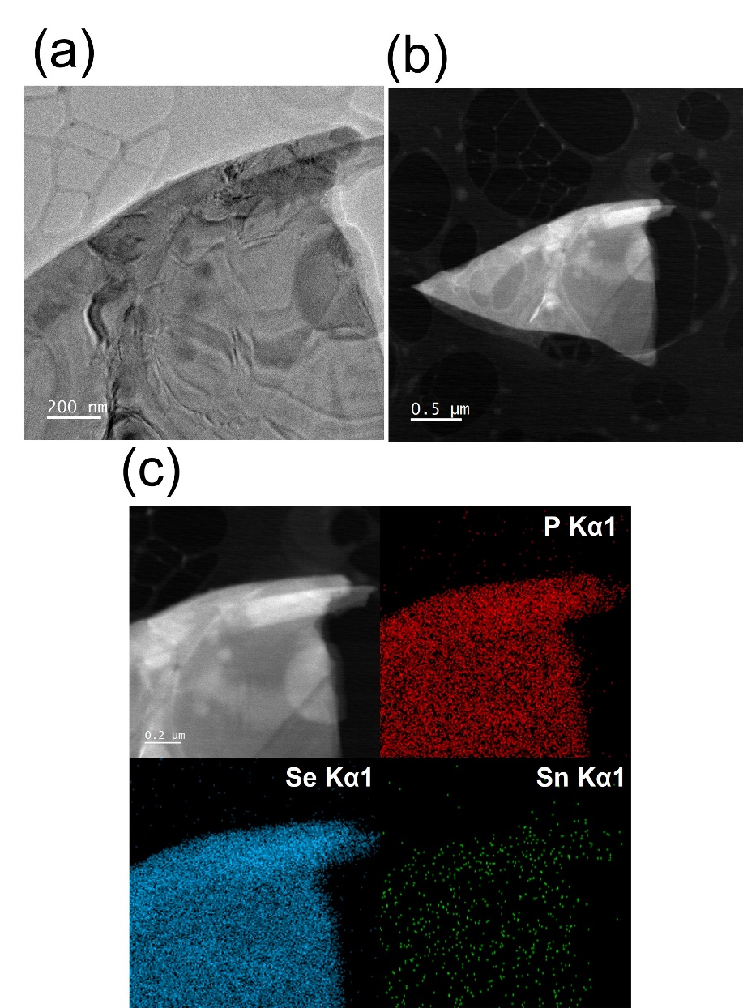

Figure S8. a) High-resolution transition electron microscopy (HRTEM) bright-field image of a representative SnP₂Se₆ flake. The yellow box marks the region where HRTEM measurements were conducted (Figure 2d). b) High-angle annular dark-field scanning (HAADF) image of the same SnP₂Se₆ flake of interest. c) Scanning transition electron microscopy-electron X-ray diffraction spectroscopy (STEM-EDS) maps in the zoomed-in region showing the homogeneous distribution of P, Se, and Sn.

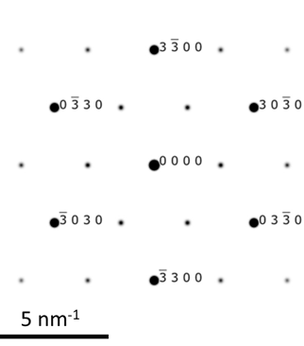
Figure S9. The simulated¹⁷ SAED pattern of SnP₂Se₆ along the [0001]-zone axis. The pattern is simulated with a voltage of 300 keV and a camera length of 200 cm and matches well with the experimentally obtained diffraction pattern.

Table S6. The composition in the atomic percentage of the representative SnP₂Se₆ flakes that evaluated by STEM-EDS. Note that only the Sn, P, and Se atomic percentages are shown. The rest of the detected elements was C from the lacey-C support. When normalized to Sn, the obtained composition matches well with the expected ratio Sn:P:Se = 1:2:6.

Element | Atomic % | Ratio to Sn
Sn | 1.4 ± 0.11 | 1.0 ± 0.079
P | 2.9 ± 0.068 | 2.1 ± 0.0049
Se | 8.6 ± 0.071 | 6.1 ± 0.051

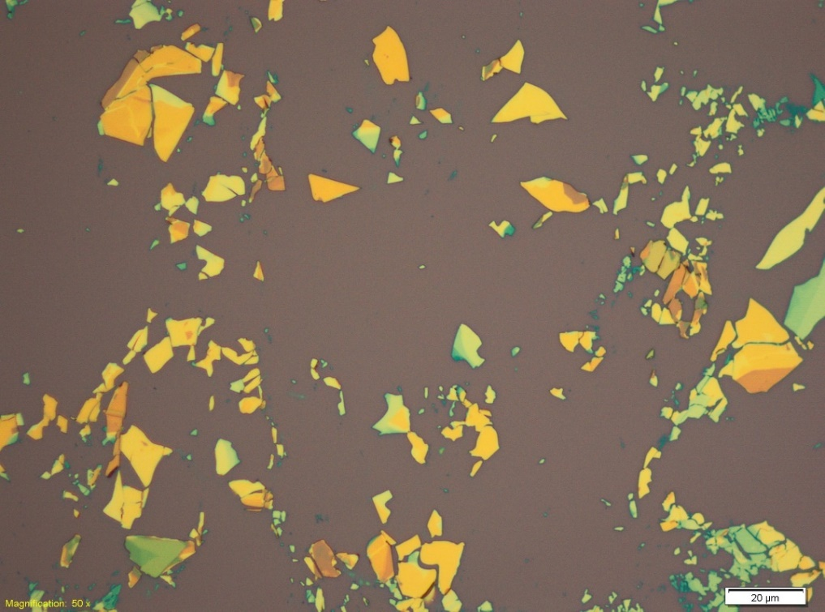
Figure S10. An optical micrograph of thin exfoliated SnP₂Se₆ flakes on an oxidized (300 nm SiO₂) silicon wafer. The scale bar is 20 microns.

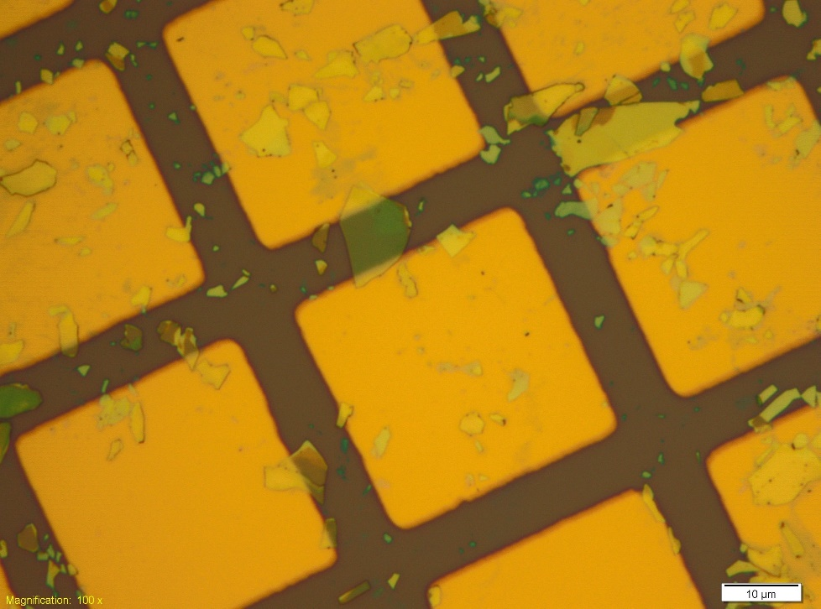
Figure S11. Optical micrographs of SnP₂Se₆ field-effect transistors (FETs) on Si wafers were obtained by thermal evaporation of metal (Au) through a shadow mask randomly aligned over SnP₂Se₆ flakes. The scale bar is 10 microns.

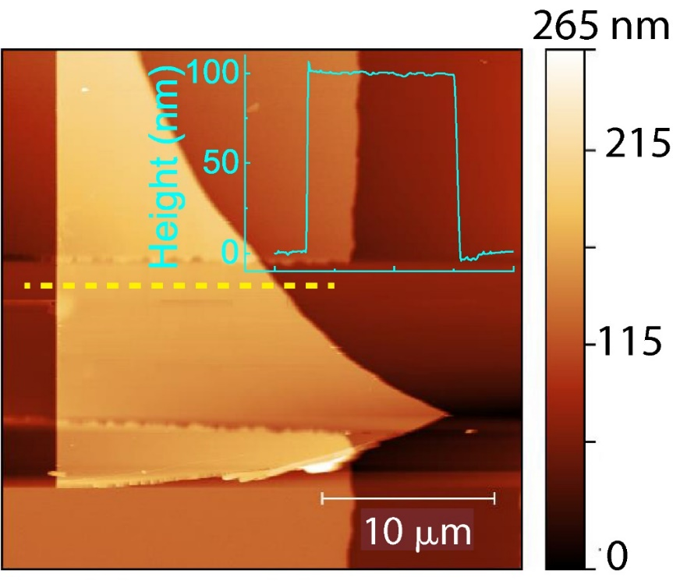

Figure S12. Atomic force microscopy (AFM) topography image of the SnP₂Se₆ FET corresponding to Figure 3a of the main text. The inset shows a height profile of the SnP₂Se₆ flake taken along the yellow dashed line.

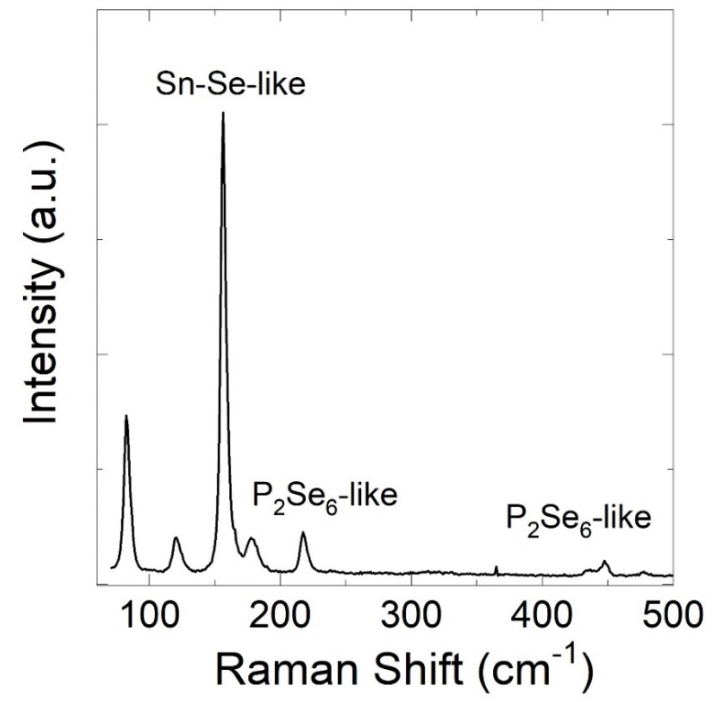
Figure S13. Raman spectra from a SnP₂Se₆ flake using a 532 nm excitation.

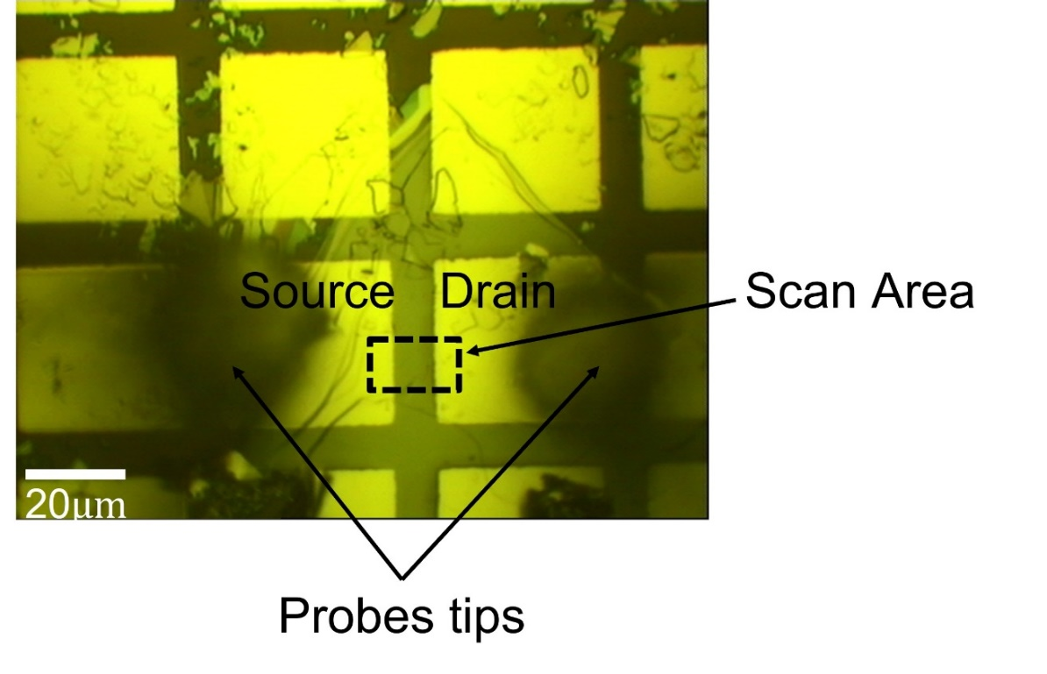
Figure S14. An optical image of the SnP₂Se₆ device used for bulk photovoltaic measurement in a scanning photocurrent microscope, as shown in the schematic in Figure 4a of the main text. The photocurrent map in Figure 4a is taken from the dashed rectangle.

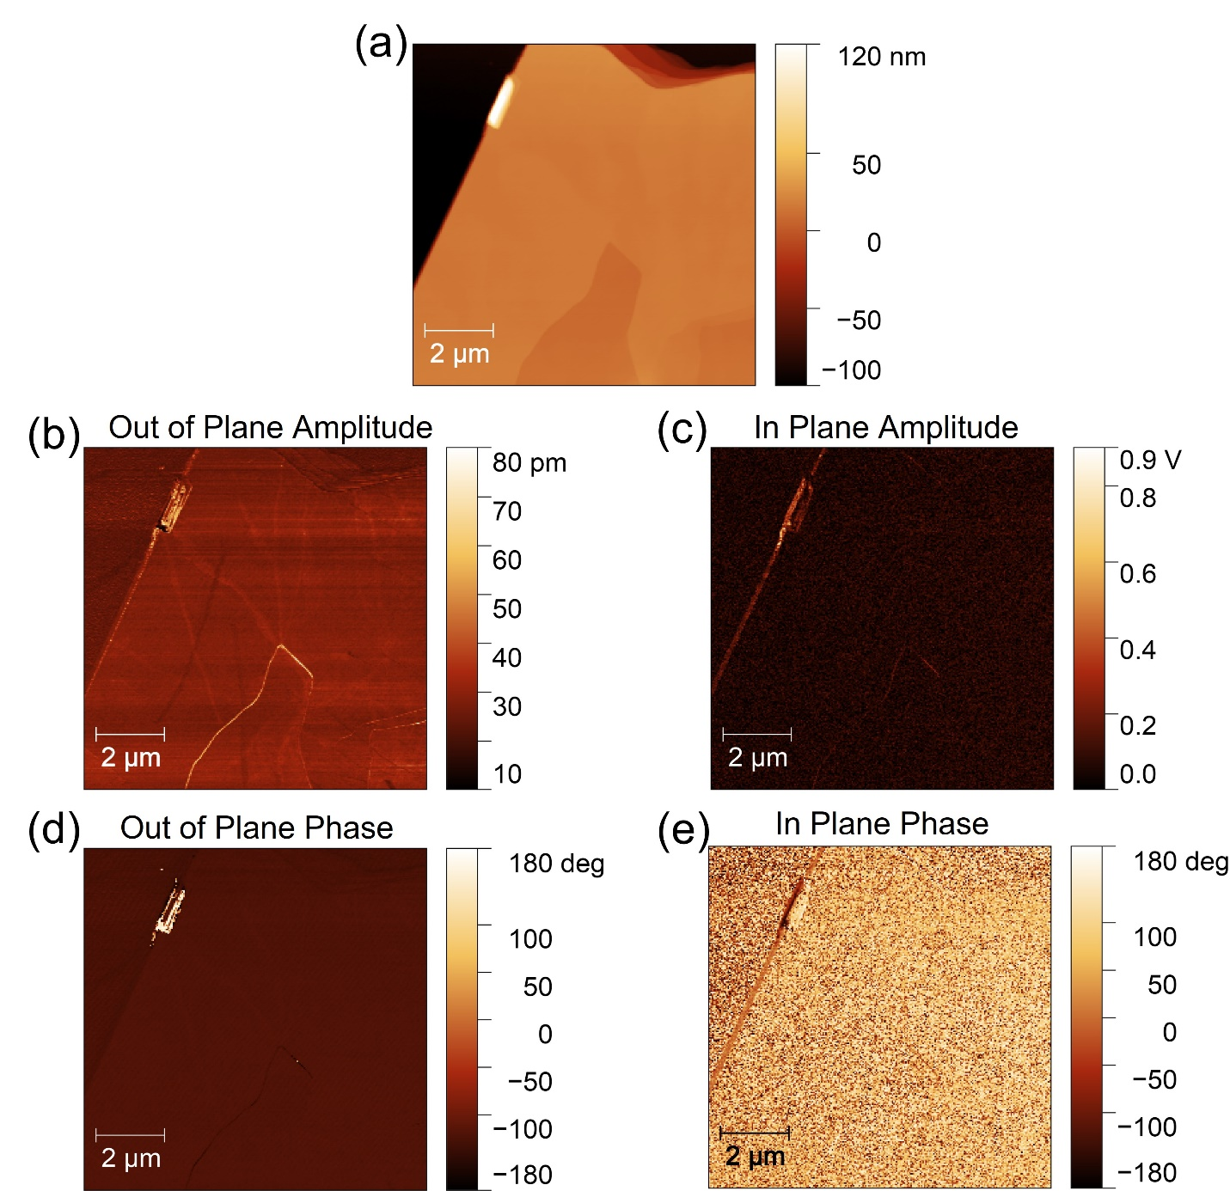
Figure S15. (a) AFM topography image of a SnP₂Se₆ flake exfoliated on an Au-coated substrate. (b), (c) Out-of-plane and in-plane piezo-force microscopy (PFM) amplitude of the flake, respectively, showing little or no contrast between the flake and Au surface. (d), (e) Out-of-plane and in-plane PFM phase of the flake, respectively, showing little or no contrast between the flake and Au surface.
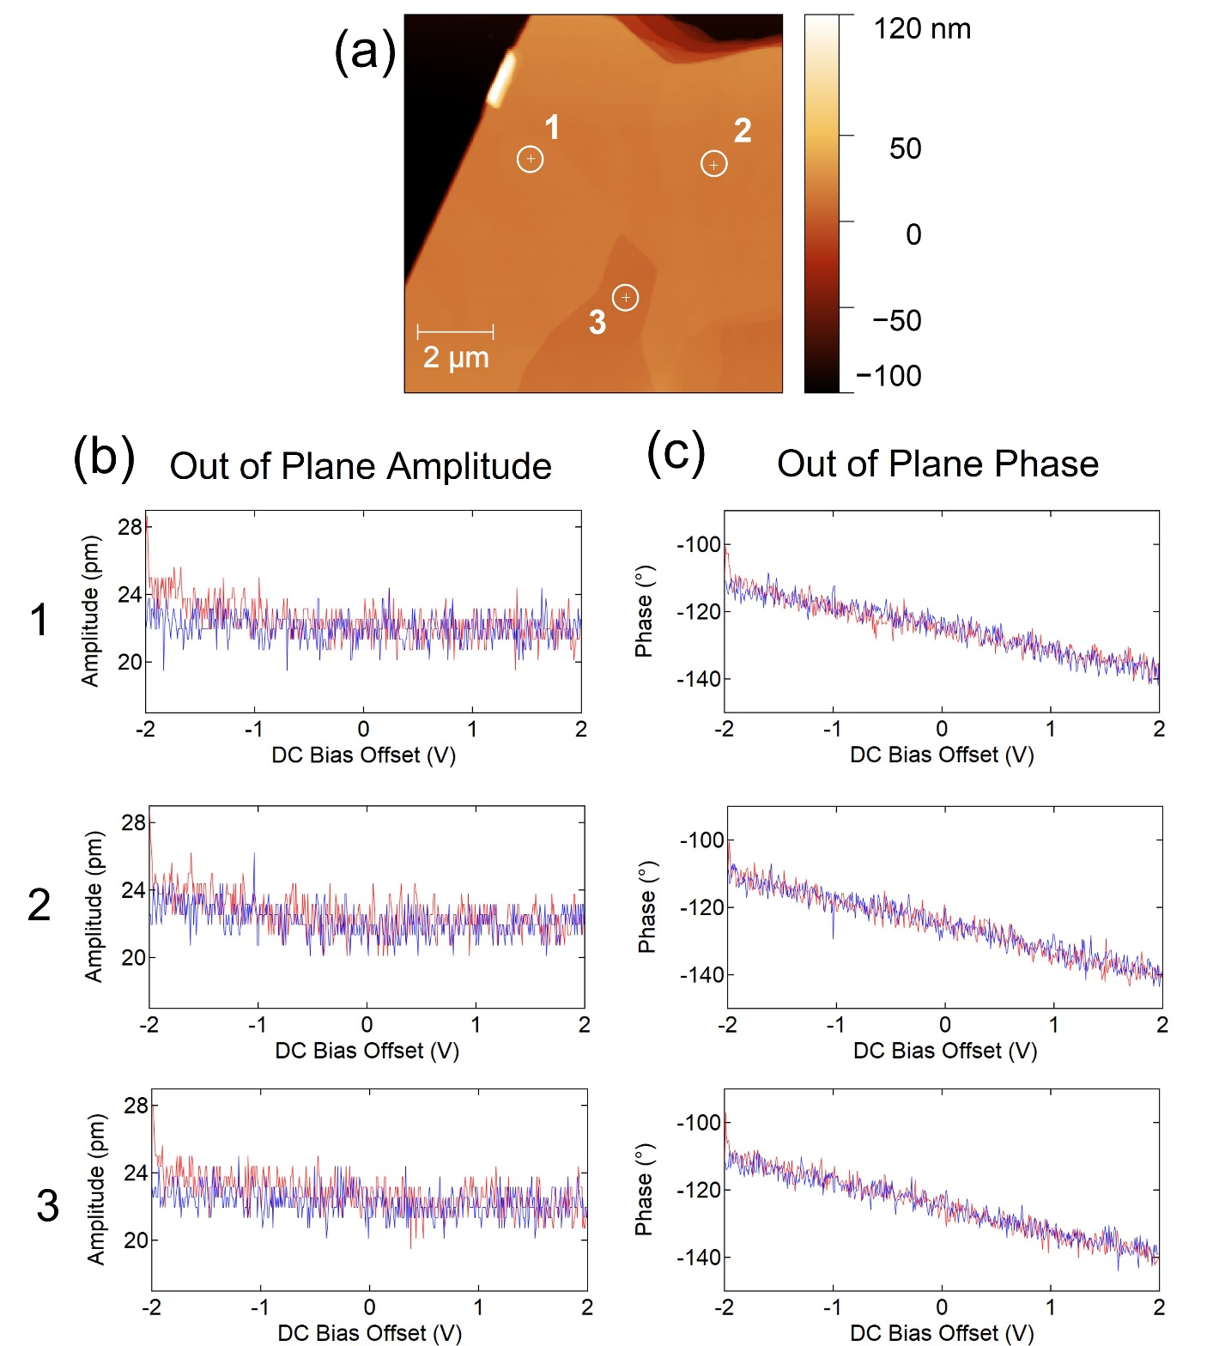

Figure S16. (a) AFM topography image showing the location of 3 spots used for bias sweeping. (b) Out-of-plane amplitude versus DC bias offset at spots 1, 2, and 3 (top to bottom). (c) Out-of-plane phase versus DC bias offset at spots 1, 2, and 3 (top to bottom). The red (blue) curves show sweep direction from left to right (right to left) in (b) and (c).

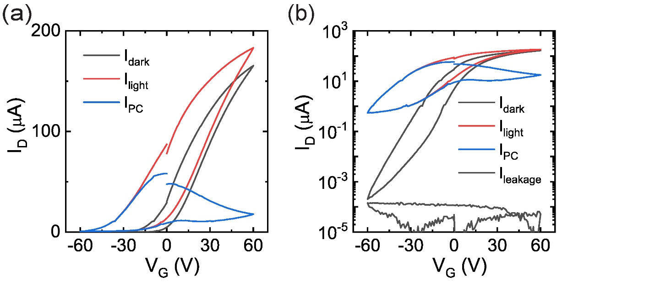
Figure S17. (a), (b) Transfer (I_{D} – V_{G}) characteristics of a SnP₂Se₆ phototransistor in dark (I_{dark}) and under illumination (I_{light}) to obtain photocurrent (I_{PC} = I_{light} – I_{dark}) at V_{D} = 5 V in linear and log scales, respectively. Illumination wavelength and intensity (P) were 515.6 nm and 56.6 mW/cm², respectively. Arrows in (b) and (c) show voltage sweep direction.

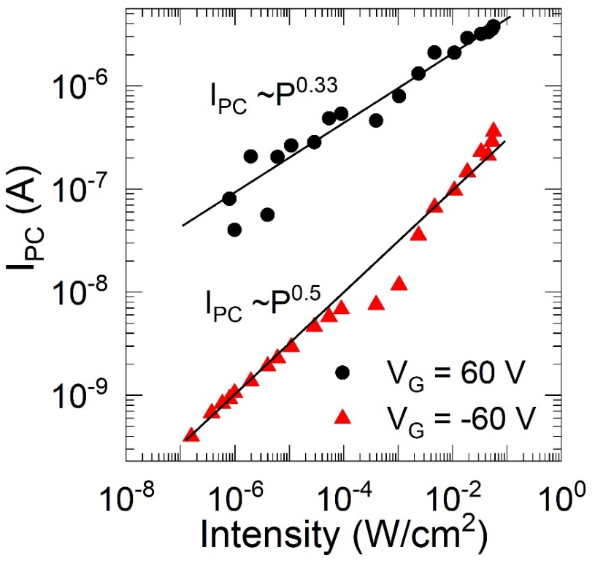
Figure S18. (a) Photocurrent (I_{PC}) versus intensity (wavelength = 515.6 nm) for a SnP₂Se₆ phototransistor at V_{D} = 1 V showing different power-law behavior for different V_{G} values. Extracted responsivity is shown in Figure 3e of the main text.

References

1. Binnewies M., Glaum R., Schmidt M. & Schmidt P. Transport of Selenides: In Chemical Vapor Transport Reactions. De Gruyter, Inc: Berlin/Boston, 2012.

2. Carpentier C. D. & Nitsche R. Vapour growth and crystal data of the thio(seleno)-hypodiphosphates Sn₂P₂S₆, Sn₂P₂Se₆, Pb₂P₂Se₆ and their mixed crystals. MRS Bull 9, 401-410 (1974).

3. Makuła P., Pacia M. & Macyk W. How to correctly determine the band gap energy of modified semiconductor photocatalysts based on UV–Vis spectra. J Phys Chem Lett 9, 6814-6817 (2018).

4. Sheldrick G. Crystal structure refinement with SHELXL. Acta Crystal Sec C 71, 3-8 (2015).

5. Perdew J. P., Burke K. & Ernzerhof M. Generalized gradient approximation made simple. Phys Rev Lett 77, 3865-3868 (1996).

6. Kresse G. & Furthmüller J. Efficient iterative schemes for ab initio total-energy calculations using a plane-wave basis set. Phys Rev B 54, 11169-11186 (1996).

7. Buscema M., et al. Large and tunable photothermoelectric effect in single-layer MoS₂. Nano Lett 13, 358-363 (2013).

8. Yuan H., et al. Generation and electric control of spin–valley-coupled circular photogalvanic current in WSe₂. Nat Nanotechnol 9, 851-857 (2014).

9. Yang M.-M., Kim D. J. & Alexe M. Flexo-photovoltaic effect. Science 360, 904-907 (2018).

10. Tauc J. Generation of an emf in semiconductors with nonequilibrium current carrier concentrations. Rev Mod Phys 29, 308-324 (1957).

11. Zhang Y. J., et al. Enhanced intrinsic photovoltaic effect in tungsten disulfide nanotubes. Nature 570, 349-353 (2019).

12. Cook A. M., M. Fregoso B., de Juan F., Coh S. & Moore J. E. Design principles for shift current photovoltaics. Nat Commun 8, 14176 (2017).

13. Fridkin V. M. Bulk photovoltaic effect in noncentrosymmetric crystals. Crystal Reports 46, 654-658 (2001).

14. Brody P. S. High voltage photovoltaic effect in barium titanate and lead titanate-lead zirconate ceramics. J Solid State Chem 12, 193-200 (1975).

15. Akamatsu T., et al. A van der Waals interface that creates in-plane polarization and a spontaneous photovoltaic effect. Science 372, 68-72 (2021).

16. Tan L. Z. & Rappe A. M. Upper limit on shift current generation in extended systems. Phys Rev B 100, 085102 (2019).

17. Generated Using SinglyCrystalTM: A Single-Crystal Diffraction Program for Mac and Windows. CrystalMaker Software Ltd, Oxford, England

