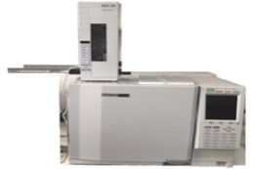
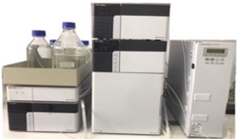
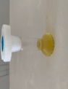
Phenolics
*Catechin
*Gallic acid
*3,4-Dihydroxybenzoic acid
*Rutin

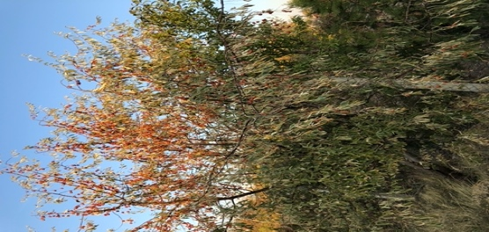
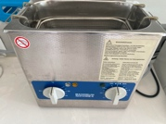
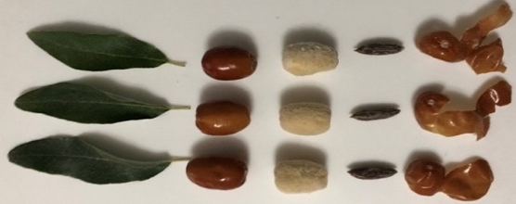
Fatty acids
*Linoleic
*Oleic
*Palmitic
*Stearic

Bioactive properties
*Carotenoid content
*Total phenolic content
*Total flavonoid content
*Antioxidant activity

Sonication Process

Graphical Abstract: In this study, it was monitored changes in bioactive properties, polyphenols, fatty acids and minerals (macro- and micro elements) in several parts (leaf, peel, flesh and seeds) of oleaester pleans.

