Appendix
Appendix Table 1. Abbreviations and expanded names of 76 brain regions in primate connectome. These regions are bilateral, and thus, there are only 38 listed because there are each of these regions in both the left and right hemispheres.

Abbreviation | Region
A1 | primary auditory cortex
A2 | secondary auditory cortex
AMYG | amygdala
CCA | cingulate cortex anterior
CCP | cingulate cortex posterior
CCR | cingulate cortex retrosplenialis
CCS | cingulate cortex subgenualis
FEF | frontal eye field
G | gustatory cortex
HC | hippocampal cortex
IA | insula anterior
IP | insula posterior
M1 | primary motor cortex
PCI | parietal cortex inferior
PCIP | parietal cortex intraparietal sulcus
PCM | parietal cortex medial
PCS | parietal cortex superior
PFCCL | prefrontal cortex centrolateral
PFCDL | prefrontal cortex dorsolateral
PFCDM | prefrontal cortex dorsomedial
PFCM | prefrontal cortex medial
PFCORB | prefrontal cortex orbital
PFCPOL | prefrontal cortex pole
PFCVL | prefrontal cortex ventrolateral
PHC | parahippocampal cortex
PMCDL | premotor cortex dorsolateral
PMCM | premotor cortex medial (supplementary motor cortex)
PMCVL | premotor cortex ventrolateral
S1 | primary somatosensory cortex
S2 | secondary somatosensory cortex
TCC | temporal cortex central
TCI | temporal cortex inferior
TCPOL | temporal cortex pole
TCS | temporal cortex superior
TCV | temporal cortex ventral
V1 | primary visual cortex
V2 | secondary visual cortex
CC | ---
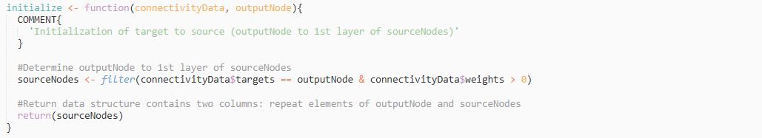
Appendix Figure 1. Pseudocode for initialization function of modularity algorithm. This method unpacks the connectome from the output node (M1), identifying all of its source nodes.
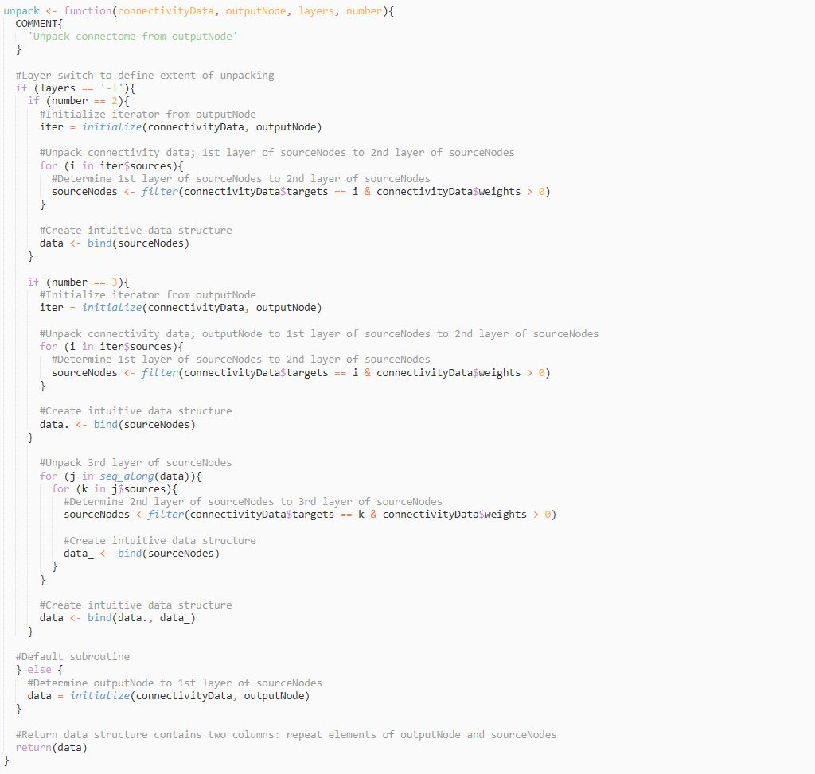
Appendix Figure 2. Pseudocode for unpacking function of modularity algorithm. This method initializes the algorithm and further unpacks the connectome dependent on the desired depth of unpacking.
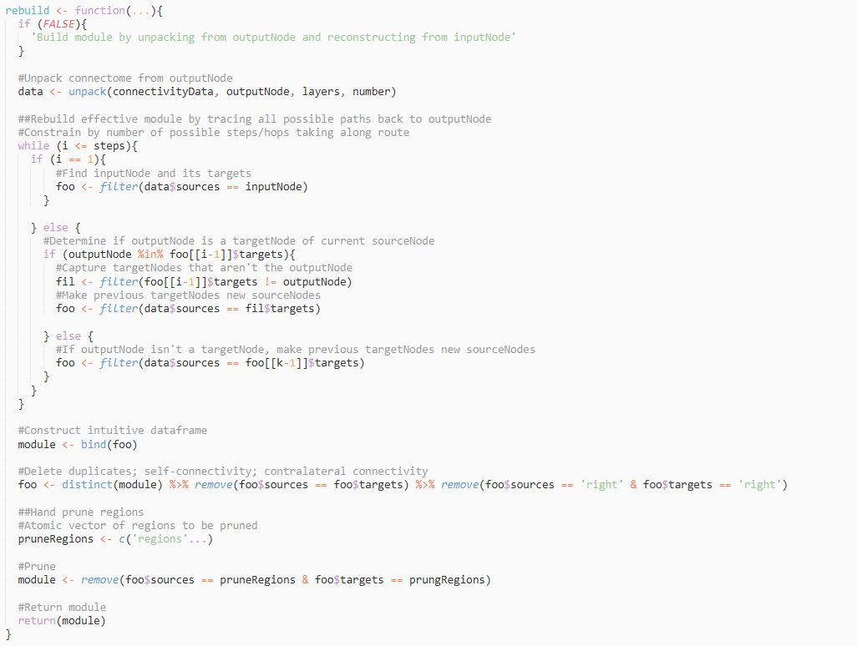
Appendix Figure 3. Pseudocode for rebuilding function of modularity algorithm. This method unpacks the connectome, and from the input node (V1), traces all possible paths back to the output node. This portion of the modularity algorithm is self-constrained by only considering the input node from the final layer of unpacking, further constrained by the number of steps the algorithm can take along the followed paths.

