SUPPLEMENTARY INFORMATION
Insights into the enumeration of mixtures of probiotic bacteria by flow cytometry

Harry Tracey, Niall Coates, Eleri Hulme, Daniel John, Daryn Robert Michael and Susan Frances Plummer

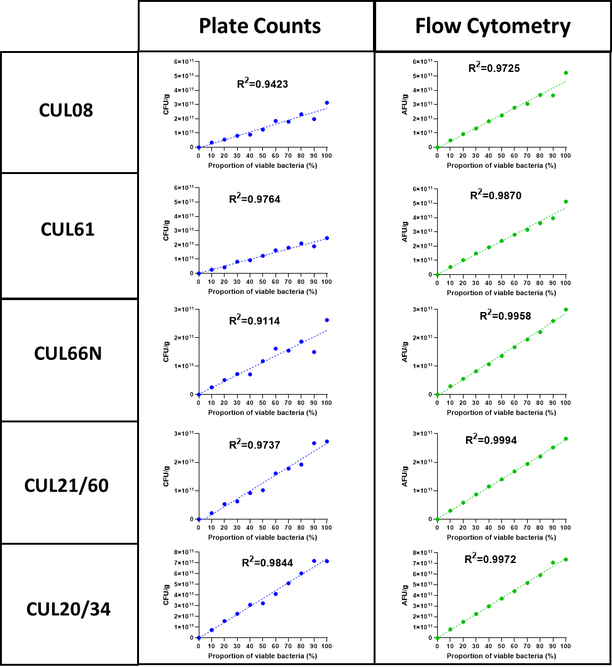

Supplementary Figure S1. Accuracy of FC and PC methods. Viable bacteria were mixed with ethanol killed bacteria (exposed to 70% ethanol for 15 minutes at room temperature) in proportions ranging between 0 and 100%. The numbers of viable bacteria present within each mixture were quantified by plate count and flow cytometry and the data analysed by linear regression with R² values as stated. The data represents the mean of duplicate samples from a single experiment. Abbreviations: CFU, colony forming units; AFU, active fluorescent units.
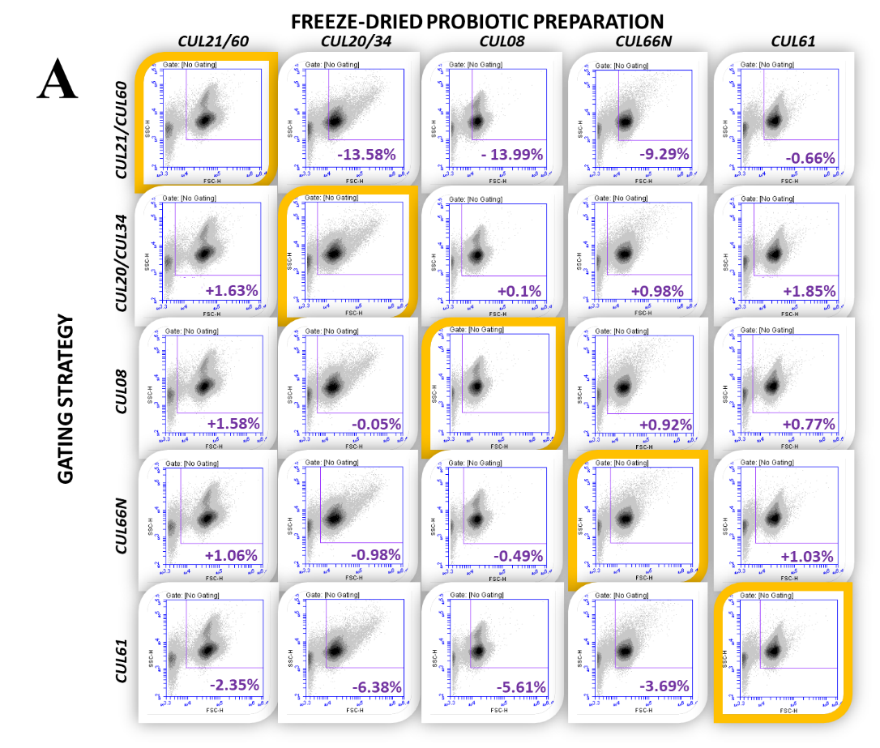
CUL61
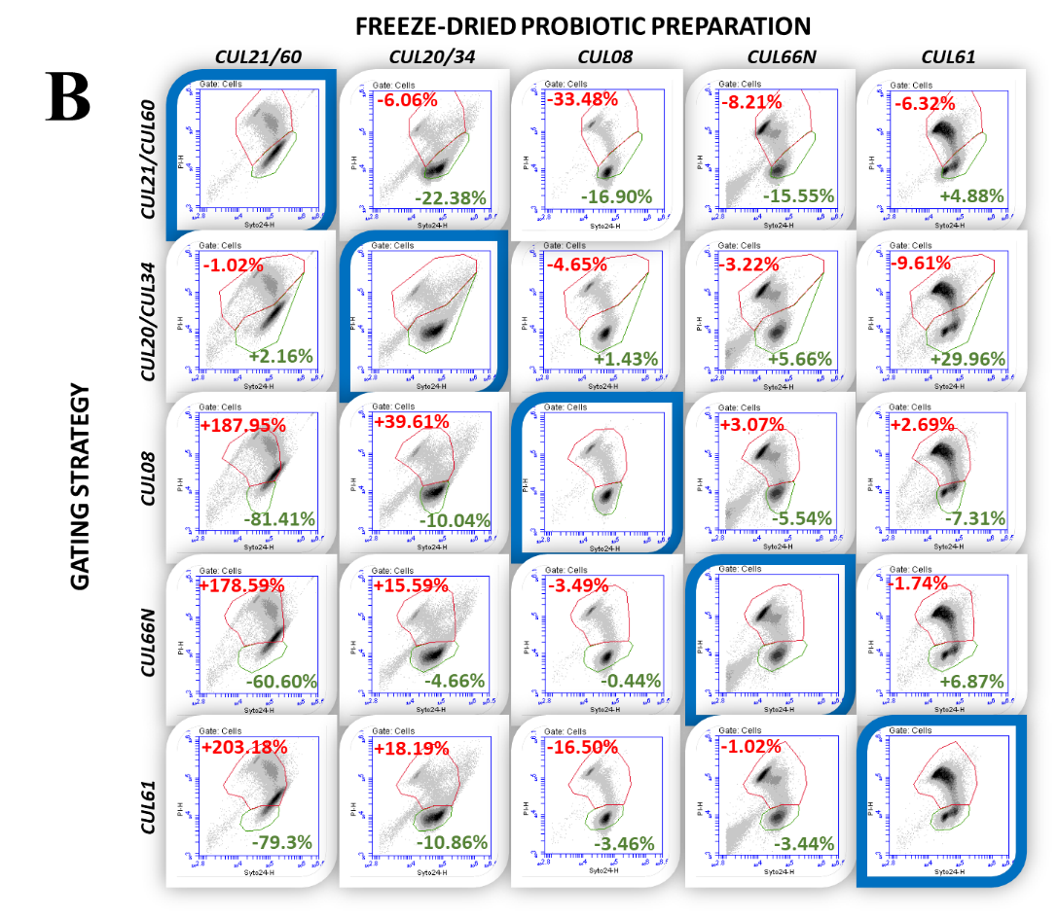
Supplementary Figure S2. Specificity of specific gating strategy. Matrices of (A) forward/side scatter and (B) green/red fluorescence flow cytometric multi-parameter dot plots of each freeze-dried probiotic preparation (FDPP) overlaid with the FDPP specific gating strategies. FDPP overlaid with the appropriate gating strategy are highlighted. Values represent enumeration of: cells (A), AFU and n-AFU (B) compared to the appropriate gating.

