Supporting Information

Demonstration of solute-specific synergism in binary solvents

Fig.S.1(a)-(b) Absorption spectra of RhB and Rh101 in MeOH+DMF with different mole fractions of MeOH(X_{MeOH} = 0.0,0.1,0.2,0.3,0.4, 0.5,0.6,0.7,0.8,0.9,1.0).

Fig.S.2 Variation of Absorption peak [e*(10-4M)*(0.1cm)] of Rh and Rh101 in MeOH+DMF with the volume fractions of MeOH(X_{MeOH} = 0.0,0.1,0.2,0.3,0.4, 0.5,0.6,0.7,0.8,0.9,1.0).

Fig.S.3 Variation of Absorption maxima of RhB and Rh101 in MeOH+DMF with the volume fractions of MeOH(X_{MeOH} = 0.0,0.1,0.2,0.3,0.4, 0.5,0.6,0.7,0.8,0.9,1.0).

Fig.S.4 Variation of Absorption molar electronic energy E_{T} of RhB and Rh101 in MeOH+DMF binary solvent mixture with a fraction of methanol.

Fig.S.5(a)-(b) Normalized emission spectra of RhB and Rh101 in MeOH+DMF binary solvent with different mole fractions of MeOH(XMeOH= 0.00,0.1,0.2,0.3,0.4 0.5,0.6,0.7,0.8,0.9,1.0).The excitation wavelength was 500 nm

Fig.S.6 Variation of Integrated Area of emission normalized by Absorption(D) with the volume fractions of methanol in MeOH+DMF binary solvent mixture.

Table.1.Optimized Geometry,dipole moment and energy gap of RhB and Rh101 using Gaussion 09 program basis set B3LYP/6-311 level.
Compound | Dipole moment  (Debye) | Total Energy (a.u) | HOMO (a.u) | LUMO (a.u) | Energy Gap
Rhodamine 101 | 7.0186 | -1572.281 | 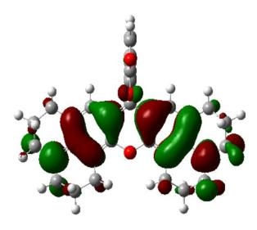--0.17697  (4.82eV) | 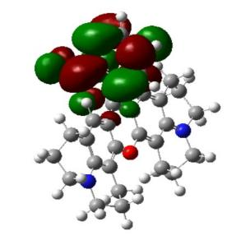-0.04016  (1.09eV) | 0.13681  (3.72eV)
Rhodamine B | 17.3642 | -1880.645 | 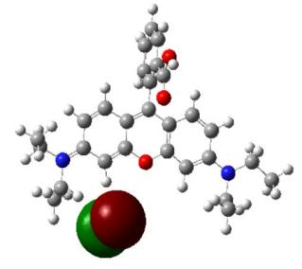  -0.13044  (3.55eV) | 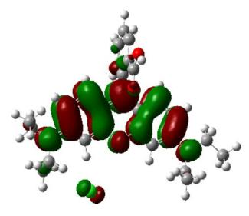-0.10185  (2.77eV) | 0.02859  (2.64eV)

