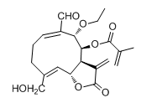
Supplementary Fig. 1. The chemical structure of So-2.
The compound SO-2 was identified as (1(10)E,4Z,6α,8β,9α)-9-ethoxy-6,15-dihydroxy-8-(2-methylacryloxy)-14-oxogermacra-1(10),4,11(13)-trieno-12,6-lactone (SO-2) based on the comparison of NMR data with reported values [1].

Supplementary Fig. 2. ¹H NMR spectrum (600 MHz) of SO-2 in CDCl₃.
Supplementary Fig. 3. ¹³C NMR spectrum of SO-2 in CDCl₃.

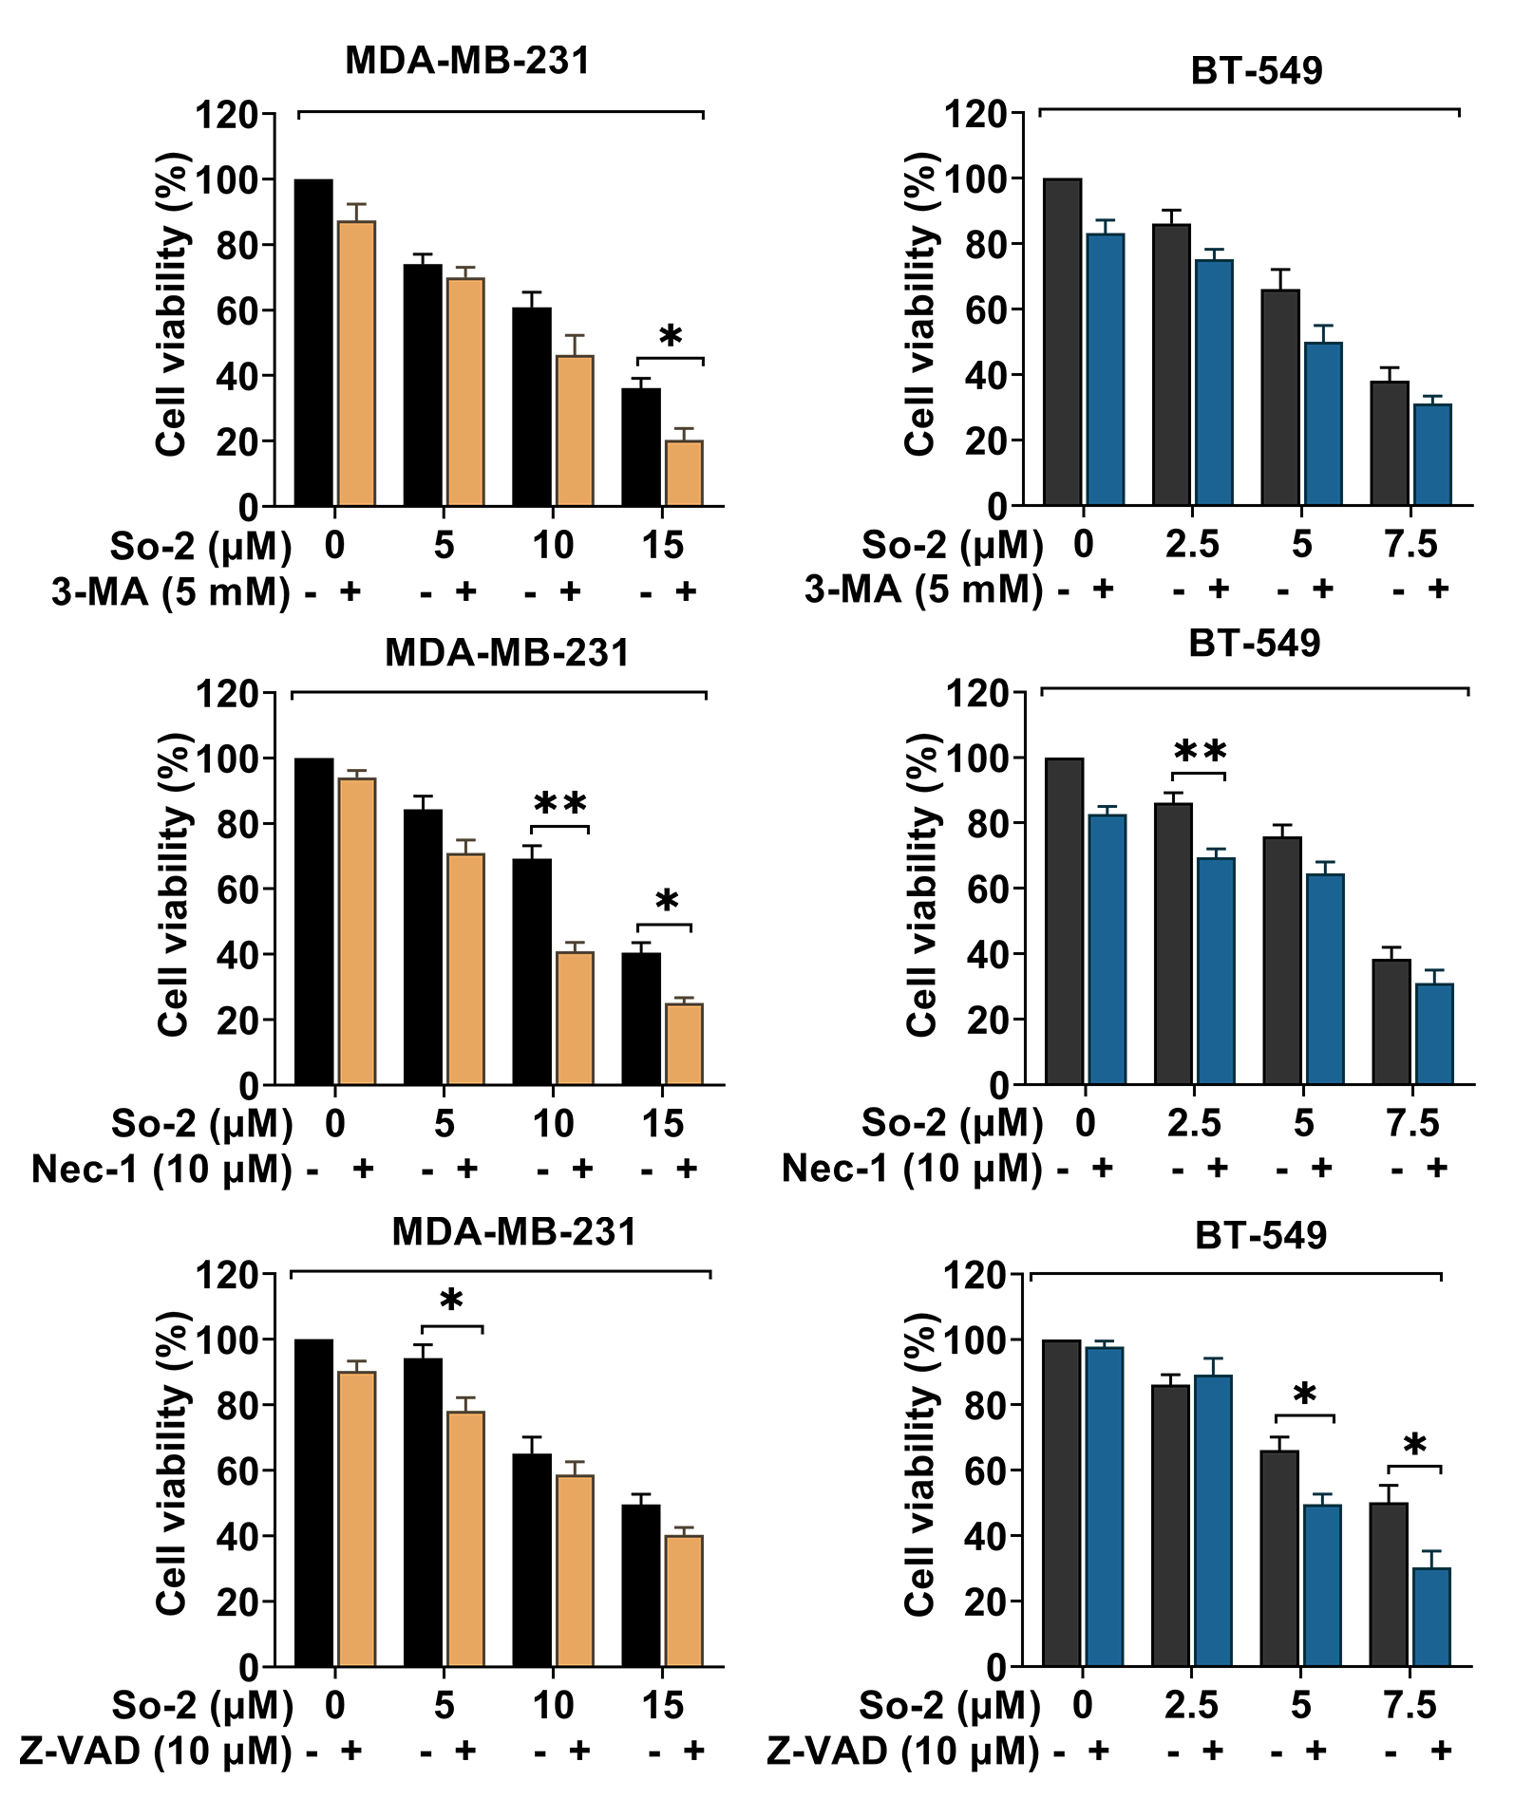
Supplementary Fig. 4. Z-VAD-FMK, 3-Methyladenine, or necrostatin-1 did not protect against So-2 induced cell death in these cells.

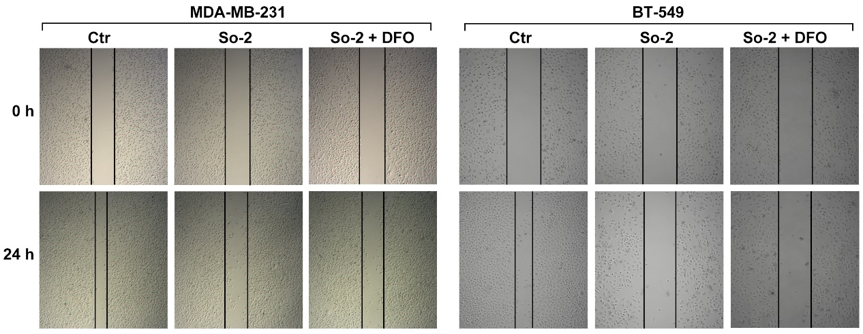
Supplementary Fig. 5. Ferrostatin-1 and deferoxamine protected So-2-induced migration.

Reference:
[1] R. Wang, L.L. Liu, Y.P. Shi, Pubescone, A Novel 11(76) Abeo-14-norcarabrane Sesquiterpenoid from Siegesbeckia pubescens, Helv. Chim. Acta 93 (2010) 2081–2085.

