Content
Figure S1. Sensitive analysis of significant causal relationships of food intake on microbiome. 2
Figure S2. Sensitive analysis of significant causal relationships of microbiome on food intake. 3
Figure S3. Sensitive analysis of significant causal relationships of telomere length on food intake. 4
Figure S4. Sensitive analysis of significant causal relationships of telomere length on microbiome. 5
Figure S5. Sensitive analysis of significant causal relationships of food intake on telomere length. 6
Figure S6. Sensitive analysis of significant causal relationships of microbiome on telomere length. 7
Figure S7. GO enrichment analysis of telomere length and G_Sutterella (gene ratio and pvalue). 8
Figure S8. GO enrichment analysis of telomere length and G_Sutterella (gene). 8
Figure S9. GO enrichment analysis of glasses of water per day and G_Barnesiella (gene ratio and pvalue). 9
Figure S10. GO enrichment analysis of glasses of water per day and G_Barnesiella (gene). 10
Figure S11. GO enrichment analysis of glasses of overall alcohol intake and G_unclasssified_K_Bacteria (gene ratio and pvalue). 11
Figure S12. GO enrichment analysis of overall alcohol intake and G_unclasssified_K_Bacteria (gene). 12
Figure S13. GO enrichment analysis of glasses of overall processed meant intake and F_Desulfovibrionaceae (gene ratio and pvalue). 13
Figure S14. GO enrichment analysis of overall processed meant intake and F_Desulfovibrionaceae (gene). 14
Figure S15. GO enrichment analysis of glasses of overall processed meant intake and F_Desulfovibrionaceae (gene ratio and pvalue). 15
Figure S16. GO enrichment analysis of pieces of dries fruit per day and G_Barnesiella (gene). 16
Figure S17. GO enrichment analysis of slices of bread per week and G_unclassified_F_Prevotellaceae (gene ratio and pvalue). 17
Figure S18. GO enrichment analysis of slices of bread per week and G_unclassified_F_Prevotellaceae (gene). 18

Figure S1. Sensitive analysis of significant causal relationships of food intake on microbiome.

Figure S2. Sensitive analysis of significant causal relationships of microbiome on food intake.

Figure S3. Sensitive analysis of significant causal relationships of telomere length on food intake.

Figure S4. Sensitive analysis of significant causal relationships of telomere length on microbiome.

Figure S5. Sensitive analysis of significant causal relationships of food intake on telomere length.

Figure S6. Sensitive analysis of significant causal relationships of microbiome on telomere length.

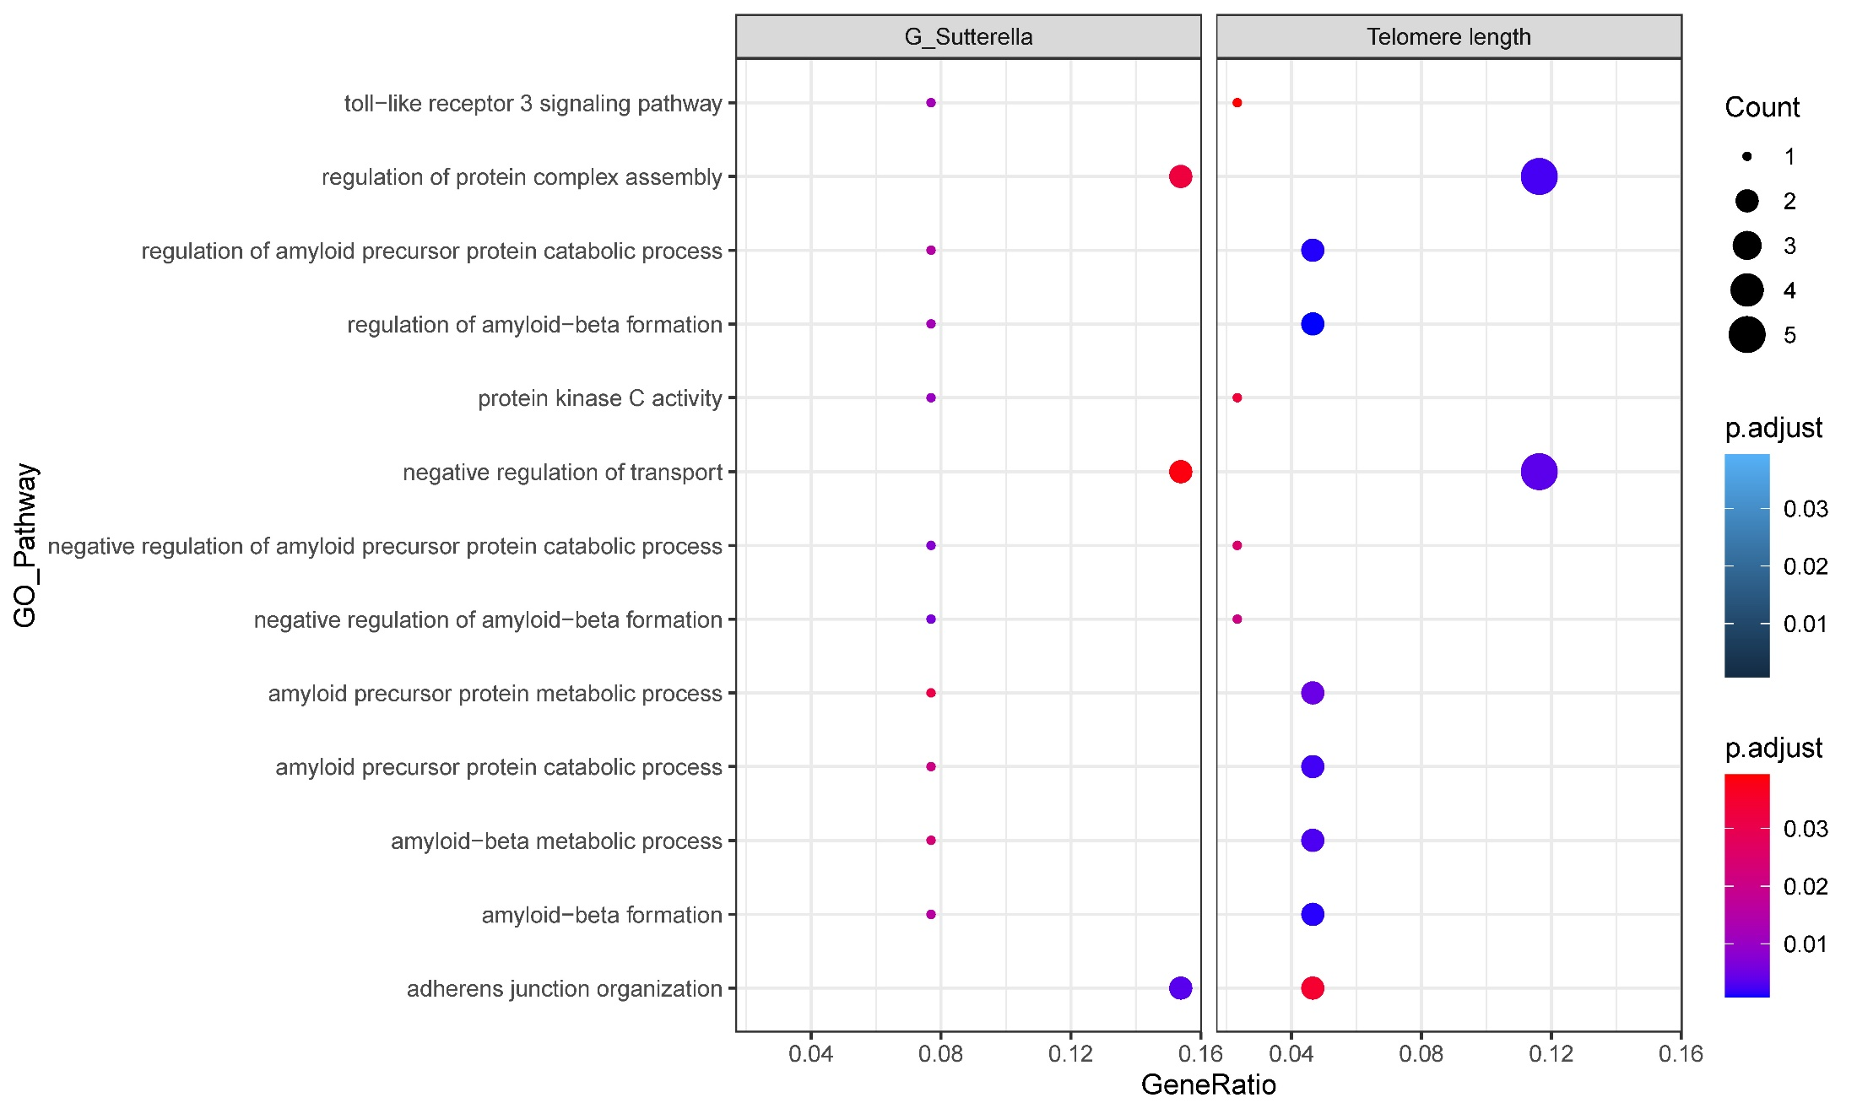

Figure S7. GO enrichment analysis of telomere length and G_Sutterella (gene ratio and pvalue).

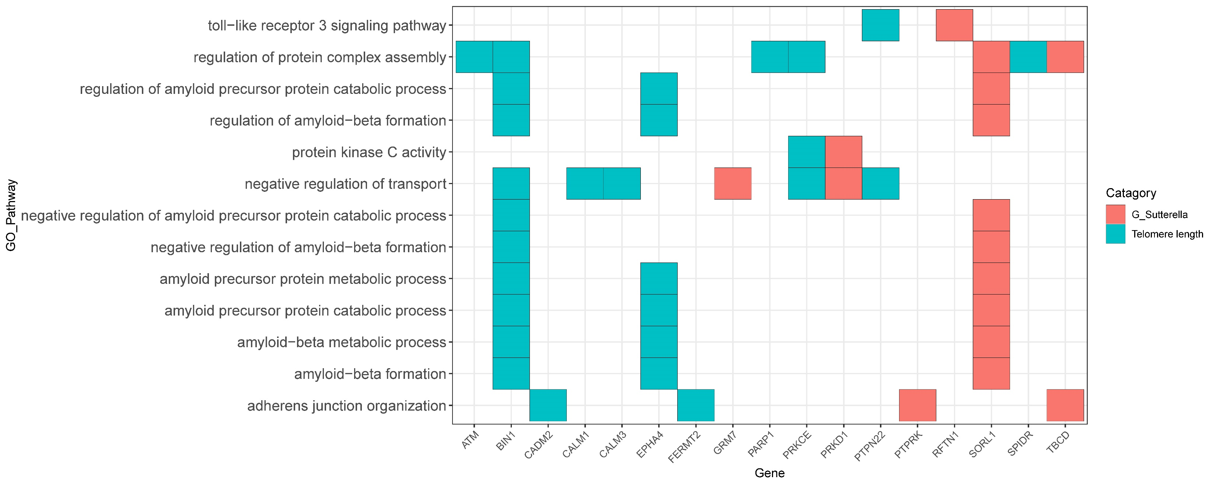

Figure S8. GO enrichment analysis of telomere length and G_Sutterella (gene).

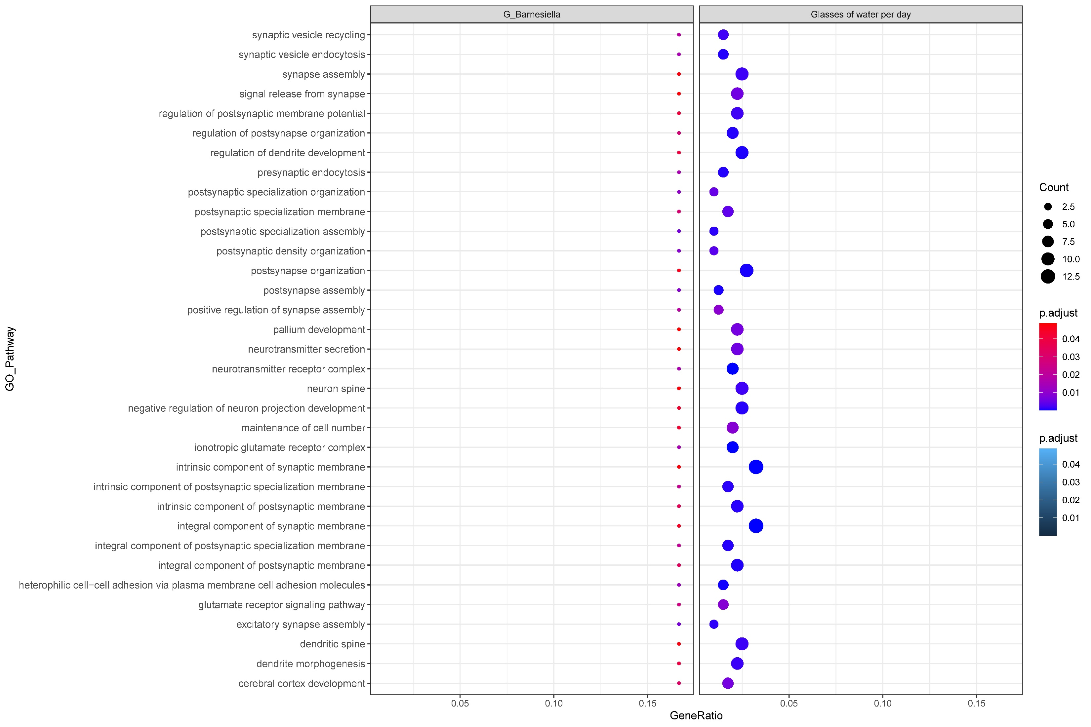

Figure S9. GO enrichment analysis of glasses of water per day and G_Barnesiella (gene ratio and pvalue).

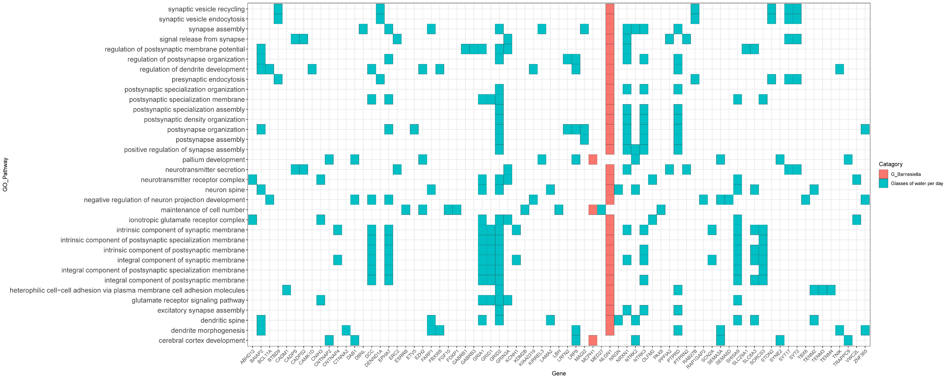

Figure S10. GO enrichment analysis of glasses of water per day and G_Barnesiella (gene).

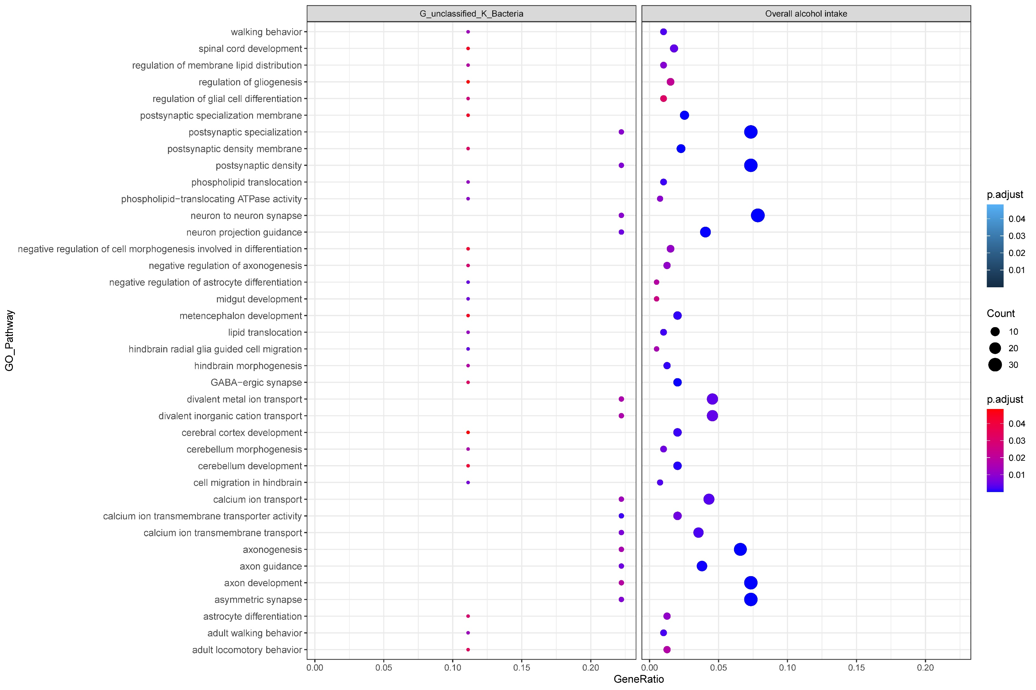

Figure S11. GO enrichment analysis of overall alcohol intake and G_unclasssified_K_Bacteria (gene ratio and pvalue).

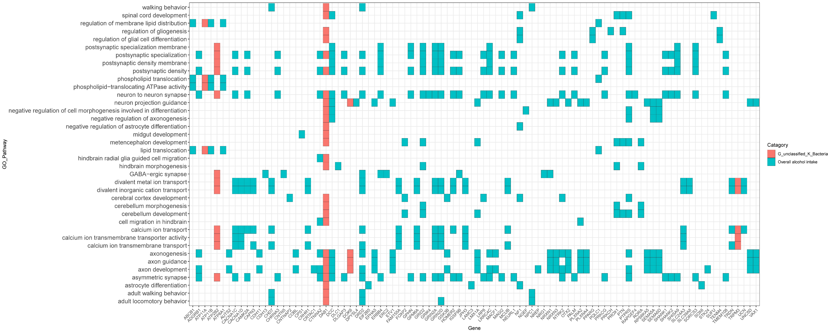

Figure S12. GO enrichment analysis of overall alcohol intake and G_unclasssified_K_Bacteria (gene).

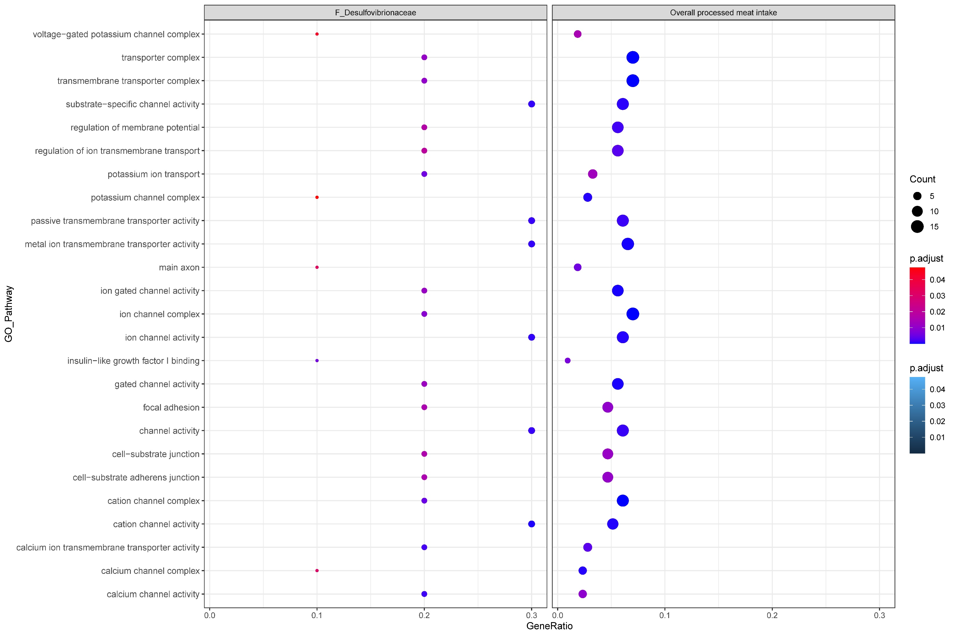

Figure S13. GO enrichment analysis of overall processed meant intake and F_Desulfovibrionaceae (gene ratio and pvalue).

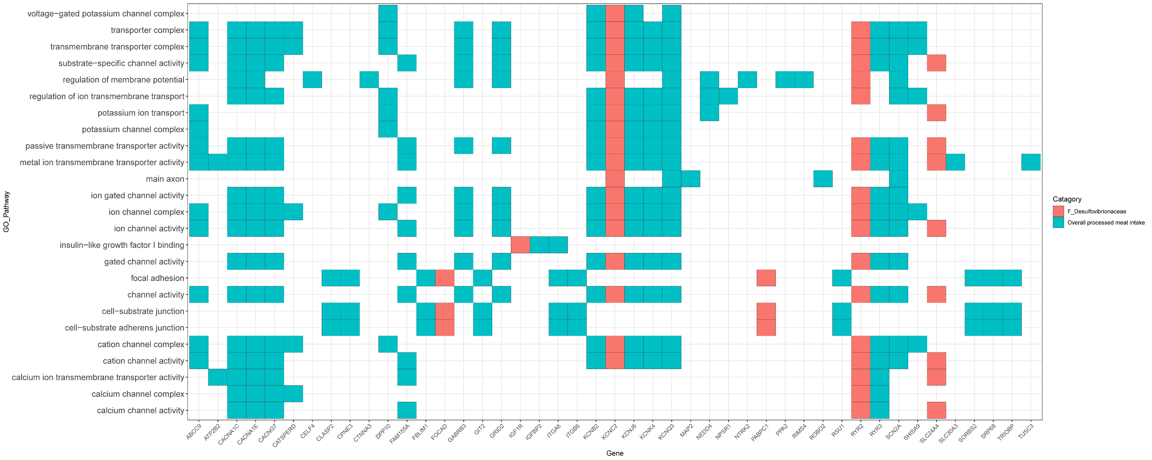

Figure S14. GO enrichment analysis of overall processed meant intake and F_Desulfovibrionaceae (gene).

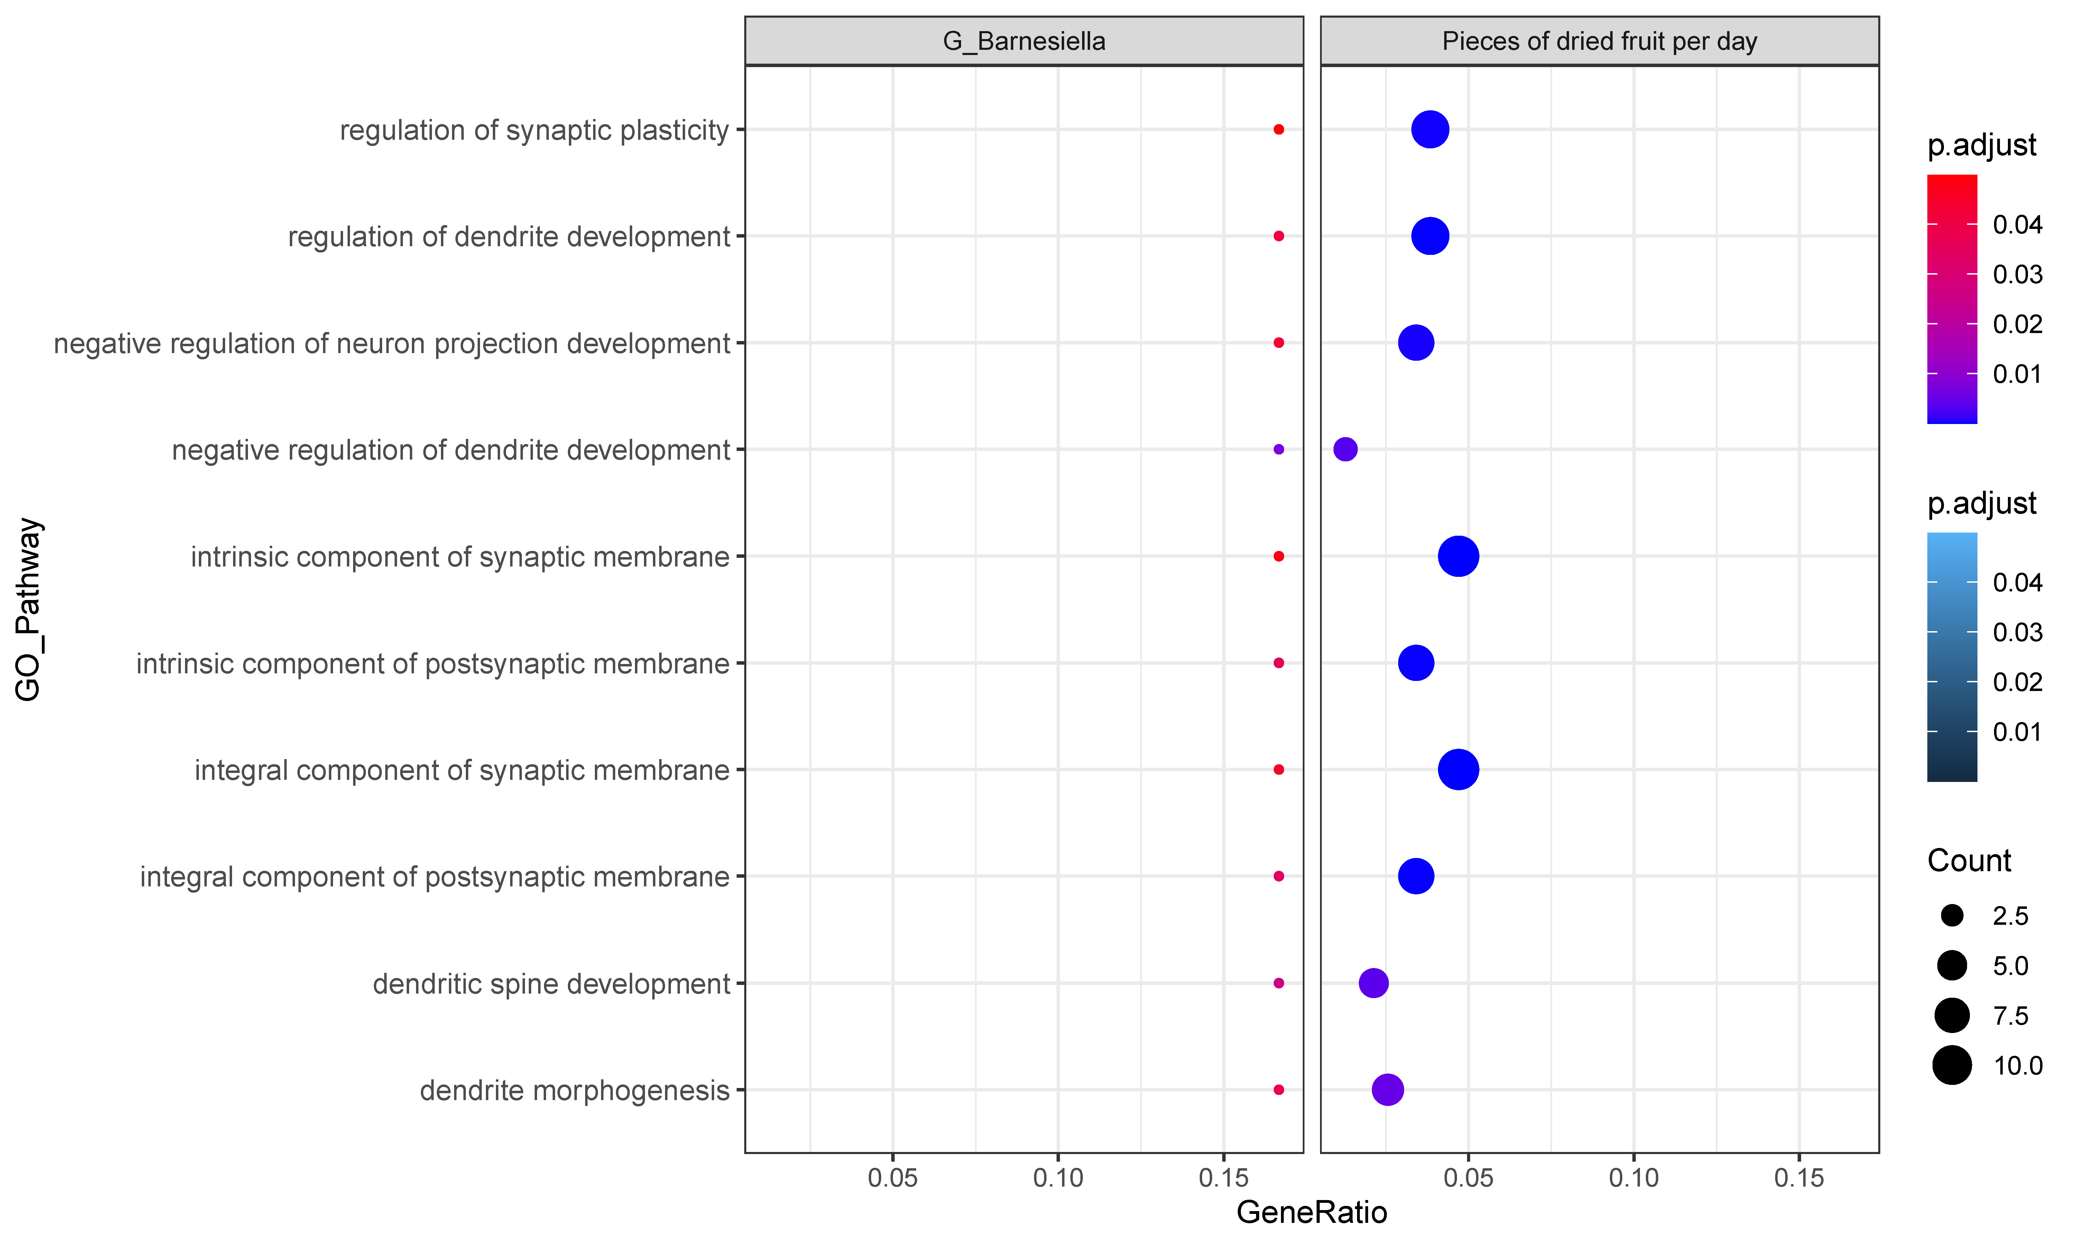

Figure S15. GO enrichment analysis of overall processed meant intake and F_Desulfovibrionaceae (gene ratio and pvalue).

Figure S16. GO enrichment analysis of pieces of dries fruit per day and G_Barnesiella (gene).

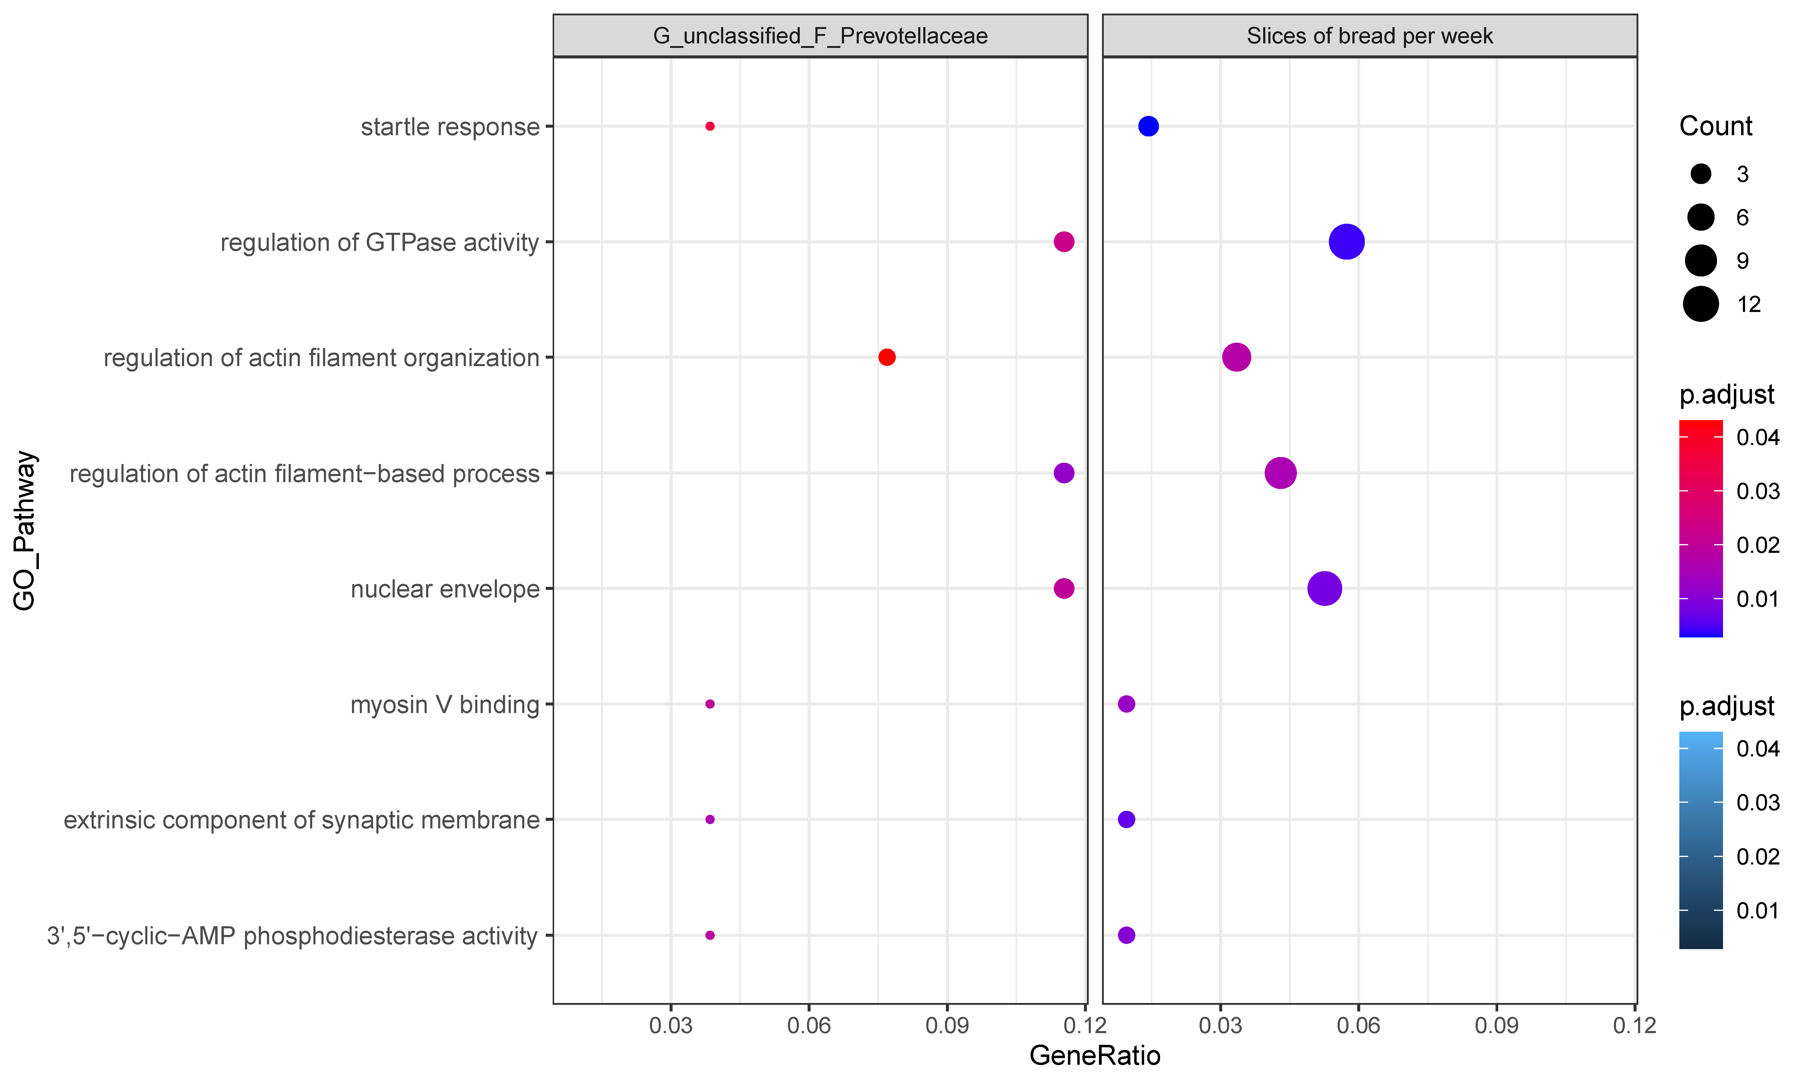

Figure S17. GO enrichment analysis of slices of bread per week and G_unclassified_F_Prevotellaceae (gene ratio and pvalue).

Figure S18. GO enrichment analysis of slices of bread per week and G_unclassified_F_Prevotellaceae (gene).

