Graphical Abstract

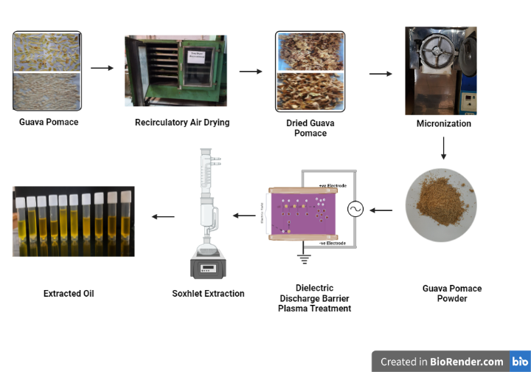
Schematic representation of DBDA plasma assisted solvent extraction of PT-GPP oil

