Table 3 Brief description of studied parameters for spatio-temporal analysis
Sr. No. | Study Parameters | Illustrative diagram | Descriptions | Sources
1. | Average Rainfall in the year | 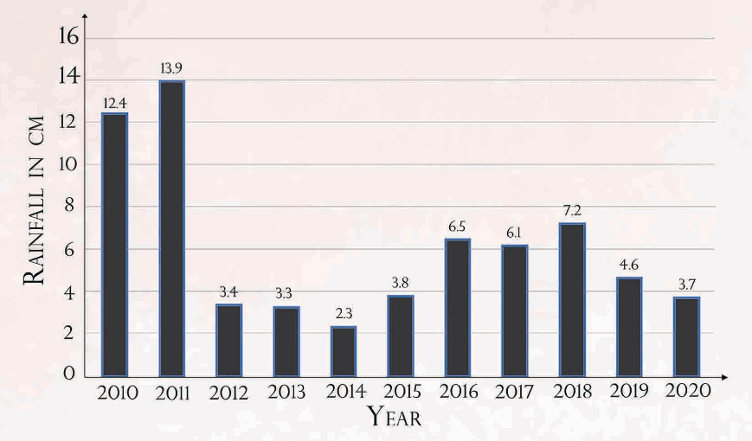 | The average yearly rainfall over a period of last 30 years come to 663.9 mm, which is quite moderate. The actual rainfall over a period in 2021 come to 713.0 mm, 30.8%.
2. | Average Depth of Ground water | 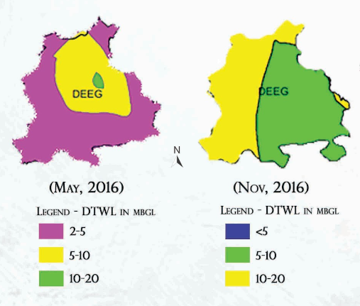 | Average depth to ground water level is changes during monsoon and non-monsoon at different region in the Deeg city as shown in the figure.
3. | Digital Elevation Model (DEM) | 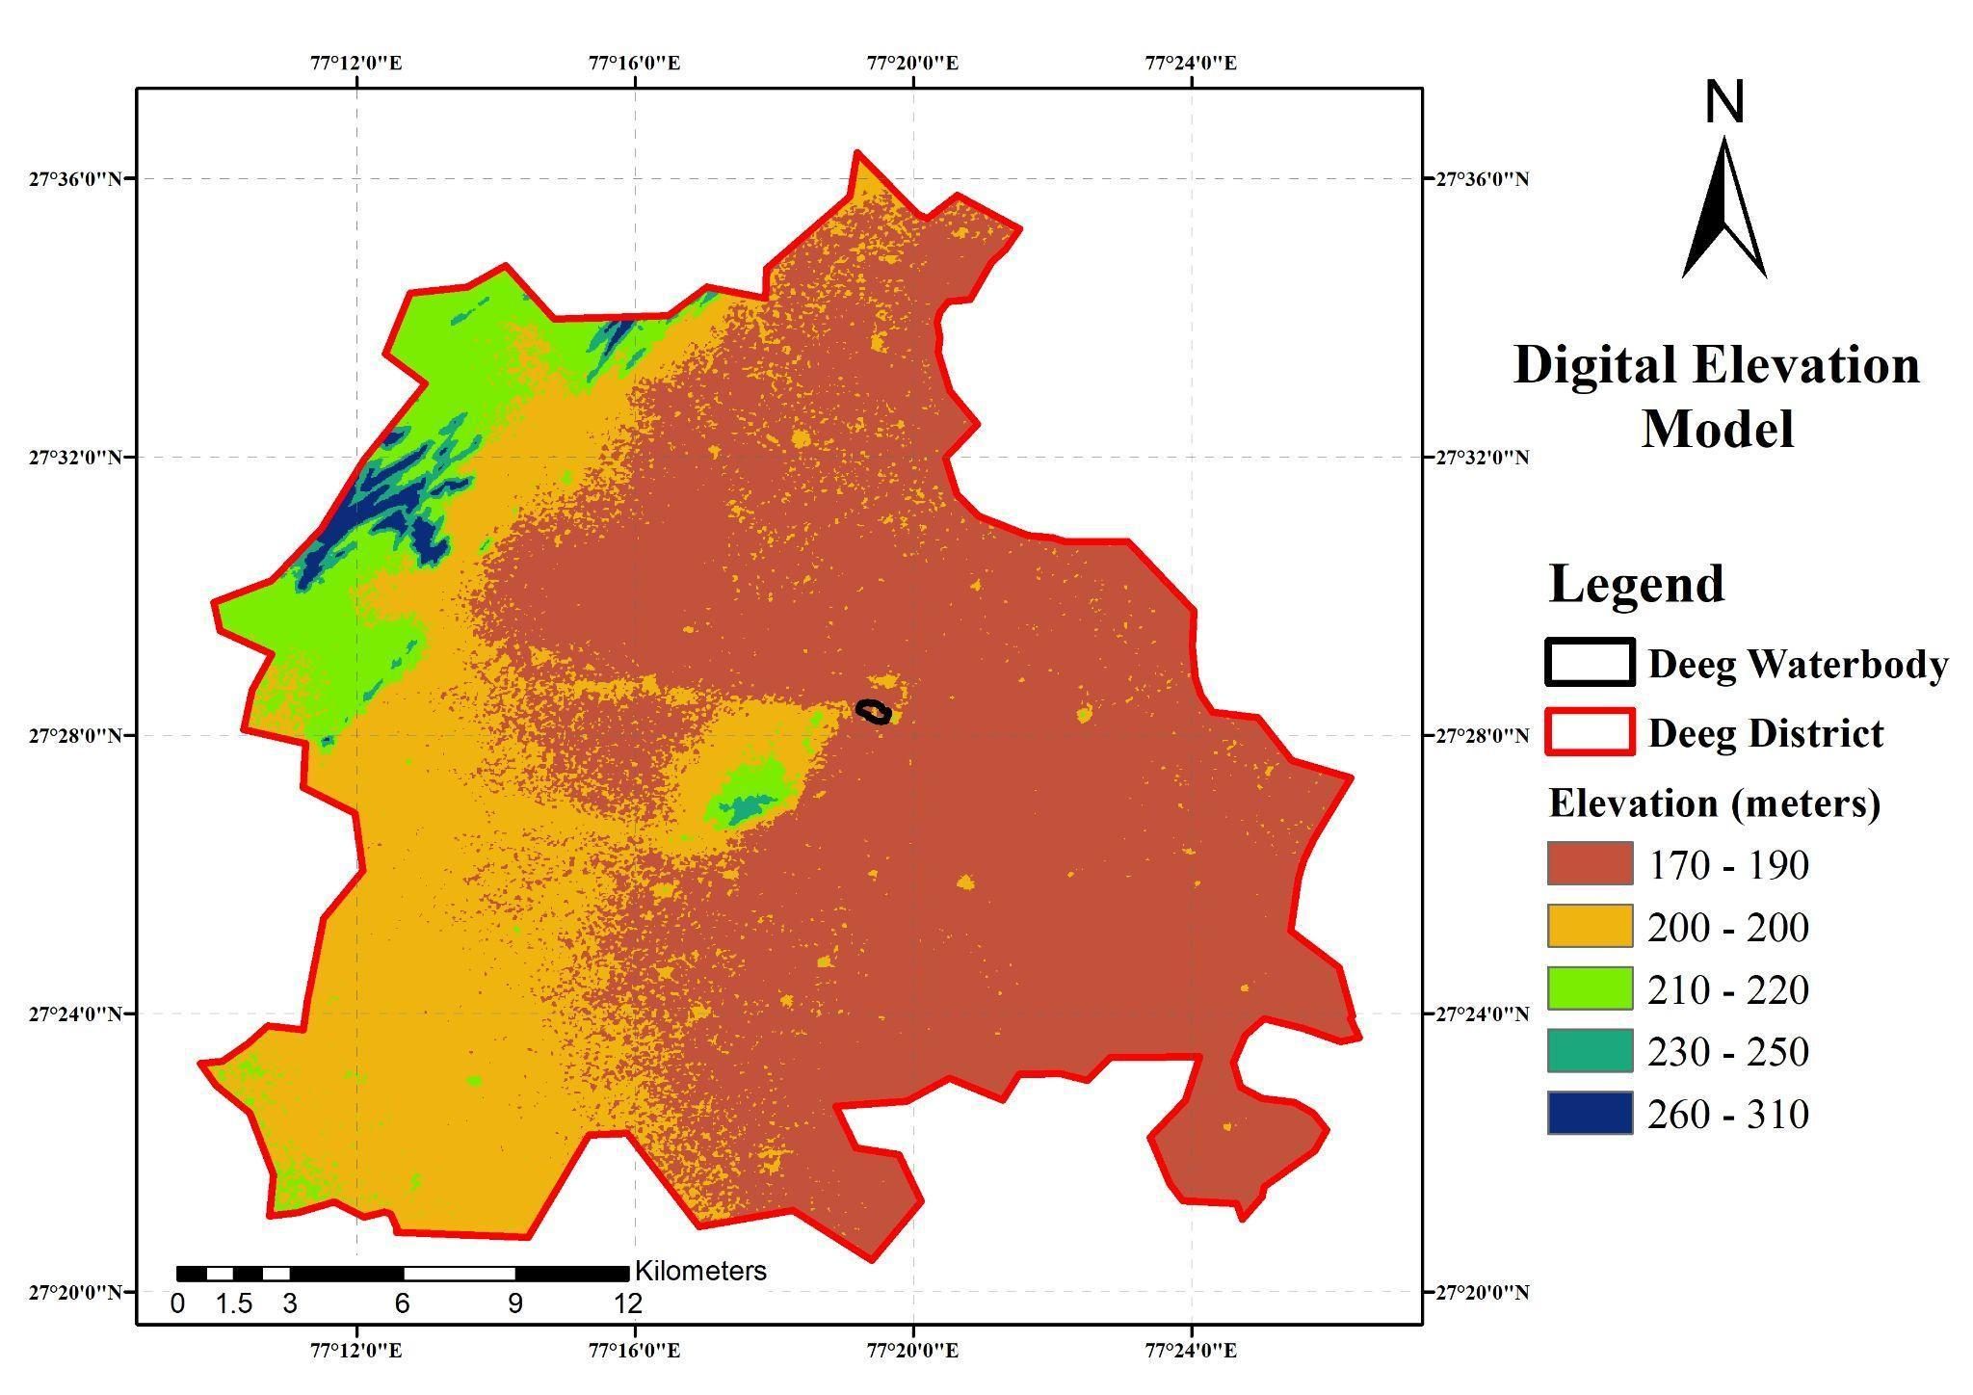 | DEM data contain Elevation of the Deeg district ranging from 170-310 meters from mean sea level (MSL).
4. | Elevation map of Gopal Sagar | 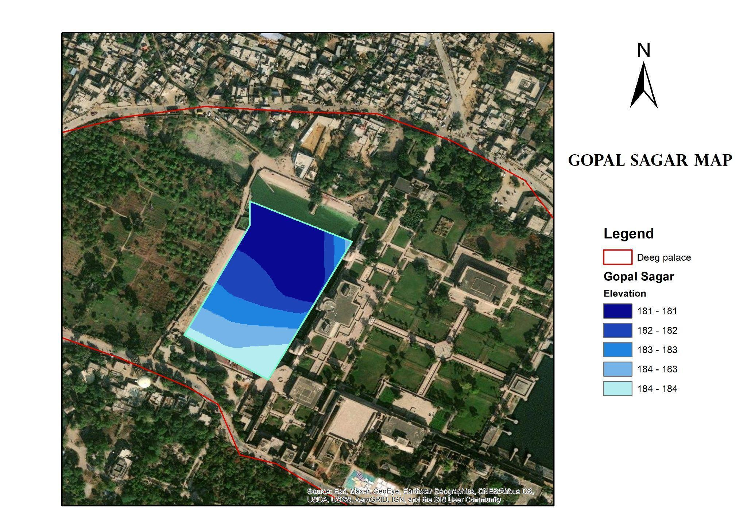 | The elevation of Gopal Sagar ranges from 178m to 183m as shown in the contour map. | Google Earth and GIS
5. | Elevation map of Roop Sagar | 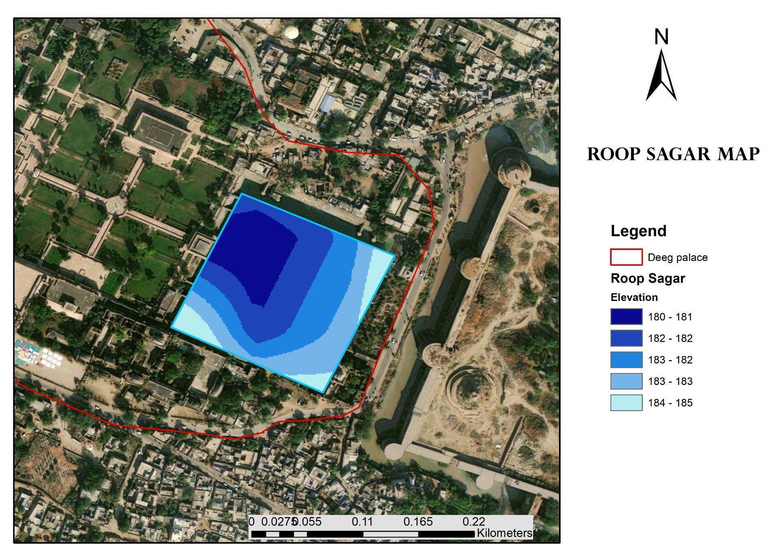 | The elevation of Roop Sagar shown in the contour map. | Google Earth and GIS
6. | Watershed Map | 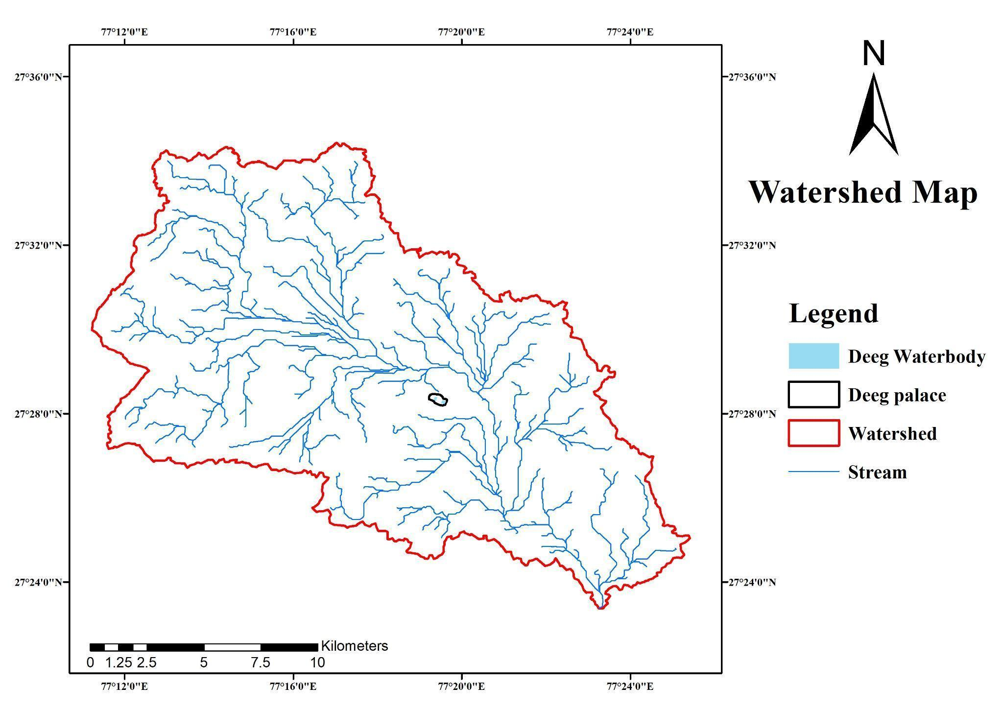 | A stream order can be derived from flow direction and it shows the section of stream network flowing into the water bodies of Deeg Palace. | GIS
7. | Land Use Land Cover | 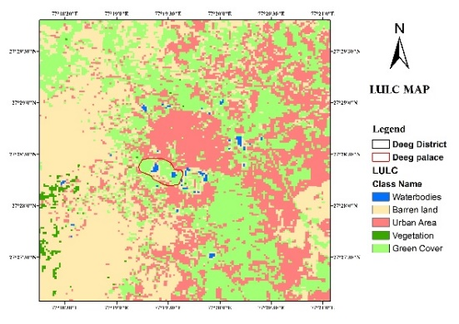 | The LULC map covers the area of built-up, Barren land, vegetation, water body and green cover around the Deeg Palace. Due to built-up area around the waterbody the contamination of water takes place. | LANDSAT Imagery- GIS Processing
8. | Urban Growth of Deeg City | 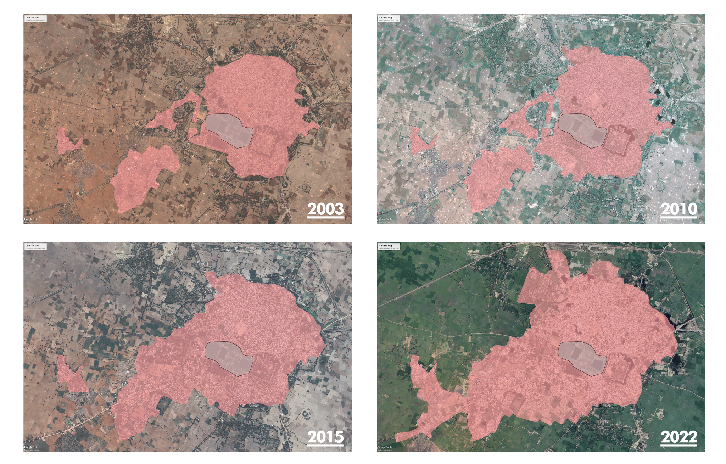 | Urban growth expansion of Deeg city is represented by Google earth photos of respective 10 years. In the recent years the city tends to grow further in the south-west direction along the urban fabric. | Google Earth
9. | Waterbody variation over time | 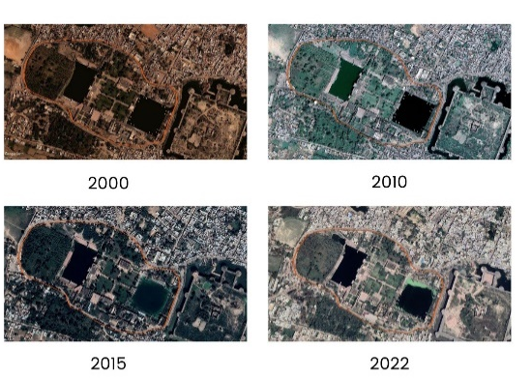 | The water quality of Roop Sagar is degraded years by years as can be seen from Google earth imagery. The water quality of Gopal Sagar somewhat remained same throughout the years. | Google Earth
10. | Spatio-temporal utility in a day | 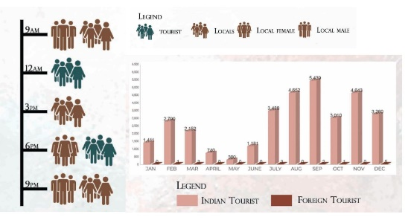 | The tourist footfall at forenoon and evening. Annually, most tourist from all around the district and neighboring areas during the festivals in march and august. | Tourist Data from Primary Survey

Table 5 Issues and Challenges associated with Gopal Sagar and Roop Sagar
S.No. | ISSUES | CHALLENGES | SOLUTIONS
1. | Sewage disposal in water body- Gopal Sagar  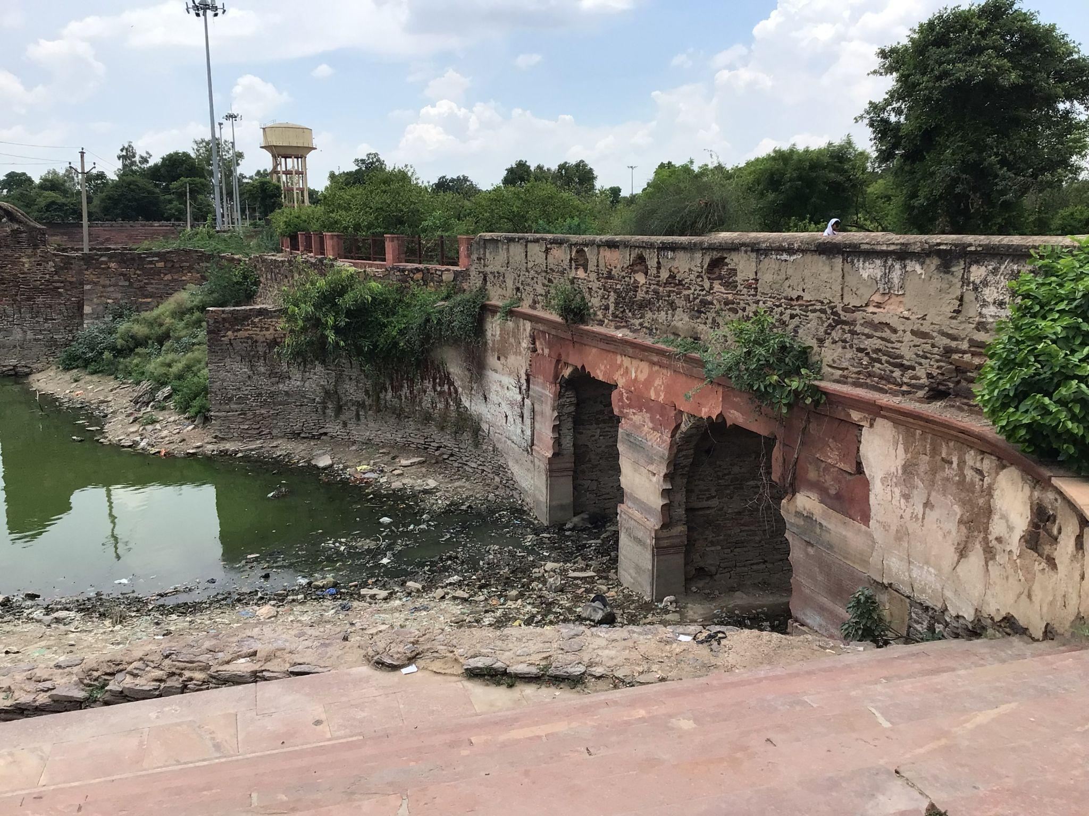  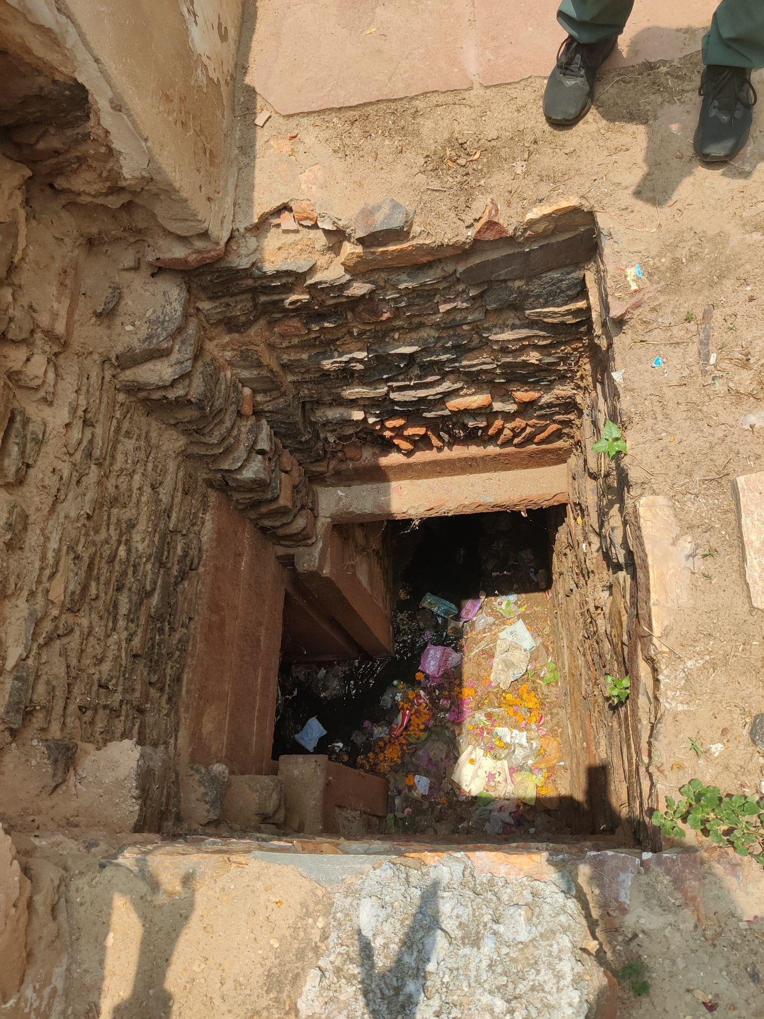 | 1)No separate channels  2)Open drainage system  3)Bad sewage management system in the town  4)Lack of awareness about waste management and hygiene amongst people in the town  5)Lack of awareness of municipality for cleanliness  6)Absence of regulation of regulation bodies. | 1)Closed drains  2)Setting up STPs  3)Creating awareness  4)A good sewage and waste management system in the town  5)Separating waste from water before it gets stuck in outlets  6)Plastic Ban
2. | People bathing in water  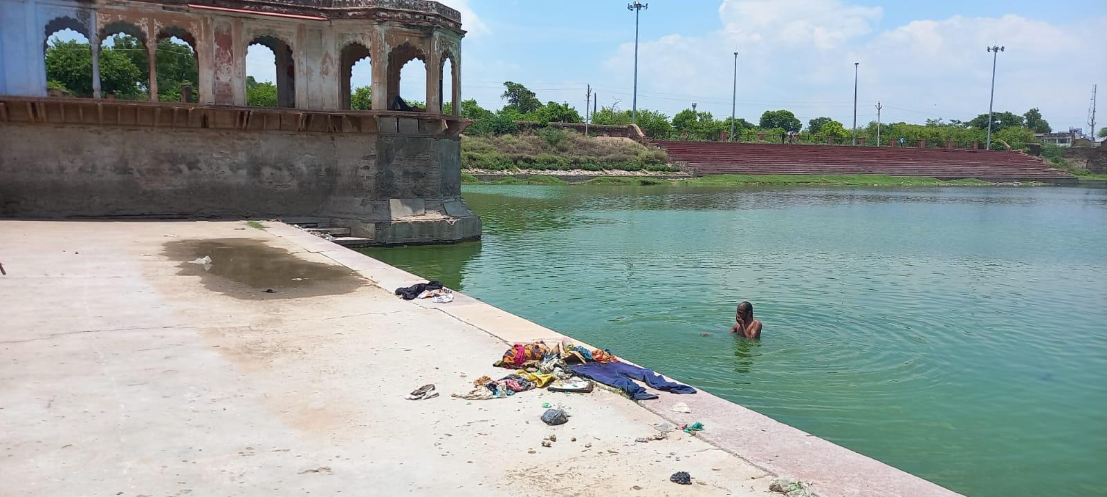  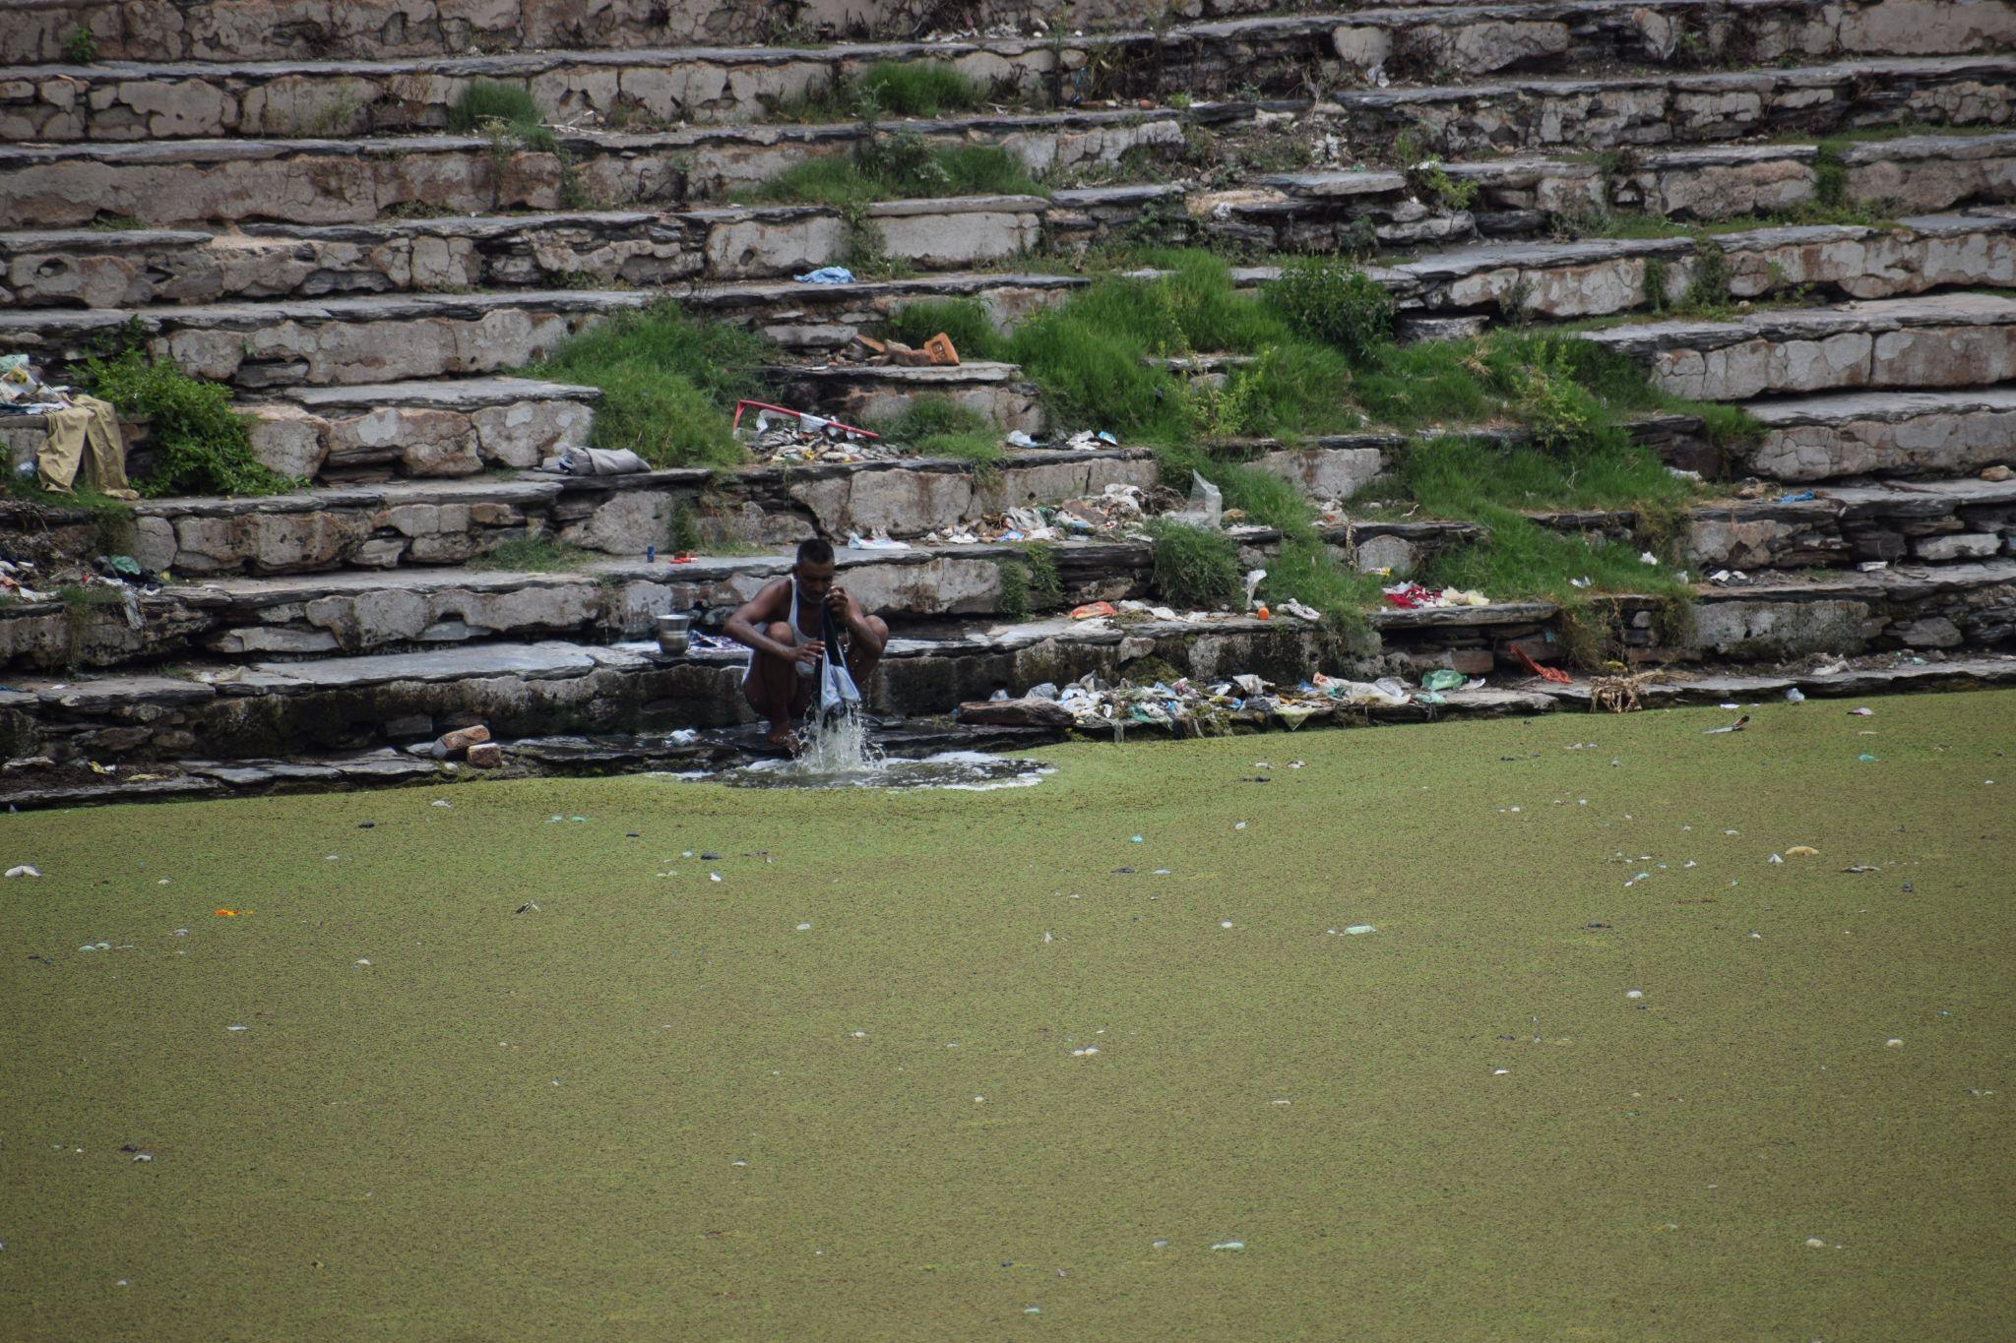 | 1)Lack of water supply in town  2)Beliefs of people  3)Lack of public washrooms | 1)Creating a secluded space within the waterbody in order to separate zones for public usage for the locals.  2)Knowing their beliefs and finding them a new place  3)Providing more public toilets
3. | Overgrown vegetation on the stairs  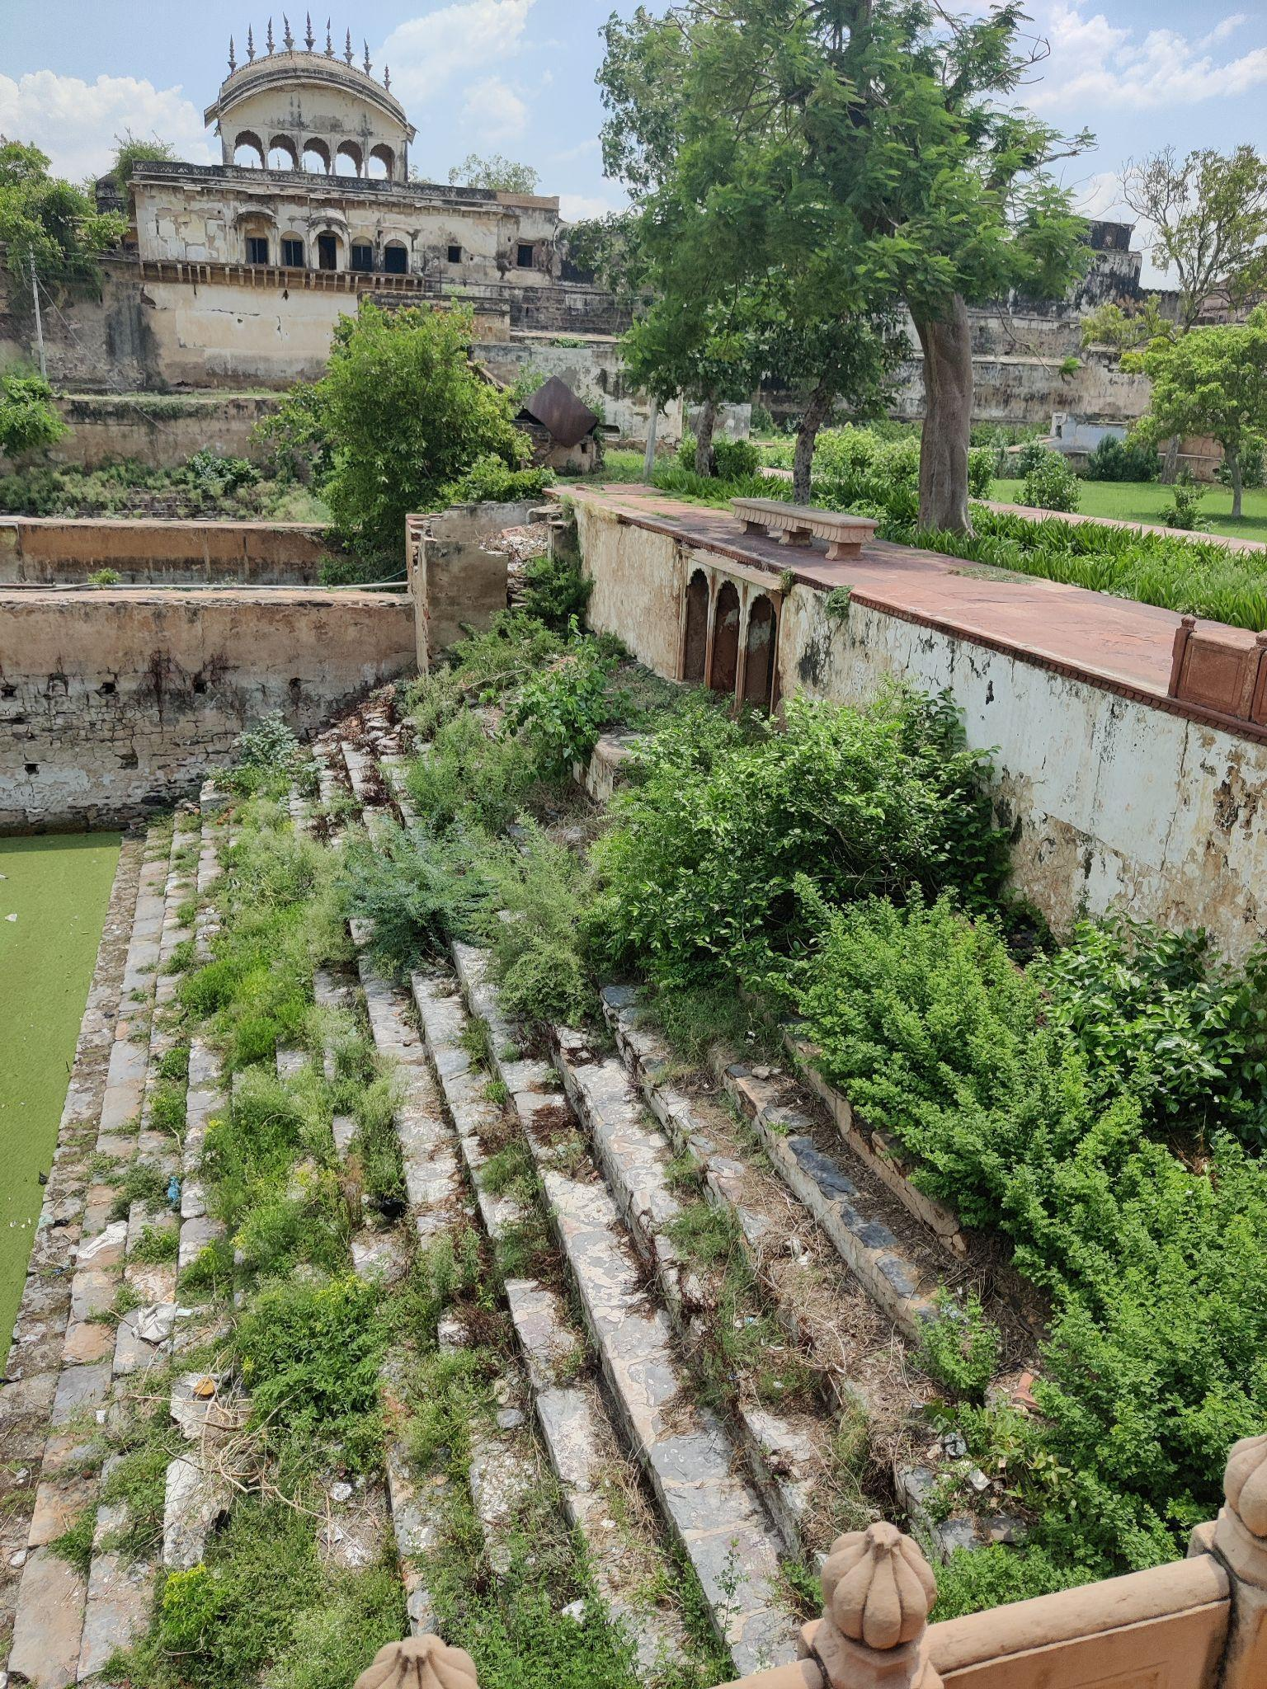 | 1)Time to time maintenance once cleaned | 1)Using the stairs as a sitting space  2)Safe and thoughtful vegetation in between  3)Injecting and grouting.  4)Lights on the shore  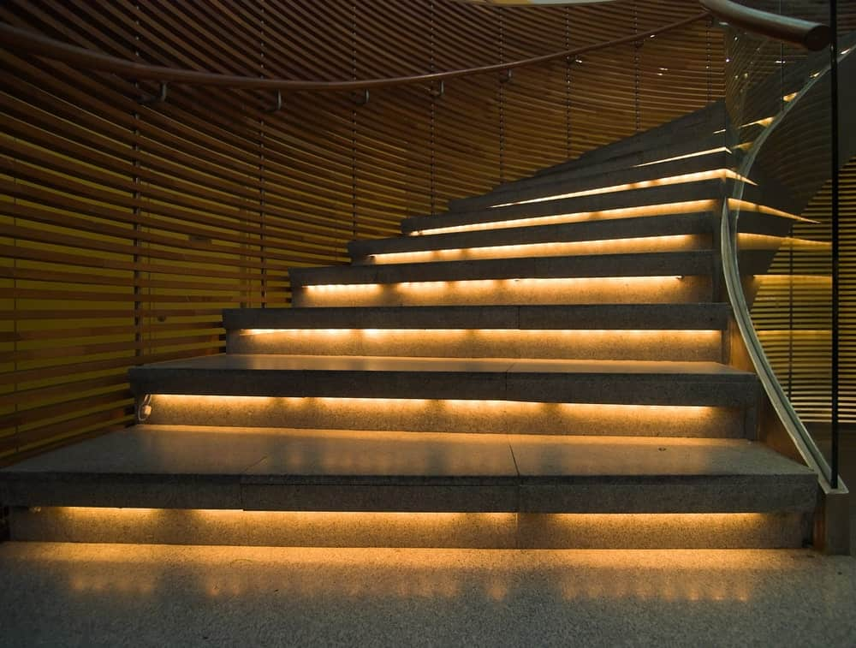
4. | Unauthorised access due to broken walls  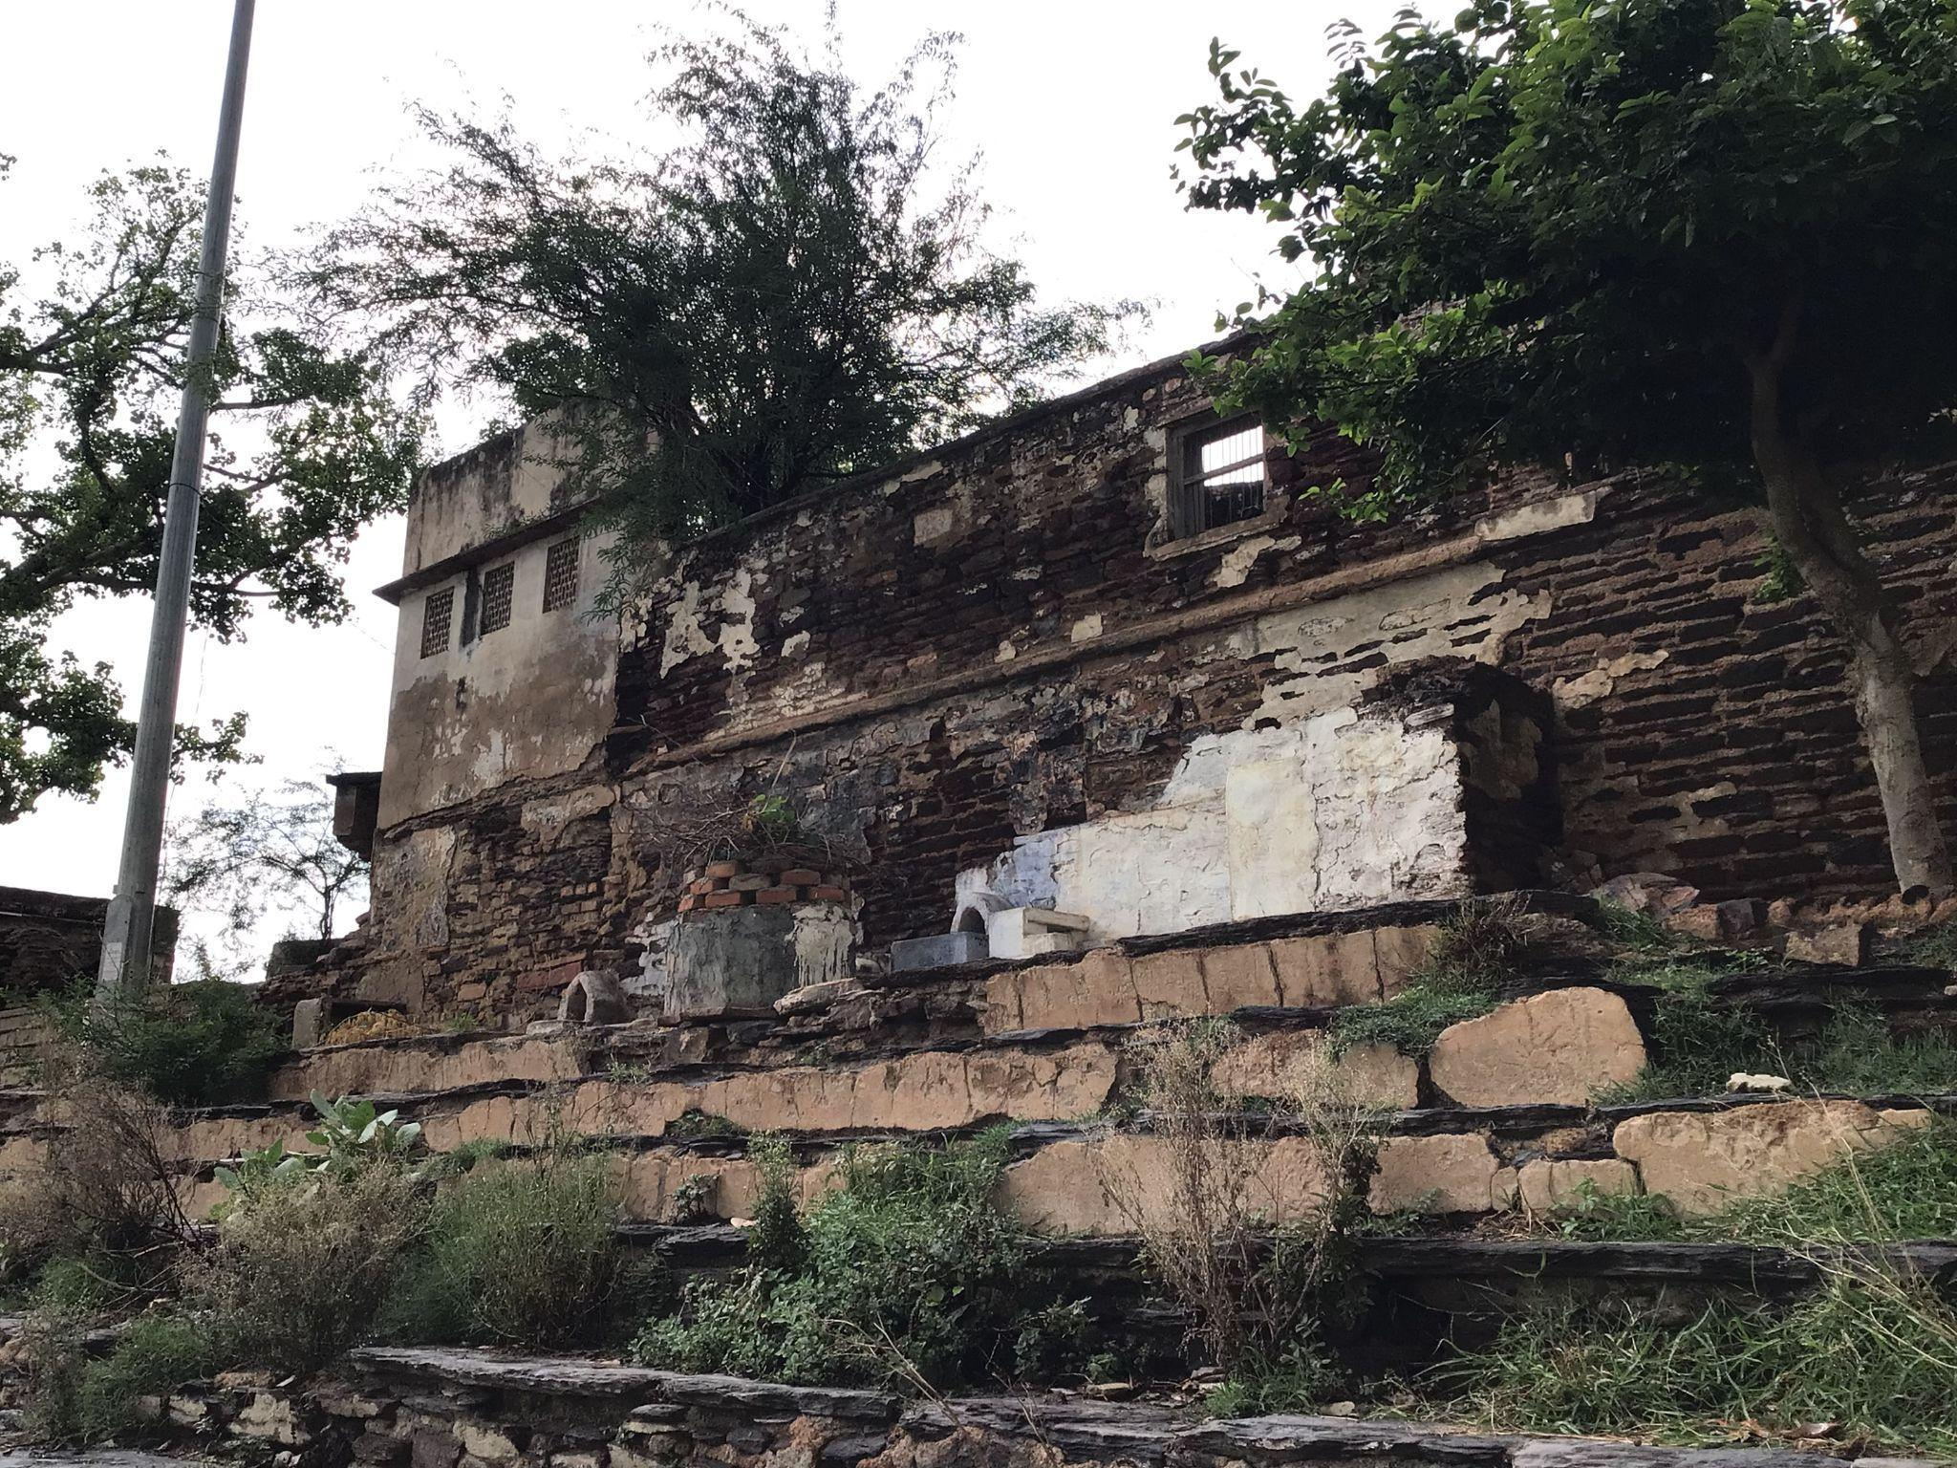 | 1)Sudden cessation of access is impractical  2)Restricting vehicular access.  3)Barricading people from throwing waste in the waterbody  4)Making it a no drinking and no smoking zone. | 1)Restricting people with one step at a time  2)Surveillance of the space 24x7.  3)Abdicating the shady pathways and narrow lanes, rather than making better and lively pathways.
5. | Religious Beliefs  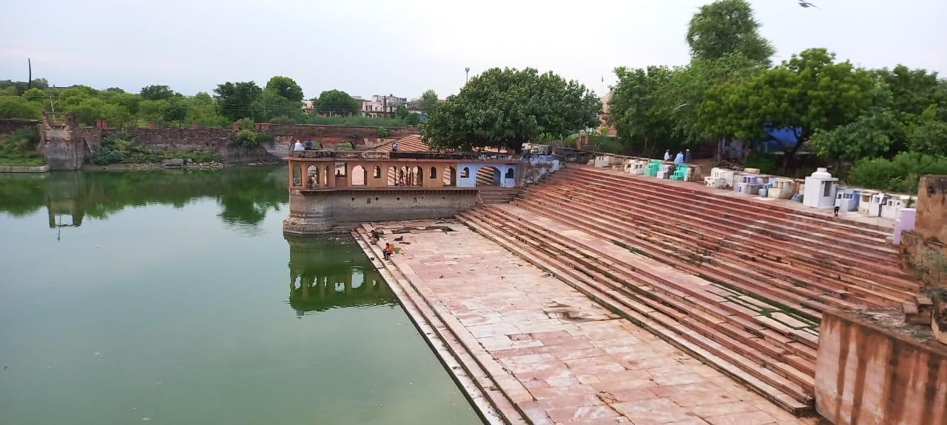 | 1)Breaking or shifting the mannat molds will anger people | A new place
6. | No activities to interest people  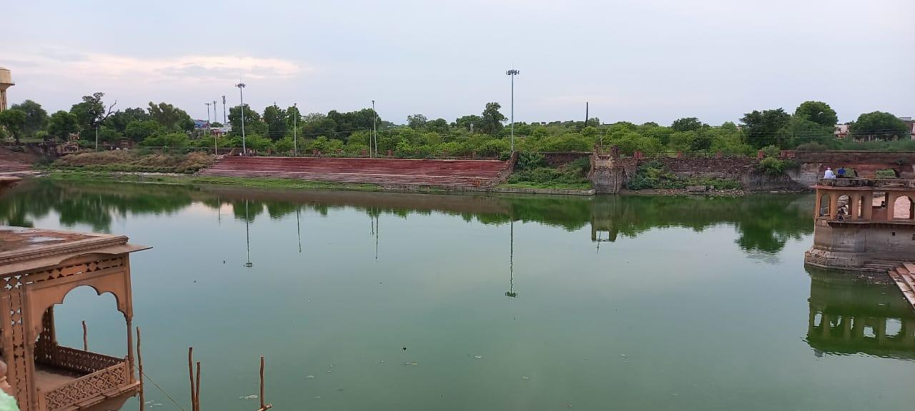 | 1)Activities that take less manpower, skills, time, money, maintenance and safety | 1)Jetties to feed fishes  2)Water and sound show, with fire crackers and lights at night.  