Supporting Information

High-Yield Grafting of Carboxylated Polymers to Wood Pulp Fibers

Hongfeng Zhang¹, Paul Bicho,² Erin A.S. Doherty,³ Richard J. Riehle, ³ Jose Moran Mirabal,⁴ Robert H. Pelton *¹
¹Department of Chemical Engineering, McMaster University, 1280 Main Street West, Hamilton, Ontario, Canada, L8S 4L7
² Canfor Pulp, Unit 138 - 8610 Glenlyon Parkway, Burnaby, BC, Canada, V5J 0B
³ Solenis LLC, 2475 Pinnacle Drive, Wilmington, Delaware, United States of America, 19803
⁴ Department of Chemistry and Chemical Biology, McMaster University, 1280 Main Street West, Hamilton, Ontario, Canada, L8S 4M1
* corresponding author: peltonrh@McMaster.ca

Table S1 Summary of northern softwood bleached kraft pulp PEMAc treatment experiments.

 | Impregnation solution |  |  |  | Drying/Curing |  | PEMAc Content Fiber Titration |  | PEMAc Content Wash Titration |  |  | Comments
Row | MW | % MF | Dose meq/g | pH | Temp. ºC | Time min | COOH meq/g | Yield | COOH meq/g | Yield | Wet TI  Nm/g
1 | H | 0 | 0 | - | none | - | 0.045 | - | - | - | 1.37 | Untreated pulp titration
2 | H | 2 | 0.460 | 8 | 23 | 24×60 | 0.24 | 0.522 | - | - | 0
3 | H | 2 | 0.366 | 2 | 23 | 24×60 | 0.184 | 0.503 |  |  | 0
4 | H | 2 | 0.374 | 4 | 23 | 24×60 | 0.261 | 0.697 |  |  | 0
5 | H | 2 | 0.454 | 6 | 23 | 24×60 | 0.218 | 0.48 |  |  | 0
6 | H | 2 | 0.463 | 11 | 23 | 24×60 | 0.19 | 0.41 |  |  | 0
7 | H | 2 | 0.467 | 8 | 120 | 10 | 0.256 | 0.548 | 0.24 | 0.55 | 0.43
8 | H | 2 | 0.480 | 8 | 130 | 10 | 0.24 | 0.50 | - | - | 0.93
9 | H | 2 | 0.491 | 8 | 140 | 10 | 0.27 | 0.55 | 0.31 | 0.66 | 2.26
10 | H | 2 | 0.464 | 8 | 150 | 10 | 0.26 | 0.56 | 0.35 | 0.72 | 4.18
11 | H | 2 | 0.464 | 8 | 120 | 120 | 0.26 | 0.56 | 0.36 | 0.68 | 2.51
12 | H | 2 | 0.451 | 8 | 120 | 60 | 0.23 | 0.51 | 0.30 | 0.61 | 1.44
13 | H | 2 | 0.346 | 2 | 120 | 10 | 0.346 | 1 | 0.36 | 0.92 | 7.33
14 | H | 2 | 0.429 | 4 | 120 | 10 | 0.39 | 0.91 | 0.42 | 0.93 | 12
15 | H | 2 | 0.452 | 5 | 120 | 10 | -- | -- | 0.38 | 0.837 | 8.98
16 | H | 2 | 0.479 | 7 | 120 | 10 | 0.23 | 0.48 | 0.273 | 0.58 | 1.21
17 | H | 2 | 0.464 | 10 | 120 | 10 | 0.127 | 0.274 | 0.23 | 0.47 | 0
18 | H | 2 | 0.409 | 11 | 120 | 10 | 0.124 | 0.282 | 0.173 | 0.37 | 0
19 | L | 2 | 0.392 | 8 | 120 | 10 | 0.00 | 0 | - | - | 1.12
20 | L | 2 | 0.391 | 7 | 120 | 10 | 0.157 | 0.402 | - | - | 1.05
21 | L | 2 | 0.322 | 4 | 120 | 10 | 0.30 | 0.932 | - | - | 7.41
22 | L | 2 | 0.321 | 2 | 120 | 10 | 0.278 | 0.865 |  |  | 3.62
23 | L | 2 | 0.357 | 6 | 120 | 10 | 0.234 | 0.656 |  |  | 1.74
24 | L | 2 | 0.296 | 2 | 23 | 24×60 | 0.069 | 0.233 |  |  | 1.2 | 23 ºC, 50% RH
25 | L | 2 | 0.333 | 4 | 23 | 24×60 | 0.047 | 0.141 |  |  | 1.15 | 23 ºC, 50% RH
26 | L | 2 | 0.354 | 6 | 23 | 24×60 | 0.04 | 0.113 |  |  | 1.2 | 23 ºC, 50% RH
27 | L | 2 | 0.364 | 8 | 23 | 24×60 | 0.04 | 0.11 |  |  | 1.23 | 23 ºC, 50% RH
28 | L | 2 | 0.414 | 11 | 23 | 24×60 | 0 | 0 |  |  | 1.16 | 23 ºC, 50% RH
29 | L | 2 | 0.317 | 4 | 120 | 1 | 0.11 | 0.347 |  |  | 1.33
30 | L | 2 | 0.344 | 4 | 120 | 2 | 0.199 | 0.577 |  |  | 2.38±0.06
31 | L | 2 | 0.317 | 4 | 150 | 1 | 0.275 | 0.865 |  |  | 2.71
32 | L | 2 | 0.339 | 4 | 180 | 1 | 0.229 | 0.675 |  |  | 1.03 ± 0.02 | Dried 23 ºC, oven cured
33 | H | 2 | 0.450 | 4 | 120 | 1 | 0.239 | 0.531 |  |  | 1.70
34 | H | 2 | 0.427 | 4 | 150 | 1 | 0.406 | 0.951 |  |  | 3.18
35 | H | 2 | 0.490 | 4 | 150 | 1 | 0.406 | 0.828 |  |  | 2.25 | Pulp sheet not pressed
36 | H | 2 | 0.437 | 4 | 180 | 1 | 0.336 ± 0.003 | 0.77 |  |  | 0.82 ± 0.08 | Dried 23 ºC, oven cured
37 | H | 0.5 | 0.111 | 8 | 120 | 10 | 0.021 | 0.19 | 0.04 | 0.37 | 1.25
38 | H | 4 | 1.105 | 8 | 120 | 10 | 0.269 | 0.24 | 0.35 | 0.31 | 0.23
39 | H | 8 | 2.620 | 8 | 120 | 10 | 0.30 | 0.11 | - | - | 0
40 | H | 2 | 0.455 | 8 | 120 | 10 | 0.15 | 0.33 | 0.22 | 0.48 | 0.37 | NaCl 10 mM
41 | H | 2 | 0.464 | 8 | 120 | 10 | 0.13 | 0.28 | 0.22 | 0.48 | 0.37 | NaCl 100 mM
42 | H | 2 | 0.444 | 8 | 120 | 10 | 0.08 | 0.18 | 0.17 | 0.37 | 0.26 | NaCl 1000 mM
43 | H | 0.2 | 0.033 | 4 | 120 | 10 | 0.019 | 0.57 | 0.033 | 1 | 3.12
44 | H | 0.5 | 0.092 | 4 | 120 | 10 | 0.084 | 0.91 | 0.092 | 1 | 5.23
45 | H | 4 | 0.894 | 4 | 120 | 10 | 0.728 | 0.814 | 0.80 | 0.89 | 11.31
46 | H | 8 | 2.12 | 4 | 120 | 10 | 1.60 | 0.76 | 1.79 | 0.85 | 9.8
47 | H | 2 | 0.452 | 8 | 23 | 24×60 | 0.197 | 0.436e |  |  | 0 | EDTA treated pulp
48 | H | 2 | 0.463 | 8 | 23 | 24×60 | 0.232 | 0.501^{f} |  |  | 0 | Calcium treated pulp
49 | H | 2 | 0.45 | 4 | 120 | 0.167 |  |  |  |  | 1
50 | H | 2 | 0.45 | 4 | 120 | 0.5 |  |  |  |  | 1.1
51 | H | 2 | 0.45 | 4 | 120 | 5 |  |  | 0.392 | 0.87 | 8.9
52 | H | 2 | 0.45 | 4 | 120 | 60 |  |  | 0.42 | 0.93 | 13.9
53 | H | 2 | 0.45 | 4 | 120 | 120 |  |  | 0.423 | 0.94 | 18.41
54 | H | 2 | 0.45 | 4 | 140 | 10 |  |  | 0.42 | 0.93 | 15.41
55 | H | 2 | 0.45 | 4 | 150 | 10 |  |  | 0.42 | 0.93 | 18.56
56 | H | 0.5 | 0.10 | 8 | 100 | 10 |  |  |  |  | 0.93
57 | H | 0.5 | 0.112 | 8 | 130 | 10 |  |  |  |  | 1.9
58 | H | 0.5 | 0.11 | 8 | 150 | 10 |  |  |  |  | 4.5
59 | H | 1 | 0.221 | 8 | 120 | 10 |  |  |  |  | 0.89
60 | H | 2 | 0.509 | 4 | 120 | 10 |  |  |  |  | 11.1 | Soak 1 mM NaCl 1 day
61 | H | 2 | 0.509 | 4 | 120 | 10 |  |  |  |  | 10.5 | Soak 1 mM NaCl 7 day
62 | H | 2 | 0.461 | 4 | 120 | 10 |  |  |  |  | 10.6 | Soak 0.1 M NaOH 5 min
63 | H | 2 | 0.461 | 4 | 120 | 10 |  |  |  |  | 9.9 | Soak 0.1 M NaOH 1 day
64 | H | 2 | 0.461 | 4 | 120 | 10 |  |  |  |  | 7.5 | Soak 0.1 M NaOH 7 day
65 | H | 2 | 0.36 | 2 | 120 | 10 |  |  |  |  | 11.43±0.41 | 1 wt% NaH₂PO₂.
66 | H | 2 | 0.31 | 4 | 120 | 10 |  |  |  |  | 8.16±0.55 | 1 wt% NaH₂PO₂.
67 | H | 2 | 0.35 | 8 | 120 | 10 |  |  |  |  | 0.2±0 | 1 wt% NaH₂PO₂.
68 | PAA | 2 | 0.49 | 8 | 120 | 10 | 0.153 | 0.313 | - | - | 0.48±0.11
69 | PAA | 2 | 0.442 | 5 | 120 | 10 |  |  |  |  | 5.12±0.2
70 | PAA | 2 | 0.387 | 4 | 120 | 10 |  |  |  |  | 4.62±0.42
71 | PAA | 2 | 0.378 | 2 | 120 | 10 |  |  |  |  | 4.91±0.22
72 | H | 2 | 0.465 | 8 | -- | -- | 0.042 | 0.09 |  |  | 0 | No drying after impregnation
73 | H | 0.5 | 0.086 | 4 | 120 | 1 | 0.075 | 0.868 |  |  | 1.22±0.07
74 | H | 0.5 | 0.086 | 4 | 120 | 3 |  |  |  |  | 3.29±0.18
75 | H | 0.3 | 0.060 | 4 | 150 | 1 | 0.059 | 0.98 |  |  | 2.03±0.02
76 | H | 0.4 | 0.075 | 4 | 150 | 1 | 0.075 | 1 |  |  | 2.43±0.05
77 | H | 0.5 | 0.094 | 4 | 150 | 1 | 0.094 | 1 |  |  | 3.05±0.21
78 | H | 0.3 | 0.059 | 4 | 120 | 1 | 0.057 | 0.97 |  |  | 1.21±0
79 | H | 0.4 | 0.077 | 4 | 120 | 1 | 0.077 | 1 |  |  | 1.28±0
80 | H | 0.5 | 0.086 | 4 | 120 | 1 | 0.075 | 0.87 |  |  | 1.22±0.07
81 | L | 0.3 | 0.053 | 4 | 120 | 1 | 0.0514 | 0.97 |  |  | 1.27±0.04
82 | L | 0.5 | 0.091 | 4 | 120 | 1 | 0.088 | 0.97 |  |  | 1.29±0.01
83 | L | 0.3 | 0.056 | 4 | 150 | 1 | 0.056 | 1 |  |  | 1.32±0.05
84 | L | 0.5 | 0.088 | 4 | 150 | 1 | 0.088 | 1 |  |  | 1.72±0.06
85 | H | 0.3 | 0.052 | 4 | 120 | 1 | 0.052 | 1 |  |  | 0.67±0.06 | Hardwood
86 | H | 0.5 | 0.091 | 4 | 120 | 1 | 0.091 | 1 |  |  | 0.67±0.04 | Hardwood
87 | H | 0.3 | 0.055 | 4 | 150 | 1 | 0.055 | 1 |  |  | 0.92±0.01 | Hardwood
88 | H | 0.5 | 0.094 | 4 | 150 | 1 | 0.094 | 1 |  |  | 1.2±0.18 | Hardwood
89 | H | 0.3 | 0.073 | 4 | 120 | 1 |  |  |  |  | 1.70±0.03 | Unbleached pulp
90 | H | 0.5 | 0.120 | 4 | 150 | 1 |  |  |  |  | 1.86±0.09 | Unbleached pulp
91 | H | 0.3 | 0.072 | 4 | 120 | 1 |  |  |  |  | 2.09±0.02 | Unbleached pulp
92 | H | 0.5 | 0.124 | 4 | 150 | 1 |  |  |  |  | 2.69±0.20 | Unbleached pulp
93 |  |  |  |  |  |  | 0.069 |  |  |  | 0.76±0.01 | Untreated hardwood
94 |  |  |  |  |  |  | 0.075 |  |  |  | 1.81±0.00 | Untreated unbleached pulp
95 | H | 0.5 | 0.094 | 4 | 150 | 10 |  |  |  |  | 4.69±0.05 | Hardwood
96 | H | 1 | 0.208 | 4 | 120 | 5 |  |  |  |  | 2.58±0.12 | Hardwood
97 | H | 1 | 0.207 | 4 | 120 | 10 |  |  |  |  | 3.85±0.04 | Hardwood
98 | H | 4 | 0.960 | 4 | 120 | 1.25 | 0.61 | 0.58 |  |  | 2.34±0.01
99 | H | 6 | 1.467 | 4 | 120 | 1.25 | 0.93 | 0.60 |  |  | 1.89±0.03
Notes: Dried pulp sheets (1.5 g target) were wetted with 3 to 3.5 mL of PEMAc solution.
PEMAc content is the amount of polymer fixed to fibers after washing.
The background fiber charge (Row 1) was subtracted from the PEMAc titration results.
% MF is the mass fraction of PEMA in the impregnation solution.
The dose is the applied meq of PEMAc per g dry fiber (COOx meq/g) in the impregnated pulp sheet before drying/curing.
MW is the PEMAc molecular weight. H for H-PEMAc and L for L-PEMAc.

Table S2 Illustrating the reproducibility of the conductometric titrations of untreated pulp and the base-case impregnation of H-PEMAc (pH 8, 120 ºC for 10 min).
 | Pulp Fiber Carboxylic Acid Contents (meq/g)
Times | Untreated Pulp | H PEMA Fiber Titration | H PEMA Wash Solution Titration
1 | 0.054 | 0.259 | 0.267
2 | 0.045 | 0.263
3 | 0.037 | 0.245
Mean | 0.045 | 0.256 | 0.267
Standard deviation | 0.0085 | 0.0097 | --
SD/Mean (%) | 19 | 3.79

Table S3 The influence of drying temperature on PAA immobilization on bleached pulp. The treatment conditions were: 1 mM NaCl, PAA concentration 2 %, pH 8, heating 10 min, 120 °C, 450 kDa, bleached pulp.
The polymer contents and corresponding yields were determined from titrations of the pulp fibers.
Drying Temperature (°C) | 70 | 100 | 120
Fiber Charge (meq/g) | 0.11 | 0.12 | 0.13
Yield | 0.231 | 0.252 | 0.273

Figure S1 Comparison of Bianchi’s titration data with a two-dissociation constant model (pK₁ 3.65, pK₂ 7) for PEMAc dissociation. (Bianchi et al. 1970)

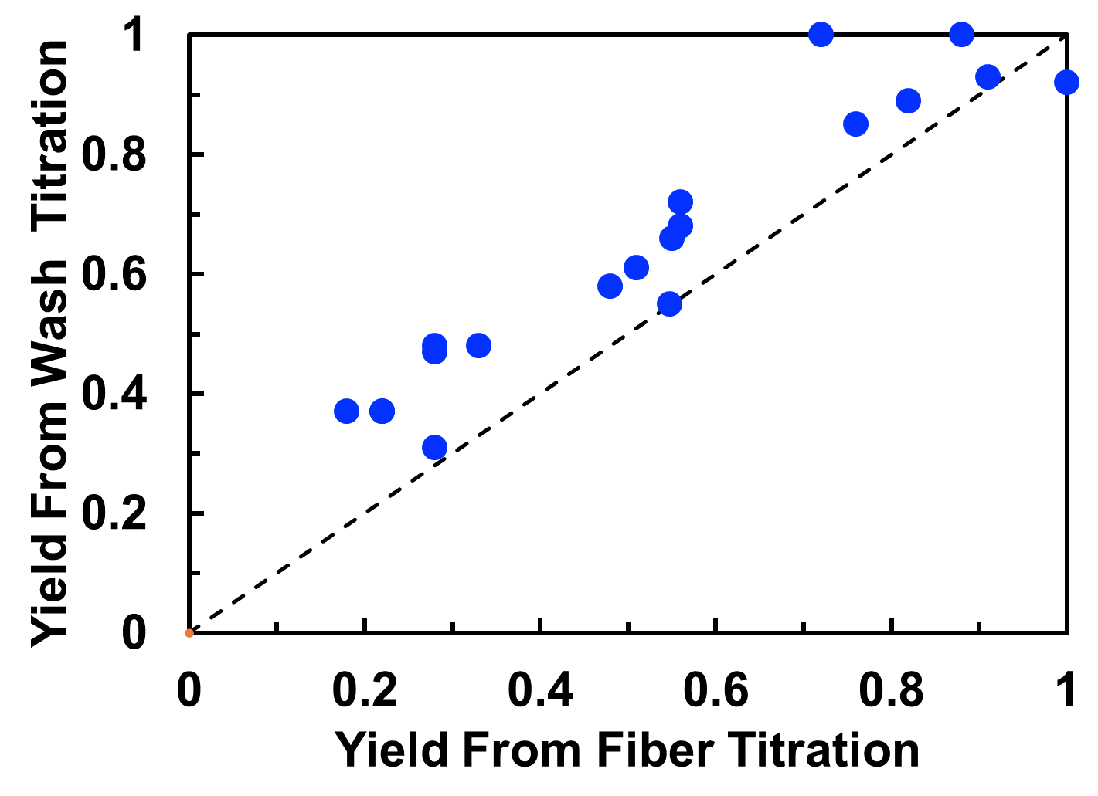
Figure S2 PEMAc fixation yields from wash water titration versus the yields from direct fiber titration.

FTIR PEMAc Films and Impregnated Pulp Sheets. The critical step in forming PEMAc ester grafts to cellulose (Figure 1) is the conversion of succinic acid moieties to succinic anhydrides. The consensus from the literature is that the conversion of PEMAc to PEMAc requires temperatures above 100 ºC and the absence of water. In other words, anhydride formation is likely to involve a polymer melt with low water content.
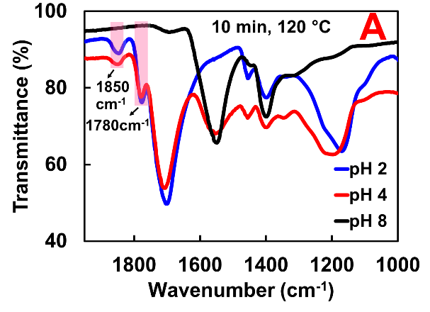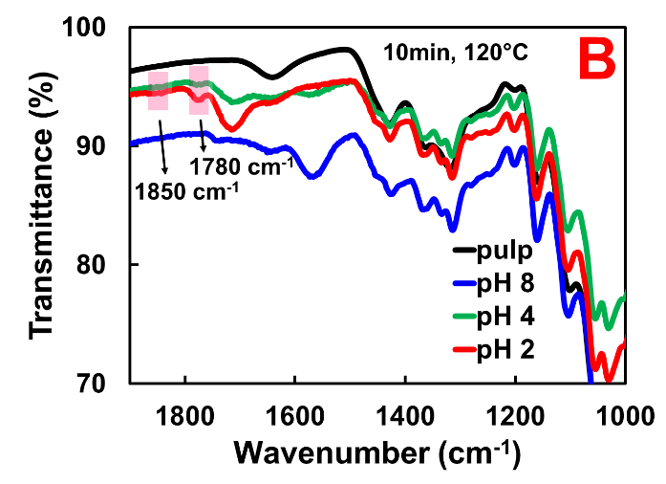
Figure S3 Influence of PEMAc solution pH on anhydride formation in a polymer film. A – FTIR of dried and heated PEMAc film; B – FTIR of grafted pulp. Anhydride formation is evidenced by peaks at 1780 and 1850 cm⁻¹. (Johnson 2010)
FTIR spectra dried and heated pure PEMAc films are shown in Figure S3A. Anhydride formation is evidenced by peaks at 1780 and 1850 cm⁻¹. (Johnson 2010) Anhydrides were evident for films prepared from pH 2 and pH 4 PEMAc solutions but not from the pH 8 solution. The presence of anhydride bands was less apparent in the paper films in Figure S3B.
Figure S4 Show FTIR spectra of pulp sheets impregnated at pH 2 and pH 4. There is no evidence of anhydride or ester linkages.
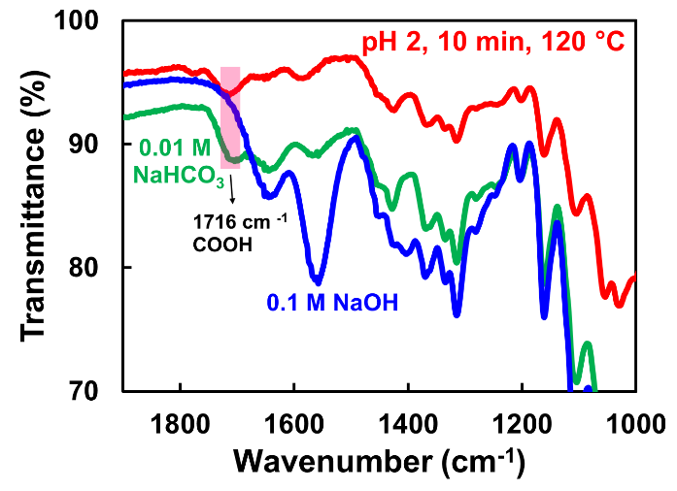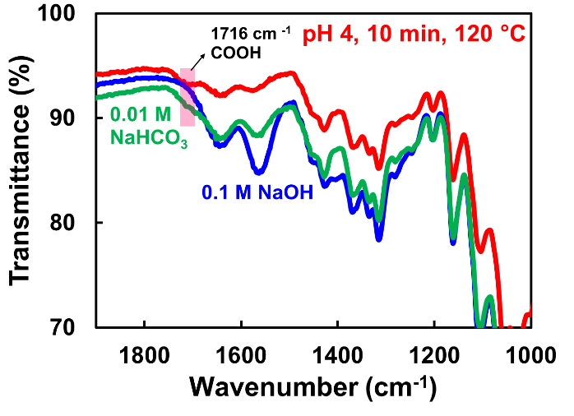
Figure S4 FTIR of PEMAc treated pulp sheets. There is no evidence of PEMAc-cellulose ester linkages.

References
Allan G, Reif W (1971) Fiber surface modification part 6. Jack-in-box effect-new mechanism for retention of polyethylenimine and other polyelectrolytes by pulp fibers. Sven. Papperstidn. 74:25-31.
Allan GG, Akagane K, Neogi AN, Reif WM, Mattila T (1970) Physical entrapment of polyelectrolytes within microporous solids: The “jack-in-the-box” effect. Nature 225:175-176. https://doi.org/10.1038/225175a0
Barzyk D, Page D, Ragauskas A (1997) Acidic group topochemistry and fibre-to-fibre specific bond strength. J Pulp Paper Sci 23:J59-J61.
Belgacem MN, Gandini A (2005) The surface modification of cellulose fibres for use as reinforcing elements in composite materials. Composite Interfaces 12:41-75. http://dx.doi.org/10.1163/1568554053542188
Bianchi E, Ciferri A, Parodi R, Rampone R, Tealdi A (1970) Ethylene-maleic anhydride copolymers and derivatives. Potentiometric titrations and interactions with polypeptides. J Phys Chem 74:1050-1056. https://doi.org/10.1021/j100700a014
Chen DZ, Yang CQ, Qiu XQ (2005) Aqueous polymerization of maleic acid and cross-linking of cotton cellulose by poly(maleic acid). Ind Eng Chem Res 44:7921-7927. https://doi.org/10.1021/ie050651+
Cooper WJ, Krasicky PD, Rodriguez F (1985) Effects of molecular weight and plasticization on dissolution rates of thin polymer films. Polymer 26:1069-1072. https://doi.org/10.1016/0032-3861(85)90230-7
Fras L, Johansson LS, Stenius P, Laine L, Stana-Kleinschek K, Ribitsch V (2005) Analysis of the oxidation of cellulose fibres by titration and xps. Colloids Surf, A 260:101-108. https://doi.org/10.1016/j.colsurfa.2005.01.035
Greenberg AR, Kamel I (1977) Kinetics of anhydride formation in poly(acrylic acid) and its effect on the properties of a paa-alumina composite. J Polym Sci, Polym Chem Ed 15:2137-2149. https://doi.org/10.1002/pol.1977.170150908
Gu X, Yang CQ (1998) FT-IR and ft-raman spectroscopy study of the cyclic anhydride intermediates for esterification of cellulose: I. Formation of anhydrides without a catalyst. Res Chem Intermed 24:979-996. https://doi.org/10.1163/156856798x00672
Higuchi T, Miki T, Shah AC, Herd AK (1963) Facilitated reversible formation of amides from carboxylic acids in aqueous solutions. Intermediate production of acid anhydride. JACS 85:3655-3660. https://doi.org/10.1021/ja00905a028
Johnson D (2010) New applications for poly (ethylene-alt-maleic anhydride). Ph.D. Thesis, Durham University.
Katz S, Scallan AM (1984) The determination of strong and weak acidic groups in sulfite pulps. Sven Papperstidn 87:48-54.
Kitaoka T, Isogai A, Onabe F (1999) Chemical modification of pulp fibers by TEMPO-mediated oxidation. Nord Pulp Pap Res J 14:279-284. https://dx.doi.org/10.3183/NPPRJ-1999-14-04-p279-284
Laine J, Lindstrom T, Bremberg C, Glad-Nordmark G (2003) Studies on topochemical modification of cellulosic fibres - part 4. Toposelectivity of carboxymethylation and its effects on the swelling of fibres. Nord Pulp Pap Res J 18:316-324. http://dx.doi.org/10.3183/NPPRJ-2003-18-03-p316-324
Laine J, Lindstrom T, Nordmark GG, Risinger G (2000) Studies on topochemical modification of cellulosic fibres part 1. Chemical conditions for the attachment of carboxymethyl cellulose onto fibres. Nord Pulp Pap Res J 15:520-526. http://dx.doi.org/10.3183/NPPRJ-2000-15-05-p520-526
Laine J, Lindstrom T, Nordmark GG, Risinger G (2002) Studies on topochemical modification of cellulosic fibres - part 2. The effect of carboxymethyl cellulose attachment on fibre swelling and paper strength. Nord Pulp Pap Res J 17:50-56. http://dx.doi.org/10.3183/NPPRJ-2002-17-01-p050-056
Lee PI, Peppas NA (1987) Prediction of polymer dissolution in swellable controlled-release systems. J Controlled Release 6:207-215. https://doi.org/10.1016/0168-3659(87)90077-0
Lepoutre P, Hui S, Robertson A (1973) The water absorbency of hydrolyzed polyacrylonitrile‐grafted cellulose fibers. J Appl Polym Sci 17:3143-3156. https://doi.org/10.1002/app.1973.070171017
Lin J, Wu J, Yang Z, Pu M (2001) Synthesis and properties of poly(acrylic acid)/mica superabsorbent nanocomposite. Macromolecular Rapid Communications 22:422-424. https://doi.org/10.1002/1521-3927(20010301)22:6<422::AID-MARC422>3.0.CO;2-R
Miller-Chou BA, Koenig JL (2003) A review of polymer dissolution. Prog Polym Sci 28:1223-1270. https://doi.org/10.1016/S0079-6700(03)00045-5
Pelton R, Zhang J, Chen N, Moghaddamzadeh A (2003) The influence of dextran molecular weight on the dry strength of dextran-impregnated paper. TAPPI 2:15-18.
Pompe T, Zschoche S, Herold N, Salchert K, Gouzy M-F, Sperling C, Werner C (2003) Maleic anhydride copolymers - a versatile platform for molecular biosurface engineering. Biomacromolecules 4:1072-1079. https://doi.org/10.1021/bm034071c
Rätzsch M (1988) Alternating maleic anhydride copolymers. Prog Polym Sci 13:277-337. https://doi.org/10.1016/0079-6700(88)90001-9
Ueberreiter K, Asmussen F (1957) Velocity of dissolution of polystyrene. J Polym Sci 23:75-81. https://doi.org/10.1002/pol.1957.1202310308
Vitta SB, Stahel EP, Stannett VT (1985) The preparation and properties of acrylic and methacrylic acid grafted cellulose prepared by ceric ion initiation. Part i. Preparation of the grafted cellulose. J Macromol Sci, Part A 22:579-590. https://doi.org/10.1080/00222338508056624
Wågberg L, Annergren G Physicochemical characterization of papermaking fibres. Baker CF (ed) The fundamentals of papermaking materials, Trans. of the XIth Fund. Res. Symp., Cambridge, 1997. pp 1-82. ISBN
Wågberg L, Winter L, Odberg L, Lindstrom T (1987) On the charge stoichiometry upon adsorption of a cationic polyelectrolyte on cellulosic materials. Colloids Surf 27:163-173. https://doi.org/10.1016/0166-6622(87)80140-3
Xu GG, Yang CQX (1999) Comparison of the kraft paper crosslinked by polymeric carboxylic acids of large and small molecular sizes: Dry and wet performance. J Appl Polym Sci 74:907-912. https://doi.org/10.1002/(SICI)1097-4628(19991024)74:4%3C907::AID-APP17%3E3.0.CO;2-9
Xu YF, Yang CQ, Chen CM (1999) Wet reinforcement of paper with high-molecular-weight multifunctional carboxylic acid. TAPPI 82:150-156.
Yang CQ (1993) Infrared spectroscopy studies of the cyclic anhydride as the intermediate for the ester crosslinking of cotton cellulose by polycarboxylic acids. I. Identification of the cyclic anhydride intermediate. J Polym Sci, Part A: Polym Chem 31:1187-1193. https://doi.org/10.1002/pola.1993.080310514
Yang CQ, Wang X (1996a) Formation of cyclic anhydride intermediates and esterification of cotton cellulose by multifunctional carboxylic acids: An infrared spectroscopy study. Text Res J 66:595-603. https://doi.org/10.1177/004051759606600908
Yang CQ, Wang X (1996b) Infrared spectroscopy studies of the cyclic anhydride as the intermediate for the ester crosslinking of cotton cellulose by polycarboxylic acids. II. Comparison of different polycarboxylic acids. J Polym Sci, Part A: Polym Chem 34:1573-1580. https://doi.org/10.1002/(SICI)1099-0518(199606)34:8%3C1573::AID-POLA22%3E3.0.CO;2-4
Yang CQ, Xu Y (1998) Paper wet performance and ester crosslinking of wood pulp cellulose by poly(carboxylic acids). J Appl Polym Sci 67:649-658. https://doi.org/10.1002/(SICI)1097-4628(19980124)67:4%3C649::AID-APP8%3E3.0.CO;2-Q
Yang CQ, Xu Y, Wang D (1996) FT-IR spectroscopy study of the polycarboxylic acids used for paper wet strength improvement. Ind Eng Chem Res 35:4037-4042. https://doi.org/10.1021/ie960207u
Zhang H, Tsenter E, Bicho P, Doherty EAS, Riehle R, Mirabal JM, Pelton RH Carboxylated bleached kraft pulp from maleic acid copolymers. Nordic Pulp and Paper Research Journal submitted January 2021.

