Supplementary Table S1. DNA methylation-based classification of central nervous system tumors.
ID | Classification | Score
1 | Control tissues | 0.89
2 | Control tissues | 1.00
3 | Low-grade glial/glioneuronal/neuroepithelial tumors | 0.43
4 | Control tissues | 1.00
6 | Control tissues | 0.93
7 | Control tissues | 0.98
8 | Ependymal tumors | 0.38
9 | Control tissues | 0.66
10 | Control tissues | 0.83
11 | Control tissues | 1.00
12 | Control tissues | 1.00
13 | NA | 0.10
14 | Control tissues | 0.98
15 | Pediatric-type diffuse high-grade gliomas | 0.49
16 | Control tissues | 0.85
17 | Control tissues | 0.91
18 | Control tissues | 0.98
19 | Control tissues | 1.00
20 | Control tissues | 0.42

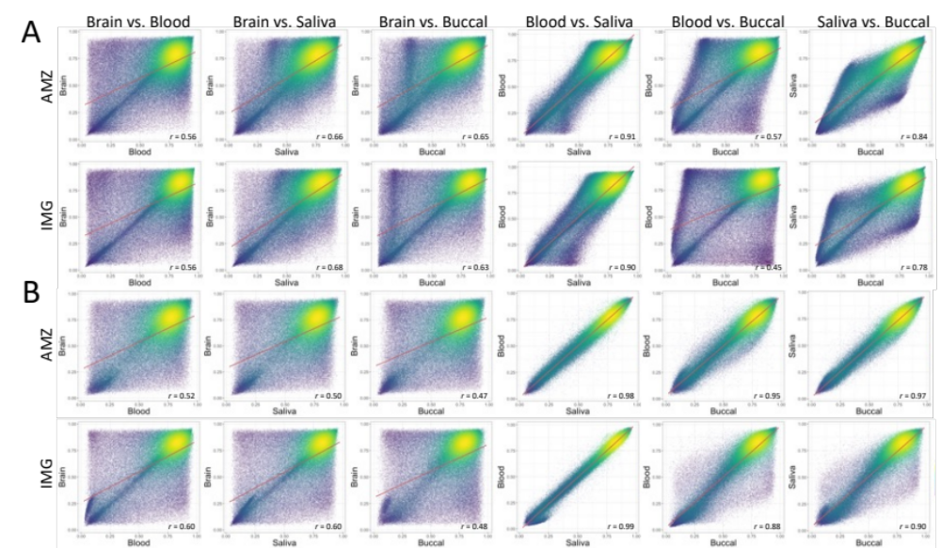
Supplementary Figure S1. Cross-tissue correlation density scatter plots for each tissue combination in variable CpGs. (A) Raw, and (B) cell proportion adjusted datasets. AMZ: AMAZE-CpG dataset, and IMG: IMAGE-CpG dataset. Red line: regression line.
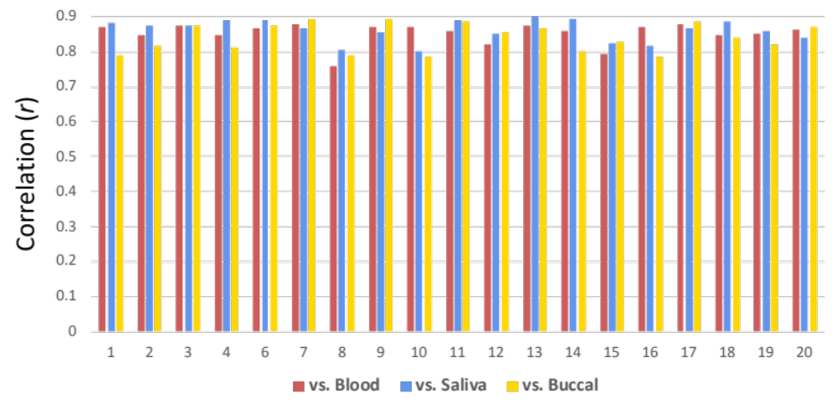
Supplementary Figure S2. Degree of DNA methylation correlation of all CpG probes between each peripheral tissue and brain for all subjects.
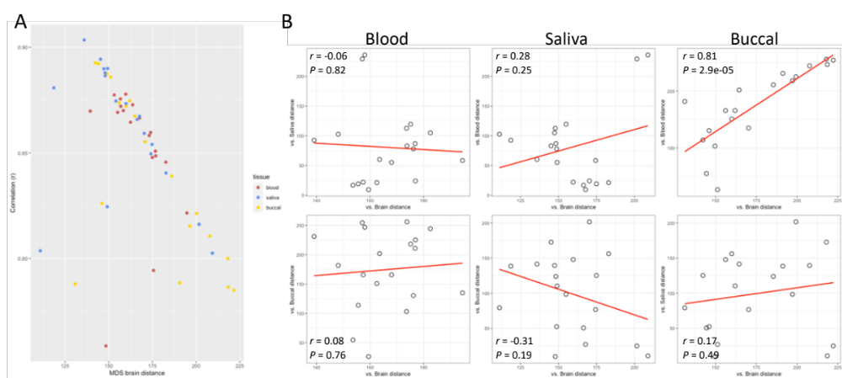
Supplementary Figure S3. (A) Calculated distance from the MDS plots between each peripheral tissue and its corresponding brain sample in AMAZE-CpG dataset is plotted against the level of correlation among those samples. (B) Relationship between the MDS distance of peripheral-brain and peripheral–another peripheral.

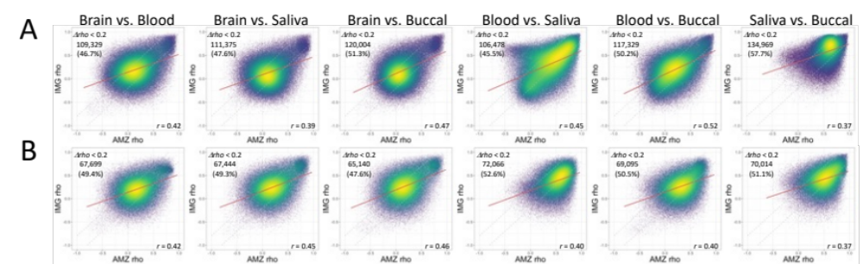

Supplementary Figure S4. Comparison of correlation coefficients in variable CpGs between the datasets. Correlation density scatter plots of spearman’s rho between the datasets for each tissue combination for (A) Raw, and (B) cell proportion adjusted datasets. AMZ: AMAZE-CpG dataset, and IMG: IMAGE-CpG dataset. Red line: regression line. Dashed line: the border line within Δrho < 0.2 between the datasets.
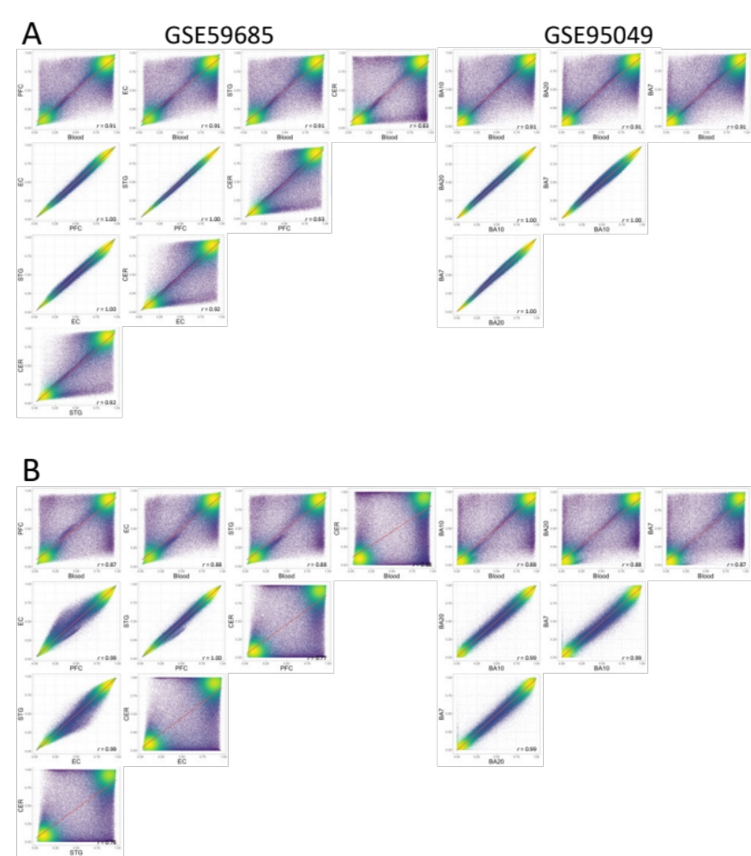

Supplementary Figure S5. Density scatter plots between each tissue from the tissues’ average methylation from GSE59685 (Left) and GSE95049 (Right). (A) Raw beta and (B) adjusted beta by cell proportion.
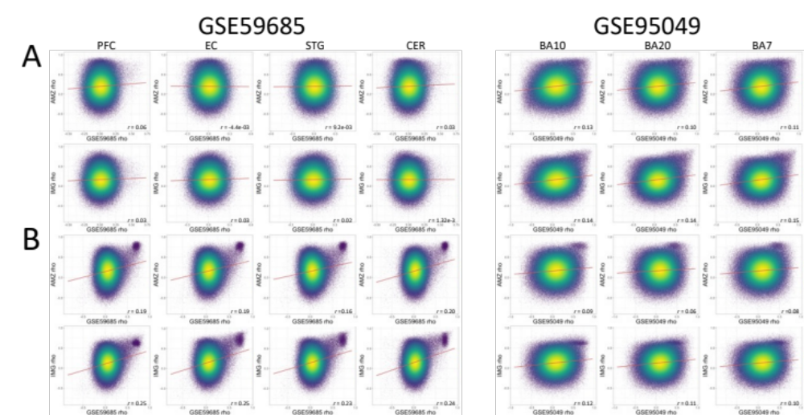

Supplementary Figure S6. Density scatter plots between AMZ or IMG rho and GSE59685 (Left) and GSE95049 (Right) between each tissue from the individual methylation. (A) Raw beta and (B) adjusted beta by cell proportion.

Supplementary Table S3. Proportion of probes evaluated as potentially affected by SNPs
Brain vs | Blood |  | Saliva |  | Buccal |  | Common
Est. cluster size | # of probes (%) | Between>1 | # of probes (%) | Between>1 | # of probes (%) | Between>1 | # of probes (%) | Between>1
1  2  3 | 566289 (68.6)  129185 (15.6)  130163 (15.8) | 115  3813  2734 | 541321 (65.6)  114593 (13.9))  169723 (20.5) | 5521  4586  17380 | 544061 (65.9)  135835 (16.4)  145741 (17.7) | 3597  6925  8758 | 383890  41265  39414 | 33  3184  1563
 | 825637 (100.0) | 6662 | 825637 (100.0) | 27487 | 825637 (100.0) | 19280 | 464569 (56.3) | 4780

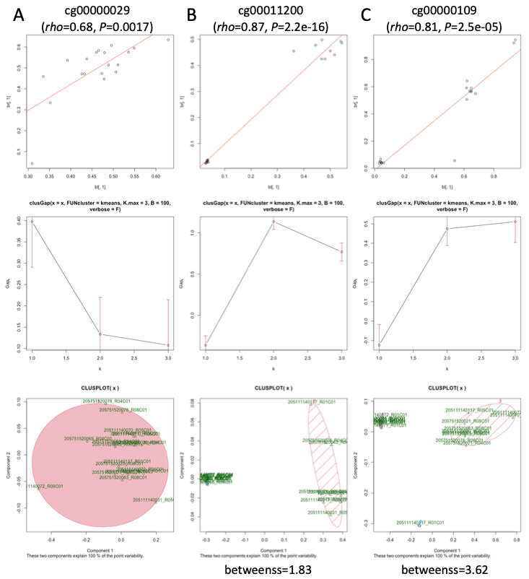
Supplementary Figure S7. Examples for each estimated cluster cases (A: 1 cluster, B:2 clusters, and C:3 clusters). Top: scatter plots between blood and brain methylation, middle: gap-k statistics plots, bottom: clustering plots using K-means method

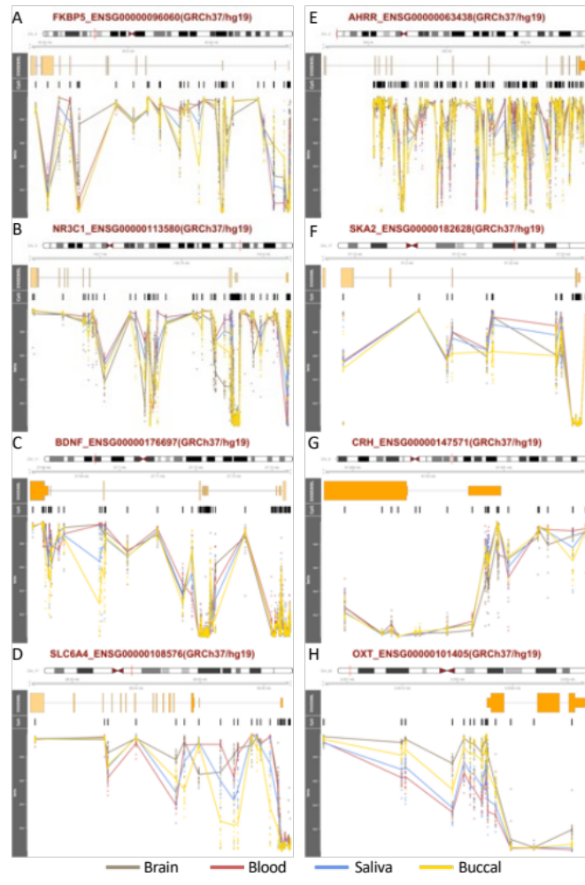
Supplementary Figure S8. Average DNA methylation (β) patterns in AMAZE-CpG dataset in candidate psychiatric genes across brain, blood, saliva, and buccal. (A) FK506 binding protein 5 (FKBP5), (B) the glucocorticoid receptor (NR3C1), (C) brain-derived neurotrophic factor (BDNF), (D) the serotonin transporter (SLC6A4), (E) aryl-hydrocarbon receptor repressor (AHRR), (F) spindle and kinetochore associated complex subunit 2 (SKA2), (G) corticotropin-releasing hormone (CHR), and (H) oxytocin (OXT).
Supplementary Table S6. OXT methylation correlations between brain and saliva from the AMAZE-CpG database
 |  | Raw |  | Adj
Probe ID | Chr:MAPINFO | rho | P | rho | P | SNP_SA | mQTL_flag | varSA_flag | varSAadj_flag | SA_A-I0.2_flag | SAadj_A-I0.2_flag
cg09129163 | Chr20:3050786 | 0.63 | 0.005 | 0.29 | 0.22 | 0 | FALSE | TRUE | FALSE | FALSE | FALSE
cg07597882 | Chr20:3051493 | 0.37 | 0.12 | 0.13 | 0.60 | 0 | FALSE | TRUE | TRUE | FALSE | FALSE
cg04528380 | Chr20:3051528 | 0.32 | 0.18 | 0.08 | 0.73 | 0 | FALSE | TRUE | TRUE | FALSE | FALSE
cg04731988 | Chr20:3051954 | 0.28 | 0.24 | 0.29 | 0.23 | 0 | FALSE | TRUE | TRUE | FALSE | FALSE
cg19776589 | Chr20:3052058 | 0.26 | 0.27 | 0.23 | 0.35 | 0 | FALSE | TRUE | TRUE | FALSE | TRUE
cg07747220 | Chr20:3052115 | 0.53 | 0.02 | 0.19 | 0.42 | 0 | FALSE | TRUE | TRUE | FALSE | TRUE
cg16887334 | Chr20:3052151 | 0.31 | 0.20 | 0.43 | 0.07 | 0 | FALSE | TRUE | TRUE | FALSE | TRUE
cg13285174 | Chr20:3052221 | 0.32 | 0.18 | 0.25 | 0.29 | 0 | FALSE | TRUE | TRUE | FALSE | FALSE
cg26267561 | Chr20:3052224 | 0.16 | 0.50 | 0.06 | 0.80 | 0 | FALSE | TRUE | TRUE | FALSE | FALSE
cg01644611 | Chr20:3052253 | 0.37 | 0.12 | 0.27 | 0.26 | 0 | FALSE | TRUE | TRUE | FALSE | FALSE
cg13725599 | Chr20:3052262 | 0.23 | 0.34 | 0.33 | 0.17 | 0 | FALSE | TRUE | TRUE | FALSE | FALSE
cg19592472* | Chr20:3052274 | 0.39 | 0.10 | 0.34 | 0.16 | 0 | FALSE | TRUE | TRUE | FALSE | TRUE
cg26955850 | Chr20:3052345 | 0.28 | 0.24 | 0.44 | 0.06 | 0 | FALSE | TRUE | TRUE | TRUE | TRUE
cg09774842 | Chr20:3052483 | 0.38 | 0.11 | 0.47 | 0.05 | 0 | FALSE | FALSE | FALSE | FALSE | FALSE
cg06404175 | Chr20:3052692 | 0.83 | 6.4e-06 | 0.84 | 0 | 0 | FALSE | FALSE | FALSE | FALSE | FALSE
cg12099952 | Chr20:3053037 | 0.03 | 0.90 | -0.25 | 0.30 | 0 | FALSE | FALSE | FALSE | TRUE | FALSE
Bold: probes constructed OXTmi (Nishitani S, et al., 2021)
*: removed by quality control process

