Supplementary file
Figure 1
Dates and periods of the 8 Canadian surveys
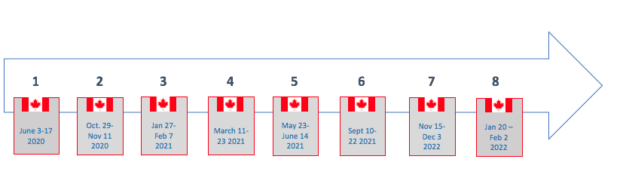

Table S1
Participant characteristics in NCD patients as a function of sex
Descriptive characteristics | Men with NCD  (n= 5 042) |  |  | Women with NCD  (n=5 483)
Variable | % (n) |  |  | % (n) |  |  | p
Age
≤25 years | 5.96 (298) |  |  | 5.39 (293) |  |  | 0.001
26-50 years | 26.6 (1 484) |  |  | 33.4 (1 817)
≥51 years or more | 64.4 (3 228) |  |  | 61.2 (3 330)
Missing values | 119
Mean (SD) | 56.7 (15.6) |  |  | 52.8 (16.3)
Education level
High school or lower | 70.0 (3 484) |  |  | 72.3 (3 932) |  |  | 0.011
Graduate or Postgraduate degree | 29.9 (1 489) |  |  | 27.6 (1 506)
Missing values | 160
Region (% from each province)
British Columbia | 13.5 (680) |  |  | 13.0 (710) |  |  | 0.733
Alberta | 10.7 (584) |  |  | 10.7 (584)
Saskatchewan | 3.1 (168) |  |  | 3.1 (168)
Manitoba | 4.1 (226) |  |  | 4.1 (226)
Ontario | 38.5 (2110) |  |  | 38.5 (2110)
Quebec | 22.6 (1238) |  |  | 22.6 (1238)
New Brunswick | 2.7 (146) |  |  | 2.7 (146)
Nova Scotia | 3.2 (176) |  |  | 3.2 (176)
Prince Edward Island | 0.3 (15.8) |  |  | 0.3 (16)
Newfoundland | 2.0 (108) |  |  | 2.0 (108)
Missing values | 46
Currently employed
Yes | 46.4 (2 297) |  |  | 40.4 (2 186) |  |  | <.001
Missing values | 209
Average annual household income
<$60 000/year | 46.6 (2 193) |  |  | 56.1 (2 672) |  |  | <.001
≥$60 000/year | 53.4 (2 516) |  |  | 43.9 (2 094)
Missing values | 1095
Presence of any mental health disorder (e.g., depression, anxiety)

No | 71.2 (3 531) |  |  | 60.8 (3 263)
Yes | 28.8 (1 427) |  |  | 39.2 (2 107) |  |  | <.001
Missing values | 241
Presence of any depressive disorder
No | 80.2 (3 983) |  |  | 74.2 (3 992) |  |  | <.001
Yes | 19.8 (984) |  |  | 25.8 (1 387)
Missing values | 222
Presence of any anxiety disorder
No | 77.3 (3 843) |  |  | 66.7 (3 591) |  |  | <.001
Yes | 22.7 (1 129) |  |  | 33.3 (1 791)
Missing values | 216
History of COVID-19 infection
COVID-19 positive | 5.1 (43) |  |  | 5.1 (45) |  |  | 0.091
COVID-19 negative | 91.9 (784) |  |  | 93.5 (830)
I am still waiting for my result | 3.1 (26) |  |  | 1.5 (13)
Missing values | 8 829

NCD: non-communicable chronic disease

Table S2
Frequency of reporting each impact “to a great extent” as a function of NCD status and sex
 | No NCD  (n=12 601) |  | NCD  (n=10 570)
 | Men  (n=6095) | Women  (n=6426) | Men  (n=5042)  % |  | Women  (n=5483)  %
 | % | %
Mental health
Anxious | 12.48 (741) | 24.33 (1538) | 16.03 (789) | 26.20 (1402)
Depressed | 11.88 (705) | 19.74 (1241) | 14.9 (731) | 21.25 (1140)
Lonely | 13.38 (791) | 21.22 (1334) | 16.03 (784) | 23.38 (1252)
Irritable/ frustrated or angry | 13.52 (802) | 20.02 (1253) | 14.73 (725) | 21.02 (1123)
Health behaviours
Less physically active | 31.33 (1402) | 36.75 (1731) | 35.18 (1336) | 39.64 (1641)
Worse diet | 18.09 (809) | 22.92 (1076) | 19.69 (744) | 24.36 (1011)
Increased alcohol consumption | 17.95 (803) | 17.67 (829) | 18.02 (684) | 14.19 (586)
Access to care
I cancelled medical appointments or avoided presenting to the emergency department | 8.85 (456) | 11.76 (634) | 13.00 (583) | 18.21 (870)
I had trouble getting access to non-COVID medical care | 8.40 (429) | 9.39 (503) | 13.07 (586) | 14.89 (713)

NCD: non-communicable chronic disease
Table S3
Adjusted* odds ratio of reporting each impact “to a great extent” as a function of sex
Women
(Reference: Men)

 | OR | 95% CI
 | OR | Lower |  |  |  |  | Upper |  |  | p
Mental health
Anxious | 1.820 |  | 1.68 |  |  |  | 1.97 |  |  | <.001
Depressed | 1.411 |  | 1.30 |  |  |  | 1.53 |  |  | <.001
Lonely | 1.47 |  | 1.36 |  |  |  | 1.59 |  |  | <.001
Irritable/frustrated/angry | 1.41 |  | 1.30 |  |  |  | 1.53 |  |  | <.001
Health behaviours
Less physically active | 1.21 |  | 1.13 |  | 1.30 |  |  |  | <.001
Worse diet | 1.28 |  | 1.18 |  | 1.39 |  |  |  | <.001
Increased alcohol consumption | 0.86 |  | 0.79 |  | 0.94 |  |  |  | <.001
Access to care
I cancelled medical appointments or avoided presenting to the emergency department | 1.26 |  | 1.14 |  |  | 1.38 |  |  |  | <.001
I had trouble getting access to non-COVID medical care | 0.99 |  | 0.90 |  |  | 1.10 |  |  |  | .972

OR: Odds Ratio, CI: Confidence interval, NCD: non-communicable chronic disease.
*Adjusted for sex, age, education, annual income, employment status, survey round and presence of mental health

