Supplementary Materials
- Participants
  - Database of Zhejiang University
Regarding the ZJU database, we recruited participants from the Second Affiliated Hospital of Zhejiang University (SAHZU) School of Medicine (http://en.z2hospital.com/). This database was created in 2012 and led by the Radiology Department of SAHZU. AD patients were recruited from the memory clinics by neurologists, and healthy controls were recruited from the spouses of patients or community advertisements. Participants from the Zhejiang University (ZJU) databased are entirely composed of the Chinese Han population, while participants from the ADNI database are mainly composed of the Caucasian population. Further, each participant in the ZJU database underwent a comprehensive cognitive scale, blood collection, and multiple sequence MRI scanning [1]. We aim to explore the neurobiological mechanisms of EOAD and find early AD imaging biomarkers.

  - Demographics
All participants underwent the evaluations of Mini-Mental State Examination (MMSE) [2] and neuropsychological battery, involving Wechsler Memory Scale-logical memory (WMS-LM), delayed recall, language (Semantic verbal fluency, SVF), attention (Trail Making Test, Part A, TMT-A), and executive function (Trail Making Test, Part B, TMT-B). Additionally, dementia severity and depression severity were assessed based on Clinical Dementia Rating (CDR) [3] and the Geriatric Depression Scale (GDS) [4]. In both databases, early-onset Alzheimer’s disease (EOAD) and young healthy controls (YHC) matched late-onset Alzheimer’s disease (LOAD) and old healthy controls (OHC), respectively, for the age, gender, education, general cognitive ability (reflected by MMSE), and disease severity (reflected by Clinical Dementia Rating, CDR). Notably, the interval between the behavioral scale and the MRI scan should not exceed one week for the ZJU database, and three months for the ADNI database.

In the ZJU database, the diagnosis of probable AD was made by an experienced neurologist according to the NINCDS/ADRDA (National Institute of Neurological and Communicative Disorders and Stroke and the Alzheimer’s Disease and Related Disorders Association) criteria [5]. Additionally, the neurologist also evaluated the neurological history, blood biochemical examination, and neuropsychological scales to exclude dementia from other causes. The age of disease onset was identified by the interview conducted with the patient’s family members or caregivers. Regarding the ADNI database, neurologists from multiple cooperation institutes made the AD diagnosis. We downloaded the “diagnosis summary” from LONI (https://ida.loni.usc.edu) in 2018 July. Consistent with previous studies, we dichotomized AD patients into early- and late-onset groups (age at onset <65 or ≥ 65 years, respectively) [6, 7].

In both databases, we defined YHC and OHC as having a CDR of 0, an MMSE between 24 and 30 (inclusive), a WMS-LM, delayed recall (≥ 9 for subjects having ≥ 16 years education; ≥ 5 for subjects having 8-15 years education; and ≥ 3 for subjects having ≤ 7 years education); absence of clinical depression (GDS < 6) and dementia symptom. Further, we excluded subjects with the following manifestations: significant neurological, psychiatric, and medical illness; severe head trauma history; application of non-AD-related medication potentially influence cerebral function; clinical depression; drug or alcohol abuse.

  - Braak ROIs defined by Freesurfer [8]
Braak I-II: bilateral entorhinal and hippocampus
Braak III-IV: bilateral parahippocampal gyrus, fusiform, lingual, amygdala, middle temporal, thalamus, caudantcing, rostantcing, postcing, isthmuscing, insula, inferior temporal, temporal pole.
Braak V-VI: bilateral superior frontal, lateral orbitofrontal, medial orbitofrontal, frontal pole, caudal middle frontal, rostral middle frontal, pars opercularis, pars orbitalis, pars triangularis, lateral occipital, parietal supramarginal, parietal inferior, superior temporal, parietal superior, precuneus, bank superior temporal sulcus, accumbens, tranvtemp, pericalcarine, postcentral, cuneus, precentral, paracentral.
More detailed information are available in https://adni.bitbucket.io/reference/docs/UCBERKELEYAV1451/UCBERKELEYAV1451_Methods_20171114.pdf
Supplementary Table 1 shows the demographics of the ADNI database
ƚ and ǂ represent the significant difference between YHC and OHC, as well as EOAD and LOAD (p<0.05), respectively. Interactive effects comprise the factors of onset age (<65 or ≥65 years) and disease status (controls or patients). Abbreviations: YHC, young healthy controls; EOAD, early-onset Alzheimer's disease; OHC, old healthy controls; LOAD, late-onset Alzheimer's disease; CDR global/sum, Clinical Dementia Rating, global score and sum score of box; MMSE, Mini-Mental State Examination; GDS, Geriatric Depression Scale; LM, Logical Memory; TMT-A/B, Trail Making Test, part A/B; SVF, Semantic Verbal Fluency

- MR imaging acquisition
Regarding ADNI database, each subject underwent MRI scanning based on the ADNI protocol using the GE 3.0 Tesla scanner across 14 institute sites. The sequence of T1-weighted structural imaging is IR-SPGR sequence with following parameters: repetition time (TR) = 6.96 ms, echo time (TE) = 2.8 ms, Invert time (TI) = 400 ms, field of view (FOV) = 256 × 256, voxel size=1.02 mm × 1.02 mm × 1.2mm, flip angle = 11°. Diffusion-weighted imaging (DWI) data were acquired using the Echo Planar Imaging (EPI) sequence with 41 directions and the following specifications: slice number = 59, acquisition matrix = 256 × 256, voxel size= 1.4 mm × 1.4 mm × 2.7 mm, flip angle= 90°, with 41 diffusion-weighted images (b = 1000 s/mm²) and 5 non-diffusion weighted images (b = 0 s/mm²). Across 14 sites, the TR was the range from 12500 to 13000 ms.

- Tract-based spatial statistics
To compare the result differences between the novel and conventional approaches, we performed the tract-based spatial statistics (TBSS) to re-evaluate the white matter degenerations in the ZJU database (http://www.fmrib.ox.ac.uk/fsl/) [9, 10]. We calculated the commonly used metrics, fractional anisotropy (FA) and mean diffusivity (MD), then projected them to a target skeleton. Specially, (1) the FA template was selected as the target image; (2) the nonlinear transformation that mapped each subjects’ FA to the target image computed using the FMRIB’s non-linear image registration tool; (3) the same transformation was used to align each subject’s FA to the standard space. A mean FA image was then created by averaging the aligned individual FA images and thinned to generate an FA skeleton representing white matter (WM) tracts common to all subjects. After generating the FA skeleton, we then performed a voxel-wise comparison by using the threshold-free cluster enhancement to determine group differences between EOAD and YNC, as well as LOAD and ONC (Threshold-Free Cluster Enhancement, TFCE corrected, p < 0.05) [11].

In the ZJU database, regarding the EOAD versus YHC, the results of TBSS are similar to fixel based analysis (FBA). However, regarding the LOAD versus OHC, results of TBSS showed more extensive WM tracts microstructural changes than FBA. Specifically, we found that EOAD patients had decreased FA in the whole corpus callosum (CC), corona radiate, bilateral dorsal and left ventral cingulum, bilateral posterior thalamic radiation (PTR) and superior longitudinal fasciculus (SLF). Also, EOAD had increased MD in CC, corona radiate, right dorsal cingulum and left ventral cingulum, left PTR, bilateral SLF, and uncinated fasciculus (UF). Regarding LOAD, results of TBSS results exhibited far more extended regions with FA decrease and MD increase than FBA. Specifically, LOAD had decreased FA in CC, corona radiate, fornix column, bilateral external and internal capsule, bilateral cingulum bundle, and right UF. Additionally, LOAD had increased MD in CC, corona radiate, fornix column, bilateral external and internal capsule, bilateral dorsal cingulum and left ventral cingulum, right SLF, and UF (TFCE corrected, p < 0.05).

Our TBSS results also showed that LOAD had a more extensive FA decreased or MD increased than both the results of FD or FC. The difference between the results of FBA and TBSS was especially pronounced in the anterior association tracts. Methodologically, interpretation might be that mixed factors such as free water contamination, contribute to the false positive results derived from tensor-derived model. Numerous cross U-fiber in frontal lobe thus may further exacerbate the effects.

Supplementary Figure 1: Tract-based statistical analysis of FA and MD in EOAD and LOAD patients in the ZJU database. Red-yellow highlights show areas of decreased FA and increased MD (TFCE corrected, p < 0.05). Upper panel: EOAD versus YHC. Bottom panel: LOAD versus OHC. Abbreviations: FA, fractional anisotropy; MD, mean diffusion; EOAD, early-onset Alzheimer’s disease; LOAD, late-onset Alzheimer’s disease; Threshold-Free Cluster Enhancement
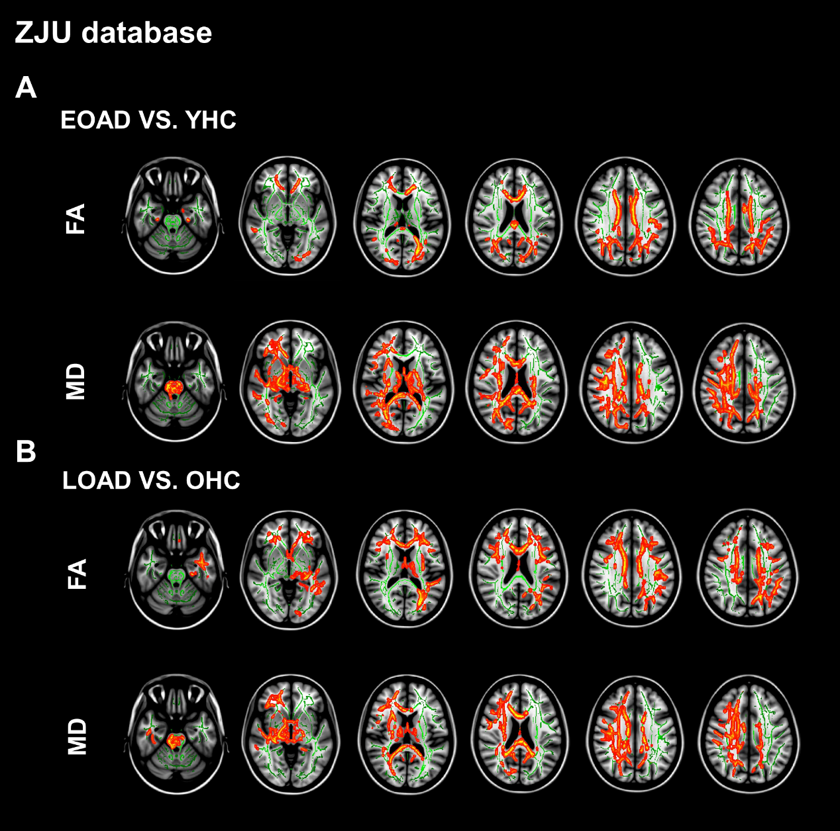

- Supplementary information regarding the fixel-based analysis
Supplementary Figure 2 illustrates the fiber tract-specific reduction in EOAD/LOAD versus controls from whole-brain FBA. Figure A and B represent results from ZJU and ADNI databases, respectively. We color-coded the significant streamlines (patients versus controls) by streamline orientation (left-right: red; inferior-superior: blue; anterior-posterior: green).
Abbreviation: EOAD, early-onset Alzheimer’s disease; LOAD, late-onset Alzheimer’s disease; FBA, fixel-based analysis; FD, fiber density; FC, fiber bundle cross-section; FDC, fiber density & bundle cross-section
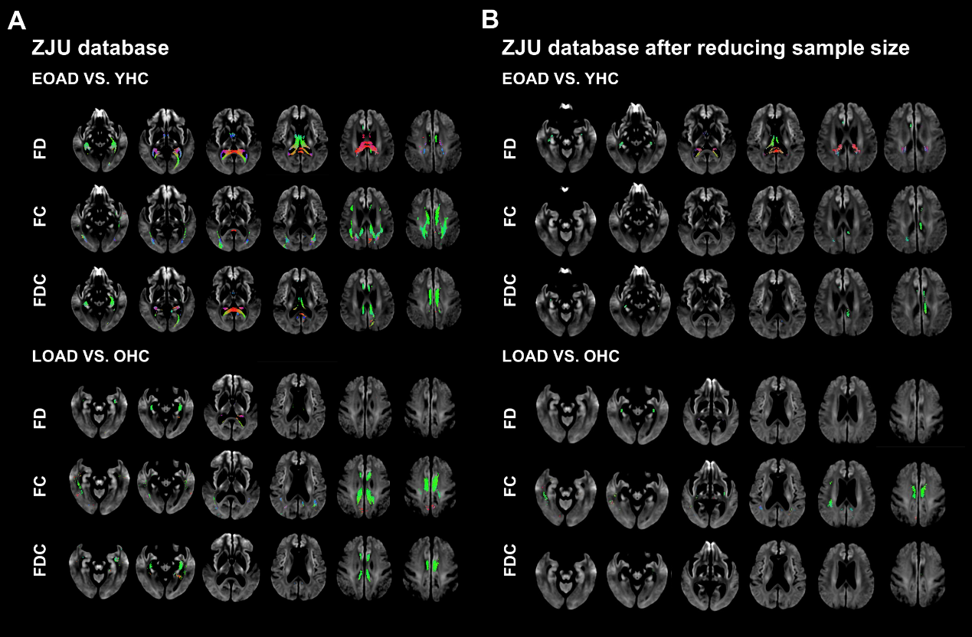

5.2 Repeated FBA based on the matched sample size of both databases
Due to the differences in the sample sizes of two independent databases, different statistical effects may contribute to the repeated result difference between databases. To eliminate the potential factor, we compressed the sample of the ZJU database to the same size as the ADNI database. There is still no significant differences in age, gender, education, general cognitive, and disease severity between groups of patients and controls in the compressed ZJU database. Then, we re-performed a whole brain-based FBA in the ZJU database after sample reduction (FWE-corrected, p < 0.05, 5000 permutations) [12].

Although the affected regions got smaller, the trend of results remained unchanged (Supplementary Figure 3). We found that EOAD had widespread FD decreases in the splenium of corpus callosum (SCC), left fornix-HP, and bilateral dorsal and ventral cingulum relative to YHC. Additionally, EOAD had an FC decrease in the bilateral dorsal cingulum relative to YHC. Regarding the FDC, we found that EOAD patients had a widespread decrease in the bilateral dorsal and ventral cingulum, and left fornix-HP relative to YHC. By contrast, we found that LOAD patients had a marked FD decrease in the bilateral ventral cingulum and FC decrease in bilateral dorsal and ventral cingulum relative to OHC. No difference in FDC existed between LOAD and ONC.

Supplementary figure 3 illustrates the fiber tract-specific reduction in EOAD/LOAD versus controls from whole-brain FBA. Figure A and B represent results from the database of ZJU and ZJU after sample reduction, respectively. We color-coded the significant streamlines (patients versus controls) by streamline orientation (left-right: red; inferior-superior: blue; anterior-posterior: green). Abbreviation: FBA, fixel-based analysis; FD, fiber density; FC, fiber bundle cross-section; FDC, fiber density & bundle cross-section
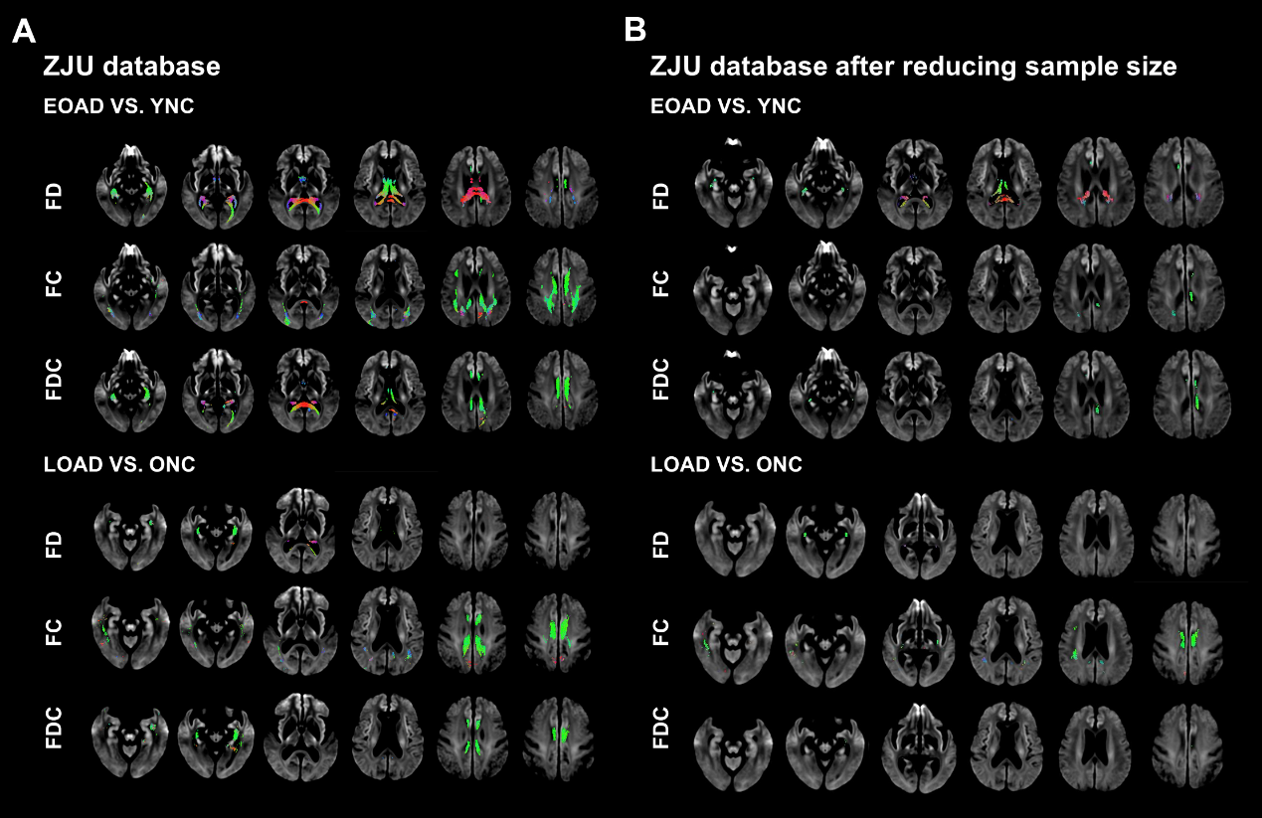
6. Association between fixel-based analysis metrics and cognitive/PET data across groups
Across four groups (EOAD, YHC, LOAD, and OHC), we correlated both the mean FD and FC of significant tracts in group differences analyses with the cognitive score (uncorrected, p < 0.001, controlling age and gender). Additionally, in the ADNI database, we also correlated both the mean FD and FC of significant tracts in group differences analyses with the PET data (uncorrected, p < 0.001, controlling age and gender).

6.1 ZJU database (across groups)
Regarding the WM microstructural metric, we found that MMSE was related with FD in SCC (r = 0.33), bilateral dorsal cingulum (r = 0.40/0.38, respectively), left ventral cingulum (r = 0.48), bilateral inferior longitudinal fasciculus/inferior frontal-occipital fasciculus (ILF/IFOF) (r = 0.23/0.25, respectively); while CDR sum was related with FD in the SCC (r = -0.31), bilateral dorsal cingulum (r = -0.28/-0.26, respectively), left ventral cingulum (r = -0.42); delay recall was related with FD in the SCC (r = 0.24), fornix column and body (r = 0.23), bilateral dorsal (r = 0.38/0.34, respectively) and ventral cingulum (r = 0.28/0.43, respectively); TMT-A was related with FD in bilateral dorsal cingulum (r = -0.35/-0.31, respectively), left ventral cingulum (r = -0.33); TMT-B was related with FD in SCC (r = -0.28), bilateral dorsal cingulum (r = -0.39/-0.33, respectively), left ventral cingulum (r = -0.39), bilateral ILF/IFOF (r = -0.27/-0.25. respectively); SVF was related with FD in the bilateral dorsal cingulum (r = 0.30/0.29, respectively) and left ventral cingulum (r = 0.36); CDT was related with FD in SCC (r = 0.31), bilateral dorsal cingulum (r = 0.30/0.31, respectively), left ventral cingulum (r = 0.30), right PTR (r = 0.24).

Regarding the macrostructural metric, we found that MMSE was related with FC in SCC (r = -0.35), bilateral dorsal cingulum (r = 0.26/0.33, respectively), ILF/IFOF (r = 0.28/0.25, respectively), and PTR (r = 0.39/0.43, respectively); while CDR sum was related with FC in SCC (r = -0.29), left dorsal cingulum (r = -0.28), and bilateral PTR (r = -0.32/-0.35, respectively). Delay recall was related with FC in SCC (r = 0.26) and bilateral PTR (r = 0.31/0.34, respectively). TMT-A was related with FC in bilateral PTR (r = -0.27/-0.30, respectively); TMT-B was related with FC in bilateral PTR (r = -0.32/-0.28, respectively). SVF was related with SCC (r = 0.28), left dorsal cingulum (r = 0.26), bilateral PTR (r = 0.29/0.38, respectively). CDT was related with FC in SCC (r = 0.26), left dorsal cingulum (r = 0.23), and bilateral PTR (r = 0.31/0.28, respectively).

6.2 ADNI database (across groups)
Regarding the WM microstructural metric, we found that MMSE was related with reduced FD in SCC (r = 0.33), bilateral dorsal cingulum (r = 0.40/0.38, respectively), left ventral cingulum (r = 0.48), and bilateral ILF/IFOF (r = 0.23/0.25, respectively); while CDR sum was related with reduced FD in SCC (r = -0.31), bilateral dorsal cingulum (r = -0.28/-0.26, respectively), left ventral cingulum (r = 0.42). Delay recall was related with FD in fornix column and body (r = 0.41). TMT-B was related with FD in SCC (r = -0.35), fornix column and body (r = -0.44), left PTR (r = -0.31). SVF was related with FD in SCC (r = 0.42), fornix column and body (r = 0.40), and left PTR (r = 0.44).

Regarding the macrostructural metric, we found that MMSE was related with reduced FC in SCC (r = 0.35), bilateral dorsal cingulum (r = 0.26/0.33, respectively), ILF/IFOF (r = 0.28/0.25, respectively), PTR (r = 0.39/0.43, respectively); while CDR sum was related with reduced FC in SCC (r = -0.29), left dorsal cingulum (r = -0.28), and bilateral PTR (r = -0.32/-0.35, respectively). Delay recall was related with FC in fornix column and body (r = -0.34). TMT-B was related with FC in SCC (r = -0.34). SVF was related with FC in left dorsal cingulum (r = 0.33).

7. Association between fixel-based analysis metrics and cognitive/PET data across patients
Subsequently, across patient groups (EOAD and LOAD), we correlated both the mean FD and FC of significant tracts in group differences analyses with the cognitive score (uncorrected, p < 0.05, controlling age and gender).

7.1 ZJU database
Regarding the WM microstructural metric, we found that MMSE was related with FD in left PTR (r = 0.23); CDT was related with FD in the bilateral PTR (r = 0.26 and 0.24, respectively); delay recall was related with FD in the left ventral cingulum (r = 0.27); SVF was related with FD in the left ventral cingulum (r = 0.26) and left ILF/IFOF (r = 0.25); TMT-A was related with FD in the SCC (r = -0.24), bilateral dorsal cingulum (r = -0.24/-0.23, respectively), and left ventral cingulum (r = -0.27); TMT-B was related with FD in the ventral cingulum (r = -0.23). Regarding the macrostructural metric, we found that MMSE was related with FC in the dorsal cingulum (r = 0.24), delay recall was related with FC in the fornix column and body (r = -0.29), bilateral fornix HP (r = -0.25/-0.25, respectively); while TMT-B was related with FC in the right PTR (r = -0.23).

  - ADNI database
Regarding the WM microstructural metric, we found that MMSE was related with FD in the SCC (r = 0.38), fornix column and body (r = 0.40), left PTR (r = 0.35); CDR was related with FD in the SCC (r = -0.31), fornix column and body (r = -0.36), right dorsal cingulum (r = -0.31), left ILF/IFOL (r = -0.35); SVF was related with FD in the SCC (r = 0.37), fornix column and body (r = 0.46), and bilateral PRT (r = 0.29/0.49, respectively); TMT-B was related with FD in the SCC (r = -0.31) and fornix column and body (r = -0.41), left PRT (r = -0.32). Regarding the WM macrostructural metric, we found that MMSE was related with FC in the fornix column and body (r = -0.37), SVF was related with FC in the left dorsal cingulum (r = 0.35), TMT-A was related with FC in the SCC (r = -0.36), bilateral dorsal cingulum (r = -0.35/-0.48, respectively), and left PTR (r = -0.33); TMT-B was related with FC in the SCC (r = -0.37). Further, we found mean tau retention of Braak I-II was related with FC in the right PTR (r = 0.83).

8. REFERENCES
[1] Li K-C, Luo X, Zeng Q-Z, Xu X-J, Huang P-Y, Shen Z-J, et al. Distinct Patterns of Interhemispheric Connectivity in Patients With Early-and Late-Onset Alzheimer’s Disease. Frontiers in aging neuroscience. 2018;10:261.
[2] Folstein MF, Robins LN, Helzer JE. The mini-mental state examination. Archives of general psychiatry. 1983;40:812-.
[3] Morris JC. The Clinical Dementia Rating (CDR): current version and scoring rules. Neurology. 1993.
[4] Sheikh JI, Yesavage JA. Geriatric Depression Scale (GDS): recent evidence and development of a shorter version. Clinical Gerontologist: The Journal of Aging and Mental Health. 1986.
[5] Dubois B, Feldman HH, Jacova C, DeKosky ST, Barberger-Gateau P, Cummings J, et al. Research criteria for the diagnosis of Alzheimer's disease: revising the NINCDS–ADRDA criteria. The Lancet Neurology. 2007;6:734-46.
[6] Canu E, Agosta F, Spinelli EG, Magnani G, Marcone A, Scola E, et al. White matter microstructural damage in Alzheimer's disease at different ages of onset. Neurobiology of aging. 2013;34:2331-40.
[7] Cho H, Choi JY, Lee SH, Lee JH, Choi Y-C, Ryu YH, et al. Excessive tau accumulation in the parieto-occipital cortex characterizes early-onset Alzheimer's disease. Neurobiology of aging. 2017;53:103-11.
[8] Fischl B. FreeSurfer. Neuroimage. 2012;62:774-81.
[9] Jenkinson M, Beckmann CF, Behrens TE, Woolrich MW, Smith SM. Fsl. Neuroimage. 2012;62:782-90.
[10] Smith SM, Jenkinson M, Johansen-Berg H, Rueckert D, Nichols TE, Mackay CE, et al. Tract-based spatial statistics: voxelwise analysis of multi-subject diffusion data. Neuroimage. 2006;31:1487-505.
[11] Smith SM, Nichols TE. Threshold-free cluster enhancement: addressing problems of smoothing, threshold dependence and localisation in cluster inference. Neuroimage. 2009;44:83-98.
[12] Nichols TE, Holmes AP. Nonparametric permutation tests for functional neuroimaging: a primer with examples. Human brain mapping. 2002;15:1-25.

