Building a Second-Opinion Tool for Classical Polygraph
Dmitri Asonov, Maksim Krylov, Vladimir Omelyusik¹, Anastasiya Ryabikina²,
Evgeny Litvinov¹, Maksim Mitrofanov², Maksim Mikhailov², Albert Efimov¹
Sberbank
Supplementary material

Supplementary Table 1 (Polygraph raw data description):
Raw signal | Description
ABDOMINAL_RESP | Abdominal respiration
ABS_BLOOD_VOLUME | Absolute blood volume
BLOOD_VOLUME | Relative blood volume
EDA | Electrodermal activity
HEART_RATE | Heart rate
OPTIONAL | Additional sensor of examiner choice
PLE | Photoelectric plethysmograph
THORACIC_RESP | Thoracic respiration
TONIC_EDA | Tonic electrodermal activity
TREMOR | Tremor

Supplementary Table 2 (Screening topics description):
Screening topic (risk factor) | Description (sample question)
Drug abuse | Have you consumed illegal drugs in the previous 12 months?
Corruption | Have you received illegal remuneration from a client ever?
Conf. info leak | Have you used information containing bank secrecy for personal purposes?
Debt | Are you currently experiencing difficulties dealing with debt?
Unrep. income | Do you receive income from outside of the corporation that you have not reported?
Criminal history | Have you ever been found guilty of a criminal offense by Court?
IRD violation | Have you ever violated an Internal (Corporate) Regulatory Document?

Supplementary Table 3 (Question types):
Question type / in Russian | Description
Relevant / Пв | Questions directly related to the focus of an investigation
Comparison / Вс | Questions for which the responses are designed to be compared to responses to relevant questions
Irrelevant / Нв | Questions which are believed to have no, or very little, emotional impact on a subject
Sacrifice relevant / 0, Жв | Question which makes it possible to reduce the probability of error, which is said to be the result of evaluating the first relevant question in the series

Supplementary Table 4 (Testing for bias in sex attribute in the dataset):
Sex | All topics |  | Drug abuse |  | Corruption |  | IRD violation
Sex | Count | % of DI | Count | % of DI | Count | % of DI | Count | % of DI
Male | 1222 | 13,7% | 1181 | 7,9% | 817 | 4% | 724 | 2,8%
Female | 872 | 10,7% | 831 | 5,3% | 619 | 2,4% | 705 | 3,7%

Supplementary Figure 1 (Convolution of raw data)
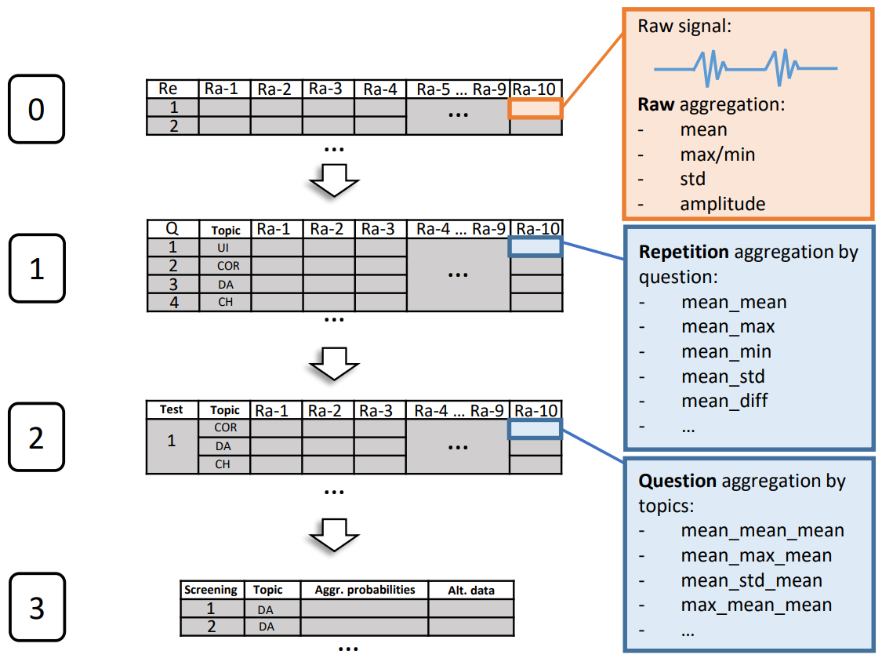

Supplementary Table 5 (Three Models built on cut but balanced by DIs dataset: a) One topic model; b) Basic model without feature “topic”; c) Basic model with feature “topic”)
 | All topics | Drug abuse | Corruption | Conf.  info leak | Debt | Unrep. income | Crime history | IRD violation
ROC AUC (Std.) | a. 0.67 (0.02)  b. 0.67 (0.02)  c. 0.68 (0.02) | 0.80 (0.04)  0.67 (0.10)  0.69 (0.05) | 0.66 (0.04)  0.68 (0.04)  0.66 (0.06) | 0.70 (0.04)  0.67 (0.04)  0.71 (0.03) | 0.66 (0.06)  0.65 (0.04)  0.64 (0.03) | 0.67 (0.03)  0.67 (0.06)  0.67 (0.04) | 0.65 (0.03)  0.74 (0.05)  0.70 (0.04) | 0.53 (0.04)  0.65 (0.06)  0.66 (0.03)
Recall (Std.) | a. 0.12 (0.01)  b. 0.16 (0.03)  c. 0.17 (0.01) | 0.21 (0.08)  0.19 (0.10)  0.10 (0.06) | 0.08 (0.04)  0.12 (0.03)  0.09 (0.06) | 0.21 (0.1)  0.09 (0.03)  0.19 (0.05) | 0.09 (0.06)  0.18 (0.12)  0.12 (0.05) | 0.07 (0.04)  0.16 (0.04)  0.05 (0.02) | 0.07 (0.07)  0.15 (0.09)  0.15 (0.09) | 0.10 (0.04)  0.23 (0.07)  0.27 (0.04)
Precision (Std.) | a. 0.04 (0.00)  b. 0.06 (0.01)  c. 0.06 (0.00) | 0.09 (0.04)  0.05 (0.03)  0.15 (0.09) | 0.04 (0.02)  0.06 (0.02)  0.06 (0.04) | 0.05 (0.02)  0.04 (0.02)  0.07 (0.03) | 0.02 (0.02)  0.05 (0.02)  0.06 (0.03) | 0.03 (0.02)  0.07 (0.02)  0.02 (0.02) | 0.01 (0.01)  0.05 (0.04)  0.05 (0.04) | 0.02 (0.01)  0.08 (0.02)  0.08 (0.01)
F1_score  (Std.) | a. 0.06 (0.00)  b. 0.08 (0.01)  c. 0.09 (0.01) | 0.10 (0.04)  0.08 (0.04)  0.12 (0.07) | 0.06 (0.02)  0.07 (0.02)  0.07 (0.05) | 0.08 (0.03)  0.05 (0.02)  0.10 (0.01) | 0.04 (0.02)  0.07 (0.03)  0.08 (0.03) | 0.04 (0.03)  0.10 (0.02)  0.02 (0.02) | 0.02 (0.02)  0.07 (0.05)  0.07 (0.06) | 0.04 (0.02)  0.12 (0.03)  0.13 (0.02)
Accuracy (Std.) | a. 0.93 (0.01)  b. 0.94 (0.00)  c. 0.94 (0.00) | 0.94 (0.01)  0.94 (0.00)  0.96 (0.01) | 0.93 (0.01)  0.93 (0.01)  0.92 (0.01) | 0.94 (0.01)  0.94 (0.01)  0.94 (0.01) | 0.94 (0.01)  0.93 (0.00)  0.92 (0.00) | 0.94 (0.01)  0.95 (0.00)  0.95 (0.01) | 0.93 (0.01)  0.94 (0.00)  0.93 (0.00) | 0.91 (0.01)  0.93 (0.01)  0.92 (0.01)
TNR  (Std.) | a. 0.95 (0.01)  b. 0.95 (0.00)  c. 0.95 (0.00) | 0.95 (0.01)  0.96 (0.00)  0.97 (0.01) | 0.94 (0.01)  0.95 (0.01)  0.94 (0.01) | 0.95 (0.01)  0.95 (0.01)  0.95 (0.01) | 0.96 (0.01)  0.95 (0.01)  0.93 (0.01) | 0.96 (0.00)  0.96 (0.00)  0.96 (0.01) | 0.95 (0.01)  0.95 (0.01)  0.94 (0.01) | 0.92 (0.01)  0.94 (0.01)  0.93 (0.01)
FPR  (Std.) | a. 0.05 (0.01)  b. 0.05 (0.00)  c. 0.05 (0.00) | 0.05 (0.01)  0.04 (0.00)  0.03 (0.01) | 0.06 (0.01)  0.05 (0.01)  0.05 (0.01) | 0.05 (0.01)  0.05 (0.01)  0.05 (0.01) | 0.04 (0.01)  0.05 (0.01)  0.07 (0.01) | 0.04 (0.00)  0.04 (0.00)  0.04 (0.01) | 0.05 (0.01)  0.05 (0.01)  0.06 (0.01) | 0.08 (0.01)  0.06 (0.01)  0.07 (0.01)
Number of DI | 158 | 30 | 30 | 30 | 30 | 24 | 24 | 30

Sber Innovation and Research Department
Internal Security Department
Contact author: MAKrylov@sberbank.ru

