Supplementary Information for
London Underground air pollution particles are finer than you think
H. A. Sheikh^{1*}, P.Y. Tung^{1,2}, E. Ringe^{1,2}, R.J. Harrison¹
¹Department of Earth Sciences, University of Cambridge, Cambridge, UK
²Department of Materials Sciences, University of Cambridge, Cambridge, UK
*has57@cam.ac.uk

This file includes:
Supplementary text S1
Figures S1 to S11
Tables S1 to S3
SI References

Supplementary Information Text

Methods

Sampling campaign. The first sampling campaign was conducted between 15th February 2019 to 4th March 2019. The samples we looked at included personal monitors on station staff conducting gate line duties or static monitors at platforms (see Supplementary Table S2 for locations of the samples analyzed). The air was sampled for 4 hours, and the dust concentration was normalized to an 8-hr time-weighted average (TWA) concentration for respirable dust. The dust concentrations reported in Supplementary Table S2 are TWA concentrations equivalent to 8-hr exposure in an 8-hr period, for example, 4-hr exposure in an 8-hr period, the TWA is 1/2 of the level measured for the 4-hr period. The second sampling campaign was undertaken over three working shifts between 21st April and 8th July 2021 on each of the nine LU tube lines using SKC Personal Environmental Monitor PM_{2.5} and PM₁₀ impactor heads with glass fibre filters. The train operator duty times determined how long the air is sampled which varied between 3-6 hours, and the concentrations are reported in TWA. Route and duty details for the trains are presented in Supplementary Table S3.

LT-SIRM data acquisition. Each sample was wrapped in a cling film and inserted into a gel cap before measuring on the magnetic property measurement system (MPMS). The protocol was sequence was based on¹ and is as follows (a) a room temperature SIRM (RT-SIRM) was imparted in a 2.5 T field and then measured on cooling from 300 to 10 K; (b) the RT-SIRM was then measured on warming back to 300 K; (c) the sample was zero-field cooled (ZFC) to 10 K and a low-temperature SIRM (LT-SIRM) imparted in a 2.5 T field; (d) the ZFC LT-SIRM was measured on warming to 300 K; (e) the sample was then field cooled (FC) in 2.5 T from 300 to 10 K and the resulting FC LT-SIRM was measured from 10 to 300 K.

Tomographic reconstruction. We manually removed frames that were obscured at high angle. The first 13 frames of region 5 (Fig. 4A), last 15 frames of region 11 (Fig. 4B), and last 4 frames of region 12 (Fig. 4C) were not usable, therefore, were removed. We then performed image-shift alignment on Sobel-filtered images using a phase correlation algorithm and tilt-axis alignment using a manual procedure to minimise arcing in the reconstructions. We ran a total of 1000 iterations for all three reconstructions of Chambolle-Pock algorithm² with a weighting of 0.05 for the total variation regularisation term. Dragonfly software was then used to perform intensity thresholding and segmentation of particles (see Fig. 4).

LT-SIRM Sequence
New Datafile "C:\QdSquidVsm\Data\Hassan has57\86\1.dat"
Set Magnetic Field 25000.0Oe at 500.00Oe/sec, Linear, Stable
Wait For Temperature, Field, Delay 300 secs (5.0 mins), No Action
Set Magnetic Field 0.0Oe at 500.00Oe/sec, No O'Shoot, Stable
Wait For Temperature, Field, Delay 300 secs (5.0 mins), No Action
Magnet Reset
Wait For Temperature, Field, Delay 1200 secs (20.0 mins), No Action
DC Measure 10 scans over 35 mm in 4 sec Auto-Tracking
Wait For Temperature, Field, Delay 60 secs (1.0 mins), No Action

New Datafile ""C:\QdSquidVsm\Data\Hassan has57\86\2_RT-SIRM_cooldown_in_ZF.dat"
MPMS3 Moment (DC) vs Temperature 300K to 10K Sweep Continuous Auto-Tracking
Wait For Temperature, Field, Delay 60 secs (1.0 mins), No Action

New Datafile ""C:\QdSquidVsm\Data\Hassan has57\86\3_RT-SIRM_warm_up_in_ZF.dat"
MPMS3 Moment (DC) vs Temperature 10K to 300K Sweep Continuous Auto-Tracking
Wait For Temperature, Field, Delay 60 secs (1.0 mins), No Action

Set Temperature 10K at 35K/min. Fast Settle
Wait For Temperature, Field, Delay 600 secs (10.0 mins), No Action

New Datafile " C:\QdSquidVsm\Data\Hassan has57\86\4_10K_remanence.dat"
Set Magnetic Field 25000.0Oe at 500.00Oe/sec, Linear, Stable
Wait For Temperature, Field, Delay 300 secs (5.0 mins), No Action
Set Magnetic Field 0.0Oe at 500.00Oe/sec, No O'Shoot, Stable
Wait For Temperature, Field, Delay 300 secs (5.0 mins), No Action
Magnet Reset
Wait For Temperature, Field, Delay 1200 secs (20.0 mins), No Action
DC Measure 10 scans over 35 mm in 4 sec Auto-Tracking
Wait For Temperature, Field, Delay 60 secs (1.0 mins), No Action

New Datafile " C:\QdSquidVsm\Data\Hassan has57\86\5_LT-SIRM_warm_up_in_ZF.dat"
MPMS3 Moment (DC) vs Temperature 10K to 300K Sweep Continuous Auto-Tracking
Wait For Temperature, Field, Delay 60 secs (1.0 mins), No Action

Set Magnetic Field 25000.0Oe at 500.00Oe/sec, No O'Shoot, Stable
Wait For Temperature, Field, Delay 600 secs (10.0 mins), No Action

New Datafile " C:\QdSquidVsm\Data\Hassan has57\86\6_MvT_cooldown_in_25000Oe.dat"
MPMS3 Moment (DC) vs Temperature 300K to 10K Sweep Continuous Auto-Tracking
Wait For Temperature, Field, Delay 60 secs (1.0 mins), No Action

New Datafile " C:\QdSquidVsm\Data\Hassan has57\86\7_10K_remanence_after_FC.dat"
Set Magnetic Field 0.0Oe at 500.00Oe/sec, No O'Shoot, Stable
Wait For Temperature, Field, Delay 300 secs (5.0 mins), No Action
Magnet Reset
Wait For Temperature, Field, Delay 1200 secs (20.0 mins), No Action
DC Measure 10 scans over 35 mm in 4 sec Auto-Tracking
Wait For Temperature, Field, Delay 60 secs (1.0 mins), No Action

New Datafile " C:\QdSquidVsm\Data\Hassan has57\86\8_LT-SIRM_warm_up_in_ZF_after_FC.dat"
MPMS3 Moment (DC) vs Temperature 10K to 300K Sweep Continuous Auto-Tracking
Wait For Temperature, Field, Delay 60 secs (1.0 mins), No Action

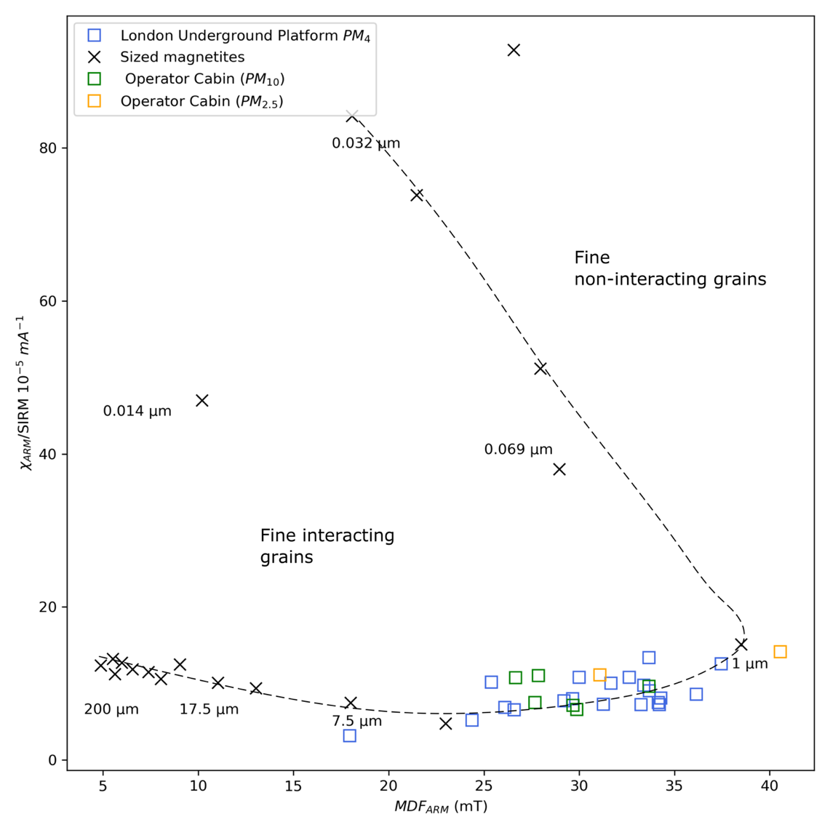

Figure S1. Bulk room temperature magnetic granulometric measurements presented on a classic sized-magnetite measurements and is indicative of mean grain size^{3,4}. On y-axis we have plotted a ratio of room temperature anhysteretic remanent magnetization (ARM) susceptibility (χ_{ARM}) normalized by saturation isothermal remanent magnetization (SIRM). On x-axis, the ARM mean destructive field (MDF_{ARM}) of each sample is plotted, which is defined when the magnetic fraction loses half of its remanent magnetization.

Figure S2. Low-temperature remanent magnetization curves for four different samples from different localities within the London Underground. Room temperature saturation isothermal remanence (RT-SIRM) warming, and cooling curves (A, C, E) do not show any evidence of Verwey transition at 120-125 K or lower K, hinting the sample has had time to oxidize sufficiently to suppress the transition. Zero-field cooled, and field cooled (ZFC and FC) curves (B, D, F) also do not show any evidence for Verwey transition or dampened transition (usually seen for surface oxidized magnetite).

Figure S3. Frequency dependent curves as a function of temperature. (A and C): At each temperature, in phase (real) susceptibility curves at frequencies f= 1.0, 5.3, 28.3, 150.5 to 800.5 Hz for sample 180487-56 and 180487-92 respectively, (B and D): Out of phase susceptibility (imaginary) curves at each temperature. (E and F) frequency dependent susceptibility calculated by subtracting susceptibility at 150 Hz from 1.0 Hz.

Figure S4. Domain state signals from conventional FORC and FORC-type diagrams of ⁵ from sample 180487-58. (A) a conventional FORC diagram shows a SD and a Vortex/PSD signal. (B) signal from remanence-bearing particles includes an interacting SD component, and a component near the SP/SD threshold that is visible in the negative B_{u} axis. (C) The transient (tFORC) diagram shows absence of an ‘MD’ wing and upper and lower lobes of the diagram represent vortex state annihilation and nucleation. (D) The induced (iFORC) diagram shows weak evidence of the negative-positive-negative-positive (NPNP) signal associated with vortex and/or interacting SD particles.

Figure S5. Scanning electron microscopy (SEM) (A): Zoomed out BSE image of the TEM grid showing sparse clusters of Fe-oxide. (B): EDS sum spectra of the region showing strong signals of Al and Cu which are coming from the stub and the grid respectively. (C) confirms the Al signal is from scattering of electrons from the TEM stub holder for the SEM, and also confirms the presence of Fe-rich clusters.

Figure S6. Scanning electron microscopy (SEM). Detailed textural and chemical analysis using backscatter electron (BSE) image and elemental maps produced using energy dispersive x-ray spectroscopy (EDS). (A) shows the associated BSE image; (B) EDS spectrum; (C) elemental maps for the region of interest, (D) BSE image and respective cluster map showing at least 4 identifiable phase; Red: Fe-rich, Yellow: Ca-rich, Green: Si-rich, and Blue: Nb-rich (E) Soft-max normalised signal⁶ for each element where strong signal shows that elements are present at above-average levels and EDS spectrum of cluster 3 (Fe-rich phase); (F) EDS spectrum after performing non-negative matrix factorisation (NMF) on the identified clusters removes the dominant background peak due to the Al SEM stub.

Figure S7. Scanning electron microscopy (SEM) (A) BSE image of an Fe-oxide particle cluster, (B) sum spectrum of elemental count from region A, (C) elemental maps showing presence of Ca-rich signal from a particle in the background.

Figure S8. Transmission electron microscopy (TEM) images of sample 180487-86 showing (A) isolated Fe-oxide nanoparticles and clusters of Fe-oxide nanoparticles (B) showing interacting individual nanoparticles.

Figure S9. Morphological and chemical fingerprints of representative Fe-bearing particles from London Underground. (A) HAADF-STEM imaging of spherical Fe-O nanoparticles. (B) EDS spectrum of the marked region. (C) HAADF and EDS chemical maps of the marked region, confirming strong signals from Fe and O, consistent with particles examined using the SEM-EDS.

Figure S10. Quantification of particle sizes done by individually measuring particle diameters from clusters in HRTEM images. (A) shortest diameter (B) longest diameter (C) aspect ratio i.e., the circularity of particles measured as a ratio of width/length (a value of 1.0 is a perfect sphere).

Figure S11. Quantification of particle sizes from segmented 3D tomography data on dragonfly. (A) shortest diameter of particle (B) longest diameter of particle (C) aspect ratio i.e., the circularity of particles measured as a ratio of width/length (a value of 1.0 is a perfect sphere. Green: Reconstruction-region-12; Red: Reconstruction-region-11; Blue: Reconstruction-region-5.

Table S1. Dimensional measurements for Fe-oxide particles observed under transmission electron microscopy (TEM) of PM-loaded air filters.

Table S2. List of samples analysed in this study. Route details for operator cabin data is presented in Table S3.

Table S3. Route details and timings of sampling PM in the operator cabins.

SI References

1. Lagroix, F. & Guyodo, Y. A new tool for separating the magnetic mineralogy of complex mineral assemblages from low temperature magnetic behavior. Front Earth Sci (Lausanne) 5, (2017).
2. Chambolle, A. & Pock, T. A first-order primal-dual algorithm for convex problems with applications to imaging. J Math Imaging Vis 40, (2011).
3. Maher, B. A. Magnetic properties of some synthetic sub‐micron magnetites. Geophysical Journal 94, (1988).
4. Thompson, R. & Oldfield, F. Environmental Magnetism. Environmental Magnetism (1986). doi:10.1007/978-94-011-8036-8.
5. Zhao, X. et al. Magnetic domain state diagnosis using hysteresis reversal curves. J Geophys Res Solid Earth 122, (2017).
6. Tung, P.-Y., Sheikh, H. A., Ball, M. R., Nabiei, F. & Harrison, R. SIGMA: Spectral Interpretation using Gaussian Mixtures and Autoencoder. Earth and Space Science Open Archive 22 (2022) doi:10.1002/essoar.10511396.1.

