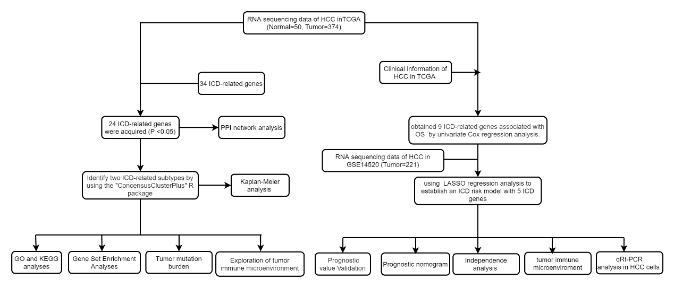

Supplementary Figure 1

Flow graph of this study.

