Supplementary material

Search strategy
The searches were conducted in title, abstract and keywords. Search terms used for each category are provided in Table A1. For the specific search terms for each database, see supplementary information: https://www.crd.york.ac.uk/PROSPEROFILES/227092_STRATEGY_20210111.pdf
Table S1: Search terms
1. Household energy use | a. Cooking | cook*or stove* or hob
1. Household energy use | b. Heating | heat* or “gas fire “or “gas appliance”
1. Household energy use | c. Lighting | light* or lamp* or lantern*
1. Household energy use | d. General | “household energy” or “household fuel”
2. Fuels | “clean fuel*” or “cleaner fuel*” or “alcohol fuel*” or “biogas” or “butane” or “dimethyl ether” or “ethanol” or “gas” or “gel fuel” or kerosene or “liquefied petroleum gas” or “liquified petroleum gas” or LPG or methane or methanol or “natural gas” or paraffin* or “piped natural gas” or propane or gasoline or oil or diesel
3. Pollutants | emission* or pollutant* or concentration or exposure or acenaphthene or acenaphthylene or anthracene or “benz[a]anthracene” or benzene or C₆H₆ or “benzo[a]pyrene” or “benzo[k]fluoranthene” or “benzo[g,h,i,]perylene” or “benzo[k]fluoranthene” or butadiene or “carbon monoxide” or chrysene or “dibenzo[a,h]anthracene” or fluoranthene or C₁₆H₁₀ or fluorene or formaldehyde or “Indeno[1,2,3-c,d]pyrene” or naphthalene or “nitric oxide” or “nitrogen dioxide” or NO2 or “nitrogen oxide*” or NOx or “nitrous acid” or HONO or “particulate matter” or PM* or phenanthrene or “polycyclic aromatic hydrocarbon*” or PAH or PAHs or pyrene or “sulfur dioxide” or “sulphur dioxide” or SO₂ or “ultrafine particle*” or UFP
4. Health  effects or symptoms or burns, injuries, poisoning | Effects related to emissions or accidents/ injuries | health or “acute lower respiratory” or ALRI or “all cause mortality” or asthma or birthweight* or “birth weight” or “still birth*” or stillbirth* or stunting or stunted or “cognitive development” or “cardiovascular disease” or CVD or “cognitive impair*” or “chronic obstructive pulmonary disease” or COPD or cataract* or cancer* or “lung function” or stroke or tuberculosis or TB or “small for gestational age” or “coronary heart disease” or chd or “coronary artery disease” or hypertension or “heart disease” or “isch* heart disease” or “IHD or diabetes or pneumonia or “congenital defect*” or “heart attack” or “congestive heart failure” or “CHF” or “lung infection” or “bronchial reactivity” or “bronchoconstriction” or “airway inflammation” or asphyxia* or bronchitis or tumour* or lympho* or (respiratory) W/1 (disease* or illness* or disorder* or condition* or arrest) or accident* or injur* or burn* or poisoning or scald*
4. Health  effects or symptoms or burns, injuries, poisoning | Symptoms related to emissions | symptom* or cough or drowsiness or headache* or phlegm or “running eye*” or “runny eye*” or “sore eye*” or tired* or wheez* or unconsciousness or dizziness or nausea or confusion or disorientation or “chest pain” or weakness or “memory loss” or “speech problem*” or “insomnia” or breathlessness or paraesthesia or fatigue
5. Context | housing or house* or household or residential or dwelling* or home or domestic or community or flat* or apartment or towerblock* or “tower block” or bedsit or “bed sit” or “high rise” or highrise or multisor* or “multi stor*” or bungalow or indoor or “indoor air quality” or indoor or “living environment” or “living quarter” or “indoor air pollution” or “household air pollution”

Searches were run separately by household energy use and then combined as followed:
Cooking: (1a) and (2) and [(3) or (4)]
Heating: (1b) and (2) and [(3) or (4)] and (5)
Lighting: (1c) and (2) and [(3) or (4)] and (5)
General: (1d) and (2) and [(3) or (4)]
All: Cooking or Heating or Lighting or General

Data extraction form
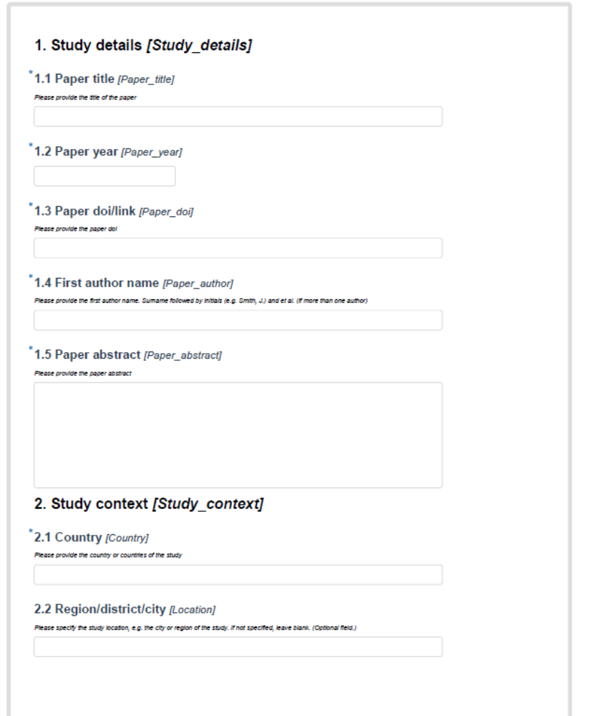
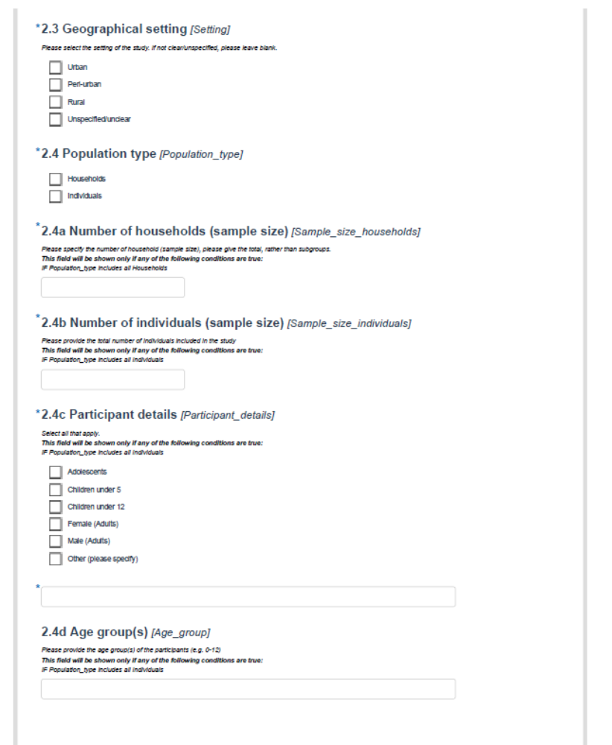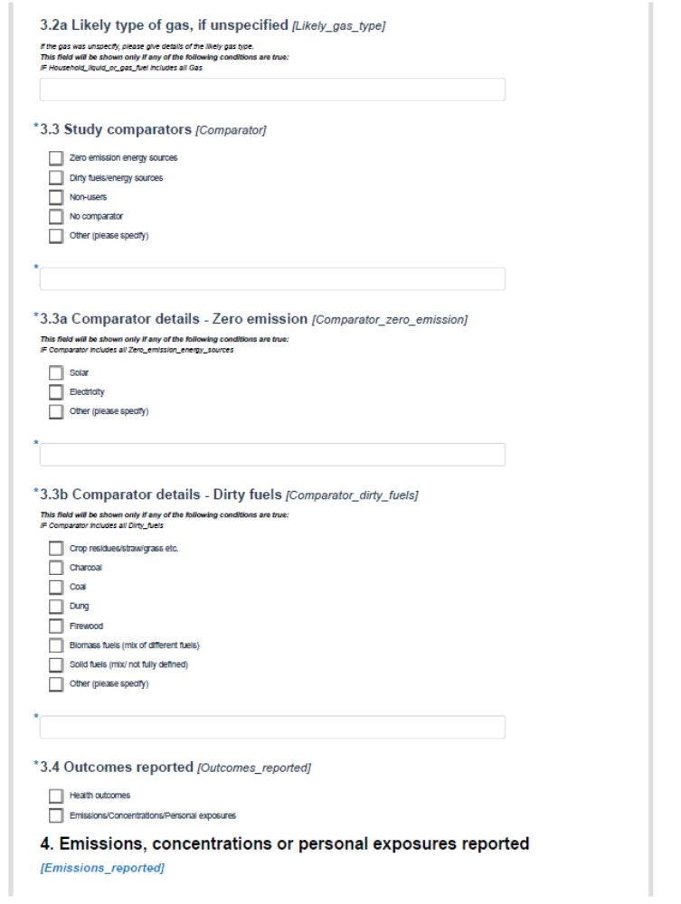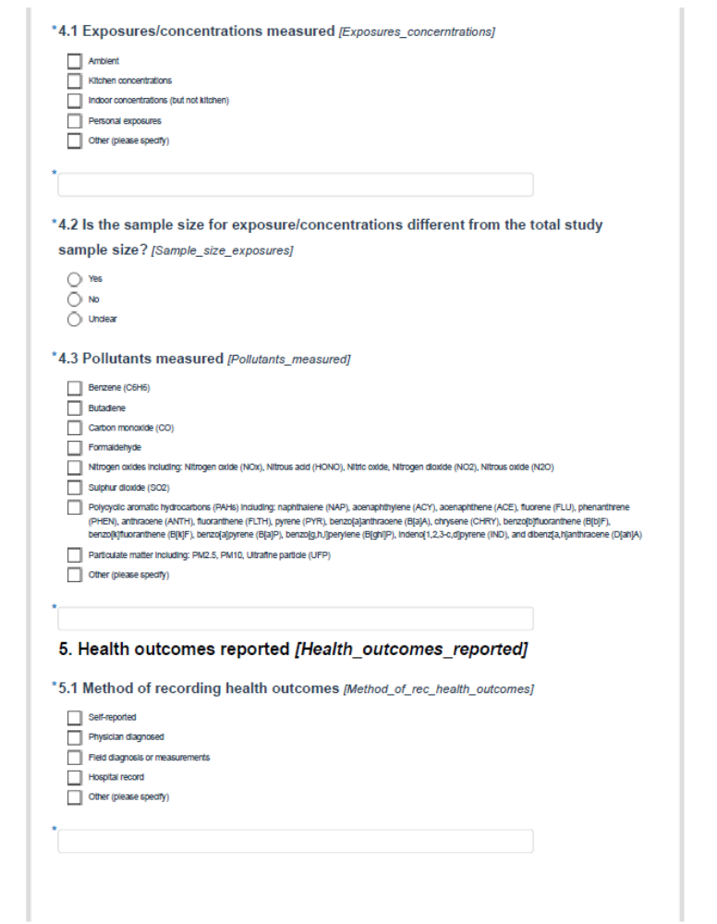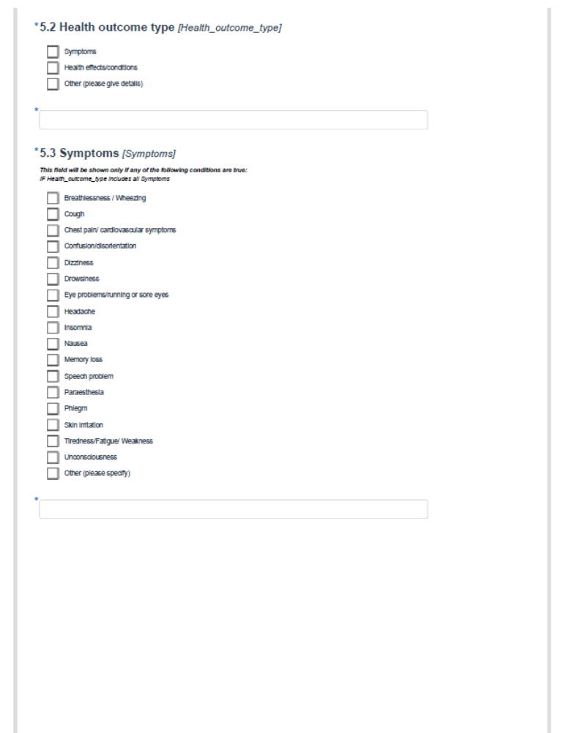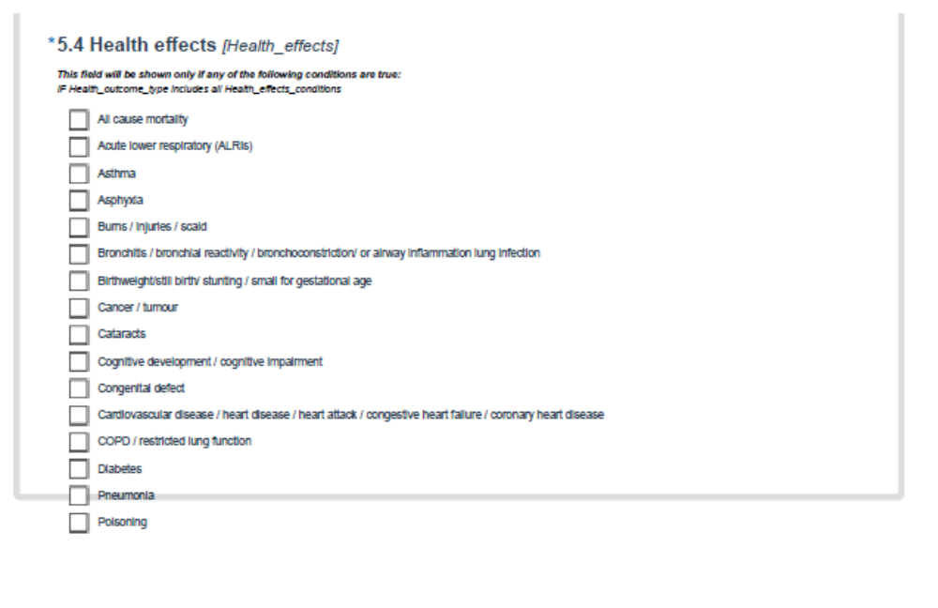

Database summary
The following table presents the database variables grouped into different sections using the same colour coding scheme as the Excel file. The variables correspond to the columns of the Excel database according to the following collapsed schema:
Section Name | Paper_info |  |  | …
Variable Name | Author | … | Paper_Language | …
Paper 1 | xxx | … | xxx | …
Paper 2 | xxx | … | xxx | …
… | … | … | … | …
Paper n | xxx | … | xxx | …

Variable name |  | Variable type
Section: Paper_info
Author |  | Info
Year |  | Numerical
Title |  | Info
Doi |  | Info
Abstract |  | Info
Paper_Language |  | Info
Section: Study_context
Country |  | Info
Income_level |  | Categorical
Location |  | Info
Setting_Urban |  | Binary (Yes/No)
Setting_Peri_Urban |  | Binary (Yes/No)
Setting_Rural |  | Binary (Yes/No)
Setting_Unspecified |  | Binary (Yes/No)
Section: Study_population
Population_Type_Households |  | Binary (Yes/No)
Population_Type_Individuals |  | Binary (Yes/No)
Sample_Size_Households |  | Numerical
Sample_Size_Individuals |  | Numerical
Adolescents_12_to_17 |  | Binary (Yes/No)
Children_0_to_4 |  | Binary (Yes/No)
Children_5_to_11 |  | Binary (Yes/No)
Female_Adults |  | Binary (Yes/No)
Male_Adults |  | Binary (Yes/No)
Unspecified_demografic |  | Binary (Yes/No)
Participant_Other_Comment |  | Info
 | Section: Study_Design
 | Study_Design | Categorical
 | Study_Design_Other | Info
 | Section: Household_Energy_End_Use
 | Cooking | Binary (Yes/No)
 | Heating | Binary (Yes/No)
 | Lighting | Binary (Yes/No)
 | Unspecified | Binary (Yes/No)
 | Section: Liquid_or_gaseous_fuels
 | Biogas | Binary (Yes/No)
 | Diesel | Binary (Yes/No)
 | Ethanol | Binary (Yes/No)
 | Gas_Unspecified | Binary (Yes/No)
 | Gasoline_petrol | Binary (Yes/No)
 | Kerosene_Paraffin | Binary (Yes/No)
 | LPG | Binary (Yes/No)
 | Natural_Gas_Piped_Natural_Gas_Methane | Binary (Yes/No)
 | Oil_Including_Lamp_Oil | Binary (Yes/No)
 | Section: Emissions_concentration_or_personal_exposure_studies
 | Emissions_Concentrations_or_Personal_Exposures_included | Binary (Yes/No)
 | Ambient_Concentrations | Binary (Yes/No)
 | Kitchen_Concentrations | Binary (Yes/No)
 | Indoor_Concentrations_But_Not_Kitchen | Binary (Yes/No)
 | Personal_Exposures | Binary (Yes/No)
 | Black_Carbon | Binary (Yes/No)
 | BTEX | Binary (Yes/No)
 | Butadiene | Binary (Yes/No)
 | Carbon_Monoxide_CO | Binary (Yes/No)
 | Formaldehyde | Binary (Yes/No)
 | Nitrogen_Oxides | Binary (Yes/No)
 | Sulphur_Dioxide_SO2 | Binary (Yes/No)
 | Polycyclic_Aromatic_Hydrocarbons_PAHs | Binary (Yes/No)
 | Particulate_Matter | Binary (Yes/No)
 | VOC | Binary (Yes/No)
 | Section: Health_outcomes_studies
 | Health_Outcomes_included | Binary (Yes/No)
 | Self_Reported | Binary (Yes/No)
 | Physician_Diagnosed | Binary (Yes/No)
 | Field_Diagnosis_or_Measurements | Binary (Yes/No)
 | Hospital_Record | Binary (Yes/No)
 | Laboratory_results | Binary (Yes/No)
 | Other_recording_methods | Info
 | Section: Biomarkers_studies
 | Biomarkers_included | Binary (Yes/No)
 | Section: Symptoms_studies
 | Symptoms_included | Binary (Yes/No)
 | Allergic_symptoms | Binary (Yes/No)
 | Chest_Pain_Cardiovascular_Symptoms | Binary (Yes/No)
 | Chest_Tightness | Binary (Yes/No)
 | Cough | Binary (Yes/No)
 | Dizziness | Binary (Yes/No)
 | Ear_Problems | Binary (Yes/No)
 | Eye_Problems_Running_Or_Sore_Eyes | Binary (Yes/No)
 | Gastrointestinal_symptoms | Binary (Yes/No)
 | Headache | Binary (Yes/No)
 | Nausea | Binary (Yes/No)
 | Phlegm | Binary (Yes/No)
 | Respiratory_symptoms_(lower_track_or_unspecified) | Binary (Yes/No)
 | Rhinitis_Allergic_and_non | Binary (Yes/No)
 | Sore_Throat_or_runny_nose_or_other_upper_respiratory_symptoms | Binary (Yes/No)
 | Skin_Irritation_rashes | Binary (Yes/No)
 | Tiredness_Fatigue_Weakness | Binary (Yes/No)
 | Unconsciousness | Binary (Yes/No)
 | Wheezing_Breathlessness_Dyspnea | Binary (Yes/No)
 | Other_Symptoms | Binary (Yes/No)
 | Other_Sympptoms_Comments | Info
 | Section: Disease_and_injury _outcomes_studies
 | Disease_Injury_Outcomes_included | Binary (Yes/No)
 | Accidental_Poisoning_Injuries | Binary (Yes/No)
 | Adverse_Pregnancy_Outcomes | Binary (Yes/No)
 | All_Cause_Mortality | Binary (Yes/No)
 | ALRIs_Pneumonia | Binary (Yes/No)
 | Asthma | Binary (Yes/No)
 | Bronchitis_Bronchial_Reactivity_Bronchoconstriction_Lung_Infection | Binary (Yes/No)
 | Burns_Injuries_Scalds | Binary (Yes/No)
 | Cancer_Tumour | Binary (Yes/No)
 | Cardiovascular_Disease_Heart_Disease_Heart_Attack_Congestive | Binary (Yes/No)
 | Cataracts | Binary (Yes/No)
 | Cognitive_Development_Cognitive_Impairment | Binary (Yes/No)
 | Congenital_Defect | Binary (Yes/No)
 | COPD_Emphysema_Lung_health | Binary (Yes/No)
 | CO_Poisoning | Binary (Yes/No)
 | Diabetes | Binary (Yes/No)
 | Ear_Infections | Binary (Yes/No)
 | Eczema | Binary (Yes/No)
 | Hypertension | Binary (Yes/No)
 | Impaired_immune_function | Binary (Yes/No)
 | Other_Lung_Function_Indicators | Binary (Yes/No)
 | Respiratory_Chest_illness | Binary (Yes/No)
 | Stroke | Binary (Yes/No)
 | TB | Binary (Yes/No)
 | Upper_Respiratory_track_infections | Binary (Yes/No)
 | Other_Outcomes | Binary (Yes/No)
 | Other_Outcomes_Comment | Info

Figures summarising the evidence base

Figure S1 – Number of studies by type of study design (n=587)
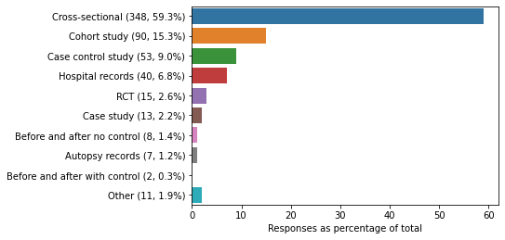

Figure S2 – Number of studies by liquid and gaseous fuels investigated (n=587)
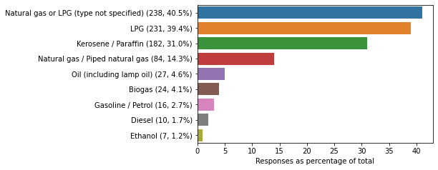
Note: Figure S2 results not mutually exclusive (total % does not sum to 100)

Figure S3 – Number of studies by population type (n=439)
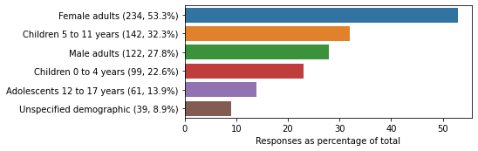
Note: Figure S3 results not mutually exclusive (total % does not sum to 100)

Figure S4 - Locations of air pollution monitoring (n=262)
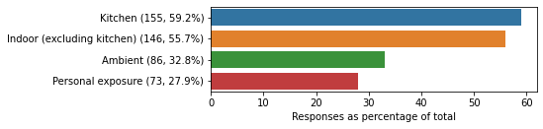
Note: Figure S4 results not mutually exclusive (total % does not sum to 100)

Figure S5 – Method of health outcome assessment (n=415)
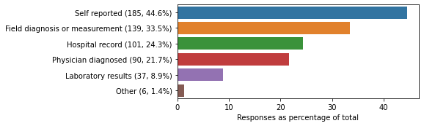
Note: Figure S5 results not mutually exclusive (total % does not sum to 100)

Figure S6 - Number of studies by symptom and fuel type
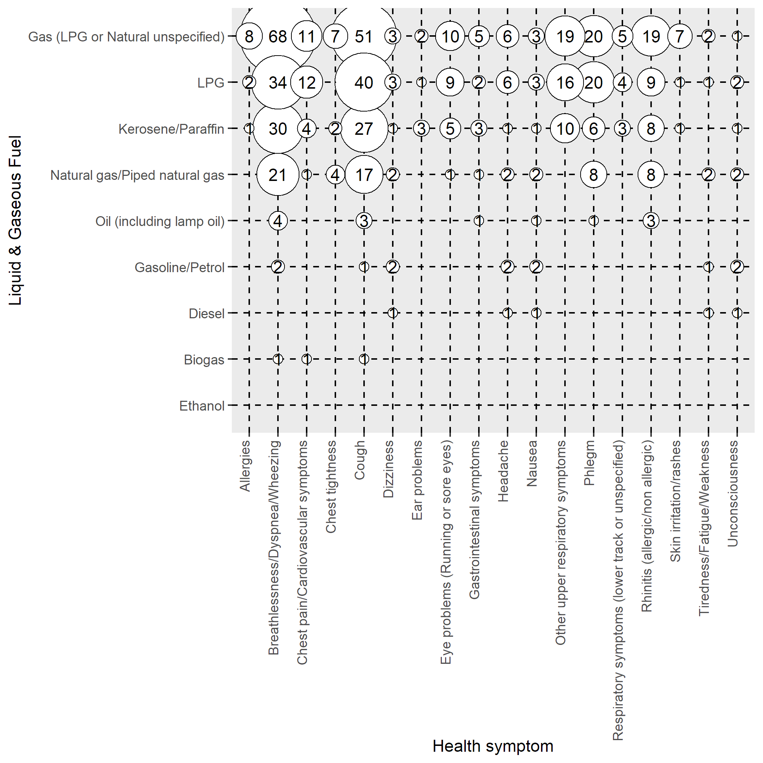

Figure S7 - Number of studies by health effect and fuel type investigated
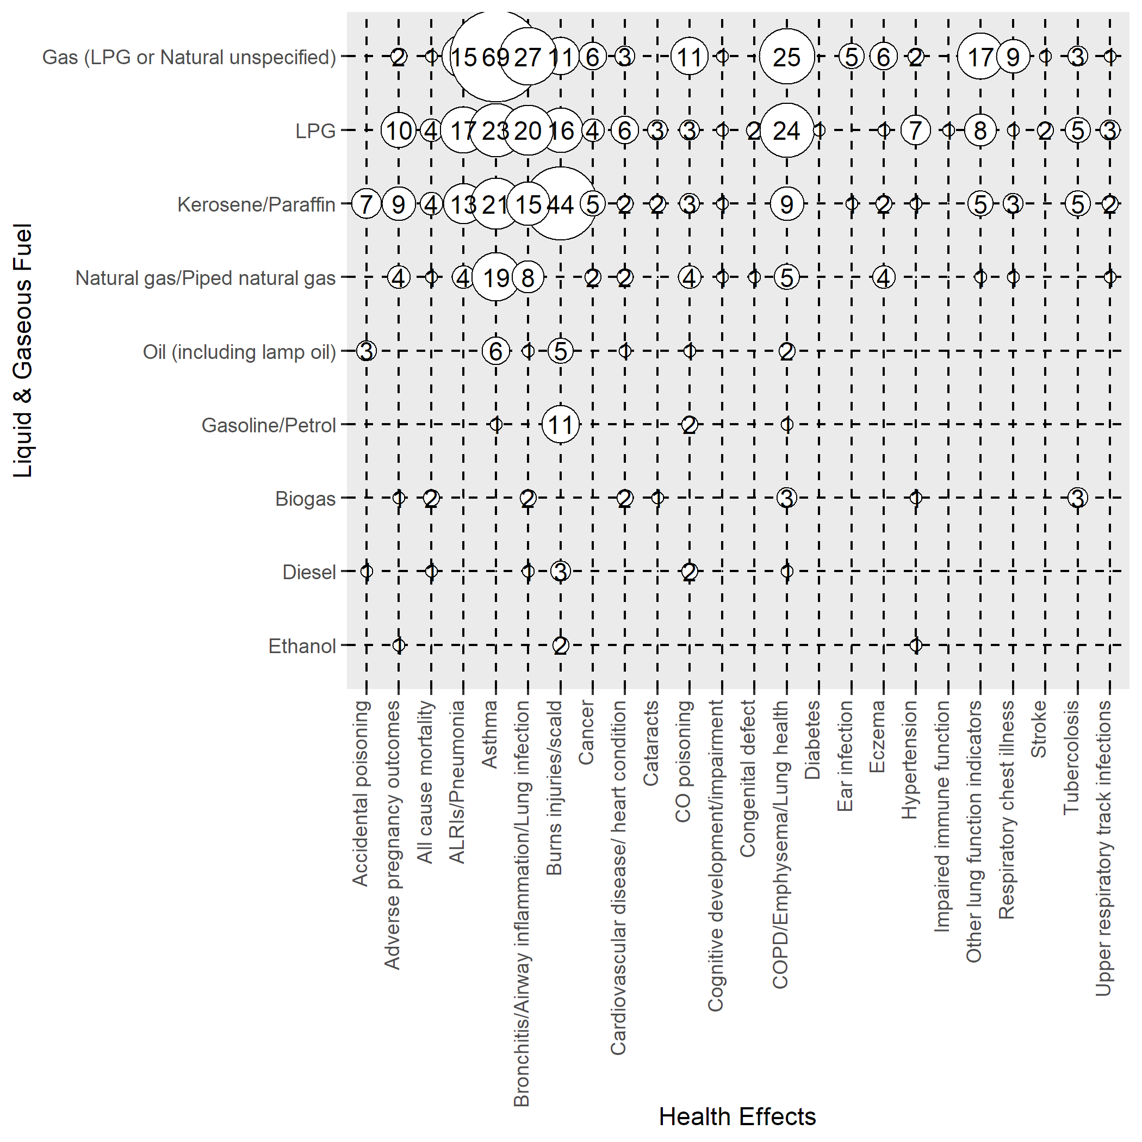

A separate search was also conducted for solar lighting ("solar light*" or "solar lantern*" or "solar lamp*) and [(3) or (4)] and (5). This is because there is a risk that some of the gaseous or liquid fuels would be missed by searching only title, abstract and key words if the main focus of the paper is on clean lighting sources. However, these papers may include a comparison with polluting gaseous or liquid fuels alternatives, which will meet the systematic review inclusion criteria. This extra search was combined (using or) with the lighting search in (1b).
For the majority of databases, the context terms were applied only to lighting and heating. The context terms were also added to cooking for searching Scopus and Web of Science.

