BIOGRAPHY OF AUTHORS
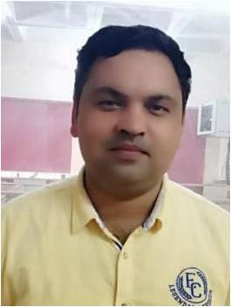
Madan Kumar Sharma received the B.Eng. degree in electronics and communication engineering from UPTU University, Lucknow, India in 2006 and the Masters Degree from MDU, Rohatak in 2009 and Ph.D. degrees in RF microwaves and antenna, from Rajasthan Technical University, Kota, India in 2020.He has more than 15 years of academic experience in Engineering Institutions. Currently, he is an Assistant Professor at the Department of Information and Communication Engineering, College of Engineering, University of Buraimi. His research interests include UWB-MIMO diversity antenna and Microwave Sensor and sensor network security. He has been published more than 30 research article in referred journal and conference proceeding. He can be contacted at email: madan.k@uob.edu.om.
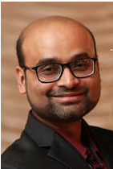
Dr. Syed Faraz Hasan is currently working as a Director, Research Service at University of New England (AU) Armidale, New South Wales, Australia. He has more than 15 years experience of academic and research with specialization of wireless communication system development. He published more than 100 articles in reputed journals and conferences.For more details please visit on the web: https://farazhasan.weebly.com/.

