Supporting Information

Title:
Increasing phosphorus fertilizer value of recycled iron phosphates in strong P-fixing soils by prolonged flooding and organic matter addition

Authors: Rochelle Joie Saracanlao^{1*}, Hannah Van Ryckel¹, Maarten Everaert¹, Mieke Verbeeck², Erik Smolders¹
Affiliation: ¹Division of Soil and Water Management, Department of Earth and Environmental Science, KU Leuven, Kasteelpark Arenberg 20, B-3001, Belgium
²Soil Service of Belgium, Willem De Croylaan 48, 3001 Leuven, Belgium

*Corresponding Author: RJ Saracanlao; email: rj.saracanlao@kuleuven.be

- Methodology
1.1 Determination of P doses
The P doses used in the pot trial were determined based on the P sorption index (PSI) of the different soils, which represents the amount of adsorbed P (mg P/kg) equivalent to a P solution concentration of 0.1 mg P/L (i.e. the solution concentration required for maximum rice growth). The P adsorption isotherms for the different soils were determined by incubating the soil in P solutions with a concentration varying between 0-1500 mg P kg⁻¹ at a liquid: solid ratio of 10 L kg⁻¹. The suspensions were shaken end-over-end for 16 h, after which they were centrifuged (2500 g, 10 mins) and filtered (0.45 µm, Chromafil ® Xtra PET -45/25; Macherey- Nagel, Germany). The P concentration of the filtrates was determined using malachite green method and absorbance was read at 630 nm using a spectrophotometer (Perkin Elmer Lambda 20). The adsorption isotherms of the soils were fitted to the Freundlich equation:
P_{sorbed} =k P_{solution}^{n} (Eqn S1)
With P_{sorbed} the P adsorbed in the solid phase (mg P /kg), P_{solution} the P concentration in the solution (mg P/L) and k and n the Freundlich parameters.
Acid
Neutral
Calcareous
v
Figure S1. P sorption isotherms of acid ( ) , neutral ( ), and calcareous ( ) soil with corresponding Freundlich equations.

Results

Table S1. Parameter estimates of the model describing the P uptake of X265 rice plants for TSP treatments in each soil. P uptake = β₀ + β₁*(P dose) + β₂*(Flooded) + β₃*(P dose – c)² + β₄*((P dose – c)*Flooded).

 | β₀ | β₁ | β₂ | β₃ | β₄ | c
Acid soil | 0.33* | 0.04* | -0.18* | -0.0006* | -0.009* | 18.5
Neutral soil | 0.52* | 0.06* | -0.26* | -0.003* | -0.01* | 9
Calcareous soil | 0.19* | 0.007* | -0.01n.s. | / | 0.002n.s. | 15
*: significant, n.s.: not significant (P < 0.05).

Table S2. Effect of flooding on the P uptake of X265 rice shoots grown in acid, neutral, and calcareous soils for FePs and TSP.

 |  | P uptake (mg P/pot)
 | Control |  | V-WWTP | V-fert | V-syn | Fe(III)P-gravel | Fe(III)P-sand | Fe(III)P-sludge | TSP
Acid soil |  | n.s. | n.s. | n.s. | n.s. | n.s. | n.s. | n.s. | *
Neutral soil |  | * | * | * | * | * | * | * | *
Calcareous soil |  | * | * | n.s. | n.s. | n.s. | * | * | n.s.
*: significant effect (P<0.05), n.s.: not significant.

Table S3. Parameter estimates of the model describing the shoot P of X265 rice plants for TSP treatments in each soil. Y = β₀ + β₁*(P dose) + β₂*(Flooded) + β₃*(P dose – c)² + β₄*((Pdose – c)*Flooded) where Y is DMY, P in shoot, or P uptake.
 | β₀ | β₁ | β₂ | β₃ | β₄ | c | R²_{adj}
Acid soil
DMY | 0.28* | 0.01* | -0.02n.s. | -0.0004* | -0.001n.s. | 18.6 | 0.84
P in shoot | 1.08* | 0.04* | -0.26* | -0.0008* | -0.01* | 18.6 | 0.82
P uptake | 0.33* | 0.04* | -0.18* | -0.0006* | -0.009* | 18.5 | 0.95
Neutral soil
DMY | 0.35* | 0.02* | -0.02n.s. | -0.001* | / | 9 | 0.74
P in shoot | 1.46* | 0.06* | -0.49* | -0.001* | -0.004n.s. | 9 | 0.91
P uptake | 0.52* | 0.06* | -0.26* | -0.003* | -0.01* | 9 | 0.94
Calcareous soil
DMY | 0.12* | 0.004* | / | / | / | / | 0.55
P in shoot | / | / | / | / | / | / | /
P uptake | 0.19* | 0.007* | -0.01n.s. | / | 0.002n.s. | 15 | 0.45
*: significant, n.s: not significant (P<0.05)

Table S4. Effect of water treatment on the DMY, P in shoot, and P uptake of rice grown in acid, neutral, and alkaline soils for FePs and TSP.

 | Fertilizer Treatments
 | Control | V-WWTP | V-fert | V-syn | Fe(III)P-gravel | Fe(III)P-sand | Fe(III)P-sludge | TSP
Acid soil
DMY | n.s. | n.s. | n.s. | n.s. | n.s. | n.s. | n.s. | n.s.
P in shoot | * | n.s. | * | n.s. | * | n.s. | n.s. | *
P uptake | n.s. | n.s. | n.s. | n.s. | n.s. | n.s. | n.s. | *
Neutral soil
DMY | * | * | * | * | n.s. | * | * | n.s.
P in shoot | * | * | * | * | * | * | * | *
P uptake | * | * | * | * | * | * | * | *
Calcareous soil
DMY | * | * | n.s. | n.s. | n.s. | * | n.s. | n.s.
P in shoot | * | n.s. | n.s. | * | n.s. | * | * | n.s.
P uptake | * | * | n.s. | n.s. | n.s. | * | * | n.s.
*: significant, n.s: not significant (P<0.05)

Table S5. Mean iron concentration (mg Fe/kg tissues) of rice shoots in the calcareous soil under flooded and non-flooded conditions. Standard error of the three replicates (except for control where n=6) between brackets. Mean values with the same letter are not significantly different (TUKEY , P<0.05).
Fertilizer treatment | Nonflooded | Flooded
Control | 82.2 (3.0)a | 59.5 (3.4) a
TSP | 60.4 (13.6) a | 56.8 (3.6) a
V-WWTP | 66.5 (4.1) a | 51.1 (6.4) a
V-fert | 69.3 (6.6) a | 54.6 (0.8) a
V-syn | 66.2 (9.8) a | 56.5 (4.8) a
Fe(III)P-gravel | 49.2 (15.4) a | 55.8 (4.1) a
Fe(III)-Psludge | 70.9 (5.6) a | 57.4 (5.3) a
Fe(III)-Psand | 67.5 (7.8) a | 66.4 4.5) a

Table S6. Statistical significance of glutamate addition on the CaCl₂-extractable P for each FeP treatment per sampling time (TUKEY, P< 0.05).
Soil | Recycled FePs | 3rd day | 14th day | 60th day
Acid soil | V-WWTP | n.s. | n.s. | n.s.
Acid soil | Fe(III)P-sludge | n.s. | * | *
Acid soil | control | n.s. | n.s. | n.s.
Neutral soil | V-WWTP | n.s. | * | n.s.
Neutral soil | Fe(III)P-sludge | n.s. | n.s. | *
Neutral soil | control | n.s. | n.s. | n.s.
Calcareous soil | V-WWTP | * | * | n.s.
Calcareous soil | Fe(III)P-sludge | * | * | *
Calcareous soil | control | * | * | *
*: significant, n.s: not significant (P<0.05)

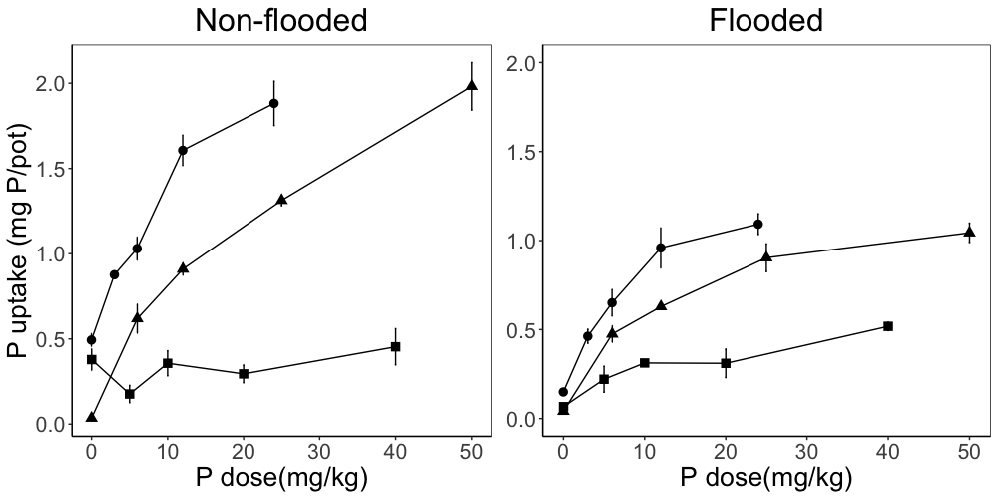

Acid
Neutral
Calcareous

Figure S2. The shoot P uptake by rice grown in the acid ( ), neutral ( ) and calcareous
( ) soils with increasing TSP dose. Data are means of 3 replicates (except for control where n=6) and error bars represent standard errors.

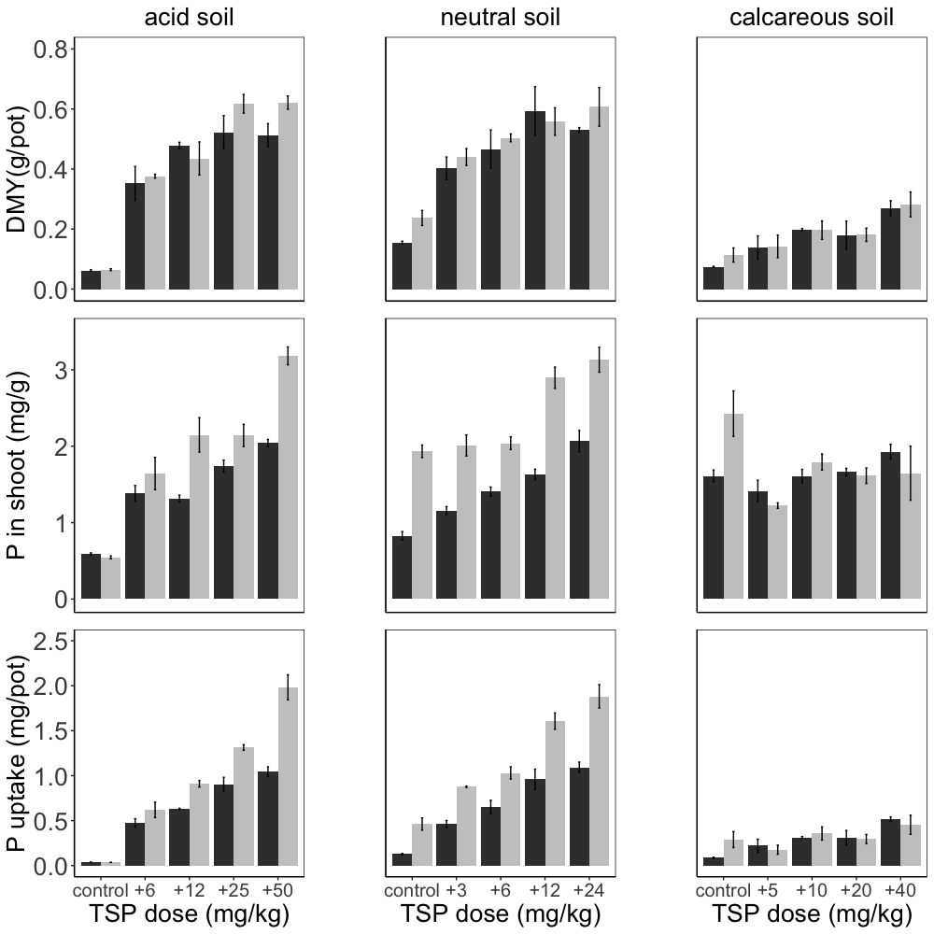
flooded
non-flooded

Figure S3. Dry matter yield, shoot P concentration, and P uptake of rice grown amended by increasing doses of TSP in three different soils under flooded and non-flooded conditions. Data are means of 3 replicates (except for control where n=6) and error bars represent standard error of means.
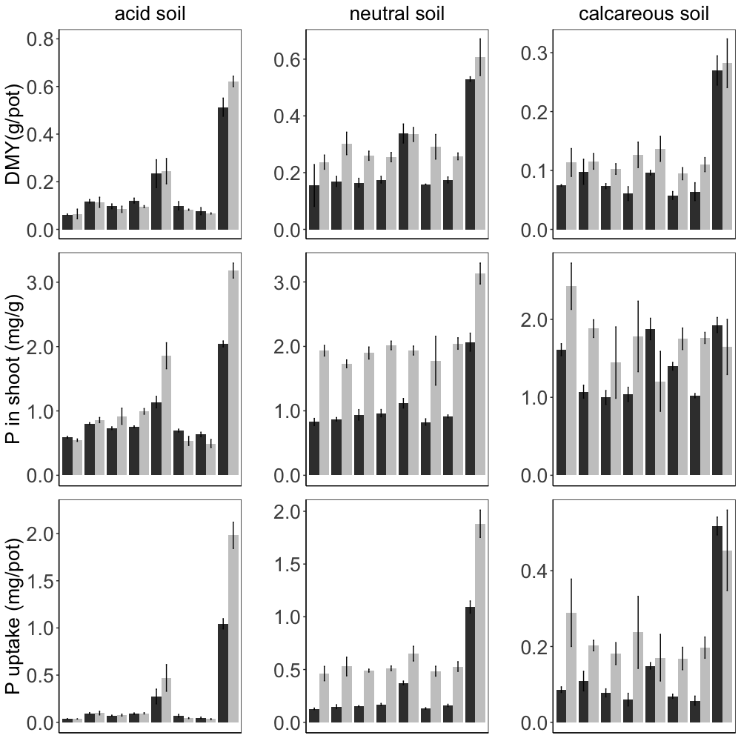
flooded
non-flooded
A
B
B
B
B
B
B
B
a
c
c
b
c
c
c
c
A
B
CD
C
D
CD
CD
CD
a
b
c
bc
c
bc
c
c
A
B
B
AB
B
B
B
B
a
b
b
b
b
b
b
b
A
D
D
B
C
C
C
D
a
de
cd
b
cd
cd
c
e
A
AB
B
B
B
B
B
B
a
b
b
b
b
b
b
b
a
b
c
c
c
c
c
c
DE
A
E
B
C
CD
CD
E
a
b
c
cd
c
d
cd
cd
A
B
B
B
B
B
B
B
a
b
c
c
c
c
c
c
A
A
A
A
A
A
A
A
a
b
c
bc
bc
c
bc
c
A
B
A
AB
AB
AB
AB
AB

Figure S4. Dry matter yield, P concentration in shoots and P uptake of rice grown for 3
weeks amended by different FePs in comparison with TSP (applied at 50 mg P/kg in acid soil, 25 mg P/kg in neutral soil, and 40 mg P/kg in calcareous soil) and control treatments in three different soils under flooded and non-flooded conditions. Data are means of 3 replicates (except for control where n=6) and error bars represent standard error.

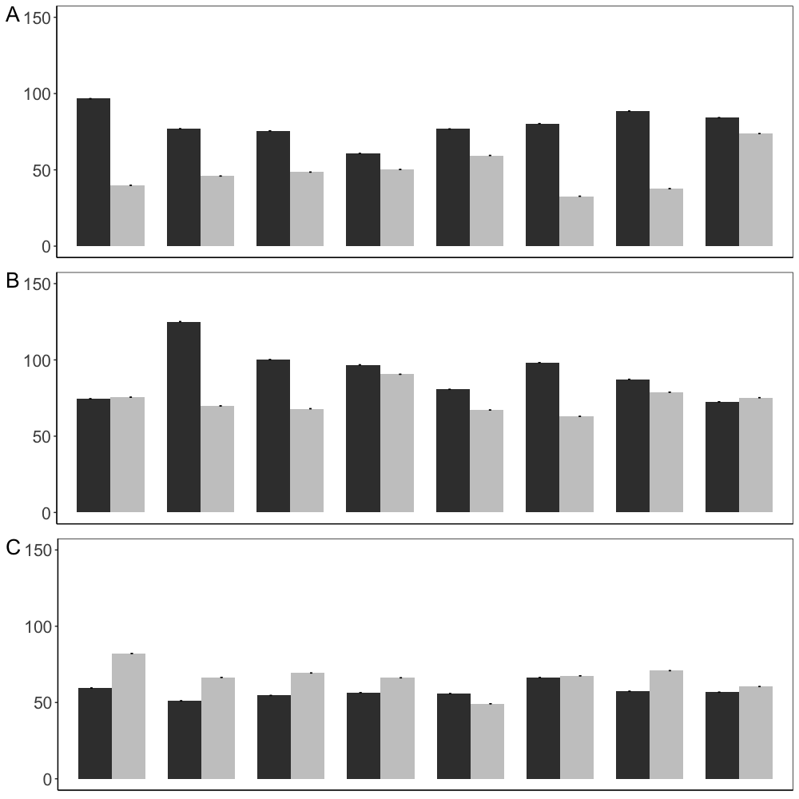
non-flooded
flooded
control
V-WWTP
V-fert
V-syn
Fe(III)P-gravel
Fe(III)P-sand
Fe(III)P-sludge
TSP
Shoot Fe concentration (mg Fe/kg)
*
*
*
n.s.
*
*
*
n.s.
n.s.
n.s.
*
n.s.
n.s.
n.s.
n.s.
n.s.
n.s.
n.s.
n.s.
n.s.
n.s.
n.s.
*
n.s.
BC
D
A
CD
AB
BC
BCD
CD
ab
a
ab
ab
ab
ab
b
ab
A
B
AB
AB
AB
AB
AB
AB
a
b
b
ab
ab
ab
ab
ab
A
A
A
A
A
A
A
A
a
a
a
a
a
a
a
a

Figure S5. Mean iron concentration (mg Fe/kg tissues) of rice shoots in the acid (A), neutral (B) and calcareous (C) soils under flooded and non-flooded conditions. Treatments were applied at a dose of 50 mg P/kg in A, 25 mg P/kg in B, and 40 mg P/kg in C. Data are means of 3 replicates (except for control where n=6) and error bars represent standard error of means. Different letters denote significant differences among treatments (Tukey, P<0.05).

