Supplemental figure S1. Plot of the autocorrelation function of an intercept-only mixed-effects model to visualize the time lag of autocorrelation. We used this approach to determine criteria for creating ‘clusters’ to control for temporal autocorrelation using generalized estimating equations as suggested by Forrester et al. (2009). We observed autocorrelation to decay after a lag of 18 observations (alpha = 0.05), or 54 hours.

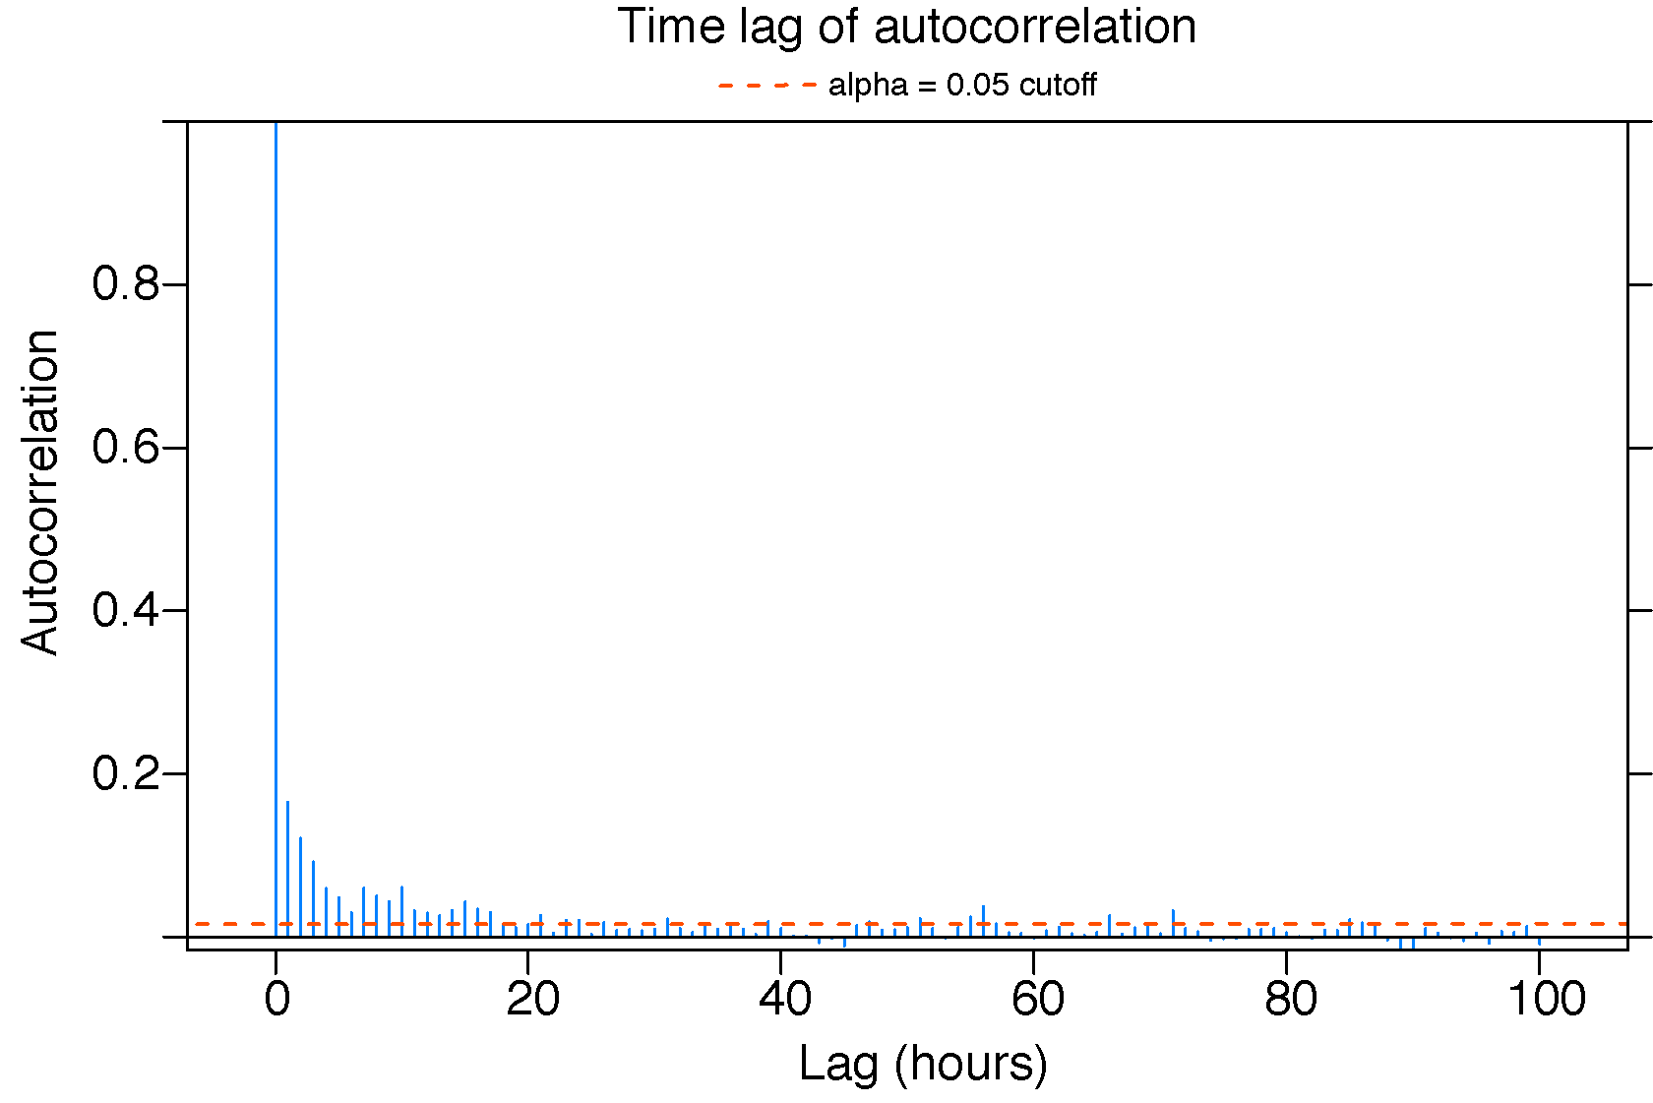

Supplemental figure S2. Example plot of quasi-likelihood under independence criterion (QIC) plotted against candidate knot (scaled distance from urban-natural boundary) values for segmented regressions. Knot values were chosen on the basis of lowest QIC.

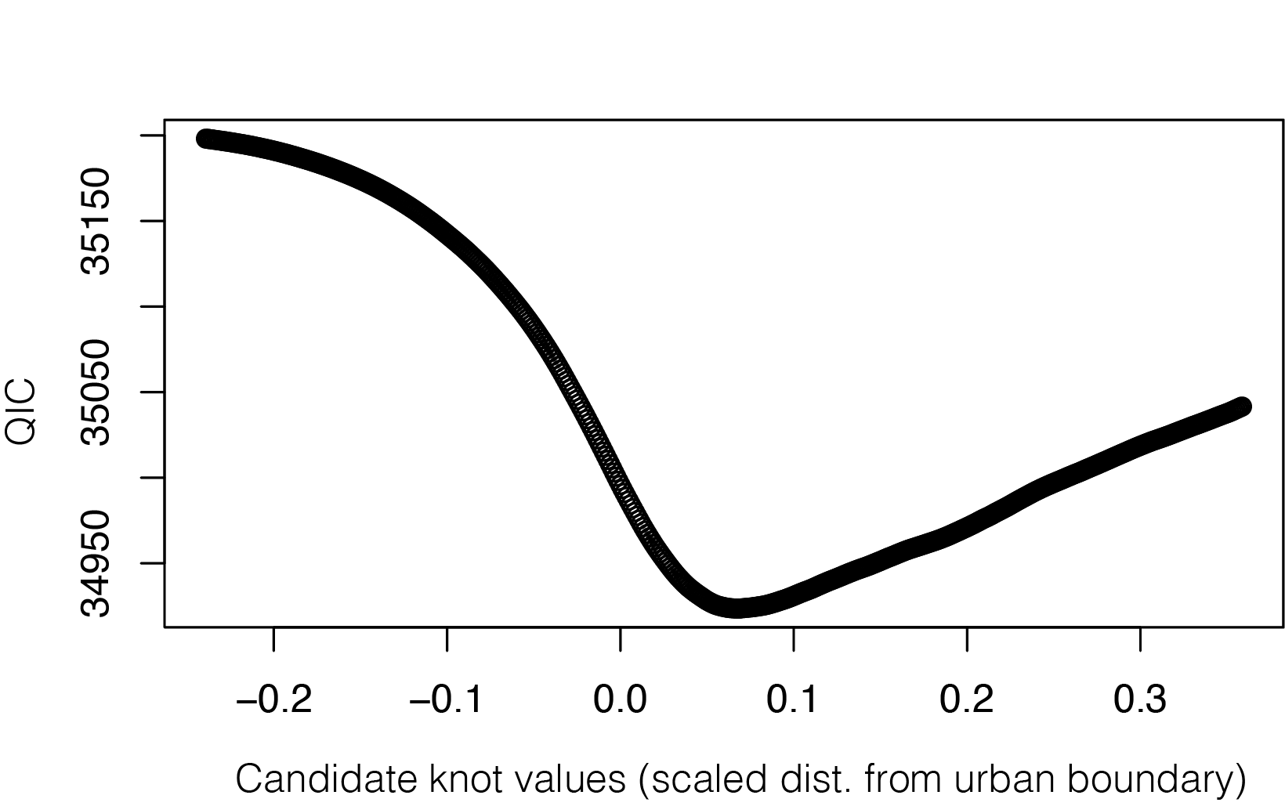

Supplemental Figure S3. Proportion of caracal active locations plotted against time of day. We did not detect shifts towards increased nocturnality in the high risk urban-dominated region, nor differences in activity between adults and subadults in the urban-dominated region. Thus, the activity curve presented represents activity for all three subgroups combined.
