Supporting Information

Influence of Synthesis Procedures on the Preparation of Strontium Titanate Nanoparticles and Photocatalytic application for Methylene blue degradation
Emriye Ay¹ and Pelin Sözen Aktaş²*
¹Department of TobaccoTechnology Engineering, Manisa Celal Bayar University, School of Tobacco Expertise, Manisa, Türkiye
²Department of Chemistry, Manisa Celal Bayar University, Faculty of Arts & Sciences
Prof. Dr. İlhan Varank Campus 45140 Muradiye-Manisa, Türkiye
E-mail: pelin.sozen@cbu.edu.tr
ORCID ID: 0000-0003-2140-2650

FİGURES

Figure S1. FT-IR spectra of ST1 samples were treated at different temperatures, as prepared at 120 °C and calcined at 400 °C.

Figure S2. FTIR spectra of ST1 and ST2 samples synthesized by Pechini and high energy ball milling processes.

Figure S3. EDX analysis of ST1 and ST2 nanoparticles.

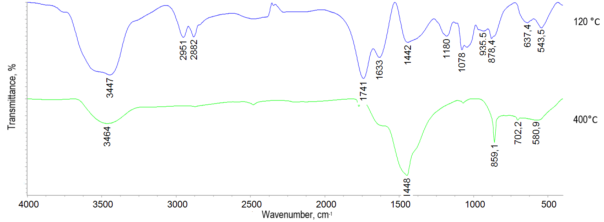
Figure S1. FT-IR spectra of ST1 samples were treated at different temperatures, as prepared at 120 °C and calcined at 400 °C.

Figure S2. FTIR spectra of ST1 and ST2 samples synthesized by Pechini and high energy ball milling processes.

Figure S3. EDX analysis of ST1 (a) and ST2 (b) nanoparticles.

