Supplementary material for
Improving the productivity of malic acid by alleviating oxidative stress during Aspergillus niger fermentation
Na Wu^{1,2}, Mingyan Xing¹, Yaru Chen¹, Chi Zhang¹, Ping Song¹, Qing Xu^{*1}, Hao Liu³, He Huang^{*1,4}
1 School of Food Science and Pharmaceutical Engineering, Nanjing Normal University, Nanjing 210023, China
2 College of Life Sciences, Nanjing Normal University, Nanjing 210046, China
3 Tianjin Engineering Research Center of Microbial Metabolism and Fermentation Process Control, Tianjin University of Science & Technology, Tianjin 300457, China
4 College of Biotechnology and Pharmaceutical Engineering, Nanjing Tech University, Nanjing 211800, China

*Corresponding author
E-mail: xu_qing@njnu.edu.cn and huangh@njnu.edu.cn

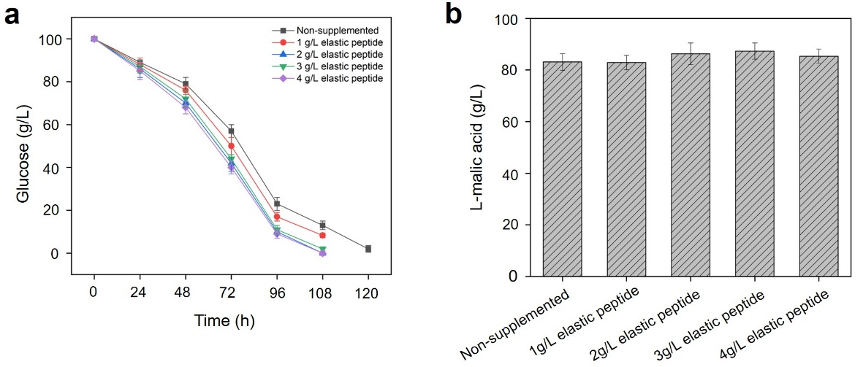
Figure S1. Fermentation assessment of different concentration peptide supplemented in A. niger bioproduction process. a, glucose consumption kinetic; b, L-malic acid titer. Data represent means +/- SD of three independent replicates.

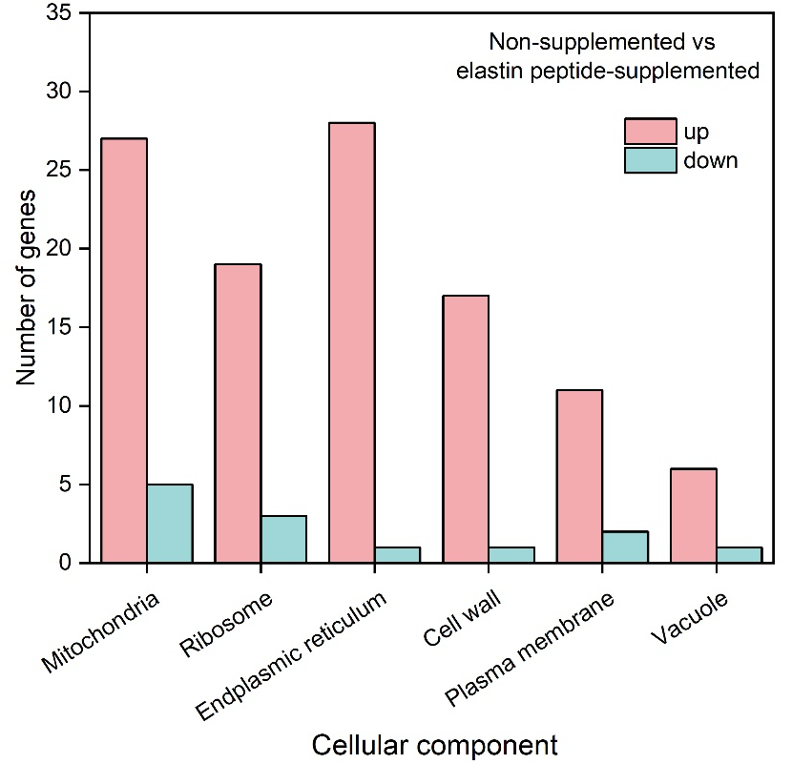
Figure S2. Change of DEGs (|log2 (Fold Change) | > 1, P-adjust (FDR) < 0.05) related to organelles in elastin peptide-treated group vs peptide-free group.

