Supplementary information (Supplementary Table S5, Figures S1-S4)
Eleven carbon signals were observed in the ¹³C NMR spectrum and six signals were matched with galactose signals in the reference¹. The anomeric proton coupling constant (J=7.86) indicated that H-1 of galactose is in the β-conformation. Two carbon signals at 39.96 and 62.00 ppm that did not correlate with other carbons were assigned as C-A1 and C-A2 carbons in aminoethyl moiety. Three signals that were well-correlated with each other were assigned as a glyceryl moiety. Correlation peaks between C-G1 of the glyceryl moiety and H-1 of galactose in the ¹³C-¹H HMBC spectrum indicated that the glyceryl moiety is attached to C-1 of the galactose. The ³¹P resonance at 0.13 ppm is typical of a phosphodiester compound and its correlation peaks in the ³¹P-¹H HMQC spectrum indicated that the phosphate group is esterified with two different moieties. This correlation was further confirmed by carbon-phosphorus splitting in the carbon signals at 62.00 (J=4.36) and 73.85 (J=4.95) ppm. These were assigned to C-A1 of the aminoethyl moiety and C-4 of the galactose moiety, respectively.

Reference
- Bubb, W. A. NMR spectroscopy in the study of carbohydrates: Characterizing the structural complexity. Concepts Magn. Reson. Part A Bridg. Educ. Res. (2003).

Supplementary Table S5. The complete NMR assignment of native MS377, 1-O-[4-O-(2-aminoethylphosphate)-β-D-galactopyranosyl]-x-glycerol
Moiety | ¹³C NMR |  | ¹H NMR |  |  | ³¹P NMR
Moiety | δ (ppm) |  | δ (ppm) | multiplicity  J_{H,H} (Hz) |  | δ (ppm) | multiplicity  J_{P,C} (Hz)
Galactose
C-1 | 102.92 |  | 4.46 | d, 7.86
C-2 | 70.60 |  | 3.58 | dd, 7.86, 10.08
C-3 | 71.83 |  | 3.77 | m |  |  | d, 2.18
C-4 | 73.85 |  | 4.47 | dd, 9.72, 3.12 |  |  | d, 4.95
C-5 | 74.40 |  | 3.78 | m |  |  | d, 3.10
C-6 | 60.46 |  | 3.76 | m
Aminoethyl
C-A1 | 62.00 |  | 4.17 | m |  |  | d, 4.36
C-A2 | 39.96 |  | 3.27 | d, 5.46
Glycerol
C-G1 | 70.68 |  | 3.92  3.75 | m  m
C-G2 | 70.28 |  | 3.93 | m
C-G3 | 62.20 |  | 3.68  3.60 | dd, 11.64, 4.10  dd, 11.64, 5.80
Phosphate |  |  |  |  |  | 0.13

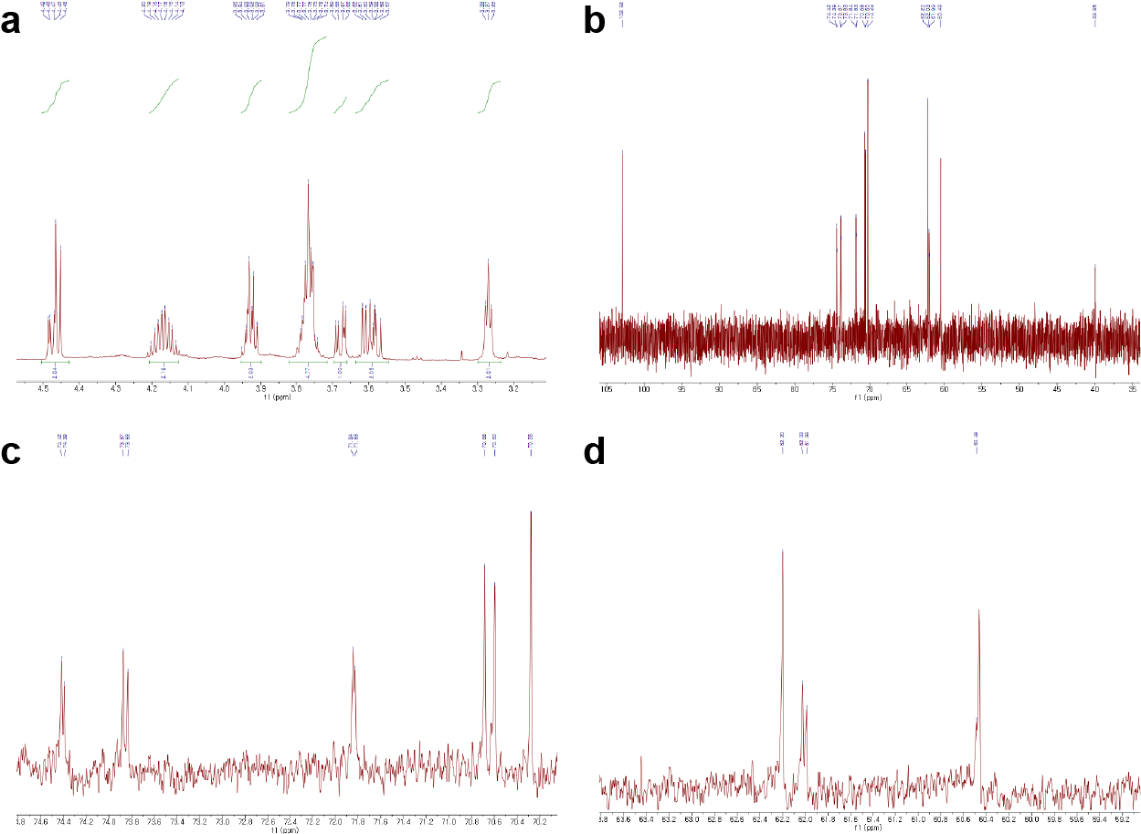
Supplementary Figure S1. NMR spectra of native MS377
(a) ¹H NMR spectrum of native MS377.
(b-d) ¹³C NMR spectra of native MS377.

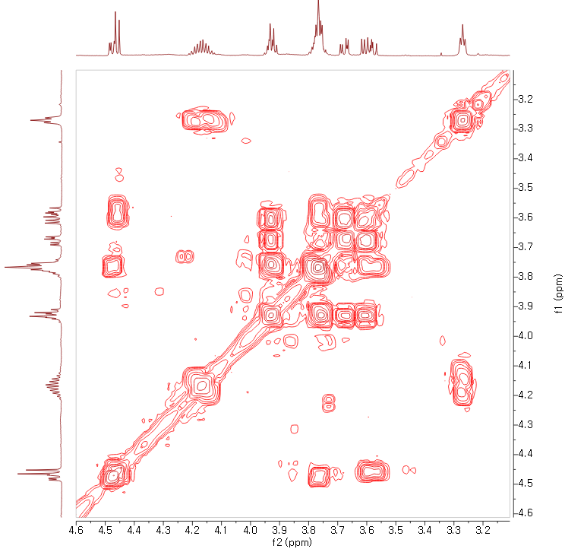
Supplementary Figure S2. ¹H-¹H COSY spectrum of native MS377

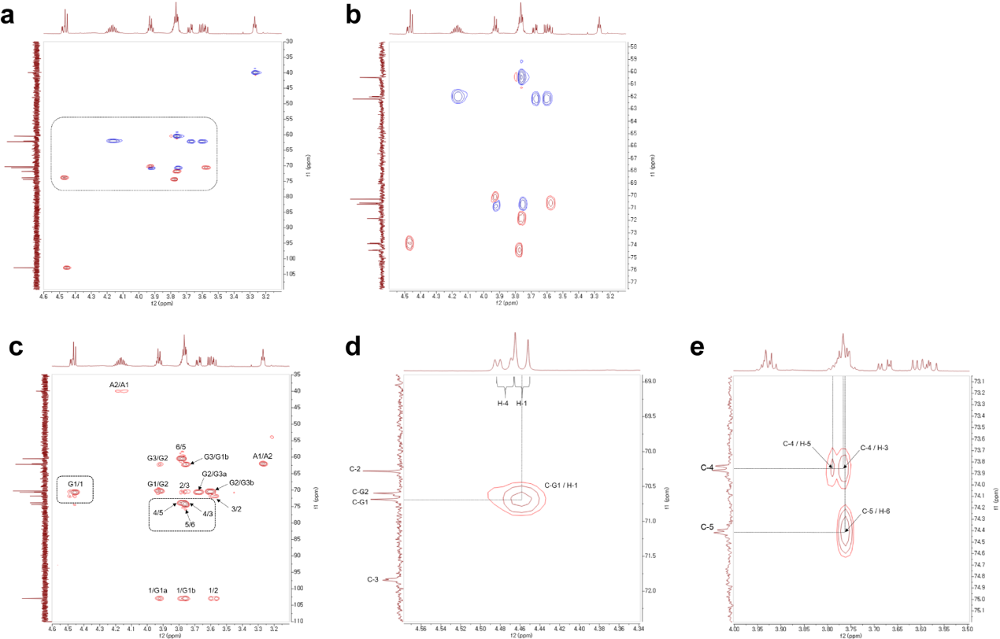
Supplementary Figure S3. Correlation spectra of native MS377
(a, b) ¹H-¹³C HMQC correlation spectrum of native MS377. Expended spectrum (b)
(c, d, e) ¹H-¹³C HMBC correlation spectrum of native MS377. Expanded spectrum (d, e)

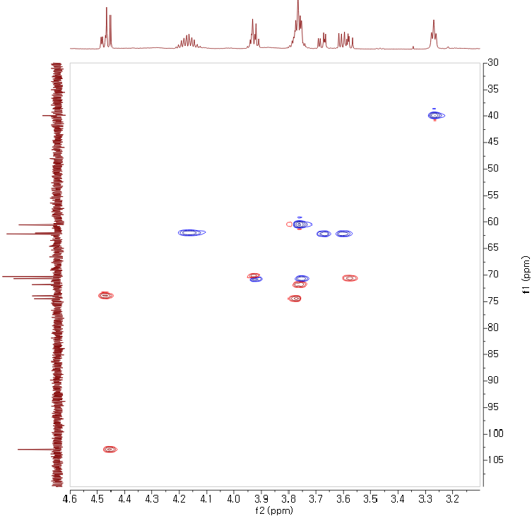
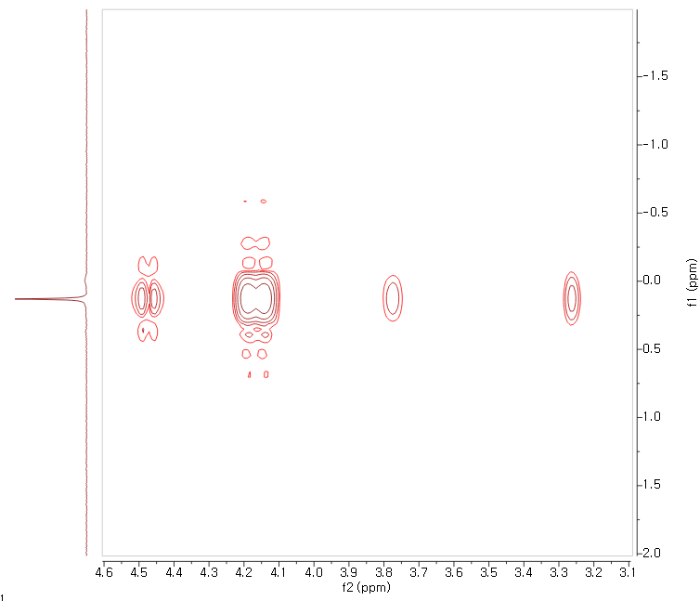
¹³C ppm
³¹P ppm
¹H ppm
1
2
3,5
4
5
6
A1
A2
G1
G2
G3
A2
4
A1
3

Supplementary Figure S4. ¹H-¹³C HMQC (top) and ¹H-³¹P HMQC (bottom) correlation spectrum of native MS377

