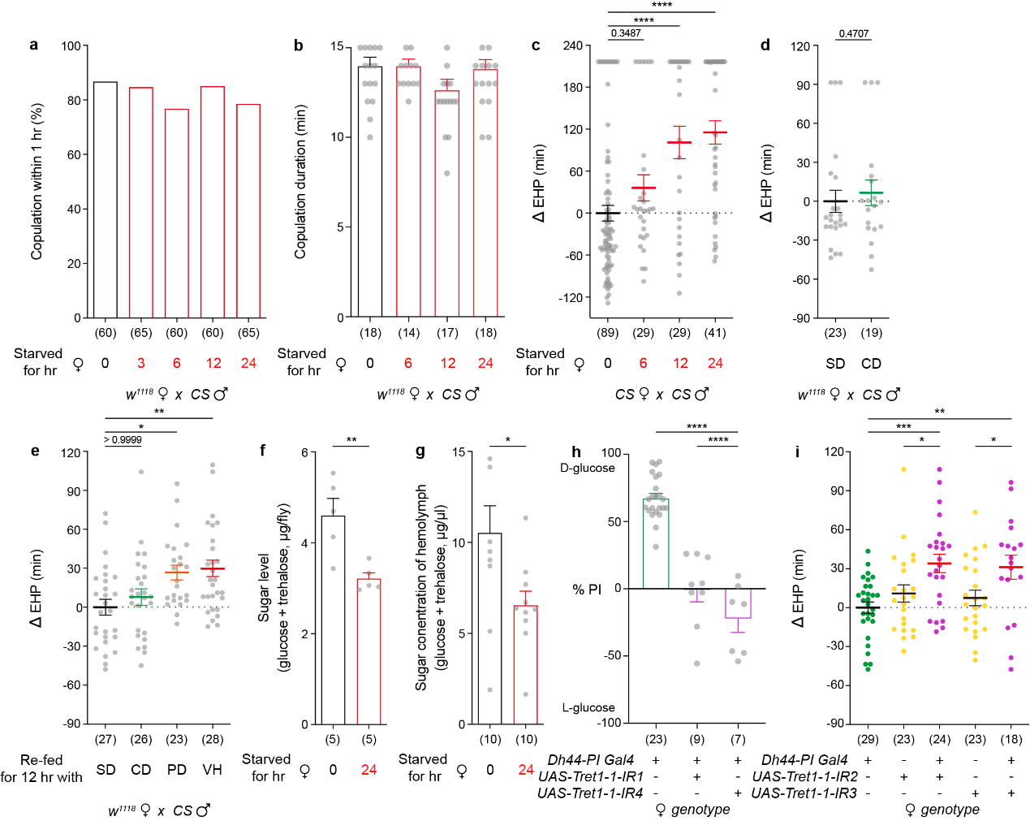

Extended Data Figure 1. Starvation-induced hypoglycemia increases EHP, and this is rescued by feeding carbohydrate
(a) Mating frequencies of virgin w¹¹¹⁸ females in the indicated feeding conditions. Females were starved for the indicated hours before mating individually with CS males. Data are shown as the percentage of females that copulate within 1 hour. The number in parentheses indicates n. Two-sided Fisher’s exact test (p > 0.05).
(b) Copulation duration of w¹¹¹⁸ females of the indicated conditions paired individually with CS males. Data are shown as means ± SEM. One-way ANOVA with Bonferroni post-hoc test (p > 0.05).
(c-e) Normalized EHP (ΔEHP) from females in the indicated feeding conditions mated with CS males. Circles indicate ΔEHP measured from individual females. (c) CS females were starved for the indicated hours before mating with CS males. (d) w¹¹¹⁸ females were kept on a standard diet (SD) or a carbohydrate-only diet (CD) for 3-4 days before mating with CS males. (e) w¹¹¹⁸ females were starved for 12 hours and then fed for additional 12 hours with the indicated diets before mating with CS males. PD, protein-only diet. VH, vehicle. Data are shown as means ± SEM. One-way ANOVA with Bonferroni post-hoc test (c, e). Two-tailed Mann Whitney test (d). The number above the column is the p value (*p < 0.05, **p < 0.01, ***p < 0.005, ****p<0.001).
(f) Whole-body sugar levels from a pool of 15-17 w¹¹¹⁸ females from the indicated conditions. Data are shown as means ± SEM. Unpaired two-tailed t-test.
(g) Hemolymph glycemia from a pool of 30-40 w¹¹¹⁸ females from the indicated conditions. Data are shown as means ± SEM. Unpaired two-tailed t-test.
(h) Food preference of starved flies of the indicated genotypes choosing between nutritive sugar (D-glucose) and nonnutritive sugar (L-glucose). Data are shown as means ± SEM. One-way ANOVA with Bonferroni post-hoc test.
(i) Normalized EHP (ΔEHP) from females of the indicated genotypes mated with CS males. Circles indicate ΔEHP measured from individual females. Data are shown as means ± SEM. One-way ANOVA with Bonferroni post-hoc test.

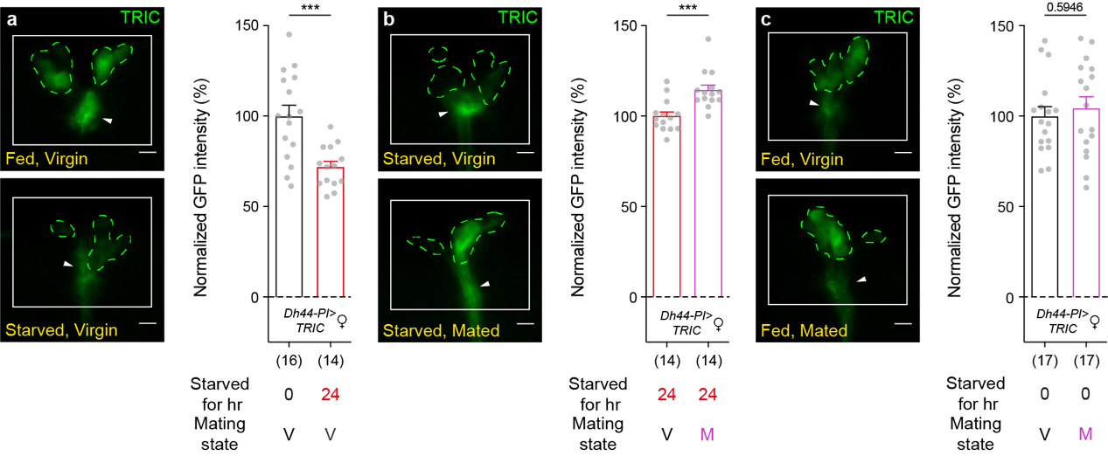

Extended Data Figure 2. Starvation and mating effects on Ca²⁺ activity of Dh44-PI neurons
(a-c) TRIC images of Dh44-PI neurons (left) and normalized TRIC activity (right) from females under the indicated feeding and mating conditions. Scale bars, 10 µm. The fluorescence intensity of the square box in each image is quantified. The dotted line and white arrowhead indicate somas and neural processes, respectively. In the mating state, V indicates virgin females and M indicates mated females. Circles indicate normalized GFP intensity from individual females, and the means ± SEM of the data are shown. The number in parentheses indicates n. Unpaired two-tailed t-tests. The number above the column is the p value (***p < 0.005).

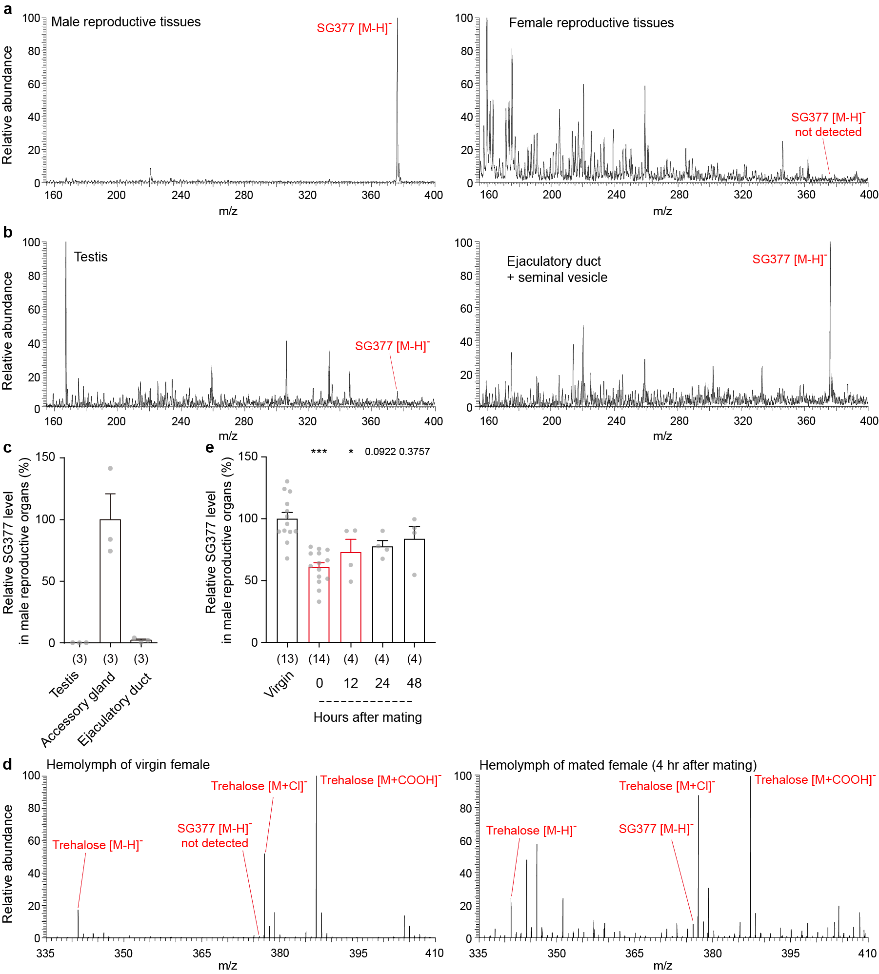

Extended Data Figure 3. Detection of SG377 in male and female reproductive tissues and hemolymph
(a) LC-MS profile of the C18 flow-through of male (left) and female (right) reproductive tissues. Virgin females were analyzed.
(b) LC-MS profile of the C18 flow-through of male testis (left) and the ejaculatory duct and seminal vesicle complex (right) .
(c) Relative SG377 levels in the three major male reproductive organs. The means ± SEM of the data are shown. The number in parentheses indicates n.
(d) LC-MS profile of the C18 flow-through of virgin (left) and mated (right) female hemolymph.
(e) Relative SG377 levels in male reproductive organs before, and at indicated times after, mating. One-way ANOVA with Bonferroni post-hoc test compares virgin and mated males. The number above the column is the p value (*p < 0.05, ***p < 0.005).
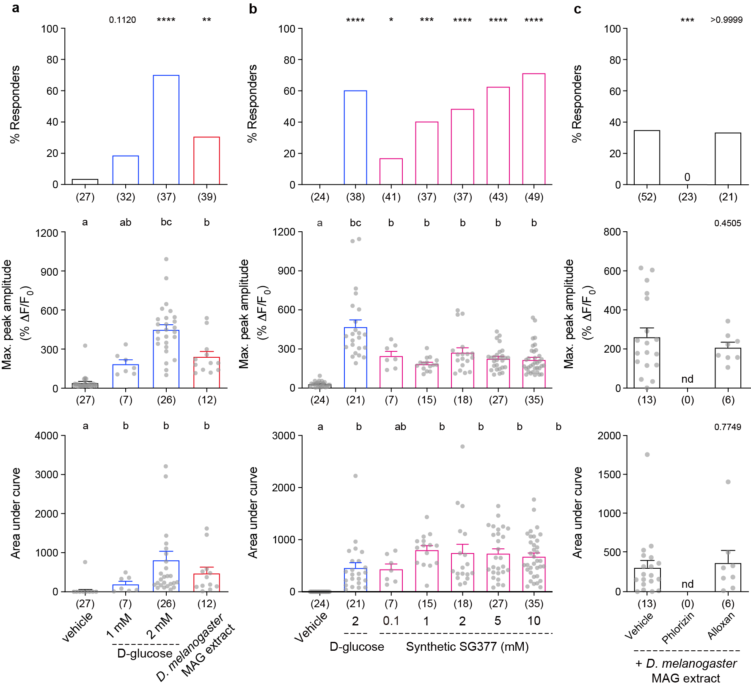

Extended Data Figure 4. SG377 induces Ca²⁺ responses in Dh44-PI neurons via glucose transporters
(a-c) GCaMP fluorescence response of Dh44-PI neurons from virgin females to D-glucose or MAG extracts of D. melanogaster (a), D-glucose or synthetic SG377 at indicated concentrations (b), and D. melanogaster MAG extracts (c). In (c), Dh44-PI neurons were pre-treated with 1 µM phlorizin or 8 µM alloxan. In this experimental setup, MAG extracts collected from 20 D. melanogaster (CS strain) males yielded 0.48 mM SG377. For % responders (upper), data are shown as means. Two-sided Fisher’s exact test compares vehicle control and the indicated treatments (a-c). For the maximum peak amplitude (middle) and area under curve (lower), data are shown as means ± SEM. One-way ANOVA with Bonferroni post-hoc test (a, middle; b, lower). Kruskal-Wallis test with Dunn post-hoc test (a lower; b middle). The letters above the columns in (a) and (b) indicate significant differences (p < 0.05) for comparisons of treatments. Unpaired two-tailed t-test compares vehicle and drug pretreatment groups (c). The number above the column is the p value (*p < 0.05, **p < 0.01, ***p < 0.005, ***p < 0.001).

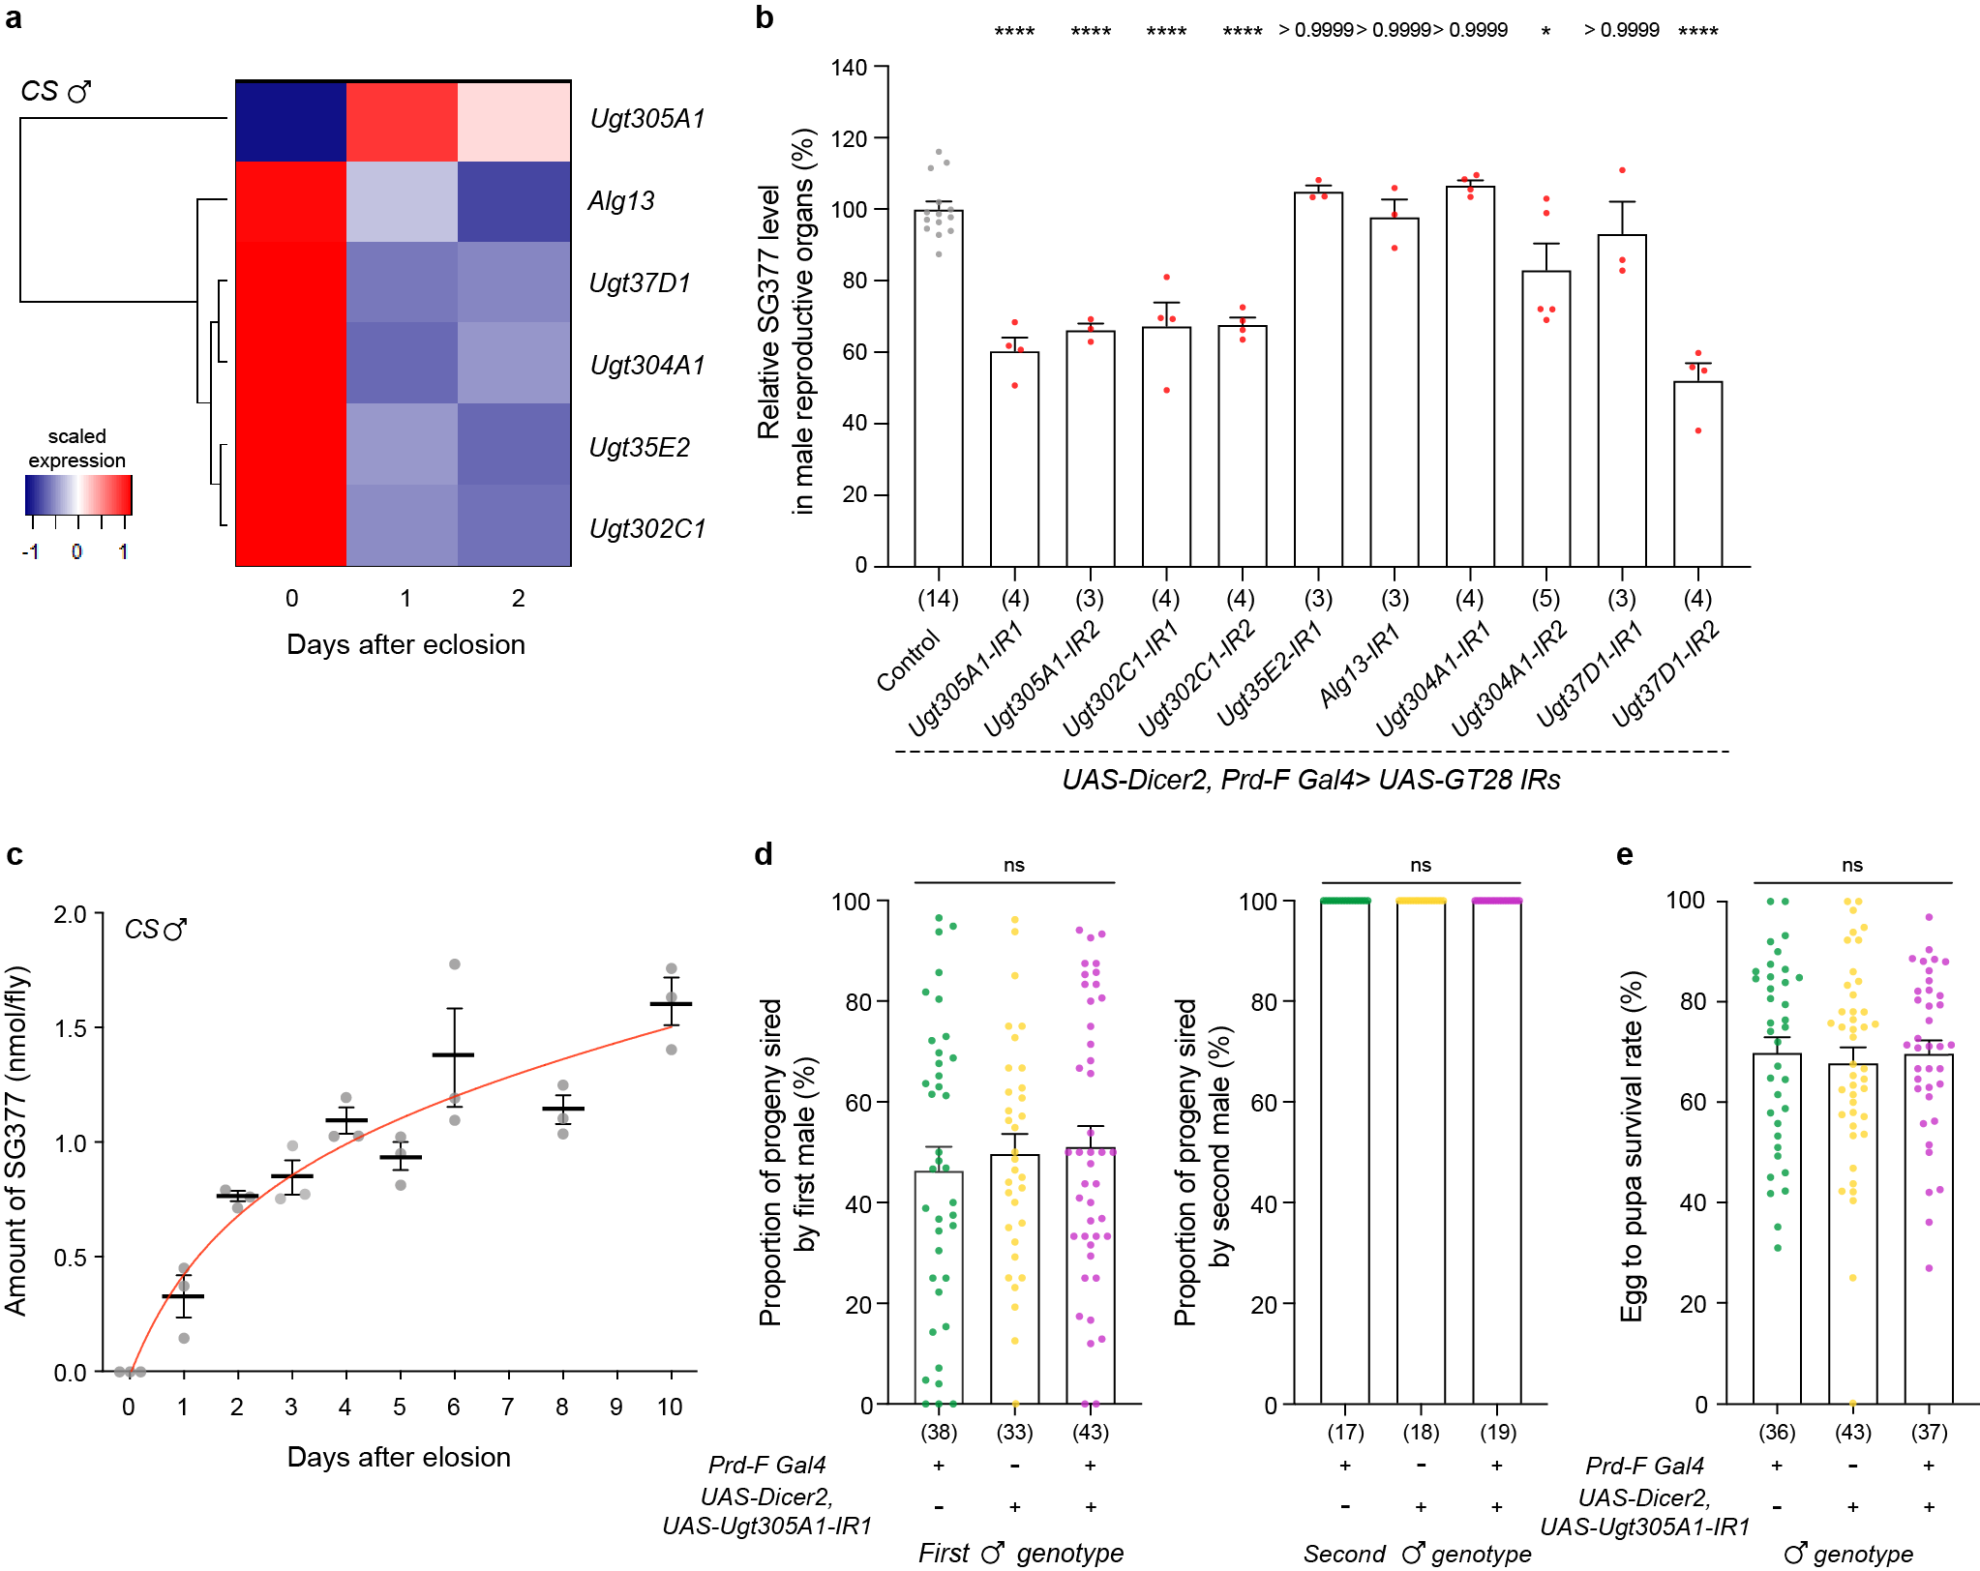

Extended Data Figure 5. RNAi knockdown of some GT28 genes expressed in the male accessory gland reduces SG377 production
(a) Heatmap representation (scaled expression) of the transcriptional changes at the indicated times after eclosion for six GT28 genes expressed in the male accessory gland. Count value, tpm value and scaled value are available in Supplementary Table 3.
(b) Relative SG377 levels in the reproductive organs of well-nourished males of the indicated genotypes. Data are shown as means ± SEM. The number in parentheses indicates n. One-way ANOVA with Bonferroni post-hoc test compares control (gray circle) and the indicated RNAi lines (red circle). The number above the column is the p value (ns, p > 0.05; *p < 0.05; **p < 0.01; ***p < 0.005; ***p < 0.001).
(c) The amount SG377 of wild type male reproductive organs collected at the indicated days after eclosion. Data are shown as means ± SEM.
(d) Sperm competition analysis. For defense assays (left), a cn bw female mates first with a male of the indicated genotype and then mates a second time with a cn bw male. The proportion of offspring produced by the first mating was measured. For offense assays, a cn bw female mates first with a cn bw male and then mates a second time with a male of the indicated genotype. The proportion of offspring produced by the second mating was measured. Data are shown as means ± SEM. One-way ANOVA with Bonferroni post-hoc test (ns, p > 0.05).
(e) Survival rate from egg to pupa. Each circle represents the egg-to-pupa survival rate of eggs laid by individual w¹¹¹⁸ females over two days. Data are shown as means ± SEM. One-way ANOVA with Bonferroni post-hoc test (ns, p > 0.05).

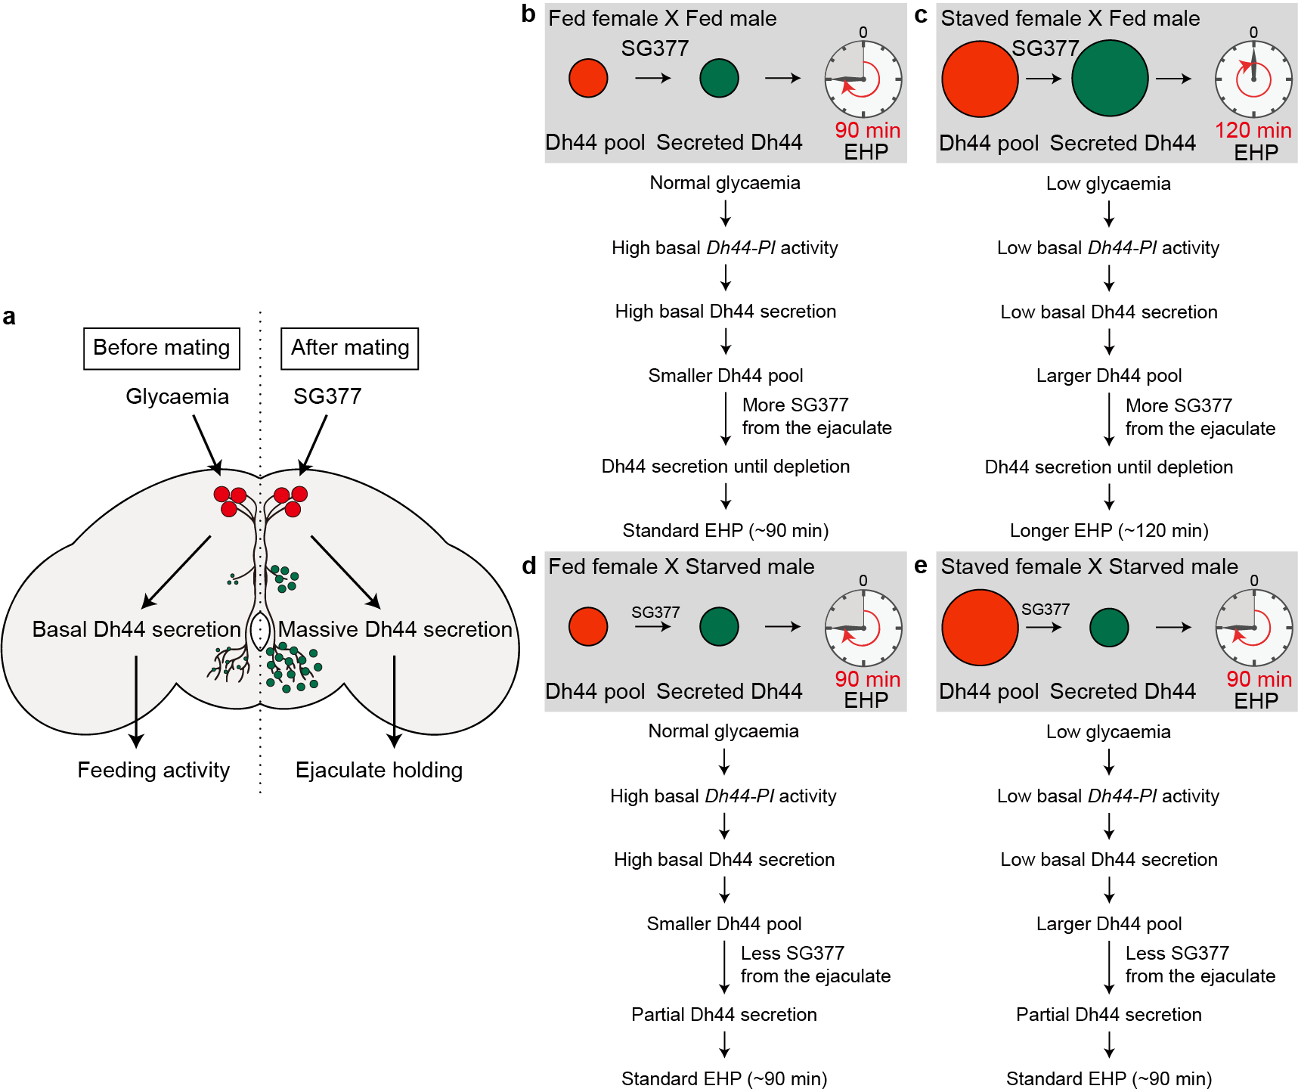

Expended Data Figure 6. Current model for the energy state-dependent modulation of EHP
(a) Before mating, glycaemia continuously induces basal levels of Dh44 secretion and determines the size of the Dh44 pool in Dh44-PI neurons available for mating or SG377-induced Dh44 secretion. After mating, SG377 from the male ejaculate enters the female hemocoel, stimulates the activity of Dh44-PI neurons, and augments the secretion of Dh44, thereby increasing EHP.
(b-c) When females mate with well-nourished males transferring SG377 large enough to sustain Dh44 secretion until depletion, the size of the Dh44 pool, determined by pre-mating glycaemic status, is a major determinant of EHP duration. Thus, mating with well-nourished males allows starved females to have longer EHPs than well-nourished females.
(d-e) When females mate with starved males producing ~50% less SG377 than well-nourished males, the amount of SG377 in the ejaculate determines EHP. Thus, when mated with starved males, the EHP of starved females and well-nourished females show limited differences in EHP.

