Supplementary Legends:

Figure S1. All simulation systems in this research processed the calculation of geometry optimization and dynamics and got a stable state. Figure (a) was the typical energy diagram in geometry optimization calculation, figure (b) was the typical temperature diagram, and figure (c) was the typical energy diagram in the dynamics calculation.

Figure S1.
(a)
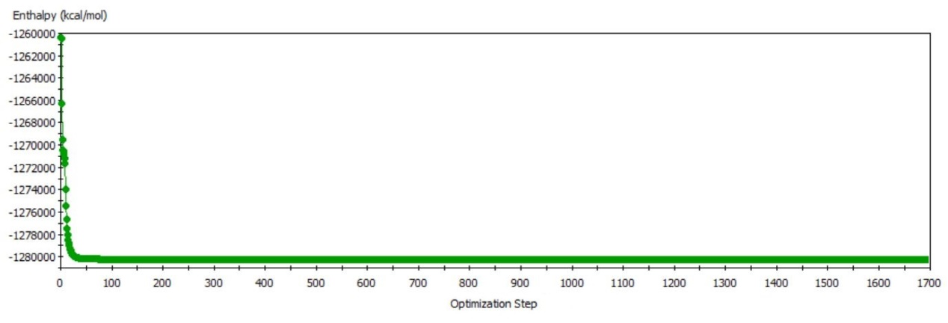
(b)
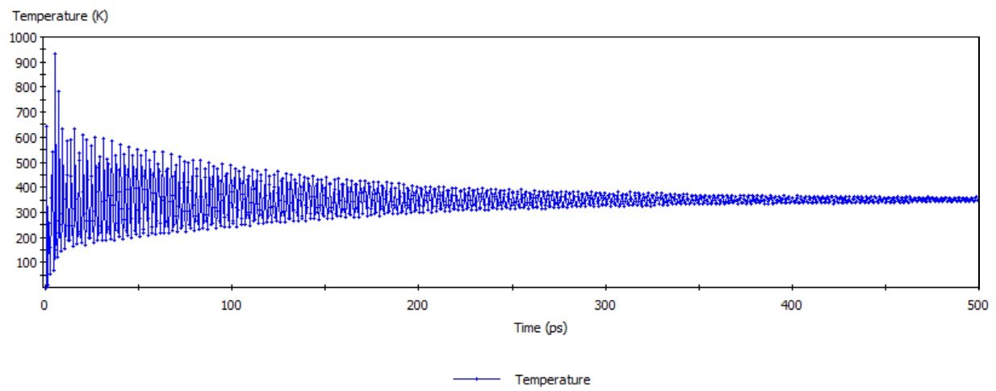
(c)
