Figure S1.
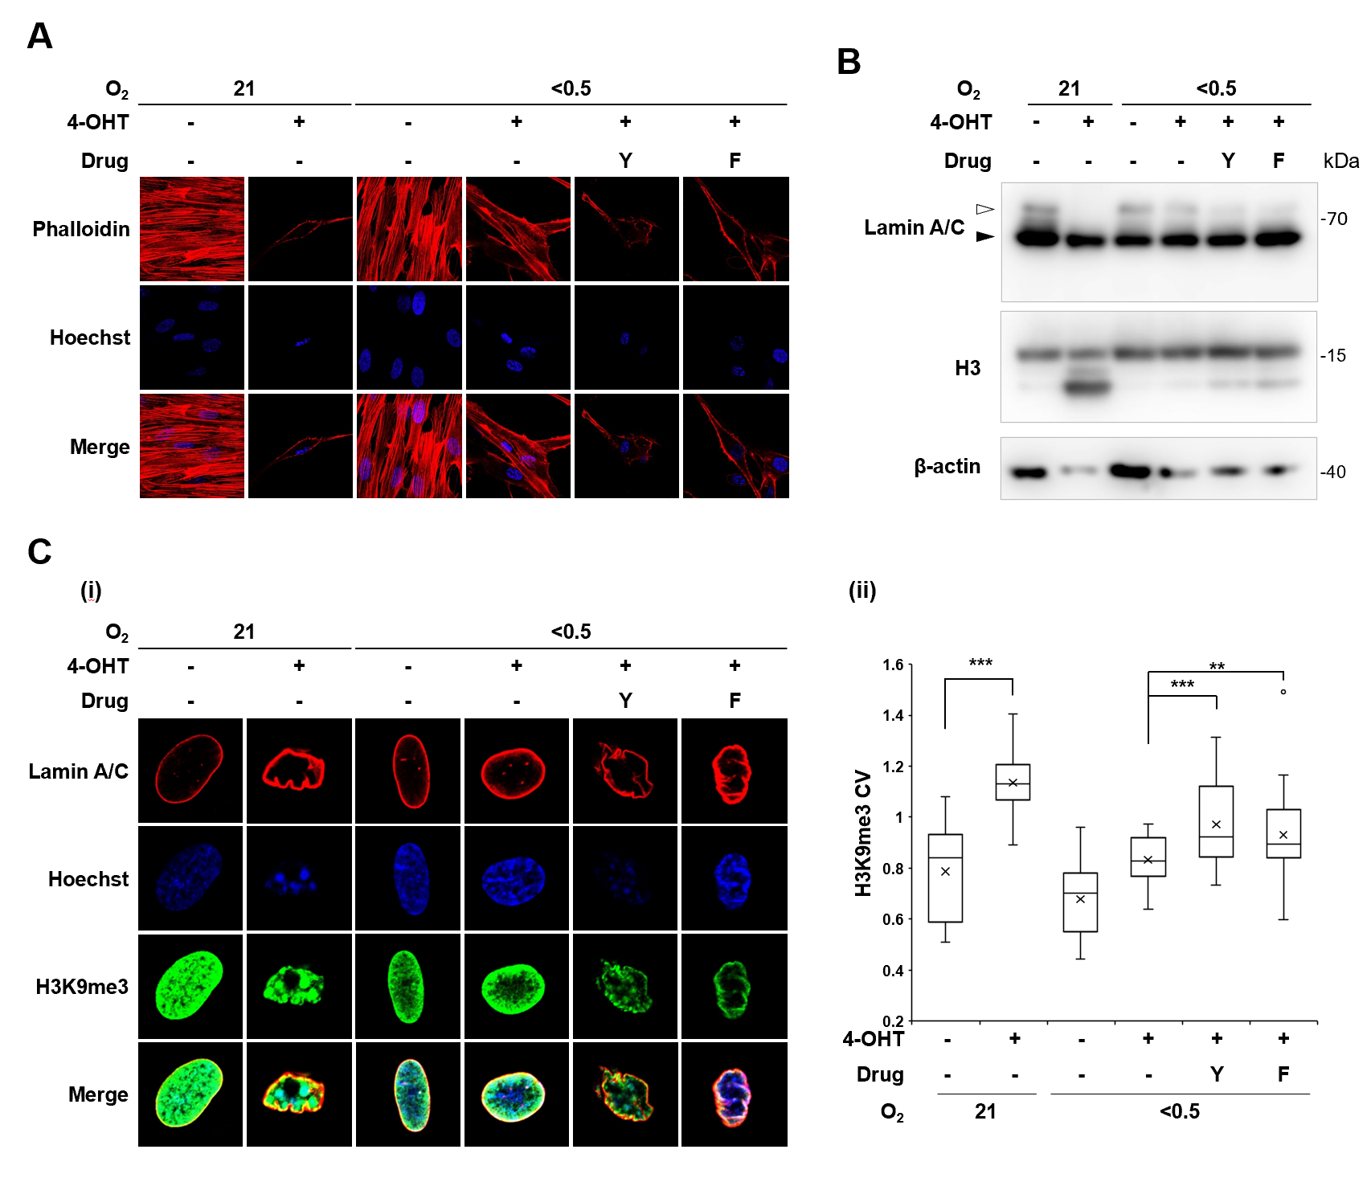
Figure S1. Effects of Fasudil, a Rho-associated protein kinase (ROCK) inhibitor on nuclear integrity of hypoxic cells
IMR90-ΔB-Raf:ER cells were treated with 4-hydroxy-tamoxifen (4-OHT; 100 nM) under normoxia (21% O₂) or hypoxia (< 0.5% O₂) for six days in the presence of inhibitors Y: Y27632 (ROCK1/2 inhibitor, 20 μM); F: Fasudil (ROCK1/2 inhibitor, 25 μM). (A) Confocal microscopic images of F-actin stress fibers stained with fluorescent-conjugated phalloidin and hoechst. (B) (i) Confocal microscopy images of cells stained with Lamin A/C, H3K9me3 antibodies, and Hoechst staining. Coefficient of variation (CV) of nuclear images stained with H3K9me3. The values on the y-axis represent the CV of nuclear images from two independent experiments (details in the Methods section). (C) Western blot analysis with the indicated antibodies. *p < 0.05, **p < 0.01, and ***p < 0.001 by Students’ t-test; ns, not significant

Figure S2
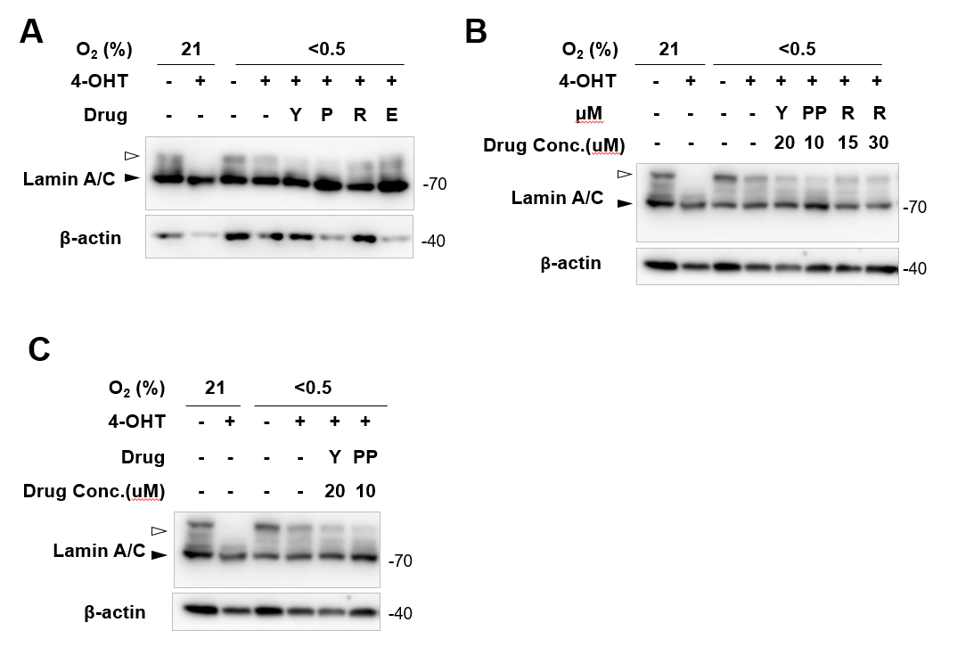
Figure S2. Effects of cytoskeleton inhibitors on the stabilities of Lamin A/C proteins
IMR90-ΔB-Raf:ER cells were treated with 4-hydroxy-tamoxifen (4-OHT; 100 nM) under normoxia (21% O₂) or hypoxia (<0.5% O₂) for 6 days in the presence of inhibitors, Y: Y27632 (ROCK1/2 inhibitor, 20 μM); P: PP2 (Src inhibitor, 10μM); R: Rhosin (Rho A inhibitor, 15, 30μM); E: EHT (Rac1/2/3 inibitor, 50μM). (A to C) Western blot analyses using Lamin A/C, Emerin, SUN1, CTSL, HIF1α, ER and β-actin antibodies. *p < 0.05, **p < 0.01, and ***p < 0.001 by Students’ t-test; ns, not significant.

Supplementary Table S1. Primers for quantitative RT-PCR analyses
Gene name | Direction | Sequence
18S rRNA | Forward | 5’ - ACCGCAGCTAGGAATAATGGAATA - 3’
18S rRNA | Reverse | 5’ - CTTTCGCTCTGGTCCGTCTT - 3’
LMNA | Forward | 5’- ATGAGGACCAGGTGGAGCAGTA - 3’
LMNA | Reverse | 5’- ACCAGGTTGCTGTTCCTCTCAG - 3’
EMERIN | Forward | 5’- CCGCCTCCTCTTATAGCTTC - 3’
EMERIN | Reverse | 5’- CTCTGGTAGAGTAAAGCGTCC - 3’
SUN1 | Forward | 5’- CTGTGAGACAGTGGATGCCGTA - 3’
SUN1 | Reverse | 5’- GCATCGTCTGCAAGTCGCCTTTG - 3’
ITGA6 | Forward | 5’- ATGCACGCGGATCGAGTTTG - 3’
ITGA6 | Reverse | 5’- TTCCTGCTTCGTATTAACATGCTG - 3’
FLNC | Forward | 5’- ATGGTAGCTGCACCGTGGAGTA - 3’
FLNC | Reverse | 5’- TCCACCACATCCTTCACTGGCA - 3’
MYL9 | Forward | 5’- GGATGTGATTCGCAACGCCTTTG - 3’
MYL9 | Reverse | 5’- CGGTACATCTCGTCCACTTCC - 3’
SRC | Forward | 5’- CTGCTTTGGCGAGGTGTGGATG - 3’
SRC | Reverse | 5’- CCACAGCATACAACTGCACCAG - 3’
WASF1 | Forward | 5’- CTGCTTTGGCGAGGTGTGGATG - 3’
WASF1 | Reverse | 5’- CCACAGCATACAACTGCACCAG - 3’
ARHGAP10 | Forward | 5’- CTGCTCCGTTTGGTTCCAGTTG - 3’
ARHGAP10 | Reverse | 5’- GGAGTCAGTATGCCTCTTGGTAC - 3’
ARHGAP18 | Forward | 5’- GCTGAAGCTCTTCATTCGGGAG - 3’
ARHGAP18 | Reverse | 5’- GGTTCAAAGCCTGTAGTTGCTGC - 3’
ARHGEF25 | Forward | 5’- GCAAGAGCTACAACGGTGTCTG - 3’
ARHGEF25 | Reverse | 5’- GACACCACATGCTCTGACTTGG - 3’
ACTG1 | Forward | 5’- CCGAGCCGTGTTTCCTTCC - 3’
ACTG1 | Reverse | 5’- GCCATGCTCAATGGGGTACT - 3’
FN1 | Forward | 5’- ACAACACCGAGGTGACTGAGAC - 3’
FN1 | Reverse | 5’- GGACACAACGATGCTTCCTGAG - 3’
MAPK3 | Forward | 5’- TGGCAAGCACTACCTGGATCAG - 3’
MAPK3 | Reverse | 5’- GCAGAGACTGTAGGTAGTTTCGG - 3’

Supplementary Table S2. Antibodies used for immunofluorescence and western blot analyses.
Antibody | Provider | Cat.No. | Application
Anti-ERα | Santa Cruz Biotechnology | sc-543 | WB, IF
Anti-HIF-1α | BD bioscience | 610959 | WB
Anti-β-actin | Cell signaling | 3700 | WB
Anti-Cathepsin L | Abcam | ab6314 | WB
Anti-Lamin A/C | Cell signaling | 2032 | WB
Anti-Lamin A/C | Cell signaling | 4777 | IF
Anti-Lamin B | Abcam | ab8982 | WB
Anti-Emerin | Protetin tech | 10351-1-AP | WB
Anti-SUN1 | Abcam | ab124770 | WB
Anti-H3 | Abcam | ab1791 | WB
Anti-H3K9me3 | Abcam | ab8898 | WB, IF
Anti-γH2AX | Millipore | 05-636 | IF
Anti-MYPT1 Thr696 | Cell signaling | 5163 | WB
Anti-MYPT1 | Cell signaling | 8574 | WB

Supplementary Table S3. The lists of the DEGs included in the individual groups and clusters. (in a separated excel file)
Ensembl IDs, Entrez IDs, symbols, descriptions, P-values, and log2-fold-changes of the DEGs are shown. P-values were computed as described in Materials and Methods section.

