Figure S1.
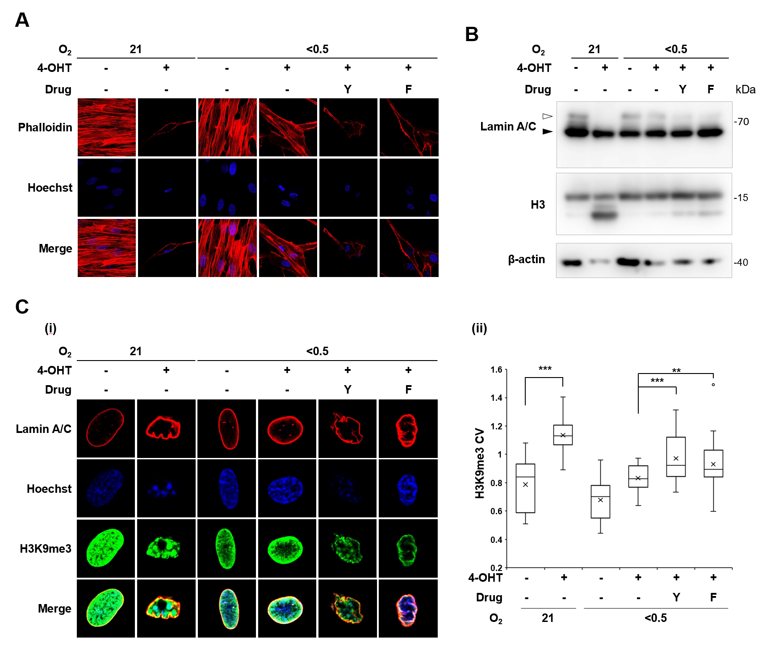

Figure S2
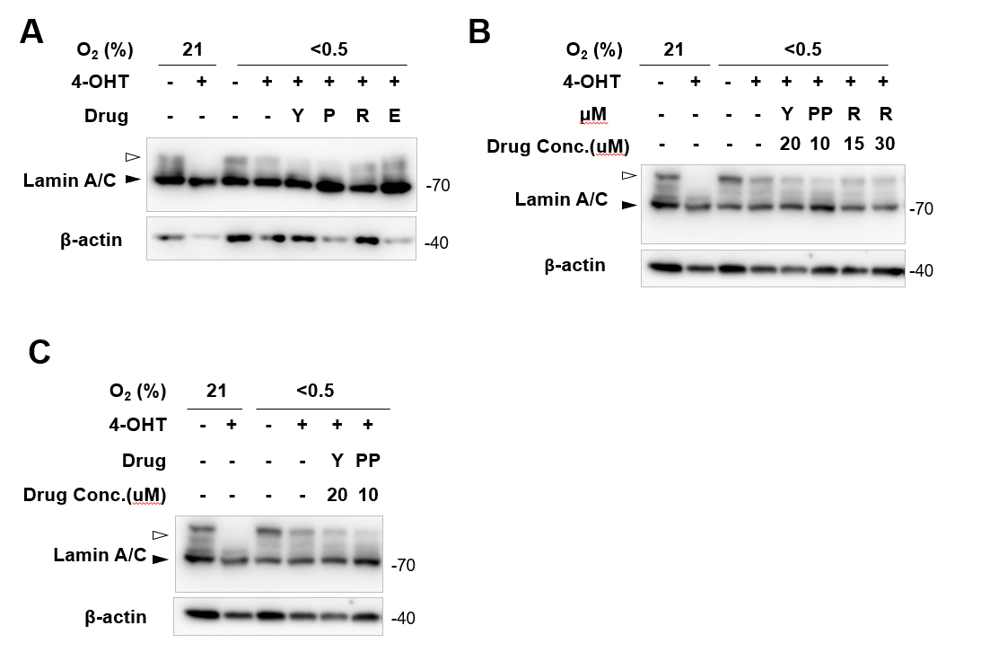

Supplementary Table S1. Primers for quantitative RT-PCR analyses
Gene name | Direction | Sequence
18S rRNA | Forward | 5’ - ACCGCAGCTAGGAATAATGGAATA - 3’
18S rRNA | Reverse | 5’ - CTTTCGCTCTGGTCCGTCTT - 3’
LMNA | Forward | 5’- ATGAGGACCAGGTGGAGCAGTA - 3’
LMNA | Reverse | 5’- ACCAGGTTGCTGTTCCTCTCAG - 3’
EMERIN | Forward | 5’- CCGCCTCCTCTTATAGCTTC - 3’
EMERIN | Reverse | 5’- CTCTGGTAGAGTAAAGCGTCC - 3’
SUN1 | Forward | 5’- CTGTGAGACAGTGGATGCCGTA - 3’
SUN1 | Reverse | 5’- GCATCGTCTGCAAGTCGCCTTTG - 3’
ITGA6 | Forward | 5’- ATGCACGCGGATCGAGTTTG - 3’
ITGA6 | Reverse | 5’- TTCCTGCTTCGTATTAACATGCTG - 3’
FLNC | Forward | 5’- ATGGTAGCTGCACCGTGGAGTA - 3’
FLNC | Reverse | 5’- TCCACCACATCCTTCACTGGCA - 3’
MYL9 | Forward | 5’- GGATGTGATTCGCAACGCCTTTG - 3’
MYL9 | Reverse | 5’- CGGTACATCTCGTCCACTTCC - 3’
SRC | Forward | 5’- CTGCTTTGGCGAGGTGTGGATG - 3’
SRC | Reverse | 5’- CCACAGCATACAACTGCACCAG - 3’
WASF1 | Forward | 5’- CTGCTTTGGCGAGGTGTGGATG - 3’
WASF1 | Reverse | 5’- CCACAGCATACAACTGCACCAG - 3’
ARHGAP10 | Forward | 5’- CTGCTCCGTTTGGTTCCAGTTG - 3’
ARHGAP10 | Reverse | 5’- GGAGTCAGTATGCCTCTTGGTAC - 3’
ARHGAP18 | Forward | 5’- GCTGAAGCTCTTCATTCGGGAG - 3’
ARHGAP18 | Reverse | 5’- GGTTCAAAGCCTGTAGTTGCTGC - 3’
ARHGEF25 | Forward | 5’- GCAAGAGCTACAACGGTGTCTG - 3’
ARHGEF25 | Reverse | 5’- GACACCACATGCTCTGACTTGG - 3’
ACTG1 | Forward | 5’- CCGAGCCGTGTTTCCTTCC - 3’
ACTG1 | Reverse | 5’- GCCATGCTCAATGGGGTACT - 3’
FN1 | Forward | 5’- ACAACACCGAGGTGACTGAGAC - 3’
FN1 | Reverse | 5’- GGACACAACGATGCTTCCTGAG - 3’
MAPK3 | Forward | 5’- TGGCAAGCACTACCTGGATCAG - 3’
MAPK3 | Reverse | 5’- GCAGAGACTGTAGGTAGTTTCGG - 3’

Supplementary Table S2. Antibodies used for immunofluorescence and western blot analyses.
Antibody | Provider | Cat.No. | Application
Anti-ERα | Santa Cruz Biotechnology | sc-543 | WB, IF
Anti-HIF-1α | BD bioscience | 610959 | WB
Anti-β-actin | Cell signaling | 3700 | WB
Anti-Cathepsin L | Abcam | ab6314 | WB
Anti-Lamin A/C | Cell signaling | 2032 | WB
Anti-Lamin A/C | Cell signaling | 4777 | IF
Anti-Lamin B | Abcam | ab8982 | WB
Anti-Emerin | Protetin tech | 10351-1-AP | WB
Anti-SUN1 | Abcam | ab124770 | WB
Anti-H3 | Abcam | ab1791 | WB
Anti-H3K9me3 | Abcam | ab8898 | WB, IF
Anti-γH2AX | Millipore | 05-636 | IF
Anti-MYPT1 Thr696 | Cell signaling | 5163 | WB
Anti-MYPT1 | Cell signaling | 8574 | WB

