Additional Files

There are two additional figures in this file: Figure S1 and Figure S2.

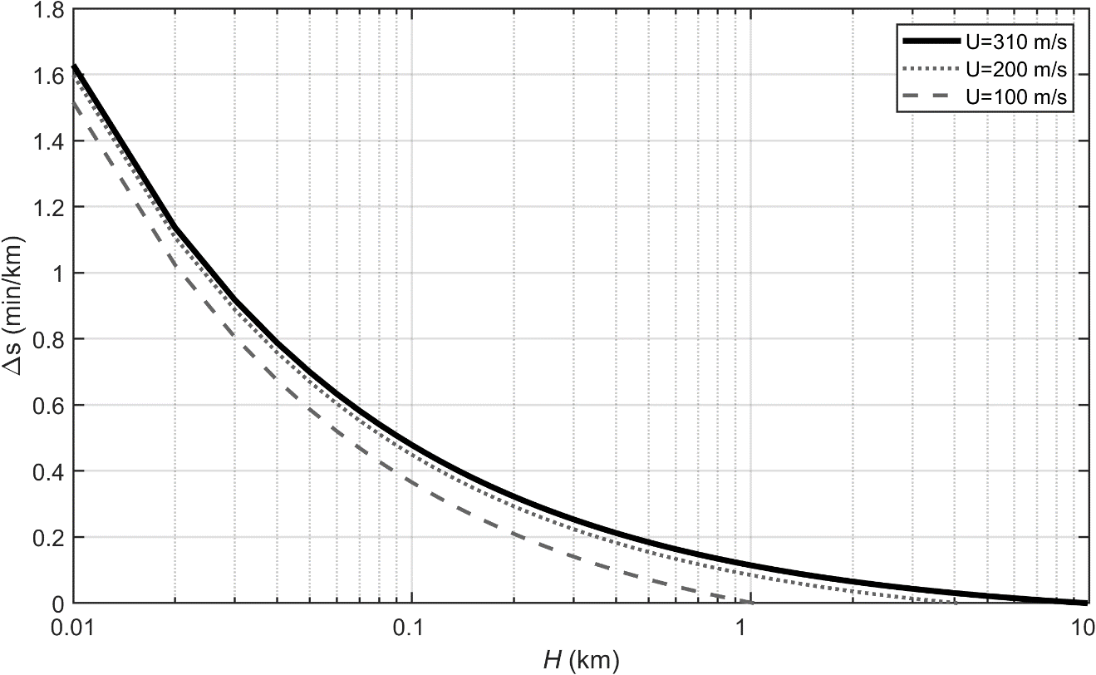

Figure S1. The change of travel time difference per unit distance $Δs$ (min/km) relative to water depth $H$.

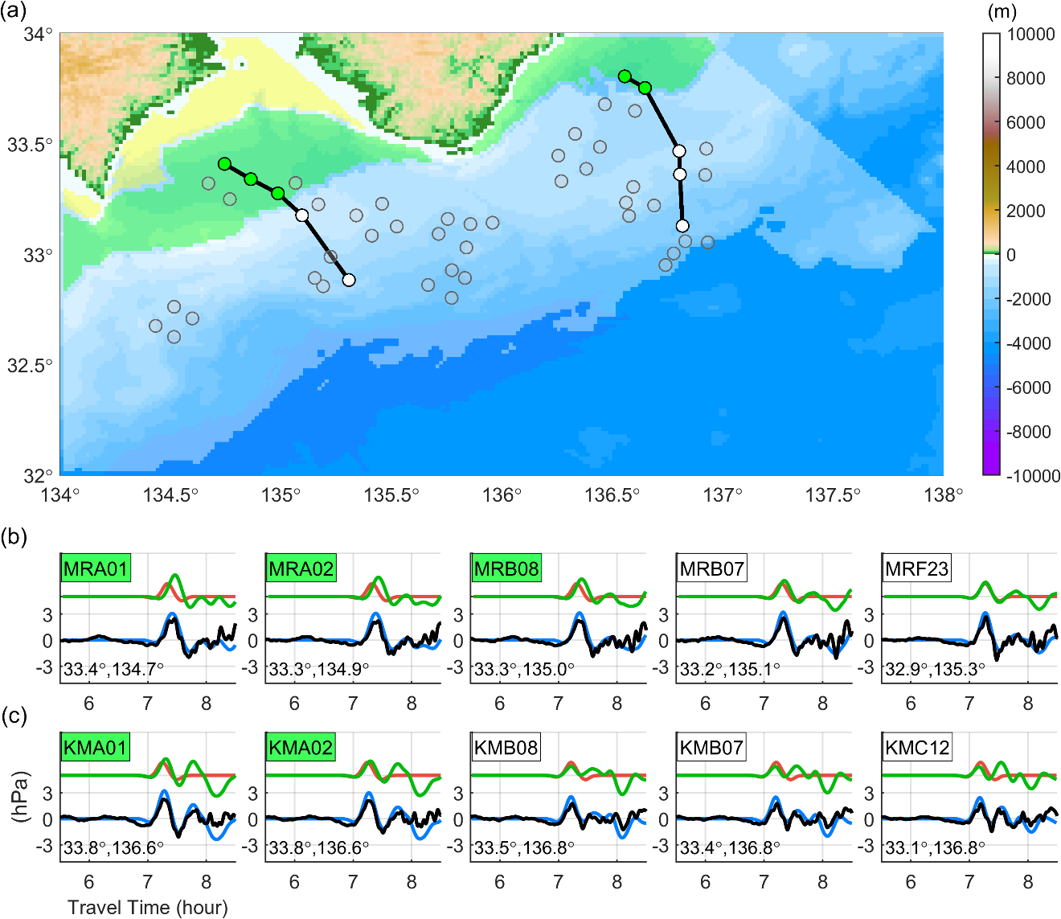

Figure S2. DONET stations and observed OBP waveforms compared to the simulated waveforms of air pressure, sea surface, and bottom pressure. (a) The circles represent the locations of DONET stations. The areas shaded by white, green, and yellow indicate the zones of $Δt\left(s\right)$ of < 6, 6-12, and > 12 minutes, respectively. The stations connected with dark lines are the circles filled with the color corresponding to their Δt. The waveforms of those stations are shown in Figures S3b-c from west to east. (b-c) The waveforms of the stations connected with dark lines from west to east in Figure S3a. Black lines illustrate the observed bottom pressure data. Red, green, and blue lines are the input air pressure wave, simulated sea surface heights, and simulated bottom pressures. The background color of the station name corresponds to the circle's fill color in Figure S3a.

