Supplementary information
Journal: Plant and soil
Authors: Xingchao Qi ^{1,2}, Zhaoming Qu ¹, Jingmin Zhang ³, Yanli Liu ¹, Chengliang Li ^{1*}

1. National Engineering Research Center for Efficient Utilization of Soil and Fertilizer Resources, Shandong Agricultural University, Taian, Shandong, 271000, P. R. China.
2. Shandong Key Laboratory of Eco-Environmental Science for Yellow River Delta, Binzhou University, Binzhou, Shandong, 256600, P. R. China.
3. Weifang University of Science and Technology, Shouguang, Shandong, 262700, P. R. China.

Corresponding author: (email: Chengliang_li11@163.com)

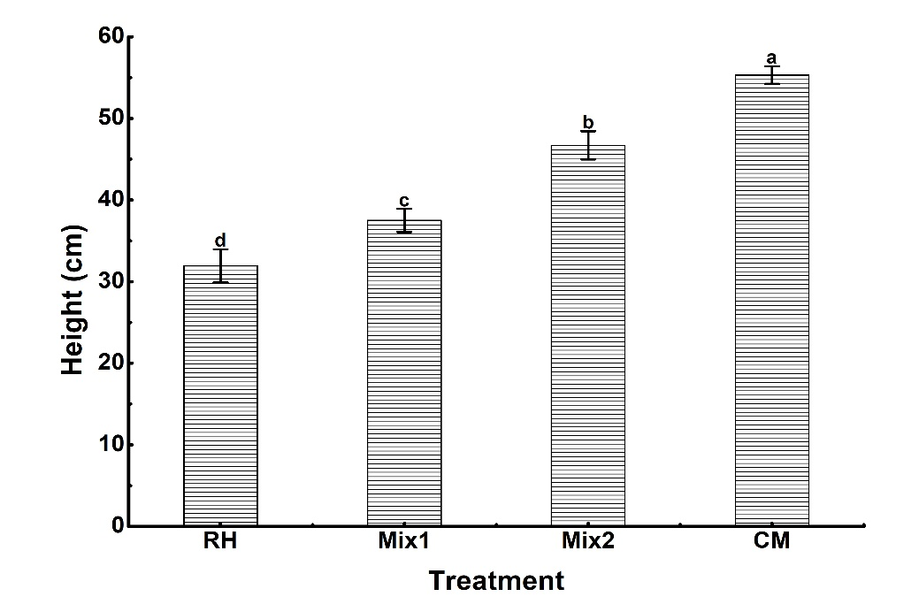
Fig. S1 Height of tomato plant at the early stage of flowering and fruiting in the early spring season of 2019.

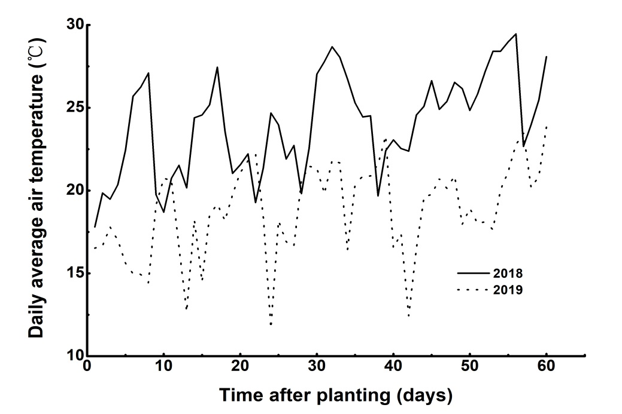
Fig. S2 Daily average air temperature of greenhouse 60 days after planting in the early spring season 2018 and 2019, respectively.

Table S1 Rates of organic carbon and nitrogen of organic amendments in the early spring season of 2018 and autumn-winter season of 2018.
Treatments | Rate of organic carbon (kg ha⁻¹) |  | Rate of nitrogen (kg ha⁻¹)
Treatments | 2018 ES | 2018AW | 2018 ES | 2018AW
RH | 76426 | 45855 | 1000 | 600
Mix1 | 39301 | 23581 | 1000 | 600
Mix2 | 25025 | 15015 | 1000 | 600
CM | 10795 | 6477 | 1000 | 600
Note: RH, Mix1, Mix2 and CM are the abbreviation of rice husk, mixture1, mixture1, and chicken manure, respectively. 2018ES and 2018AW are the abbreviation of the early spring season of 2018 and the autumn-winter season of 2018, respectively.

Table S2 Chlorophyll contents (SPAD values) of leaves of different treatments at the middle stage of flowering and fruiting of the early spring season of 2018.
Treatments | RH | Mix1 | Mix2 | CM
SPAD values | 41.61 b | 41.79 b | 41.17 b | 47.27 a
Note: RH, Mix1, Mix2 and CM are the abbreviation of rice husk, mixture1, mixture1, and chicken manure, respectively.

Table S3 Total N content (%) of organic amendments during the in-situ incubation.
Incubation days | Organic fertilizers
Incubation days | RH | Mix1 | Mix2 | CM
0 | 0.54 b | 0.93 d | 1.19 d | 1.61 a
7 | 0.60 b | 0.83 e | 1.03 e | 1.44 ab
14 | 0.69 b | 0.96 d | 1.19 d | 1.62 a
29 | 0.64 b | 0.93 d | 1.18 d | 1.38 abc
59 | 0.66 b | 0.94 d | 1.22 cd | 1.19 bcd
89 | 0.70 b | 0.97 d | 1.18 d | 1.21 bcd
124 | 0.66 b | 0.96 d | 1.21 cd | 1.05 d
181 | 0.73 b | 1.07 c | 1.31 c | 1.13 cd
241 | 0.74 b | 1.22 b | 1.42 b | 1.09 d
334 | 1.08 a | 1.61 a | 1.54 a | 1.13 cd
Note: Mean values with the same letter are not significantly different (p>0.05) within the same column.

Table S4 Date of irrigation in the early spring season of 2018 and 2019, respectively.
Season | Date | Season | Date
Early spring season of 2018 | 12 April, 2018 | Early spring season of 2019 | 16 March, 2019
Early spring season of 2018 | 17 April, 2018 | Early spring season of 2019 | 24 March, 2019
Early spring season of 2018 | 3 May, 2018 | Early spring season of 2019 | 16 April, 2019
Early spring season of 2018 | 17 May, 2018 | Early spring season of 2019 | 3 May, 2019
Early spring season of 2018 | 31 May, 2018 | Early spring season of 2019 | 12 May, 2019
Early spring season of 2018 | 10 June, 2018 | Early spring season of 2019 | 20 May, 2019
Early spring season of 2018 | 20 June, 2018 | Early spring season of 2019 | 27 May, 2019
Early spring season of 2018 | 1 July, 2018 | Early spring season of 2019 | 3 June, 2019
Early spring season of 2018 | 8 July, 2018 | Early spring season of 2019 | 11 June, 2019
Early spring season of 2018 | 16 July, 2018 | Early spring season of 2019 | 18 June, 2019
Early spring season of 2018 | 25 July, 2018 | Early spring season of 2019 | 26 June, 2019
Early spring season of 2018 |  | Early spring season of 2019 | 3 July, 2019
Early spring season of 2018 |  | Early spring season of 2019 | 10 July, 2019
Early spring season of 2018 |  | Early spring season of 2019 | 20 July, 2019
Early spring season of 2018 |  | Early spring season of 2019 | 29 July, 2019

