Fiber-specific micro- and macroscopic white matter alterations in progressive supranuclear palsy and corticobasal syndrome
Wataru Uchida,¹ Koji Kamagata,^{1*} Christina Andica,^{1, 2} Kaito Takabayashi,¹ Yuya Saito,¹ Mana Owaki,^{1, 3} Shohei Fujita,¹ Akifumi Hagiwara,¹ Akihiko Wada,¹ Toshiaki Akashi,¹ Katsuhiro Sano,¹ Masaaki Hori,⁴ Shigeki Aoki¹

Supplementary materials
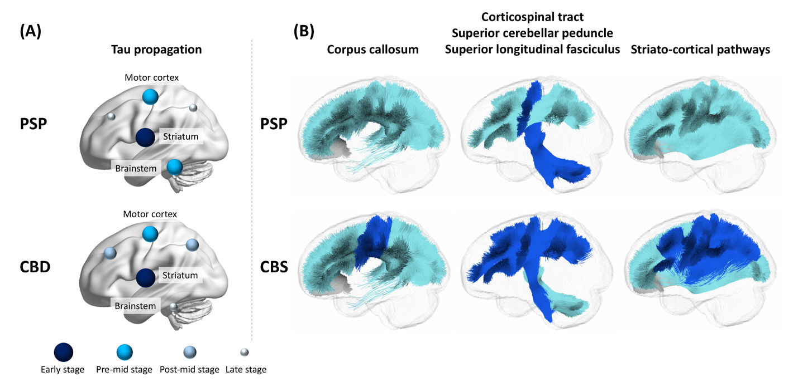

Supplementary Figure 1. Scheme of tau propagation in progressive supranuclear palsy and corticobasal degeneration and correspondence with the fixel-based analysis (FBA) results. (A) The left panel shows the propagating scheme of tau pathology in the early to late stages in progressive supranuclear palsy (PSP) and corticobasal degeneration (CBD) reported in the previous report.⁵² (B) The right panel indicates the tracts that were used in the tract-specific analysis. The tracts are colored according to the significant changes in PSP and corticobasal syndrome (CBS) compared with that in healthy controls, as follows: blue, tracts significantly decreased the log-transformed fiber cross-section (log-FC) regardless of the changes of fiber density (FD) and fiber density and cross-section (FDC); light blue, tracts with no changes in log-FC and FD or FDC changed; gray, tracts showed no-significant changes in any parameters.

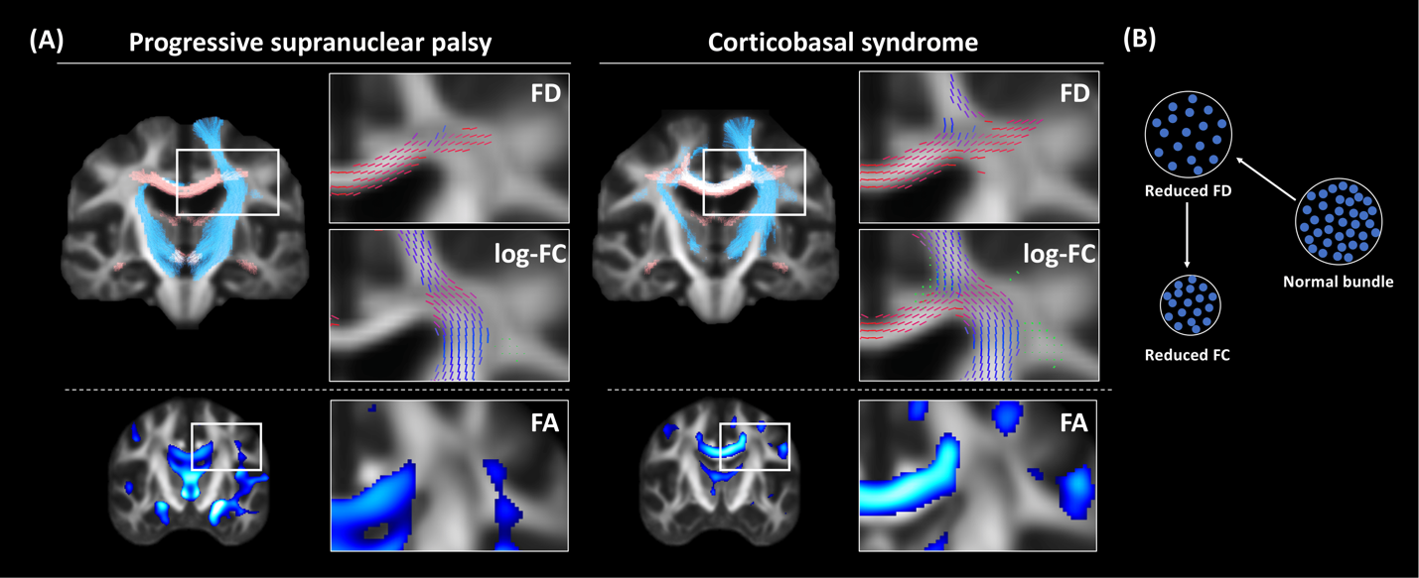
Supplementary Figure 2. The superiority of fixel-based analysis in the crossing fiber region. (A) The significant changes in fixel-wise metrics of fiber density (FD) and log-transformed fiber cross-section (log-FC) are shown in the upper panel (family-wise error-corrected P < 0.05), and voxel-wise metrics of fractional anisotropy (FA) are shown in the lower panel (uncorrected P < 0.001), displayed in progressive supranuclear palsy and corticobasal syndrome compared with that in healthy controls. As shown in the upper left, the whole-brain tractgrams were cropped by significantly decreased FD (orange) and log-FC (blue). The upper right panel represents the significant fixels colored by fiber direction (red, left-right; green, anterior-posterior; blue, inferior-superior) for each parameter. The lower panel indicates that the significant voxels shown in FA comparisons were scaled by t-values (range, 3 to 6). (B) Schematic of FD and log-FC reduction exhibiting changes in the fixel-wise metrics. The fiber density decreased due to neuronal loss from normal fiber bundles, followed by macroscopic atrophy.

