Appendix 1

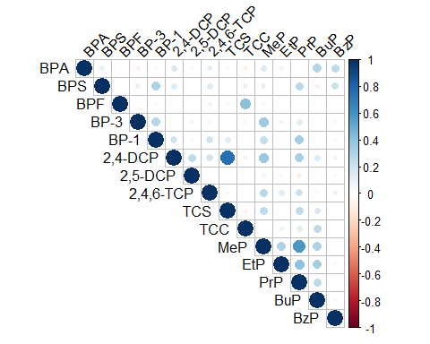

Appendix Figure 1. Pairwise correlation matrix of phenols and phalates within periconceptional or prenatal urine samples (n=35)

