Supplementary Materials for

Rapid evolution of A(H5N1) influenza viruses after intercontinental spread to North America
Ahmed Kandeil^{1†}, Christopher Patton^{1,3†}, Jeremy C. Jones^{1†}, Trushar Jeevan^{1†}, Walter Harrington^{1†}, Sanja Trifkovic¹, Jon P. Seiler¹, Thomas Fabrizio¹, Karlie Woodard¹, Jasmine C. Turner¹, Jeri-Carol Crumpton¹, Lance Miller¹, Adam Rubrum¹, Jennifer DeBeauchamp¹, Charles J. Russell¹, Elena A. Govorkova¹, Peter Vogel², Mia Kim-Torchetti⁵, Yohannes Berhane^{6,7}, David Stallknecht⁴, Rebecca Poulson⁴, Lisa Kercher¹, Richard J. Webby^{1,3}*

Correspondence to: richard.webby@stjude.org

This PDF file includes:

Supplementary Figs. 1 to 8
Supplementary Tables 1 to 4
Supplementary Materials and Methods

SUPPLEMENTARY FIGURES

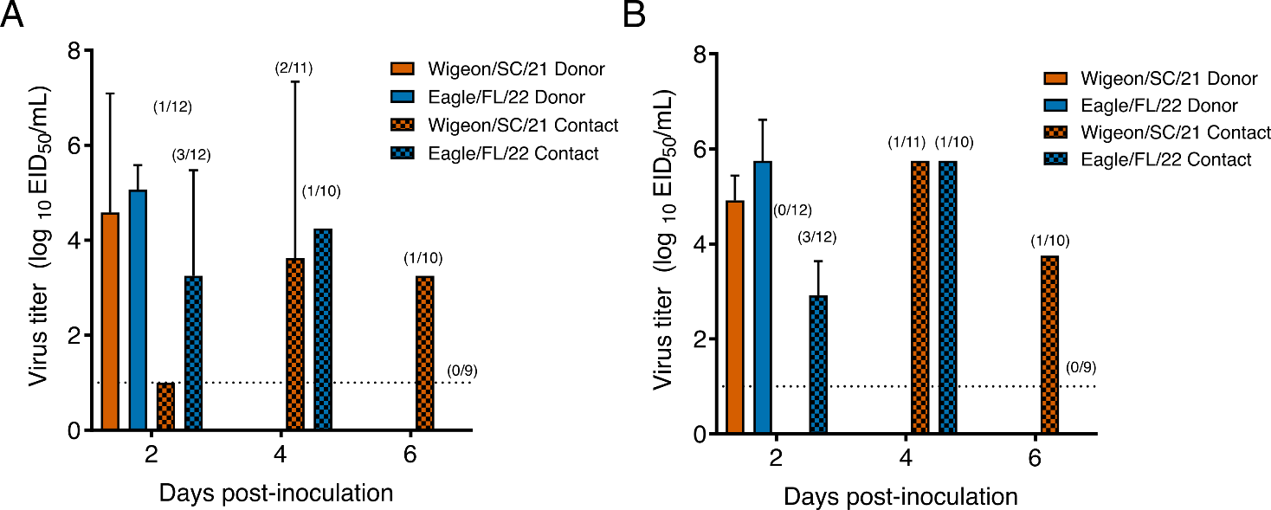
Supplementary Fig. 1. Replication and transmission of North American HPAI A(H5N1) viruses of clade 2.3.4.4b in chickens. Donor chickens (n = 3 per virus) were inoculated intranasally by natural routes with 10⁶ EID₅₀s of Wigeon/SC/21 (H5N1) or Eagle/FL/22 (H5N1) virus then were co-housed with naïve contact chickens (n = 4 per donor chicken) at 1 hpi. Infectious viral titers for oropharyngeal swabs (A) and cloacal swabs (B) were determined by EID₅₀ assays. The values are the mean virus titers (log₁₀ EID₅₀/mL) ± SD. The dashed line indicates the lower limit of virus detection (1.0 log₁₀EID₅₀/mL). All donor chickens (solid bars) died by 2 dpi. Numbers in parentheses above the bars representing the contacts (the checkered bars) represent the number of infected birds/number of alive contact birds.

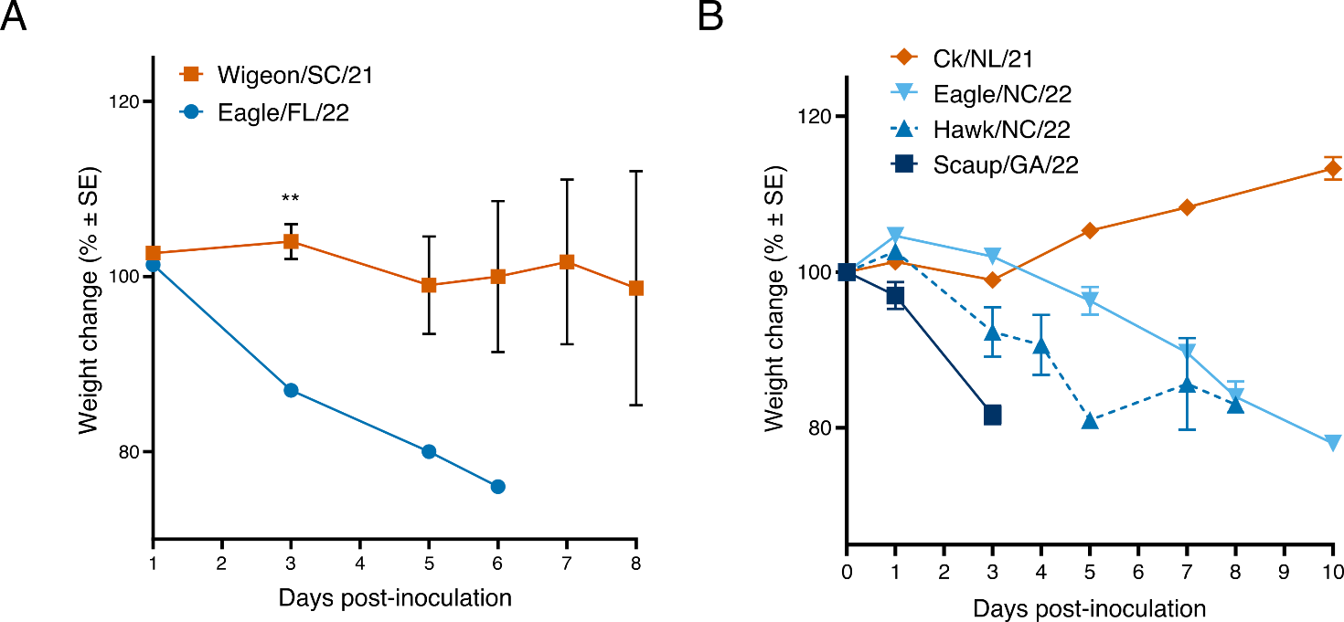

Supplementary Fig. 2. Weight changes in ferrets inoculated with North American HPAI A(H5N1) viruses of clade 2.3.4.4b. Ferrets (n = 3 per virus) were inoculated intranasally with 10⁶ EID₅₀s of Wigeon/SC/21 or Eagle/FL/22 influenza A(H5N1) virus (A) or Ck/NL/21, Eagle/NC/22, Hawk/NC/22, or Scaup/GA/22 influenza A(H5N1) virus (B). Ferrets were weighed daily, and the loss or gain of weight was calculated for each ferret as the percentage change in the initial mean weight at 0 dpi. Values are the average ± SE for each group. P values were calculated using an unpaired t-test. **, P < 0.01.

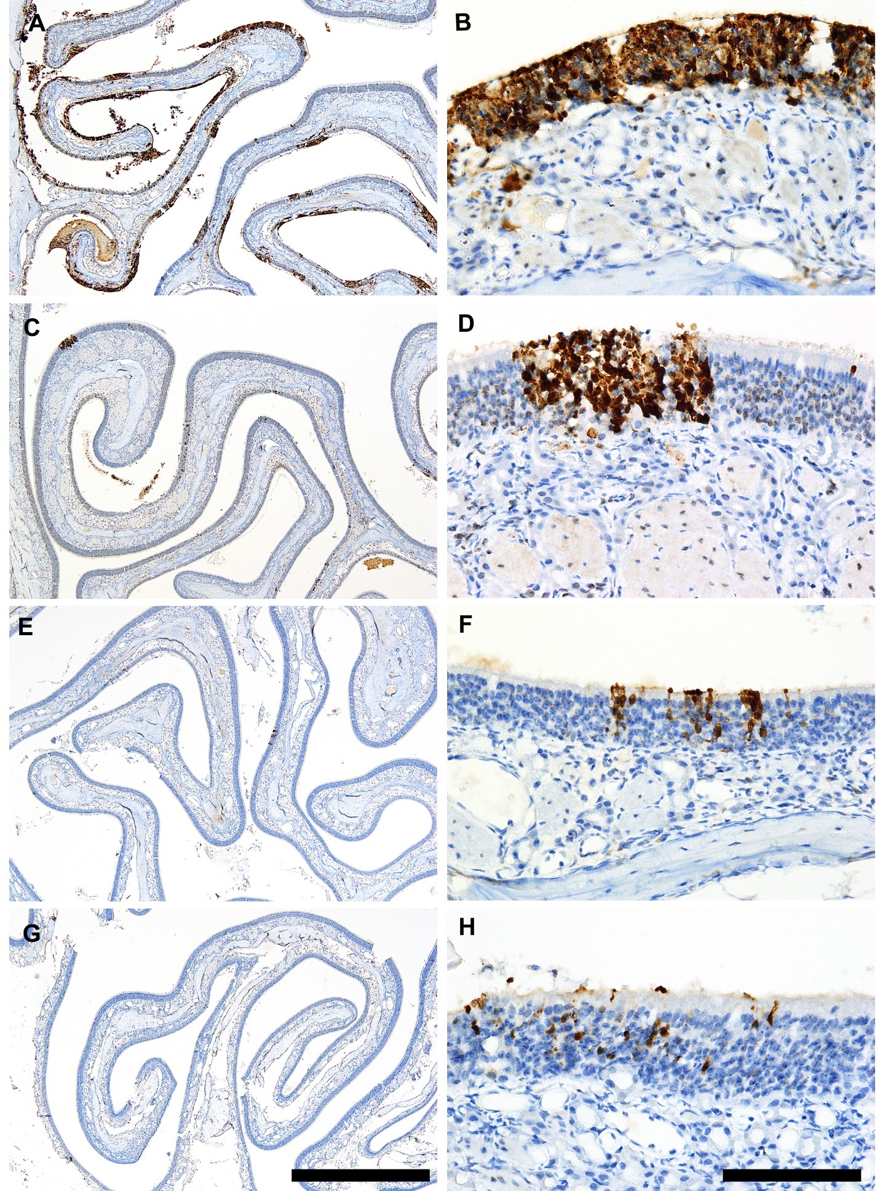
Supplementary Fig. 3. Spread of A(H5N1) virus and appearance of lesions in the upper respiratory tract of ferrets. (A) In the turbinates of ferrets infected with Scaup/GA/22 virus, there was extensive exfoliation and degeneration of virus-infected cells. (B) Virus-infected cells and tissues in affected areas included sustentacular cells, olfactory neurons, respiratory epithelium, and, occasionally, submucosal glands. (C) The extent of virus infection in Hawk/NC/22-infected ferrets was limited to multifocal clusters of neuroepithelial cells. (D) Virus-infected cells included sustentacular cells and olfactory neurons, but only occasional individual ciliated respiratory epithelial cells. (E) Only a few small foci of virus-positive cells in were detected in the olfactory neuroepithelium of Eagle/NC/22 infected ferrets. (F) Virus-infected cells included sustentacular cells and olfactory neurons, but no ciliated respiratory epithelial cells. (G) In Ck/NL/21-infected ferrets, only two small foci containing virus-infected cells were detected in three animals. (H) Virus infection was limited to sustentacular cells and olfactory neurons; no ciliated respiratory epithelial cells were infected. Scale bars in A, C, E, and G = 1 mm; those in B, D, F, and H = 100 µm.

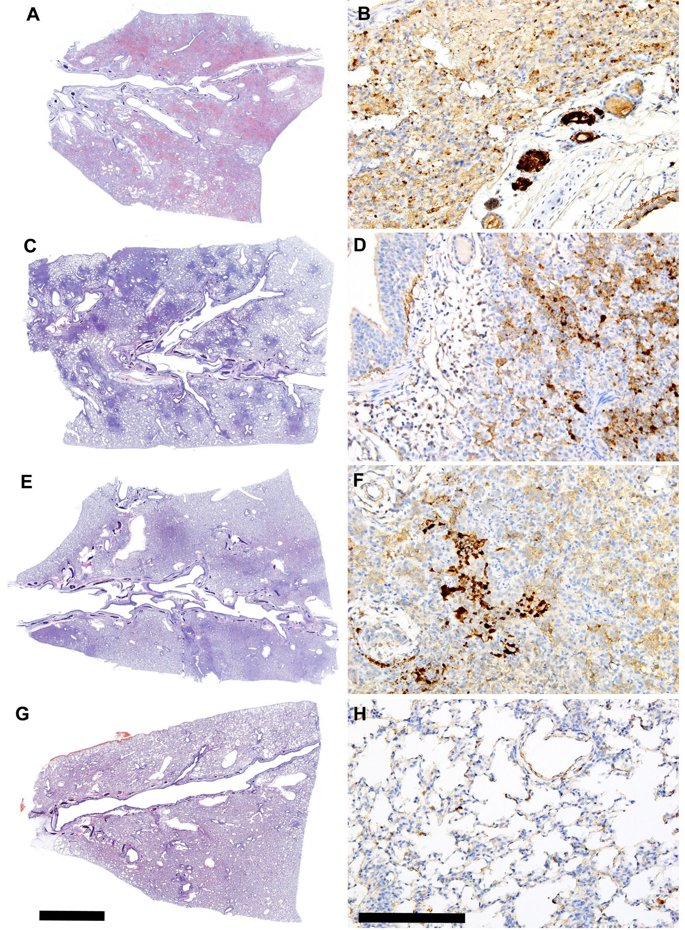 Supplementary Fig. 4. Spread of A(H5N1) influenza virus and appearance of lesions in the lower respiratory tract of ferrets. (A) In ferrets infected with Scaup/GA/22 virus, there was consolidation of entire lobes due to extensive necrotizing alveolitis, with associated hemorrhage and edema. There were numerous perivascular/peribronchiolar lymphoid nodules in affected lobes. (B) In consolidated alveolar areas, viral antigen is dispersed diffusely, with the scattered apoptotic cell debris and macrophages (C) Lung lesions in ferrets infected with Hawk/NC/22 virus are centered on terminal airways and are generally well-demarcated from the more normal surrounding parenchyma. (D) Viral antigen is mostly concentrated in cellular debris within the bronchial/bronchiolar lumens, but both the bronchiolar epithelium and the submucosal glands are virus negative. (E) In lungs infected with Eagle/NC/22, there were multifocal areas of increased cellularity characterized by hypertrophic alveolar epithelium. (F) Virus-positive debris consisting of neutrophils and cell debris is present in bronchioles, but the bronchiolar epithelium is virus negative. The is diffuse, mildly positive cytoplasmic labeling of hypertrophic alveolar epithelium, suggestive of a non-cytolytic infection of these cells. (G) In ferrets infected with Ck/NL/21 virus, only one lobe in three ferrets showed any evidence of pulmonary infection. The few lesioned areas were characterized by mildly increased cellularity but no detectable cellular exudates or edema. (H) In the affected areas, small amounts of virus antigen were detectable on the alveolar surfaces and within a few I and II types of pneumocytes. The bronchiolar epithelium was virus negative and of normal appearance. Scale bars in A, C, E, and G = 2 mm; those in B, D, F, and H = 200 µm.

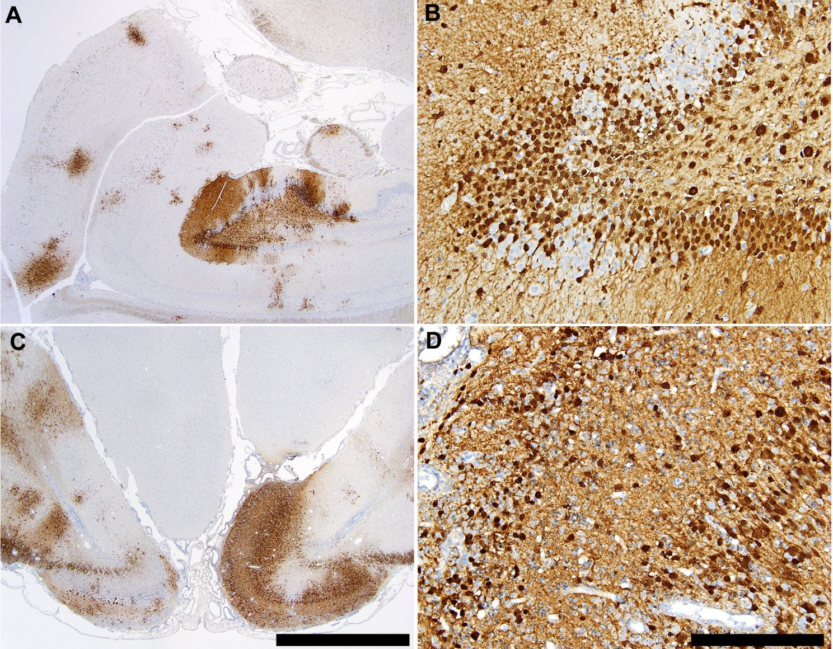

Supplementary Fig. 5. Extent of A(H5N1) influenza virus spread in the brain. (A) In ferrets exposed to Scaup/GA/22 virus, there were numerous variably sized foci containing antigen-positive neurons throughout the CNS (involving the cortex, cerebellum, brainstem, hippocampus, and thalamus, with only a single focus in the olfactory bulb of one ferret). (B) A higher-magnification image showing virus antigen in the nuclei and cytoplasm of hippocampal neurons. (C) Virus-infected neurons in ferrets infected with Hawk/NC/22 were limited to the olfactory bulb and olfactory cortex. (D) A higher-magnification image showing virus antigen in the nuclei and cytoplasm of olfactory bulb neurons. Scale bars in A and C = 2 mm; those in B and D = 200 µm.

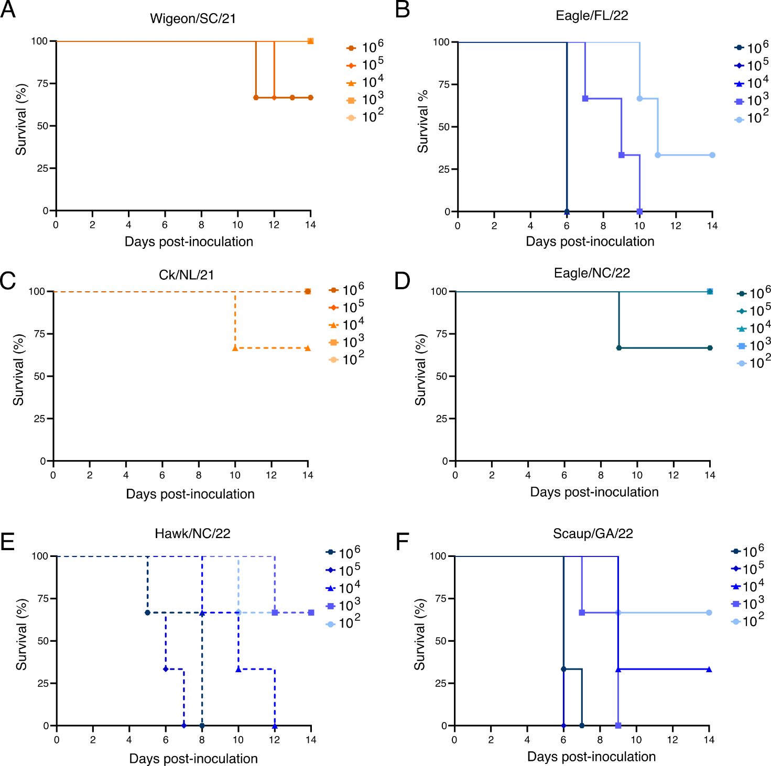

Supplementary Fig. 6. Survival of mice inoculated with North American HPAI A(H5N1) viruses of clade 2.3.4.4b. BALB/c mice (n = 3 mice per infectious dose per virus) were inoculated intranasally with the indicated dose of Wigeon/SC/21 (A), Eagle/FL/22 (B), Ck/NL/21 (C), Eagle/NC/22 (D), Hawk/NC/22 (E), or Scaup/GA/22 (F) influenza A(H5N1) virus. Mice were weighed daily and monitored for mortality (actual death or loss of ≥25% of their body weight). The Kaplan–Meier method was used to estimate the probability of survival.

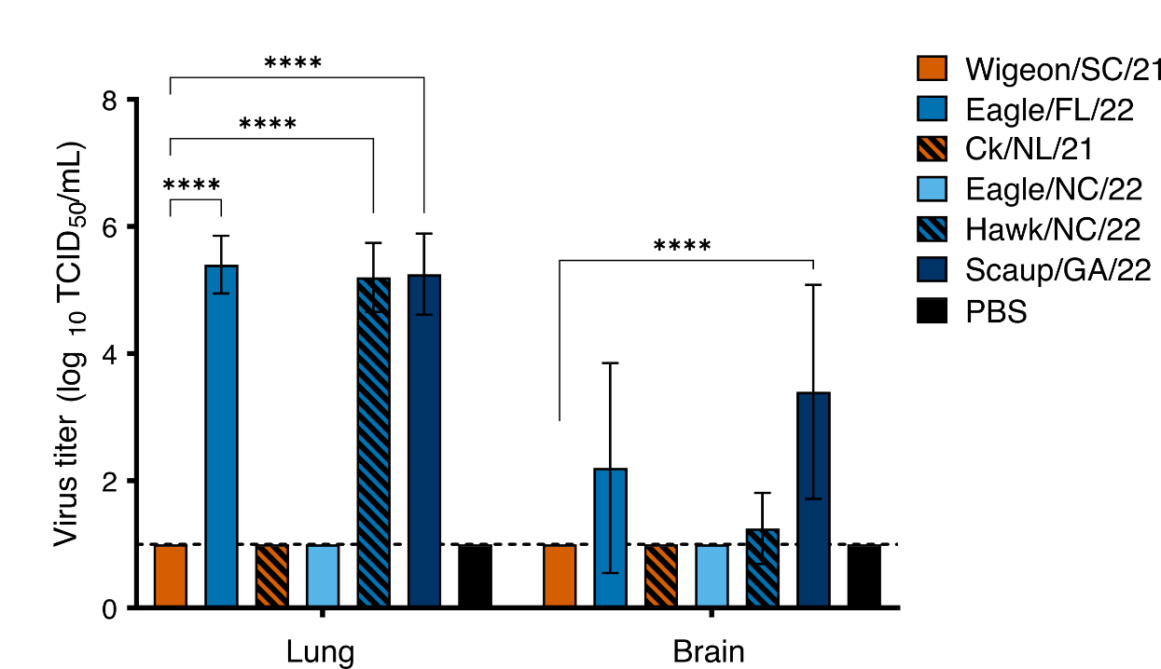

Supplementary Fig. 7. Replication of North American HPAI A(H5N1) viruses of clade 2.3.4.4b ​in the lungs and brains of mice. BALB/c mice were intranasally inoculated with 1 × 10⁴ EID₅₀s of each A(H5N1) influenza virus. Tissues were collected from mice (n = 5 mice per virus) on day 5 post infection, and infectious viral titers were determined in MDCK cells. Values are the mean virus titers (log₁₀TCID₅₀/mL) ± SD. The dashed line indicates the lower limit of virus detection (1.0 log₁₀TCID₅₀/mL). P values were calculated using two-way ANOVA with Tukey’s multiple-comparison post hoc test. ****, P < 0.0001.

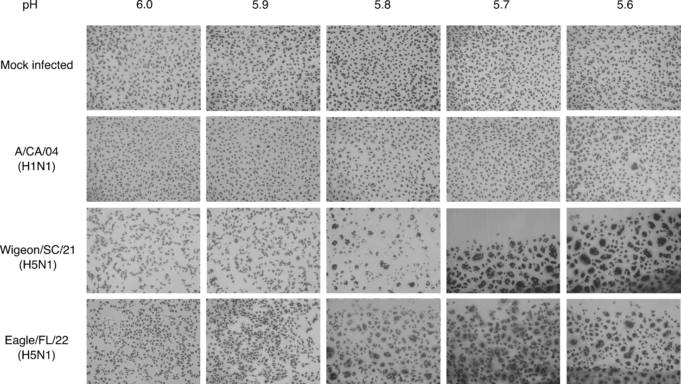

Supplementary Fig. 8. Syncytium formation in Vero cells inoculated with North America HPAI A(H5N1) viruses of clade 2.3.4.4b. Vero cells were either mock-inoculated with PBS or inoculated with Wigeon/SC/21 (H5N1), Eagle/FL/22 (H5N1), or A/CA/04 (H1N1)pdm09 influenza virus at an MOI of 3. The HA activation pH was measured by syncytium formation assays in Vero cells; the micrographs show representative results at 6 hpi for the A(H5N1) viruses and at 24 hpi for the A(H1N1)pdm09 virus. Vero cells that were mock-inoculated or inoculated with A(H1N1)pdm09 virus were used as negative and positive controls, respectively. The HA activation pH was defined as the highest pH at which syncytium formation was observed. The resolution was 0.1 pH units.

Group | Influenza A(H5N1) virus | Genotypeª | Abbreviation | Color code used in figures
1 | A/American wigeon/South Carolina/22-000345-001/2021 | EA | Wigeon/SC/21
1 | A/Bald eagle/Florida/W22-134-OP/2022 | EA/NAm  (PB1, PB2, NP) | Eagle/FL/22
2 | A/Fancy Chicken/Newfoundland/FAV-0033/2021 | EA | Ck/NL/21
2 | A/Bald eagle/North Carolina/ W22-140/2022 | EA/NAm  (PB2, NP) | Eagle/NC/22
2 | A/Red-shouldered hawk/North Carolina/W22-121/2022 | EA/NAm  (PB1, PB2, NP) | Hawk/NC/22
2 | A/Lesser scaup/Georgia/W22-145E/2022 | EA/NAm  (PB1, PB2, PA, NP) | Scaup/GA/22
Supplementary Table 1. North American HPAI A(H5N1) viruses of clade 2.3.4.4b used in the study, with their genotypes and abbreviations
ªThe gene segments acquired from avian influenza viruses from NAm wild birds are indicated in parentheses.
Abbreviations: EA, Eurasian-origin; NAm, North American-origin. PB1, polymerase basic 1 gene; PB2, polymerase basic 2 gene; PA, polymerase acidic gene; NP, nucleoprotein gene.
Supplementary Table 2. Antigenic characterization of North America HPAI A(H5N1) viruses of clade 2.3.4.4b

Influenza A(H5Nx) virus | Subtype | Mean HI titers of post-infection ferret sera against influenza virusª
Influenza A(H5Nx) virus | Subtype | A/Fujian-Sanyuan/21099/2017 | A/Astrakhan/3212/2020 | A/Gyrfalcon/WA/  41088-6/2014
Wigeon/SC/21​ | H5N1 | 20 | 80 | 40
Eagle/FL/22​ | H5N1 | 20 | 160 | 80
Ck/NL/21 | H5N1 | 40 | 160 | 160
Eagle/NC/22 | H5N1 | 40 | 160 | 160
Hawk/NC/22​ | H5N1 | 20 | 160 | 80
Scaup/GA/22​ | H5N1 | 20 | 160 | 80
Reference influenza virus
A/Fujian-Sanyuan/21099/2017 | H5N6 | 80 | 160 | 160
A/Astrakhan/3212/2020 | H5N8 | 80 | 320 | 320
A/Gyrfalcon/WA/41088-6/2014 | H5N8 | 160 | 320 | 320

ªTiters are expressed as the reciprocal of the highest dilution of serum that inhibited 4 HA units of virus. The results are the arithmetic mean titer of positive sera (HI titer >10). The titers of serum samples with homologous viruses are shown in bold and are underlined.

Supplementary Table 3. Pathogenicity of North American HPAI A(H5N1) viruses in ferrets

Influenza A(H5N1) virusª | No. surviving/  total no. | No. of ferrets showing indicated clinical signs(s) of disease/total no. |  |  |  | Relative inactivity index^{e}
Influenza A(H5N1) virusª | No. surviving/  total no. | Weight loss^{b} | Temperature increase^{b} | Respiratory signs^{c} | Neurologic signs^{d}
Wigeon/SC/21 | 3/3 | 1/3 (17 ± 9.6) | 3/3 (1.2 ± 0.5) | 0/3 | 0/3 | 0.1
Eagle/FL/22 | 0/3 | 3/3 (20 ± 6.9) | 3/3 (3.3 ± 0.5) | 3/3 | 3/3 | 1.7
Ck/NL/21 | 3/3 | 0/3 (13 ± 2.7) | 3/3 (0.9 ± 0.1) | 0/3 | 0/3 | 0.0
Eagle/NC/22 | 1/3 | 3/3 (15 ± 6.1) | 3/3 (3.0 ± 1.1) | 0/3 | 2/3 | 0.8
Hawk/NC/22 | 0/3 | 3/3 (16 ± 10.5) | 3/3 (2.0 ± 0.7) | 2/3 | 3/3 | 1.3
Scaup/GA/22 | 0/3 | 3/3 (18 ± 2.3) | 3/3 (1.8 ± 0.9) | 3/3 | 3/3 | 1.0
ªFor each virus, groups of three ferrets were lightly anesthetized with isoflurane and inoculated intranasally with 10⁶ EID₅₀ in 1.0 mL of PBS.
^{b}Maximum change in mean weight (percentage) or temperature (°C) ± SD is shown in parentheses.
^{c}Respiratory signs were sneezing, wheezing, nasal discharge, and labored breathing.
^{d}Neurologic signs were hind-limb paresis, ataxia, torticollis, and tremors.
^{e}Determined by observation for 14 days. The relative inactivity index before virus inoculation was 0.

Influenza A virus  (NA/PA substitution) | Subtype | Susceptibility to antiviral drugs
Influenza A virus  (NA/PA substitution) | Subtype | PA inhibitor (baloxavir)ª |  | NA inhibitors^{c} |  |  |  | M2 inhibitor  (amantadine)^{e}
Influenza A virus  (NA/PA substitution) | Subtype | Mean EC₅₀ ± SD (nM) | Fold change^{b} | Oseltamivir |  | Zanamivir |  | M2 inhibitor  (amantadine)^{e}
 |  |  |  | Mean IC₅₀ ± SD (nM) | Fold change^{d} | Mean IC₅₀ ± SD (nM) | Fold change^{d} | M2 inhibitor  (amantadine)^{e}
Wigeon/SC/21 | H5N1 | 0.16 ± 0.05 | <1.0 | 1.25 ± 0.65 | 4.4 | 0.22 ± 0.03 | 1.1 | S
Eagle/FL/22 | H5N1 | 0.22 ± 0.06 | 1.1 | 0.98 ± 0.57 | 3.4 | 0.19 ± 0.04 | 1.0 | S
Ck/NL/21 | H5N1 | 0.09 ± 0.09 | <1.0 | 1.26 ± 0.62 | 4.4 | 0.20 ± 0.04 | 1.0 | S
Eagle/NC/22 | H5N1 | 0.52 ± 0.04 | 2.7 | 1.07 ± 0.56 | 3.8 | 0.18 ± 0.05 | <1.0 | S
Hawk/NC/22 | H5N1 | 0.27 ± 0.03 | 1.4 | 1.34 ± 0.68 | 4.7 | 0.20 ± 0.04 | 1.0 | S
Scaup/GA/22 | H5N1 | 0.17 ± 0.08 | <1.0 | 1.13 ± 0.90 | 4.0 | 0.21 ± 0.04 | 1.1 | S
Reference influenza viruses
rg-A/CA/04  (PA I38) | (H1N1)pdm09 | 0.19 ± 0.04 | 1.0 | N/A | N/A | N/A | N/A | R (S31N)
rg-A/CA/04  (PA I38T) | (H1N1)pdm09 | 15.32 ± 3.13 | 80.6 | N/A | N/A | N/A | N/A | R (S31N)
A/Denmark/524/2009 (NA H275) | (H1N1)pdm09 | N/A | N/A | 0.29 ± 0.65 | 1.0 | 0.20 ± 0.02 | 1.0 | R (S31N)
A/Denmark/528/2009 (NA H275Y) | (H1N1)pdm09 | N/A | N/A | 118.81 ± 0.65 | 416.4 | 0.24 ± 0.05 | 1.2 | R (S31N)
Supplementary Table 4. Susceptibility of North American HPAI A(H5N1) viruses to antiviral drugs
ªReduction in plaque formation number in virus-infected MDCK cells at 72 hpi or 96 hpi. Mean values (in nM) ± SD from three independent dose–response curves are presented.
^{b}Fold change relative to the baloxavir susceptibility of reverse genetics (rg)-derived A/CA/04 (H1N1)pdm09 virus containing PA I38 (a baloxavir-susceptible genotype). A/CA/04 (H1N1)pdm09 containing PA I38T (a genotype with reduced susceptibility to baloxavir) is provided for comparison.
^{c}Reduction in fluorescence signal from NA-cleaved MUNANA substrate. Mean values (in nM) ± SD from four independent dose–response curves are presented.
^{d}Fold change relative to the NAI susceptibility of A/Denmark/524/2009 (H1N1)pdm09 containing NA H275 (a genotype with normal inhibition by NAIs). A/Denmark/528/2009 (H1N1)pdm09 containing NA H275Y (a genotype for which inhibition by oseltamivir is greatly reduced) is provided for comparison.
^{e}Susceptibility to adamantanes was based on the absence of substitutions at M2 residues known to mediate adamantane resistance (amino acids 26, 27, 30, 31, and/or 34 ).
Abbreviations: N/A, not applicable to specific inhibitor analysis. S, amantadine-susceptible virus; R, amantadine-resistant virus. Amantadine resistance-associated mutations are shown in parentheses.

SUPPLEMENATRY MATERIALS AND METHODS
Ethics statement
All animal studies were approved by the St. Jude Children’s Research Hospital Institutional Animal Care and Use Committee (IACUC, protocol number 428) in accordance with the guidelines established by the Institute of Laboratory Animal Resources, approved by the Governing Board of the US National Research Council, and carried out by trained personnel working in a United States Department of Agriculture (USDA)-inspected Animal Biosafety Level 3+ animal facility in accordance with all regulations established by the Division of Agricultural Select Agents and Toxins (DASAT) at the USDA Animal and Plant Health Inspection Service (APHIS), as governed by the United States Federal Select Agent Program (FSAP) regulations (7 CFR Part 331, 9 CFR Part 121.3, 42 CFR Part 73.3). Human sera were purchased from a commercial provider (BioIVT, Hicksville, NY) who played no role in our study. The specimens were not collected specifically for our study, and we had no access to the subject identifiers linked to the specimens.
Cell culture
Madin–Darby canine kidney (MDCK) cells (ATCC) and African green monkey kidney cells (Vero cells) (ATCC) were grown in culture in Modified Eagle’s Medium (MEM) (CellGro) supplemented with 5% fetal bovine serum (FBS) (HyClone), 1 mM L-glutamine, and 1× penicillin/streptomycin/amphotericin B (Gibco). Human embryonic kidney cells (HEK293T cells) (ATCC) were grown in culture in OptiMEM (Gibco) supplemented with 10% FBS and 1× penicillin/streptomycin/amphotericin B. Human airway epithelial cells (Calu-3 cells) (ATCC) were grown in culture in MEM supplemented with 10% FBS, 1 mM L-glutamine, 1 mM sodium pyruvate, and 1× penicillin/streptomycin/amphotericin B. All cells were maintained at 37°C in 5% CO₂.
Influenza viruses and infectivity
The A(H5N1) influenza viruses were isolated from wild birds in the allantoic cavities of 10-day-old embryonated chicken eggs (eggs) at 35°C for up to 48 h. Seasonal influenza A(H1N1) viruses were grown in MDCK cells at 37°C for up to 72 h. Viral titers were determined by injecting 0.1 mL of 10-fold dilutions of virus into the allantoic cavities of 10-day-old eggs and then calculating the 50% egg infectious dose (EID₅₀) or by inoculating MDCK monolayers and then calculating the 50% tissue culture infectious dose (TCID₅₀) by the method of Reed and Muench²⁴. The lower limit of virus detection was 1.0 log₁₀TCID₅₀/mL or 1.0 log₁₀EID₅₀/mL.
Replication kinetics
MDCK cells (1 × 10⁶ cells/well in 6-well plates) or Calu-3 cells (approximately 9×10⁵ cells/well in 6-well plates) were washed with phosphate-buffered saline (PBS) and inoculated with virus (at an MOI of 0.01) in 2.0 mL of infection medium (MEM, 1% bovine serum albumin [BSA] [Sigma], 0.3–1 μg/mL TPCK-trypsin [for non-A(H5N1) viruses], 1× penicillin/streptomycin/amphotericin B [Gibco]). One hour later, the inocula were removed, the monolayers were washed with PBS, and the supernatants were replaced with 3.0 mL of infection medium. Supernatants were sampled at 2 to 96 hours post infection (hpi), and virus titers (TCID₅₀/mL) were determined in MDCK cells by the method of Reed and Muench²⁴. Data are presented for one of two replicate experiments conducted using triplicate wells for each time point and for each virus in each cell line.
Binding assay
Flat-bottom, 96-well immune assay plates (ThermoFisher) were coated with 10 µg/mL fetuin (Sigma) at 4°C overnight then washed three times with washing buffer (PBS with 0.01 % Tween 80). Plates were blocked with PBS containing 1 % BSA then incubated at 4°C overnight with 32 HA units of the Wigeon/SC/21 (H5N1), Eagle/FL/22 (H5N1), or CA/04 (H1N1)pdm09 viruses. Plates were incubated with biotinylated sialylglycopolymers: 3'-SialLacNAc-PAA-biotin (3'-SLN) (Glycotech) or 6'-SialLacNAc-PAA-biotin (6'-SLN) (Glycotech), serially diluted in the reaction buffer (PBS with 0.02% Tween 80, 0.02 % BSA, and 5 µM oseltamivir carboxylate). After incubation for 2 h at 4ºC, the plates were washed and incubated for 1 h with horseradish peroxidase–conjugated streptavidin (Invitrogen; diluted 1:2000) in blocking solution. After washing, the plates were incubated with o-phenylenediamine dihydrochloride (Sigma) at room temperature for 10 min. The reaction was stopped by adding 1 N H₂SO₄ (Fisher Chemicals), and the absorbance was measured at 490 nm in a Synergy H1 microplate reader (BioTek).
Syncytium assay
In vitro syncytium formation in the cells was assayed as previously described²⁵. Vero cells were seeded in a 12-well plate (1.5 × 10⁵ cells/well) and incubated at 37°C overnight. The cells were then washed with PBS, inoculated with each virus at an MOI of 3.0, and incubated at 37°C for 1 h. The inocula were then removed and replaced with 1.0 mL of infection medium. At 6 hpi [for the A(H5N1) viruses] or 24 hpi [for the CA/04 (H1N1)pdm09 virus], the supernatants were removed, the cells were washed with PBS, 1.0 mL of infection medium supplemented with 5 µg/mL of TPCK-treated trypsin was added, and the plates were incubated for 10 min at 37°C. The infection medium was then removed, and residual trypsin was neutralized with 1.0 mL of MEM supplemented with 5% FBS. The supernatants were replaced with 0.5 mL of PBS, the monolayers were examined visually to verify their confluence, then the PBS was replaced with an equal volume of pH-adjusted buffer (pH 5.5–6.0) for 5 min. The pH buffer supernatants were then removed, and the cells were washed with PBS and incubated in 1.0 mL of MEM supplemented with 5% FBS at 37°C for 3 h. The cells were fixed and stained using the Hema 3 Stat Pack (Fisher Scientific). Micrographs were obtained using a Nikon Eclipse TS100 microscope with a Zeiss Axiocam ERc 5s camera at 100× total magnification. The HA activation pH was defined as the highest pH at which syncytium formation was observed. The resolution was 0.1 pH units. Mock-inoculated cells (treated with PBS only) and cells inoculated with CA/04 (H1N1)pdm09 virus were used as negative and positive controls, respectively.
pH of inactivation
The A(H5N1) influenza viruses were standardized to a concentration of 1.6 × 10⁷ TCID_{50/}mL and incubated with pH-adjusted buffer at 37°C for 1 h. Samples were neutralized by adding infection medium. The infectious titers of neutralized samples were determined in MDCK cells by TCID₅₀ assay²⁴. The resolution was 0.2 pH units. The CA/04 (H1N1)pdm09 virus was used as a positive control.
Enzyme-linked lectin assay
The presence of NA-specific antibodies was determined in enzyme-linked lectin assays (ELLAs) as previously described²⁶. Tested human sera samples were purchased from a commercial vendor (BioIVT). The vendor had no role in the study, the samples were not collected specifically for this study, and no subject identifiers linked to the specimens were available to the investigators. Briefly, flat-bottom, 96-well plates (Thermo Scientific) were coated with fetuin (Sigma) at 25 g/mL in 0.1 M PBS at 4ºC for 48 h. After blocking, heat-inactivated sera (inactivated at 56ºC for 1 h) were serially diluted in Dulbecco PBS (DPBS) (Gibco) supplemented with 1% BSA and 0.5% Tween 20 and added to the plates. This was followed by the addition of a standardized reverse genetics (rg)–derived H6Nx antigen (virus). The plates were incubated at 37ºC for 16–18 h and washed with PBS containing 0.05% Tween 20, then horseradish peroxidase–conjugated peanut agglutinin (Sigma) was added at 1 μg/mL and the plates were incubated for 2 h at room temperature. The plates were then washed and 3,3',5,5'-tetramethylbenzidine (Sigma) was added. The color reaction was stopped after 10 min by adding 1 N H₂SO₄. The plates were read at 450 nm for 0.1 s in a Synergy H1 microplate reader. The NI titers were defined as the reciprocal of the last dilution that resulted in at least 50% inhibition.
Phenotypic susceptibility to neuraminidase inhibitors
The neuraminidase (NA) inhibitors oseltamivir carboxylate (oseltamivir) and zanamivir were purchased from MedChem Express. NA susceptibility was determined by fluorometric assay using the substrate 2′-(4-methylumberlliferyl)-α-D-N-acetylneuraminic acid (MUNANA) (Sigma) with additional modifications^{27.28}. Influenza viruses were standardized to equivalent NA activity and incubated with 10-fold dilutions of each NA inhibitor (at concentrations of 5 pM to 50 µM). The fluorescence signal of the released 4-methylumbelliferone was measured using a Synergy H1 microplate reader at excitation/emission (Ex/Em) wavelengths of 360 nM/460 nM. The 50% inhibitory concentrations (IC₅₀s) were estimated from dose–response curves by using the sigmoidal, four-parameter logistic non-linear regression equation (in GraphPad Prism v9). The results are representative of the combined values of at least three independent dose–response curves and include influenza A/Denmark/524/2009 (H1N1)pdm09 (NA H275, NAI susceptible), and A/Denmark/528/2009 (H1N1)pm09 (NA H275Y, NAI reduced susceptibility) as reference viruses.
Phenotypic susceptibility to endonuclease inhibitors
The active metabolite of baloxavir marboxil, baloxavir acid (BXA), was purchased from MedChem Express. BXA susceptibility was determined by plaque-reduction assay. MDCK cells (1 × 10⁶ cells/well in 6-well plates) were inoculated with a virus volume previously determined to yield approximately 50–100 plaque-forming units (PFUs). At 1 hpi, the cells were washed and overlaid with MEM containing 0.45% immunodiffusion-grade agarose (MP Biomedical), 0.1% BSA, 1 μg/mL TPCK-trypsin (for non-A(H5N1) viruses), and 10-fold dilutions of BXA (1 pm to 1 μM). At 72 hpi, the overlays were removed, and the cell monolayers were stained with 1% crystal violet, 10% formaldehyde. The number of PFUs per well was calculated, and the 50% effective concentrations (EC₅₀s) were determined by using the log (inhibitor) versus response logistic nonlinear regression equation (in GraphPad Prism v9). The results are representative of three independent dose–response curves and include rg–derived CA/04 (H1N1)pdm09 viruses with the wild-type PA I38 (BXA sensitive) or the PA I38T substitution (reduced susceptibility to BXA) as reference viruses^{29.30}.
Genotypic susceptibility to M2 protein inhibitors
Susceptibility to M2 protein inhibitors (amantadine, rimantadine) was determined from the M2 splice product of the full-length M gene, with analysis of the M2 amino acid substitutions (residues 26, 27, 30, 31, and 34) mediating resistance.
Generation of reverse-genetics viruses
All eight genomic segments from Wigeon/SC/021 (H5N1) and Eagle/FL/22 (H5N1) were cloned into the influenza A virus rg dual-promoter expression vector pHW2000. rg viruses were generated as previously described³¹. Briefly, plasmids encoding cDNAs of all eight genomic RNA segments were transfected into HEK293T cells by using Lipofectamine 3000 reagent (Thermo Fisher). At 48 h post transfection, the cell supernatant was harvested, and 0.2 mL of the supernatant was injected into 10-day-old embryonated chicken eggs to propagate the virus. Viruses used in ELLAs were generated with the HA gene of A/Teal/Hong Kong/w312/1997 (H6N1), all internal gene segments were from A/Puerto Rico/8/1934 (H1N1), and the NA gene was from either Wigeon/SC/21 (H5N1) or Eagle/FL/22 (H5N1).
Minireplicon assay
Influenza virus genes encoding PB1, PB2, PA, and NP were cloned into pHW2000, propagated in Top 10 competent cells (Invitrogen), and purified with a HiSpeed Plasmid Maxi Kit (Qiagen). HEK293T cells (1.5 × 10⁵ cells/well in a 48-well plate) were transfected (using Mirus TransIT-LT1 transfection reagent) with the virus plasmids, a pPolI-358 NP firefly luciferase reporter gene for influenza polymerase activity (kindly provided by Megan Shaw, Mount Sinai School of Medicine, New York, NY), and a pCMV-β-galactosidase plasmid for transfection control normalization. At 24 hpi, the monolayers were lysed with 0.2 mL of passive lysis buffer (Promega) and the supernatants were clarified by centrifugation. The ratio of luciferase activity (as measured with the Luciferase Assay System [Promega]) to β-galactosidase activity was determined using 0.015 mL of clarified supernatant. Data shown are representative of one of three independent assays using at least triplicate measures for each sample.
Sanger sequencing
Viral RNA was extracted using a RNeasy Mini Kit (Qiagen), and cDNA was synthesized using a OneStep RT-RCR Kit (Qiagen). PCR amplification of influenza A virus gene segments was performed using primers (sequences available upon request). PCR products were extracted from 1.5% agarose gel by using a QIAquick Gel Extraction Kit (Qiagen). Sanger sequencing was performed by the Hartwell Center at St. Jude Children’s Research Hospital on an ABI Prism capillary sequencer (Applied Biosystems) and assembled with DNASTAR Lasergene version 15.3.0, 422.
Illumina sequencing
Viral RNA was extracted using a RNeasy Mini Kit (Qiagen), and cDNA was synthesized using the Superscript IV First-Strand Synthesis System (Invitrogen). The influenza A virus gene segments were amplified using modified universal primers in a multi-segment PCR as previously described³². PCR products were purified using Agencourt AMPure XP beads according to the manufacturer’s protocol (BeckmanCoulter). Libraries were prepared using the Nextera XT DNA Library Prep Kit (Illumina) according to the manufacturer’s protocol and sequenced using a MiSeq Reagent Kit v2 (300 cycles) on a MiSeq System (Illumina). Sequencing reads were then quality trimmed and assembled using CLC Genomics Workbench (version 22.0.1). A total of 407 gene segment sequences obtained from 51 isolates in this study were deposited in the Influenza Research Database and are available under GenBank accession numbers OP221398 – 221373, OP377322 − OP377345, OP377364 − OP377443, OP377445 − OP377467, OP377486 − OP377653, OP435198,
OP470733 − 470819.
Phylogenetic analyses
Sequences other than those found in this study were retrieved from the National Center for Biotechnology Information Influenza Virus Sequence Database and from the EpiFlu database of the Global Initiative on Sharing All Influenza Data (GISAID³³). Sequences were then aligned, and ends were trimmed to equal lengths with BioEdit sequence alignment editor software (v.7.2.5). Similar sequences, including sequences obtained in this study, were removed, and phylogenetic relationships were inferred by the neighbor-joining method from 500 bootstrap values; topology was confirmed by the maximum likelihood method³⁴; and evolutionary analyses were conducted with the MEGA 7 software³⁵.
Tanglegram
Additional North American and Eurasian influenza HA and PB2 gene sequences isolated from May 2021 to May 2022 were obtained from the GISAID database. Redundant PB2 sequences were eliminated by setting a sequence identity threshold of 97%, using CD-HIT (v.4.8.1)³⁶. Twenty-five non-redundant PB2 sequences from the GISAID database were combined with 14 studied North American A(H5N1) sequences by using BioEdit (v.7.2.5). Using the default parameters of Augur (v.15.0.1)³⁷, the sequences were aligned, and a phylogenetic tree was constructed. Furthermore, a PB2 gene time-resolved tree was generated using TreeTime (v.0.8.6)³⁸, which is included in Augur. Using exclusively the 14 studied A(H5N1) sequences, an HA gene time-resolved tree was generated through the same Augur process. These data were visualized using Auspice (v.2.29.1)³⁹.
Virulence and transmission in ferrets
Four-to-six-month-old influenza-seronegative male ferrets (Triple F Farms, Sayre, PA, USA) were lightly anesthetized with isoflurane and inoculated intranasally with 10⁶ EID₅₀s of A(H5N1) virus diluted in 1.0 mL of PBS. Ferrets (n = 3−6 per group) were monitored daily for clinical signs of infection. Characteristics monitored included body temperature, weight loss, relative inactivity indices, ataxia, respiratory symptoms, stool consistency, and neuropathologic signs. Animals reaching the humane endpoint, according to an IACUC-approved clinical scoring system, were euthanized. Nasal washes were collected from all surviving ferrets at 1, 3, 5, 7, and 10 days post infection (dpi). Ketamine was used to induce sneezing. At 3 and 5 dpi (in the initial phenotyping experiment) and 5 dpi (in the follow-up experiment), ferrets (n = 3 per group) were euthanized, and tissue samples were collected from the respiratory tract (nasal cavity, trachea, and lungs), the central nervous system (a combination of the brain stem, cerebellum, and frontal lobes), and the small intestine. Viral titers were determined in MDCK cells by TCID₅₀ assay (24). For transmission studies in the initial phenotyping experiment, three ferrets were inoculated intranasally with A(H5N1) virus as described above and housed individually in separate cages. Direct-contact transmission was assessed by placing a naïve ferret into the cage of the inoculated ferret at 1 dpi. Ferrets were monitored daily, and nasal washes were collected every 2 days, starting at 1 dpi just before the inoculated and contact ferrets were co-housed. At 25 days post contact, sera were collected from all surviving inoculated and contact ferrets to assess the degree of seroconversion by hemagglutination inhibition (HAI) assay⁴⁰.
Pathogenicity in mice
Groups of 6-to-8-week-old female BALB/c mice (Jackson Laboratory, Bar Harbor, ME, USA) were lightly anesthetized with isoflurane and inoculated intranasally with 10-fold serial dilutions of virus suspension containing 10² to 10⁶ EID₅₀s of A(H5N1) virus in 30 µL of PBS. After virus inoculation, mice were weighed daily and monitored for mortality (actual death or loss of ≥25% of their body weight) and any clinical signs of infection for 14 dpi. The 50% mouse lethal dose (MLD₅₀) was calculated after the 14-day observation period. For viral replication studies, BALB/c mice (n = 5 per group) were lightly anesthetized with isoflurane and inoculated intranasally with 10⁴ EID₅₀s of each tested virus in 30 µL of PBS. At 5 dpi, mice were euthanized, and their lungs and brains were collected and homogenized in 1 mL of infection medium. Viral titers in harvested organs were determined by TCID₅₀ assay in MDCK cells²⁴.
Transmission in chickens
Six-week-old specific-pathogen-free (SPF) white leghorn chickens (Charles River Laboratories, CT, USA) (n = 3 chickens per virus) were inoculated intranasally with 10⁶ EID₅₀s of Wigeon/SC/21 (H5N1) or Eagle/FL/22 (H5N1) virus by the natural routes (0.2 mL intranasally, 0.1 mL intraocularly, 0.1 mL intraesophageally, and 0.1 mL intratracheally). At 1 hpi, naïve chickens (n = 4 per virus) were co-housed with the donor chicken and all birds were monitored daily for disease signs. Oropharyngeal and cloacal specimens were collected at 2, 4, and 6 dpi, and the infectious viral titers were determined by EID₅₀ assay²⁴. To evaluate aerosol transmission from chickens to ferrets, naïve ferrets (n = 3) were co-housed within the same bioisolator, adjacent to the donor chicken cages. Ferret nasal washes were collected at 2, 4, 6, 8, and 10 dpi, and infectious viral titers were determined by EID₅₀ assay. All animals were monitored twice daily for disease signs. At 21 dpi, sera were collected from all ferrets to assess the degree of seroconversion by HAI assay⁴⁰.
Pathology
Ferret lungs and nasal mucosa were fixed via intratracheal/intranasal infusion with 10% neutral-buffered formalin (NBF) followed by continued immersion in 10% NBF. Tissues were routinely processed and embedded in paraffin, sectioned, and stained with hematoxylin and eosin. Serial sections were subjected to antigen retrieval for 30 min at 98°C before undergoing immunohistochemical labeling of viral antigen, using a primary goat polyclonal antibody (US Biological, Swampscott, MA) against influenza A/USSR/1977 (H1N1) virus at a dilution of 1:1000 and a secondary biotinylated donkey anti-goat antibody (Santa Cruz Biotechnology, Santa Cruz, CA) at a dilution of 1:200.
Statistical analysis
Data were analyzed using unpaired t-tests, two-way ANOVA with Tukey’s multiple-comparison post hoc test, and univariant log-rank analysis (survival curves) in GraphPad Prism v9. Replicates, group comparisons, and P values are listed in each figure legend.

Data Availability Statement
All data needed to support the findings of this manuscript are included in the main text and supplemental methods documents.

