Supplemental Material
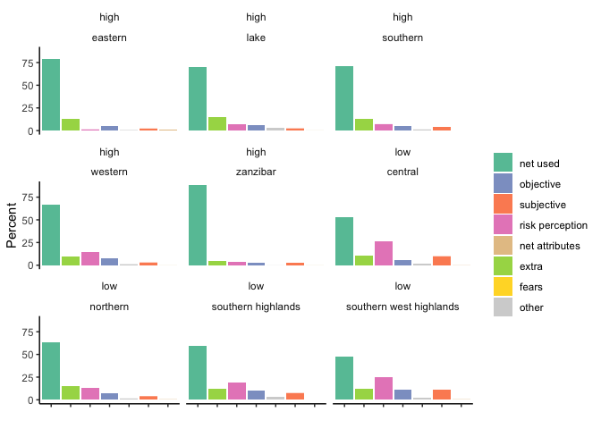
Figure 8: Reported net use and reasons for non-use by low and high transmission zones, Tanzania 2017-18 MIS
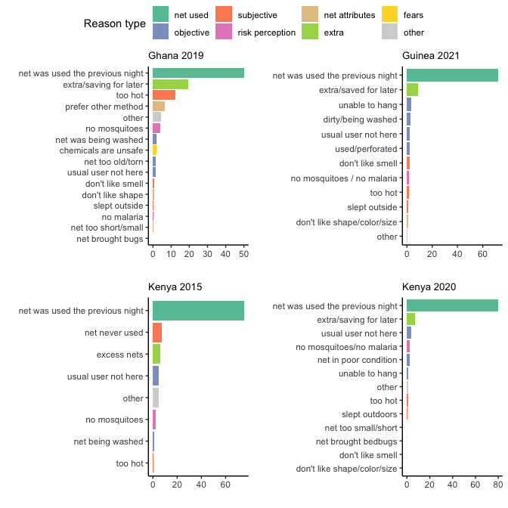
Figure 9: Reasons nets were not used the previous night, Ghana, Guinea, Kenya
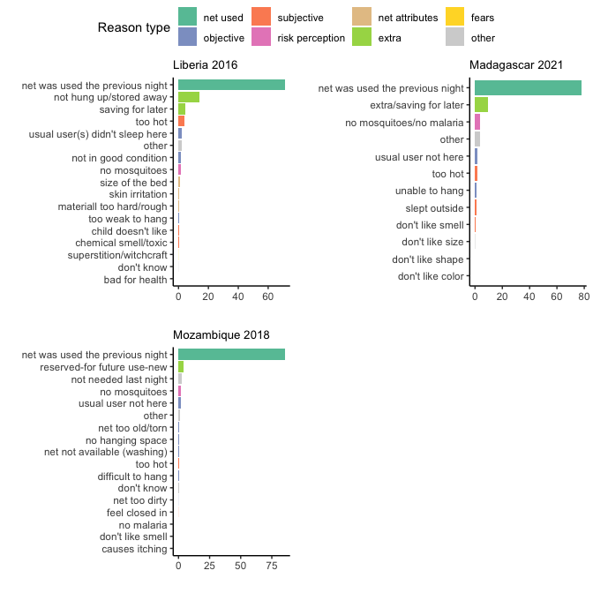
Figure 10: Reasons nets were not used the previous night, Liberia, Madagascar, and Mozambique
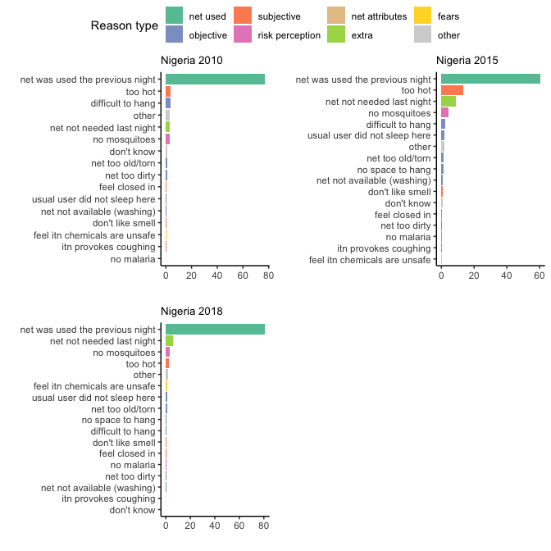
Figure 11: Reasons nets were not used the previous night, Nigeria
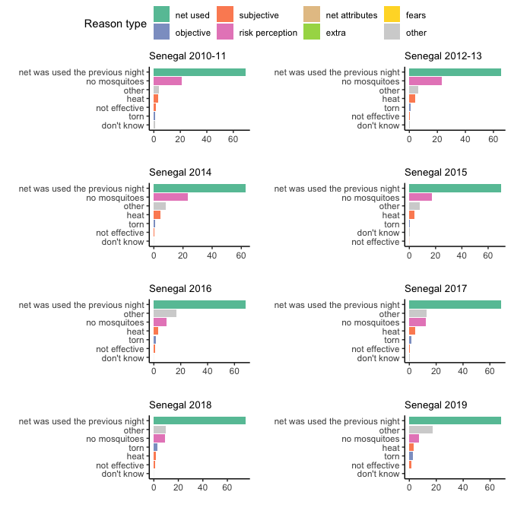
Figure 12: Reasons nets were not used the previous night, Senegal
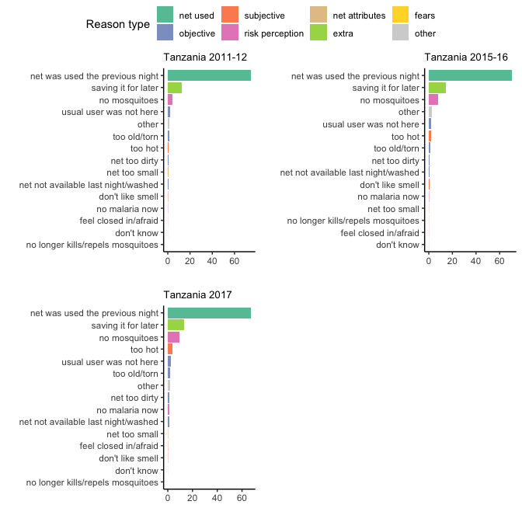
Figure 13: Reasons nets were not used the previous night, Tanzania
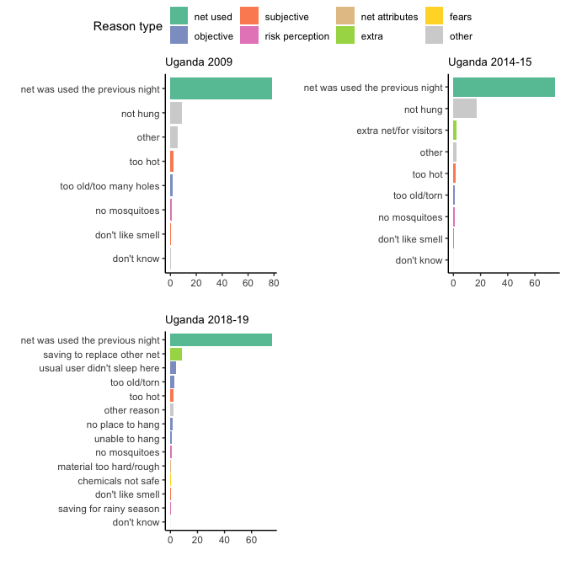
Figure 14: Reasons nets were not used the previous night, Uganda

