Supplementary Files
Functional connectivity discriminates epileptogenic states and predicts surgical outcome in children with drug resistant epilepsy

Sakar Rijal^{1,2}, Ludovica Corona1,2, M Scott Perry¹, Eleonora Tamilia3, Joseph R Madsen⁴, Scellig Stone⁴, Jeffrey Bolton⁵, Phillip L Pearl⁵ and Christos Papadelis1,2,6*

¹Jane and John Justin Institute for Mind Health Neurosciences Center, Cook Children's Health Care System, Fort Worth, TX, USA
² Department of Bioengineering, The University of Texas at Arlington, Arlington, TX, USA
³ Division of Newborn Medicine, Department of Medicine, Boston Children’s Hospital, Harvard Medical School, Boston, MA, USA
⁴ Division of Epilepsy Surgery, Department of Neurosurgery, Boston Children’s Hospital, Harvard Medical School, Boston, MA, USA
⁵ Division of Epilepsy and Clinical Neurophysiology, Department of Neurology, Boston Children’s Hospital, Harvard Medical School, Boston, MA, USA
⁶ School of Medicine, Texas Christian University, Fort Worth, TX, USA

Supplementary Figure S1
Supplementary Figure S2

For all supplementary Figures: AEC= Amplitude Envelope Correlation, PLV= Phase Locking Value, FC = Functional Connectivity.

Supplementary Figure S1: Amplitude Envelope Correlation based nodal strength for Electrodes Inside and Outside of Temporal Lobe in physiologically relevant frequency bands. Nodal strength (i.e., the average sum of all FC values connected to a node) computed from Amplitude Envelope Correlation for electrodes inside (left) and electrodes outside (right) of the temporal lobe for delta, theta, alpha, beta, low- and high- gamma frequency bands for different epileptogenic states. Each epileptogenic state is color-coded: interictal activity with no spikes (green), interictal activity with spikes (blue), pre-ictal activity before the onset of a clinical seizure (yellow), ictal activity during a clinical seizure (red), post-ictal activity after the end of a clinical seizure (orange). Significant differences (p-value <0.05) are marked with an asterisk (*) (Wilcoxon’s signed-rank test). P-values are corrected using false discovery rate correction for 10-comparisons.

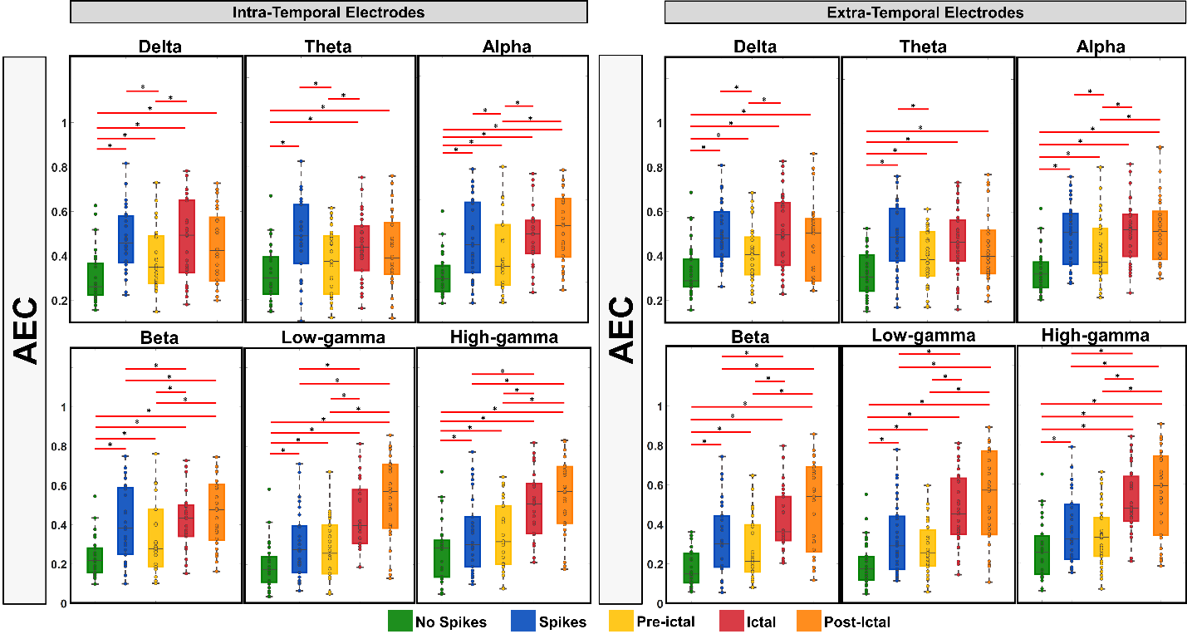

Supplementary Figure S2: Phase Locking Value based nodal strength for Electrodes Inside and Outside of Temporal Lobe in physiologically relevant frequency bands. Nodal strength (i.e., the average sum of all FC values connected to a node) computed from Phase Locking Value for electrodes inside (left) and electrodes outside (right) of the temporal lobe for delta, theta, alpha, beta, low- and high- gamma frequency bands for different epileptogenic states. Each epileptogenic state is color-coded: interictal activity with no spikes (green), interictal activity with spikes (blue), pre-ictal activity before the onset of a clinical seizure (yellow), ictal activity during a clinical seizure (red), post-ictal activity after the end of a clinical seizure (orange). Significant differences (p-value <0.05) are marked with an asterisk (*) (Wilcoxon’s signed-rank test). P-values are corrected using false discovery rate correction for 10-comparisons.

