Supplementary material Table S1: ICD-10 codes used to identify severe COVID-19 infection
Disease type | Condition | Codes
Pneumonia | Pneumonia | J12-, J15-, J168, J17-, J18-
Pneumonia | Aspiration pneumonia | J690, J698
Pneumonia | Respiratory failure (acute and unspecified) | J960, J969
Pneumonia | Pulmonary embolism | I26-
Pneumonia | Adult respiratory distress syndrome (ARDS) | J80
Pneumonia | Pulmonary fibrosis | J841+B972
Pneumonia | Acute upper respiratory conditions | J00, J040, J042, J069
Kidney disease | Renal failure (acute) | N17-
Blood clotting | Thrombocytopaenia | D695, D696, D688, D689
Blood clotting | Disseminated intravascular coagulation syndrome (DIC) | D65
Blood clotting | Venous sinus thrombosis | G08, G951
Blood clotting | Other blood clotting | I74-, I80-, I81, I82
Cardiology/ circulation | Myocarditis | I40-, I411, I514, I520, I521
Cardiology/ circulation | Acute myocardial infarction (MI) | I21-, I22-
Cardiology/ circulation | Cardiomyopathy | I430
Cardiology/ circulation | Vasculitis | I776
Neurology | Stroke (due to Covid-19) | I60-, I61-, I62-, I63-, I64
Neurology | Brain injury | A858, A86, G048, G049, G931
Digestive system | Intestinal ischaemia | K550
Sepsis | Sepsis | R572, A40-, A41-

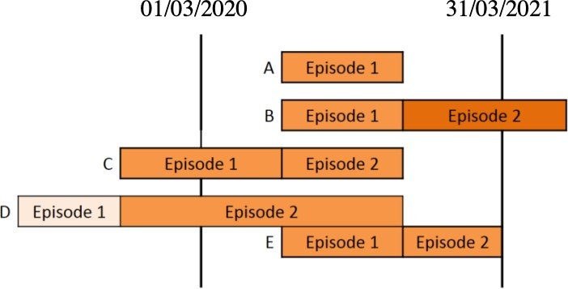
Supplementary material Figure S1: Example of the relationship between episodes and spells in the Hospital Episodes Statistics dataset. Diagram of spells extracted from Hospital Episodes Statistics dataset, with a discharge date between March 1st 2020 and March 31st 2021: The extracted spells are labelled A-E and are made up of individual episodes of care. A spell may be a single episode of care under a single consultant (spell A) or made up of multiple episodes (spells B-D). Methods 2 and 4 rely on identifying the first episode of a spell with a COVID-19 diagnosis. Adapted from Methodology to create provider and CIP (continuous in-patient) spells from HES APC (Admitted Patient Care) data (46).

Supplementary material Table S2: Optimised hyperparameters of the random forest obtained through grid search. The remaining parameters were fixed to their default scikit-learn values (17).
Hyperparameters | Values
Number of Trees | 283
Maximum Depth | 81
Bootstrap | TRUE
Class weights | None

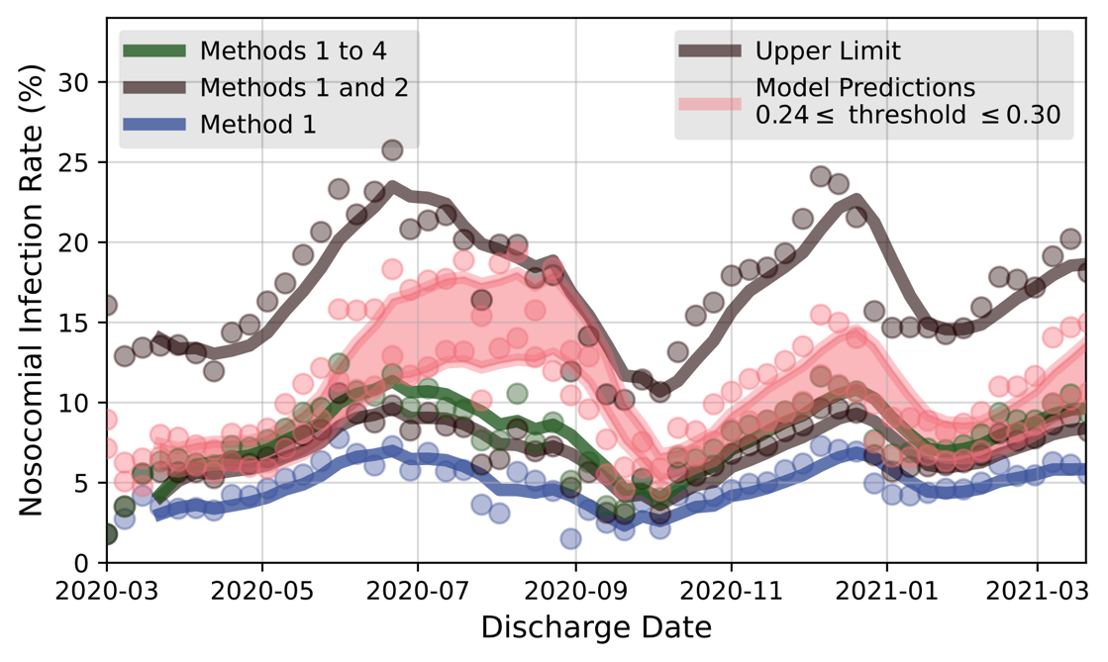

Supplementary material Figure S2: Illustration of the calibration procedure by bounding the model predictions using the upper limit (upper black curve, see Section 2.2) and the curve of definite NIs (lower black curve). The predicted time evolution of the NI rate is shown in orange, for probability thresholds between 0.24 and 0.30. The discharge date was used to calibrate the model given the nature of the extraction procedure from HES data; this leads to an expected time lag between the results and the dynamics of the pandemic.

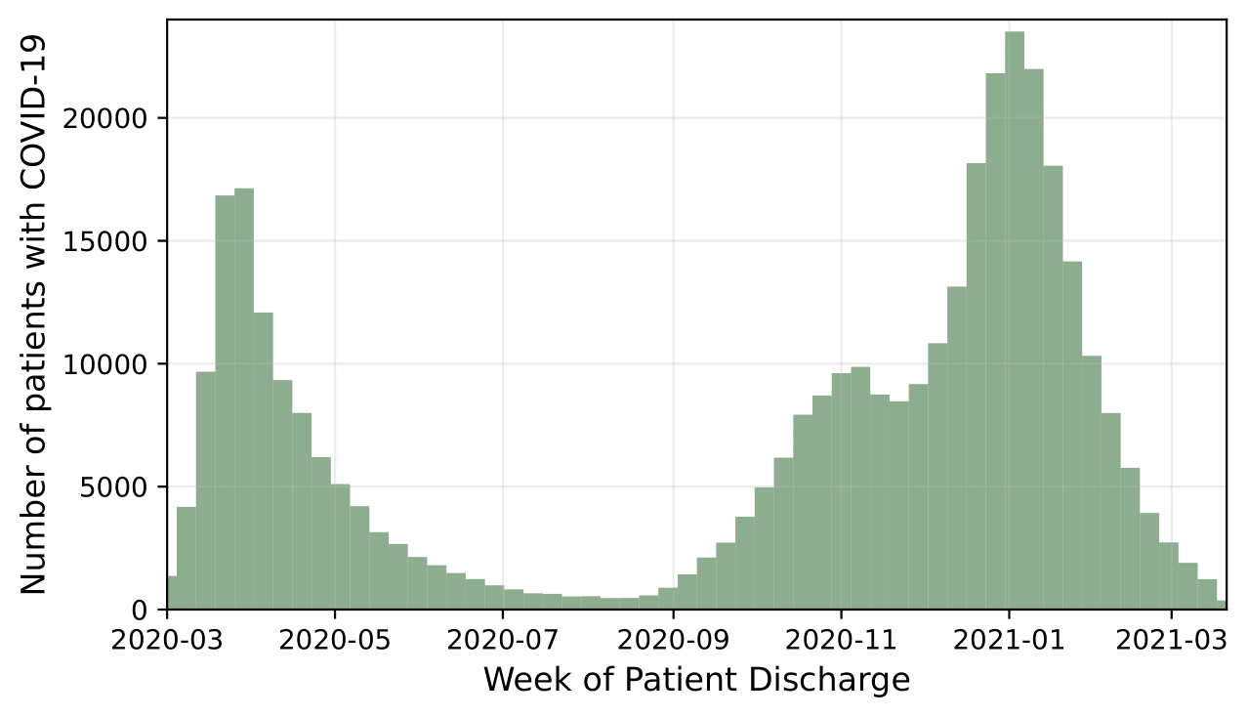

Supplementary material Figure S3: Time evolution of the extracted number of patients diagnosed with COVID-19, as function of date of discharge.

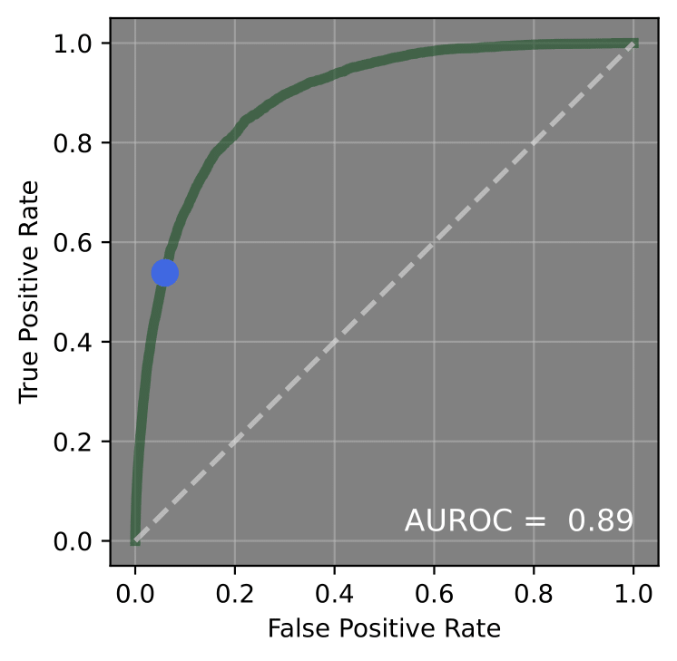

Supplementary material Figure S4. Receiver Operating Characteristics (ROC) curve obtained when applying the trained random forest classifier to the test set. The Area Under the ROC curve (AUROC) was found to be 0.89. The dotted diagonal line corresponds to a stochastic model with no learning; a perfectly accurate model would be represented by a single point on the top left corner (0, 1). The blue point corresponds to a probability threshold fixed at 0.25. The predictions shown in orange in Supplementary material Figure S2 correspond to a threshold between 0.24 and 0.30, as constrained by the designed lower and upper limits.

