Table 4 | Mean Difference | 95% Confidence Interval |  | p-value
Table 4 | Mean Difference | Lower Limit | Upper Limit | p-value
FHA:8AM-Control:8AM | 9.050833 | 4.54016 | 13.56151 | <0.0001
Control:4PM-Control:8AM | -6.66333 | -11.174 | -2.15266 | 0.000698
Control:12AM-Control:8AM | -10 | -14.5107 | -5.48933 | <0.0001
FHA:4PM-FHA:8AM | -14.365 | -18.8757 | -9.85433 | <0.0001
FHA:12AM-FHA:8AM | -18.8575 | -23.3682 | -14.3468 | <0.0001
FHA:4PM-Control:4PM | 1.349167 | -3.16151 | 5.85984 | 0.650496
Control:12AM-Control:4PM | -3.33667 | -7.84734 | 1.174007 | 0.265108
FHA:12AM-FHA:4PM | -4.4925 | -9.00317 | -0.01817 | 0.049528
FHA:12AM-Control:12AM | 0.193333 | -4.31734 | 4.704007 | 0.699995

Table 5
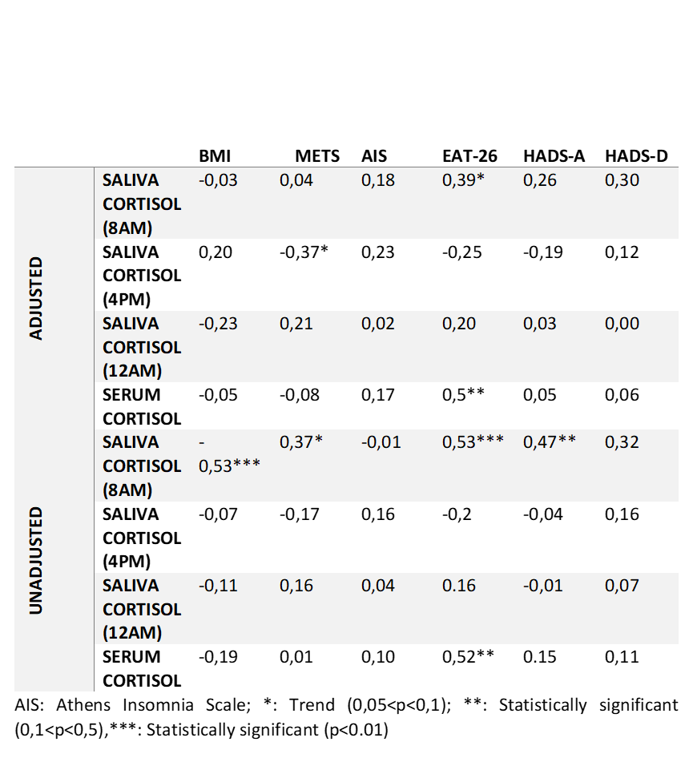
Table 4 Correlation of salivary cortisol of each group

Table 5 Correlation of salivary cortisol and questionnaires, BMI

