Supplemental Figure 1: Representative cell-binding gating
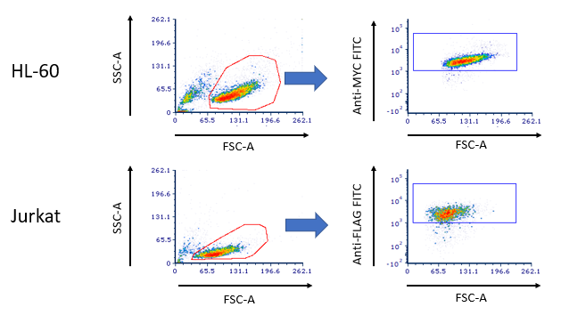
Supplemental Figure 1: Representative scatter and FITC gating used in binding experiments (Figure 2, Supplemental Figure 2&3). Cells incubated 30min with 1µg dimer or monomeric component (100µL volume).
Supplemental Figure 2: HL60-binding controls
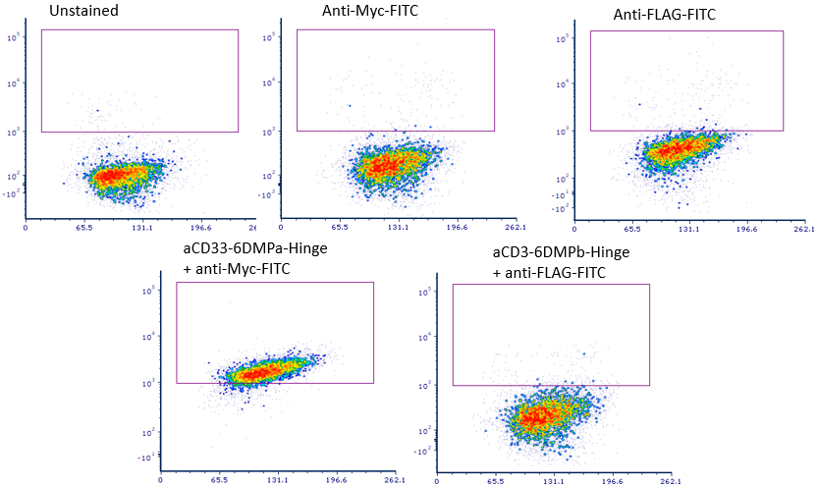

Supplemental Figure 2: Representative scatter and FITC gating used in binding experiments (Figure 2)
Supplemental Figure 3: Jurkat-binding controls
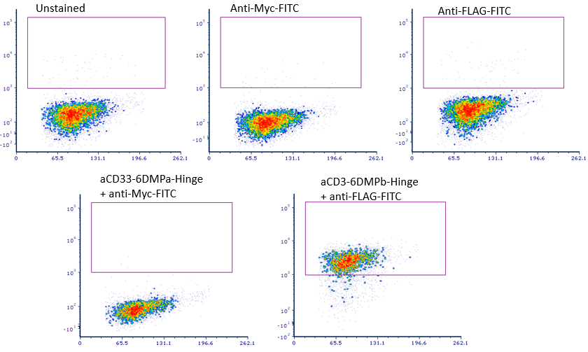
Supplemental Figure 3: Jurkat cells incubated with heterodimer or monomeric components and anti-Myc-FITC or anti-FLAG-FITC as indicated.
Supplemental Figure 4: Representative cytotoxicity gating
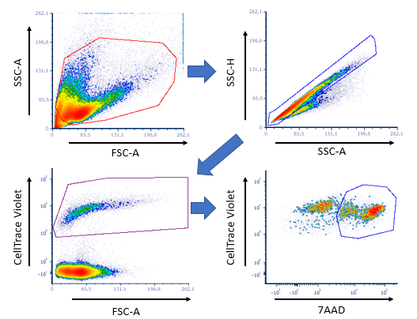
Supplemental Figure 4: Representative gating of in vitro cytotoxicity experiments (Figure 3)
Supplemental Figure 5: Monomeric components do not enhance T-cell cytotoxicity
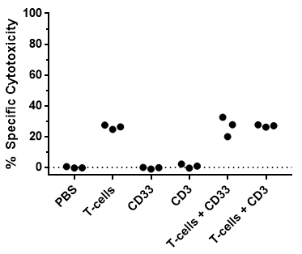
Supplemental Figure 5: Specific cytotoxicity of T-cells to HL-60 is not enhanced by monomeric components. Monomeric components are not toxic to HL-60. 3µg of monomer per well (200µL well volume), incubated 16hr. Data reported as individual values from triplicates.

* 1. Control 2. T-cells 3. Dimer + T-cells
Day 21
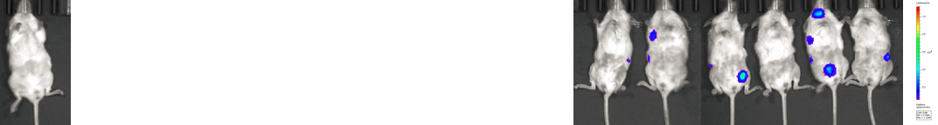
Day 23
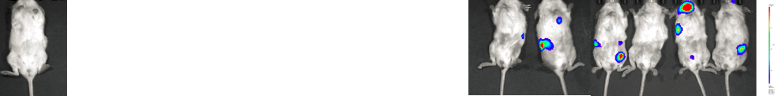
Day 27
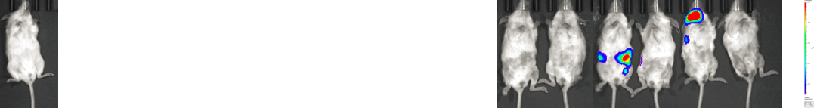
Day 31
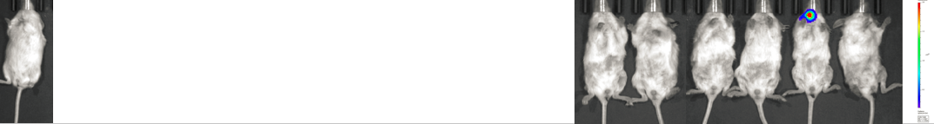
Day 33
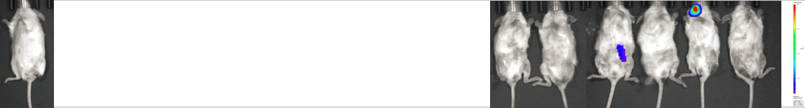
Supplemental Figure 6: Additional Whole-body bioluminescent images at listed days. Background removed according to total flux from uninjected imaging control (*).

