Supplementary Information
Fig. S1. Aboveground biomass of the three grassland communities in response to N and P additions during 2017-2019. AB community: annual and biennial community; PG community: perennial grass community; PF community: perennial forb community.
Fig. S2. Species richness and Simpson’s dominance index of the three grassland communities in response to N and P addition. AB community: annual and biennial community; PG community: perennial grass community; PF community: perennial forb community.
Fig. S3. Stability-based ranks and species numbers of different functional groups across all treatments in the three communities. Small letters indicate significant difference among different functional groups (p < 0.05).
Fig. S4. Relationship between community mean aboveground biomass and temporal standard error, temporal stability of the three communities during 2017-2019.
Fig. S5. Relationship between mean aboveground biomass and temporal standard error, temporal stability of different functional groups in the three communities during 2017-2019.
Fig. S1
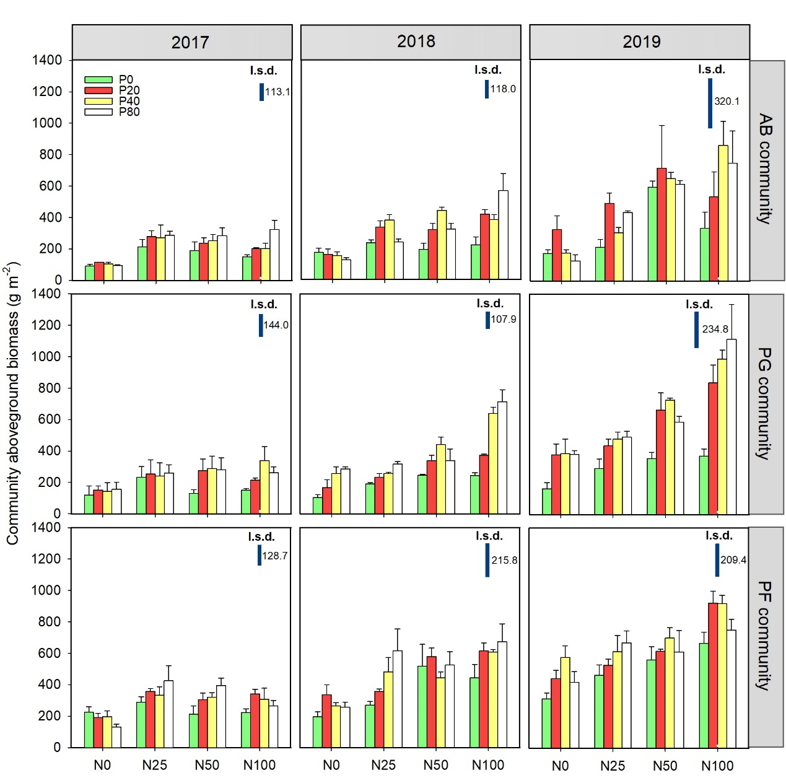

Fig. S2

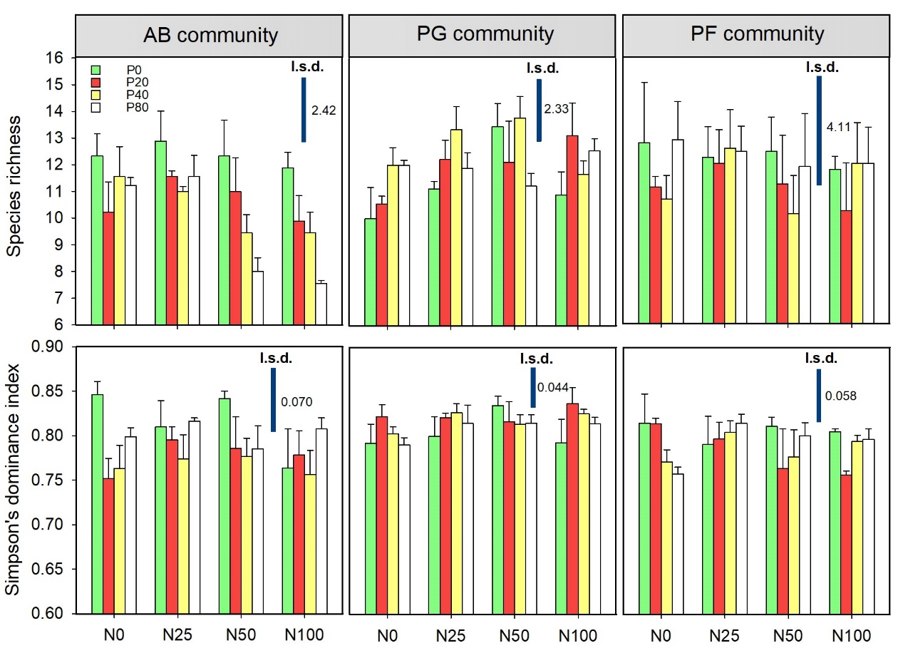

Fig. S3
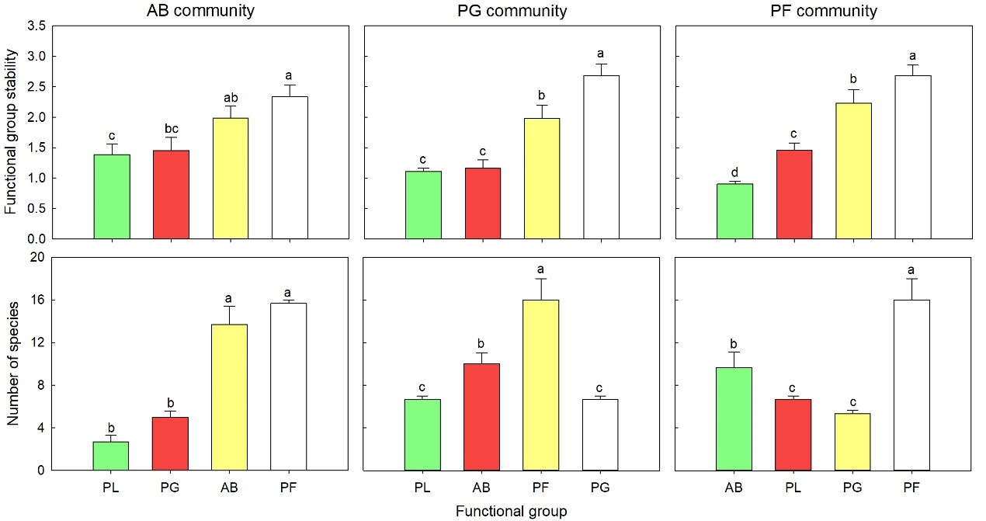

Fig. S4
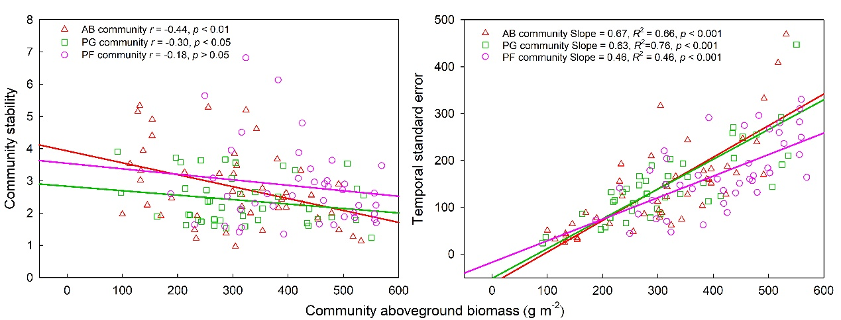

Fig. S5
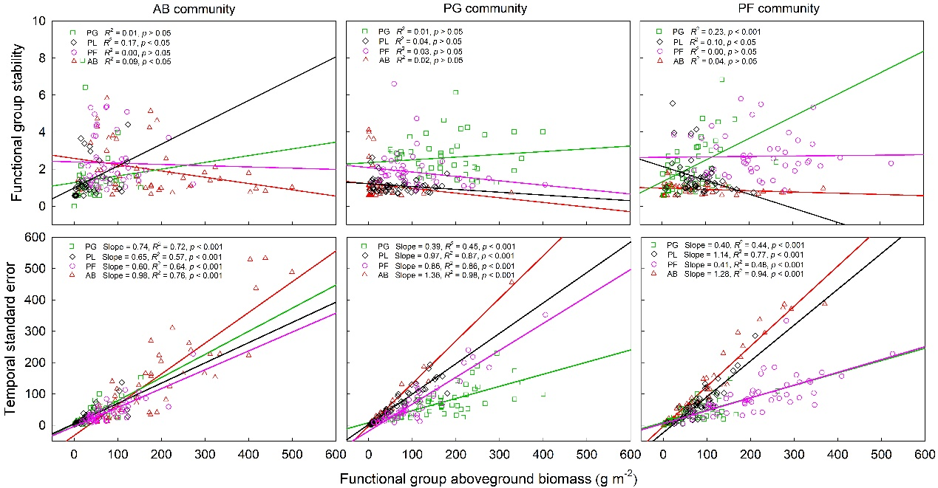

Table S1 The functional traits of different species belonging to different functional groups in AB community
Functional group | Species | Height | Clonality | N-fixing | Life history | Importance value
Perennial grass | Stipa grandis | T | C | NNF | P | 3.62
Perennial grass | Roegneria kamoji | T | NC | NNF | P | 3.39
Perennial grass | Cleistogenes chinensis | S | NC | NNF | P | 2.22
Perennial grass | Stipa bungeana | S | C | NNF | P | 2.20
Perennial grass | Leymus secalinus | T | C | NNF | P | 0.68
Perennial grass | Poa sphondylodes | S | NC | NNF | P | 0.35
Perennial legume | Lespedeza daurica | S | NC | NF | P | 7.36
Perennial legume | Thermopsis lanceolata | S | NC | NF | P | 0.09
Perennial legume | Vicia sepium | S | NC | NF | P | 0.01
Perennial forb | Artemisia mongolica | T | NC | NNF | P | 4.70
Perennial forb | Geranium wilfordii | S | NC | NNF | P | 5.06
Perennial forb | Heteropappus altaicus | S | NC | NNF | P | 2.10
Perennial forb | Artemisia sacrorum | T | C | NNF | P | 1.64
Perennial forb | Nanocnide lobata | S | NC | NNF | P | 0.86
Perennial forb | Patrinia heterophylla | S | NC | NNF | P | 0.79
Perennial forb | Dendranthema indicum | T | NC | NNF | P | 0.78
Perennial forb | Artemisia argyi | T | NC | NNF | P | 0.75
Perennial forb | Incarvillea sinensis | T | NC | NNF | P | 0.61
Perennial forb | Viola philippica | S | NC | NNF | P | 0.51
Perennial forb | Cirsium setosum | S | NC | NNF | A | 0.50
Perennial forb | Potentilla tanacetifolia | S | NC | NNF | P | 0.31
Perennial forb | Viola dactyloides | S | NC | NNF | P | 0.21
Perennial forb | Rubia cordifolia | S | NC | NNF | P | 0.17
Perennial forb | Taraxacum mongolicum | S | NC | NNF | P | 0.07
Perennial forb | Artemisia giraldii | T | C | NNF | P | 0.07
Annual and biennials | Setaria viridis | T | NC | NNF | A | 20.13
Annual and biennials | Artemisia capillaris | T | NC | NNF | B | 19.08
Annual and biennials | Bidens pilosa | T | NC | NNF | A | 5.87
Annual and biennials | Sonchus oleraceus | S | NC | NNF | A | 4.21
Annual and biennials | Artemisia scoparia | T | NC | NNF | A | 4.10
Annual and biennials | Dracocephalum moldavica | T | NC | NNF | A | 3.19
Annual and biennials | Parthenocissus tricuspidata | S | NC | NNF | A | 0.88
Annual and biennials | Youngia Japonica | S | NC | NNF | B | 0.16
Annual and biennials | Siphonostegia chinensis | T | NC | NNF | A | 0.12
Annual and biennials | Salsola collina | T | NC | NNF | A | 0.12
Annual and biennials | Pharbitis nil | S | NC | NNF | A | 0.10
Notes: T: tall; S: short; C: clonal; NC: nonclonal; NF: N-fixing; NNF: non-N-fixing; P: perennial; A: annual; B: biennial.
Table S2 The functional traits of different species belonging to different functional groups in PG community
Functional group | Species | Height | Clonality | N-fixing | Life history | Importance value
Perennial grass | Bothriochloa ischaemum | T | C | NNF | P | 17.17
Perennial grass | Stipa bungeana | S | C | NNF | P | 9.34
Perennial grass | Poa sphondylodes | S | NC | NNF | P | 3.09
Perennial grass | Leymus secalinus | T | C | NNF | P | 2.80
Perennial grass | Roegneria kamoji | T | NC | NNF | P | 2.11
Perennial grass | Carex lanceolata | S | C | NNF | P | 1.01
Perennial grass | Cleistogenes chinensis | S | NC | NNF | P | 0.67
Perennial grass | Phragmites australis | T | NC | NNF | P | 0.07
Perennial grass | Arundinella anomala | T | C | NNF | P | 0.06
Perennial legume | Lespedeza daurica | S | NC | NF | P | 22.06
Perennial legume | Oxytropis bicolor | S | NC | NF | P | 1.96
Perennial legume | Medicago sativa | S | NC | NF | P | 0.85
Perennial legume | Astragalus discolor | S | NC | NF | P | 0.64
Perennial legume | Oxytropis racemosa | S | NC | NF | P | 0.44
Perennial legume | Vicia sepium | S | NC | NF | P | 0.13
Perennial legume | Astragalus melilotoides | S | NC | NF | P | 0.13
Perennial legume | Gueldenstaedtia stenophylla | S | NC | NF | P | 0.03
Perennial forb | Artemisia sacrorum | T | C | NNF | P | 7.37
Perennial forb | Viola philippica | S | NC | NNF | P | 5.02
Perennial forb | Potentilla tanacetifolia | S | NC | NNF | P | 4.74
Perennial forb | Polygala linarifolia | S | NC | NNF | P | 2.03
Perennial forb | Polygala sibirica | S | NC | NNF | P | 1.37
Perennial forb | Cirsium setosum | S | NC | NNF | P | 1.10
Perennial forb | Heteropappus altaicus | S | NC | NNF | P | 1.09
Perennial forb | Geranium wilfordii | S | NC | NNF | P | 0.92
Perennial forb | Artemisia argyi | T | NC | NNF | P | 0.70
Perennial forb | Artemisia mongolica | S | C | NNF | P | 0.61
Perennial forb | Potentilla discolor | S | NC | NNF | P | 0.45
Perennial forb | Potentilla bifurca | S | NC | NNF | P | 0.04
Perennial forb | Taraxacum mongolicum | S | NC | NNF | P | 0.04
Perennial forb | Artemisia giraldii | T | C | NNF | P | 0.04
Perennial forb | Hemistepta lyrata | S | NC | NNF | P | 0.02
Annual and biennials | Artemisia capillaris | T | NC | NNF | B | 6.30
Annual and biennials | Artemisia scoparia | T | NC | NNF | A | 1.13
Annual and biennials | Setaria viridis | T | NC | NNF | A | 1.10
Annual and biennials | Parthenocissus tricuspidata | S | NC | NNF | A | 0.39
Annual and biennials | Sonchus oleraceus | S | NC | NNF | A | 0.31
Annual and biennials | Plantago asiatica | S | NC | NNF | A | 0.29
Annual and biennials | Allium chrysanthum | S | NC | NNF | A | 0.23
Annual and biennials | Dracocephalum moldavica | T | NC | NNF | A | 0.18
Annual and biennials | Siphonostegia chinensis | T | NC | NNF | A | 0.15
Annual and biennials | Chenopodium glaucum | S | NC | NNF | A | 0.13
Annual and biennials | Salsola collina | T | NC | NNF | A | 0.13
Annual and biennials | Youngia Japonica | S | NC | NNF | B | 0.10

Table S3 The functional traits of different species belonging to different functional groups in PF community
Functional group | Species | Height | Clonality | N-fixing | Life history | Importance value
Perennial grass | Bothriochloa ischaemum | T | C | NNF | P | 6.14
Perennial grass | Stipa bungeana | S | C | NNF | P | 3.46
Perennial grass | Cleistogenes chinensis | S | NC | NNF | P | 0.49
Perennial grass | Phragmites australis | T | C | NNF | P | 0.36
Perennial grass | Roegneria kamoji | T | NC | NNF | P | 0.31
Perennial grass | Poa sphondylodes | S | NC | NNF | P | 0.25
Perennial grass | Carex lanceolata | S | C | NNF | P | 0.12
Perennial legume | Lespedeza daurica | S | NC | NF | P | 25.72
Perennial legume | Medicago sativa | S | NC | NF | P | 2.00
Perennial legume | Oxytropis bicolor | S | NC | NF | P | 0.44
Perennial legume | Astragalus adsurgens | S | NC | NF | P | 0.16
Perennial legume | Oxytropis racemosa | S | NC | NF | P | 0.14
Perennial legume | Thermopsis lanceolata | S | NC | NF | P | 0.09
Perennial legume | Vicia sepium | S | NC | NF | P | 0.02
Perennial forb | Artemisia mongolica | T | NC | NNF | P | 12.75
Perennial forb | Artemisia sacrorum | T | C | NNF | P | 11.42
Perennial forb | Artemisia giraldii | T | C | NNF | P | 3.41
Perennial forb | Potentilla tanacetifolia | S | NC | NNF | P | 1.50
Perennial forb | Geranium wilfordii | S | NC | NNF | P | 0.99
Perennial forb | Heteropappus altaicus | S | NC | NNF | P | 0.95
Perennial forb | Viola philippica | S | NC | NNF | P | 0.82
Perennial forb | Fragaria vesca | S | NC | NNF | P | 0.78
Perennial forb | Cirsium setosum | S | NC | NNF | P | 0.50
Perennial forb | Polygala linarifolia | S | NC | NNF | P | 0.45
Perennial forb | Polygala sibirica | S | NC | NNF | P | 0.28
Perennial forb | Potentilla discolor | S | NC | NNF | P | 0.22
Perennial forb | Incarvillea sinensis | T | NC | NNF | P | 0.17
Perennial forb | Patrinia heterophylla | S | NC | NNF | P | 0.16
Perennial forb | Bupleurum chinense | S | NC | NNF | P | 0.04
Annual and biennials | Artemisia capillaris | T | NC | NNF | B | 12.11
Annual and biennials | Artemisia scoparia | T | NC | NNF | A | 10.74
Annual and biennials | Setaria viridis | T | NC | NNF | A | 1.08
Annual and biennials | Plantago asiatica | S | NC | NNF | A | 0.63
Annual and biennials | Siphonostegia chinensis | T | NC | NNF | A | 0.19
Annual and biennials | Youngia Japonica | S | NC | NNF | B | 0.06
Annual and biennials | Allium chrysanthum | S | NC | NNF | A | 0.03
Annual and biennials | Sonchus oleraceus | S | NC | NNF | A | 0.01

Table S4 Soil total nitrogen (TN) and soil total phosphorus (TP) of the three communities under different N and P additions in 2018 (mean ± s.e.; n = 3).
Community type | Treatment | TN (g kg⁻¹) |  |  |  |  |  | TP (g kg⁻¹)
Community type | Treatment | P0 | P20 |  | P40 |  | P80 | P0 | P20 |  | P40 |  | P80
AB community | N0 | 0.46±0.01 | 0.46±0.02 |  | 0.53±0.03 |  | 0.49±0.02 | 0.52±0.01 | 0.55±0.00 |  | 0.53±0.01 |  | 0.59±0.01
AB community | N25 | 0.48±0.02 | 0.53±0.02 |  | 0.46±0.01 |  | 0.48±0.01 | 0.53±0.01 | 0.56±0.01 |  | 0.55±0.01 |  | 0.57±0.01
AB community | N50 | 0.46±0.03 | 0.54±0.02 |  | 0.56±0.02 |  | 0.57±0.02 | 0.54±0.01 | 0.54±0.01 |  | 0.56±0.00 |  | 0.58±0.01
AB community | N100 | 0.42±0.01 | 0.47±0.01 |  | 0.60±0.01 |  | 0.51±0.01 | 0.52±0.01 | 0.54±0.01 |  | 0.53±0.01 |  | 0.62±0.01
PG community | N0 | 0.65±0.08 | 0.62±0.06 |  | 0.62±0.07 |  | 0.76±0.04 | 0.53±0.02 | 0.53±0.01 |  | 0.52±0.02 |  | 0.57±0.00
PG community | N25 | 0.66±0.07 | 0.66±0.00 |  | 0.69±0.01 |  | 0.69±0.08 | 0.55±0.00 | 0.53±0.00 |  | 0.54±0.01 |  | 0.50±0.01
PG community | N50 | 0.71±0.02 | 0.60±0.01 |  | 0.67±0.03 |  | 0.66±0.05 | 0.47±0.00 | 0.50±0.00 |  | 0.51±0.01 |  | 0.50±0.01
PG community | N100 | 0.67±0.01 | 0.63±0.03 |  | 0.64±0.01 |  | 0.74±0.05 | 0.47±0.01 | 0.48±0.02 |  | 0.49±0.01 |  | 0.50±0.01
PF community | N0 | 0.69±0.03 | 0.60±0.01 |  | 0.71±0.05 |  | 0.70±0.06 | 0.49±0.02 | 0.51±0.01 |  | 0.52±0.03 |  | 0.54±0.01
PF community | N25 | 0.67±0.05 | 0.65±0.04 |  | 0.66±0.02 |  | 0.61±0.01 | 0.49±0.01 | 0.53±0.01 |  | 0.53±0.01 |  | 0.55±0.00
PF community | N50 | 0.60±0.01 | 0.68±0.01 |  | 0.65±0.04 |  | 0.64±0.04 | 0.50±0.01 | 0.53±0.00 |  | 0.48±0.01 |  | 0.53±0.01
PF community | N100 | 0.75±0.04 | 0.61±0.05 |  | 0.69±0.06 |  | 0.70±0.03 | 0.54±0.02 | 0.50±0.02 |  | 0.50±0.01 |  | 0.51±0.01
AB community |  | N*** |  | P*** |  | N × P *** |  | N: n.s. |  | P*** |  | N × P**
PG community |  | N: n.s. |  | P: n.s. |  | N × P: n.s. |  | N*** |  | P: n.s. |  | N × P**
PF community |  | N: n.s. |  | P: n.s. |  | N × P: n.s. |  | N: n.s. |  | P* |  | N × P**
Note: Data in brackets are LSD values among different N and P addition treatments (p ≤ 0.05). *, ** and *** indicate statistically significantly different at p ≤ 0.05, p ≤ 0.01, and p≤ 0.001, respectively. n.s. means no significant difference.

Table S5 Soil total nitrogen (TN) and soil total phosphorus (TP) of the three communities under different N and P additions in 2019 (mean ± s.e.; n = 3).
Community type | Treatment | TN (g kg⁻¹) |  |  |  |  |  | TP (g kg⁻¹)
Community type | Treatment | P0 | P20 |  | P40 |  | P80 | P0 | P20 |  | P40 |  | P80
AB community | N0 | 0.47±0.04 | 0.43±0.08 |  | 0.48±0.03 |  | 0.53±0.02 | 0.52±0.02 | 0.49±0.05 |  | 0.54±0.03 |  | 0.58±0.02
AB community | N25 | 0.48±0.02 | 0.54±0.08 |  | 0.48±0.04 |  | 0.54±0.04 | 0.53±0.01 | 0.51±0.00 |  | 0.52±0.02 |  | 0.53±0.03
AB community | N50 | 0.48±0.10 | 0.49±0.06 |  | 0.53±0.07 |  | 0.54±0.03 | 0.49±0.02 | 0.55±0.01 |  | 0.54±0.02 |  | 0.60±0.05
AB community | N100 | 0.50±0.02 | 0.52±0.03 |  | 0.48±0.01 |  | 0.54±0.02 | 0.52±0.00 | 0.52±0.01 |  | 0.54±0.02 |  | 0.57±0.03
PG community | N0 | 0.60±0.08 | 0.52±0.05 |  | 0.62±0.05 |  | 0.60±0.09 | 0.56±0.03 | 0.57±0.03 |  | 0.60±0.03 |  | 0.60±0.04
PG community | N25 | 0.63±0.04 | 0.70±0.04 |  | 0.65±0.12 |  | 0.69±0.12 | 0.59±0.03 | 0.59±0.04 |  | 0.63±0.04 |  | 0.62±0.05
PG community | N50 | 0.52±0.10 | 0.58±0.12 |  | 0.65±0.05 |  | 0.70±0.10 | 0.55±0.06 | 0.56±0.06 |  | 0.58±0.04 |  | 0.62±0.06
PG community | N100 | 0.70±0.10 | 0.66±0.01 |  | 0.73±0.07 |  | 0.66±0.09 | 0.59±0.03 | 0.59±0.03 |  | 0.61±0.04 |  | 0.60±0.04
PF community | N0 | 0.64±0.03 | 0.57±0.06 |  | 0.63±0.12 |  | 0.57±0.03 | 0.53±0.11 | 0.54±0.09 |  | 0.56±0.10 |  | 0.56±0.09
PF community | N25 | 0.68±0.05 | 0.68±0.03 |  | 0.59±0.09 |  | 0.70±0.10 | 0.54±0.10 | 0.55±0.10 |  | 0.52±0.10 |  | 0.58±0.09
PF community | N50 | 0.54±0.05 | 0.64±0.07 |  | 0.54±0.10 |  | 0.63±0.03 | 0.50±0.09 | 0.53±0.09 |  | 0.53±0.11 |  | 0.58±0.13
PF community | N100 | 0.57±0.04 | 0.65±0.03 |  | 0.63±0.05 |  | 0.70±0.06 | 0.51±0.09 | 0.44±0.12 |  | 0.48±0.12 |  | 0.46±0.09
AB community |  | N: n.s. |  | P: n.s. |  | N × P: n.s. |  | N: n.s. |  | P: n.s. |  | N × P: n.s.
PG community |  | N: n.s. |  | P: n.s. |  | N × P: n.s. |  | N: n.s. |  | P: n.s. |  | N × P: n.s.
PF community |  | N: n.s. |  | P: n.s. |  | N × P: n.s. |  | N: n.s. |  | P: n.s. |  | N × P: n.s.

