Development of 105 SNP markers in endangered turtle species Pelodiscus sinensis using RAD-seq
Qiming Xie¹ · Fan Liu¹· Jilong Zhang¹ · Xilei Li¹ · Tiantian Chen¹ · Guoxia Fang² · Rensheng Ma² · Shiping Su^{1*}
1 College of Animal Sciences and Technology, Anhui Agricultural University, 130 Changjiang West Road, Hefei, Anhui Province 230036, P. R. China.
2 Feixi County Animal Disease Prevention and Control Center, Hefei, Anhui Province 230036, P. R. China.
*Corresponding author: Shiping Su, College of Animal Sciences and Technology, Anhui Agricultural University, 130 Changjiang West Road, Hefei, Anhui Province 230036, P. R. China.
Email: sushiping@ahau.edu.cn
Detail process of reads aligning and SNP calling
#operation system: Ubuntu 20.04
#download RAD-seq data from NCBI SRA database using SRA Toolkit
Prefetch --option-file SRR.txt

#download reference genome from NCBI
wget https://ftp.ncbi.nlm.nih.gov/genomes/all/GCF/000/230/535/GCF_000230535.1_PelSin_1.0/GCF_000230535.1_PelSin_1.0_genomic.fna.gz

#convert *.sra file to *.fastq file using SRA Toolkit
for i in *.sra
do
echo $i
pfastq-dump --split-3 -t 23 $i
Done

#indexing a reference genome using bwa
Bwa index reference_genome

# a batch script to align reads to the indexed reference sequence using samtools and bwa
for i in $your_sample_name
do
echo $i
# align indexed reads to reference sequence
bwa mem -t 23 -k 32 -M reference_genome ./$i.1.fq.gz ./$i.2.fq.gz > ./$i.sam
# convert SAM to BAM file
samtools view -bS --threads 23 -T reference_genome ./$i.sam > ./$i.bam
# sort BAM file
samtools sort -n ./$i.bam -o ./$i.sorted.bam
# Remove suspected pcr duplicates
samtools fixmate -m --threads 23 ./$i.sorted.bam ./$i.sorted.fixmate.bam
samtools sort --threads 23 ./$i.sorted.fixmate.bam -o ./$i.sorted.fixmate.position.bam
samtools markdup --threads 23 ./$i.sorted.fixmate.position.bam ./$i.sorted.fixmate.position.markdup.bam
# index the BAM file
samtools index -@ 23 ./$i.sorted.fixmate.position.markdup.bam
# remove intermediate files
rm $i.sam $i.bam $i.sorted.bam $i.sorted.fixmate.bam $i.sorted.fixmate.position.bam done

# call SNP variant site using bcftools
bcftools mpileup -O u -a FORMAT/DP,FORMAT/AD,FORMAT/ADF,FORMAT/ADR,FORMAT/SP,FORMAT/SCR,INFO/AD,INFO/ADF,INFO/ADR,INFO/SCR --threads 23 -f reference_genome $your_sample_name_list | bcftools call -mv -Oz -o calls.vcf

# Generating statistics from VCF
vcftools --gzvcf calls.vcf --site-mean-depth # Calculate mean depth per site
vcftools --gzvcf calls.vcf --site-quality # Calculate site quality

# Examining statistics in R
library(tidyverse)
var_qual <- read_delim("your_path_to_out.lqual", delim = "\t",
col_names = c("chr", "pos", "qual"), skip = 1)
a <- ggplot(var_qual, aes(qual)) + geom_density(fill = "dodgerblue1", colour = "black", alpha = 0.3)
a + theme_light()
# We recommend setting a minimum threshold of 30
var_depth <- read_delim("your_path_to_out.ldepth.mean", delim = "\t",
col_names = c("chr", "pos", "mean_depth", "var_depth"), skip = 1)
b <- ggplot(var_depth, aes(mean_depth)) + geom_density(fill = "dodgerblue1", colour = "black", alpha = 0.3)
b + theme_light()
summary(var_depth$mean_depth)
b + theme_light() + xlim(0, 30)
# We recommend set minimum depth to 3x and maximum depth to 15x 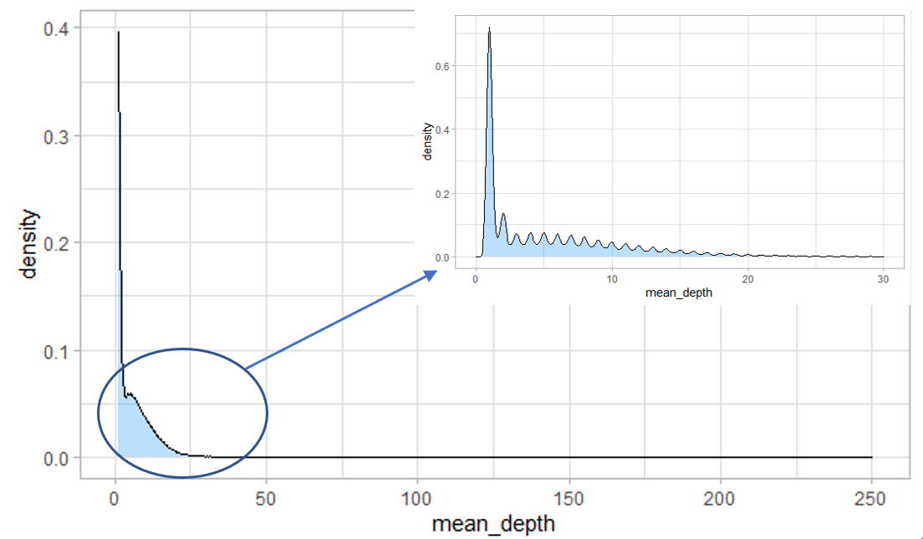
# filter low quality SNP using vcftools
vcftools --gzvcf calls.vcf \
--recode-INFO-all \
--maf 0.05 \ #minor allele frequency
--maxDP 15 \ # max loci depth
--max-meanDP 15 \ # max average loci depth across all samples
--minDP 5 \ #min loci depth
--min-meanDP 5 \ # min average loci depth across all samples
--minQ 30 \ # min Qual value
--max-missing 0.95 \ # max allow 0.05 missing loci across all samples
--recode \
--remove-indels \
--plink \ # output plink format file
--out maf0.05_minQ30_minDP3_maxDP15_missing0.95_SNPonly_filtered.vcf
# exclude those SNP sites failure HWE test with P value < 0.000001.
Plink --noweb --file out --hwe 0.000001 --recode --out cleaned
# calculate genetic statistics of SNP using PLINK
Plink --noweb --file cleaned --hardy --freq
# extract 300bp flanking sequence from reference genome according to SNP using bedtools
bedtools getfasta -fi your_reference_genome -bed SNP_position_list -fo SNP.fa.out

