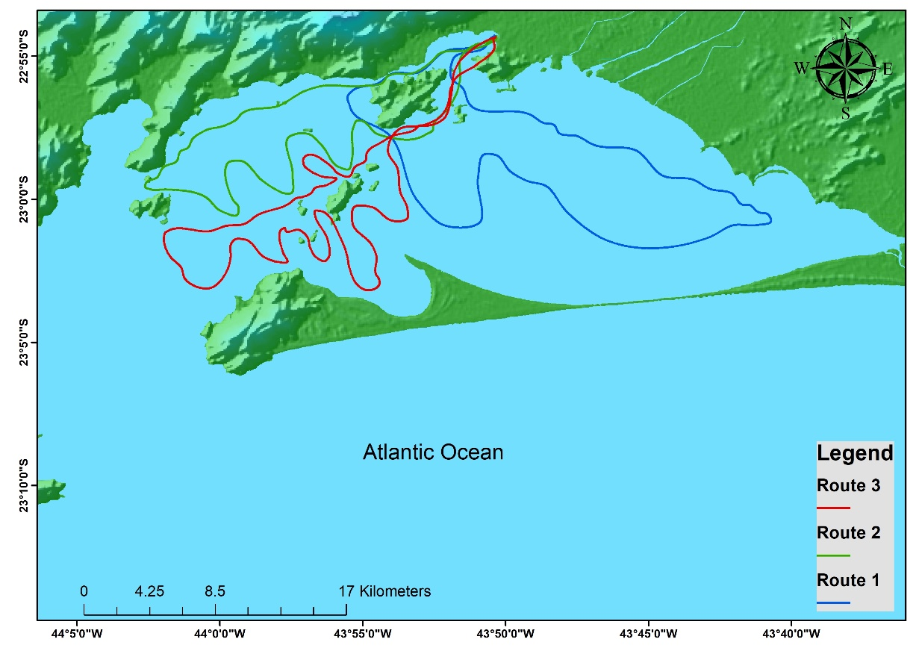
Supplement 1. Three routes (red, green, and blue) were created to sampling data in Sepetiba Bay, Southeastern Brazil.

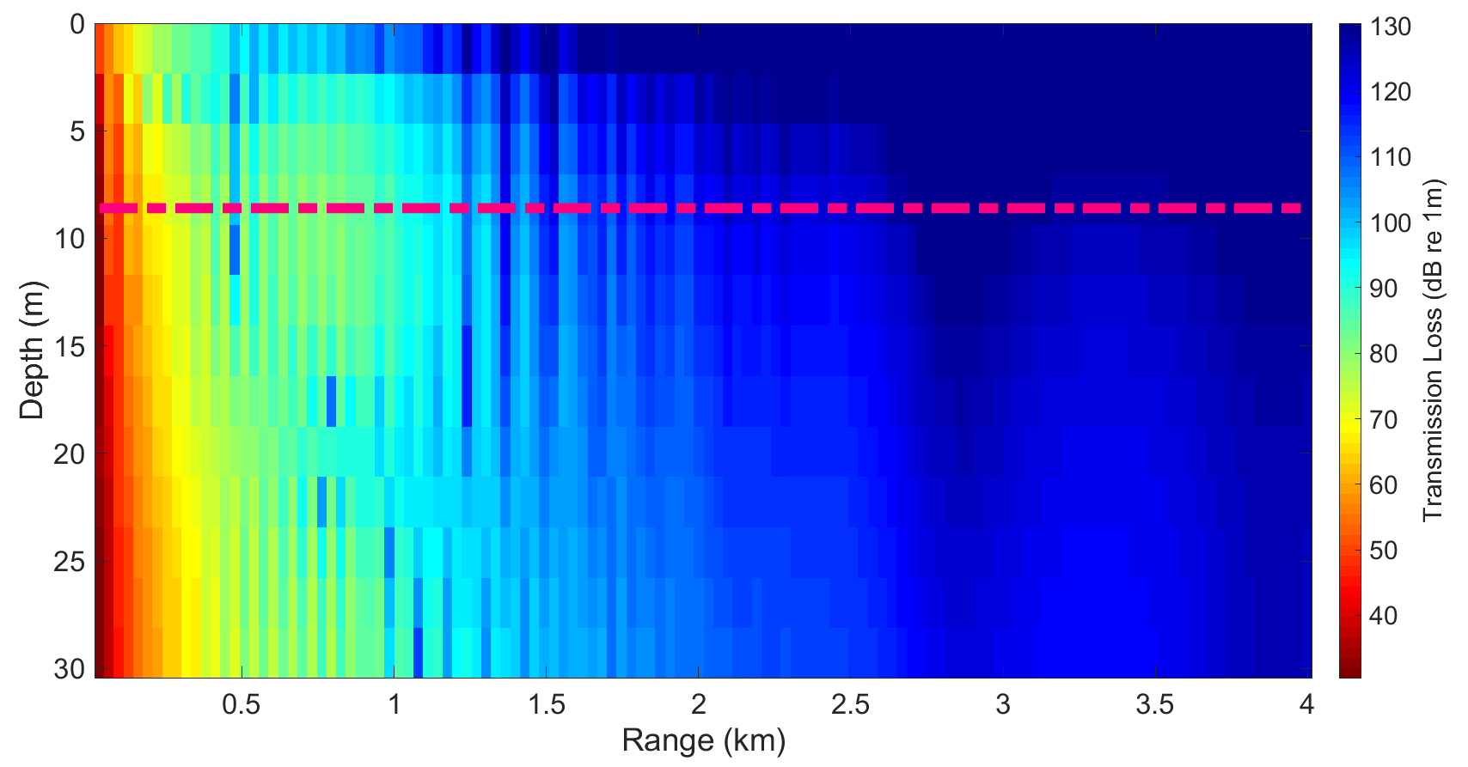
Supplement 2. Plots of the Monterey-Miami Parabolic Equation Model (MMPEM) outputs showing signal transmission loss of a 47 Hz center frequency noise emitted at 2 m depth over 4 km range. The pink dotted line indicates the average depth of Sepetiba Bay.
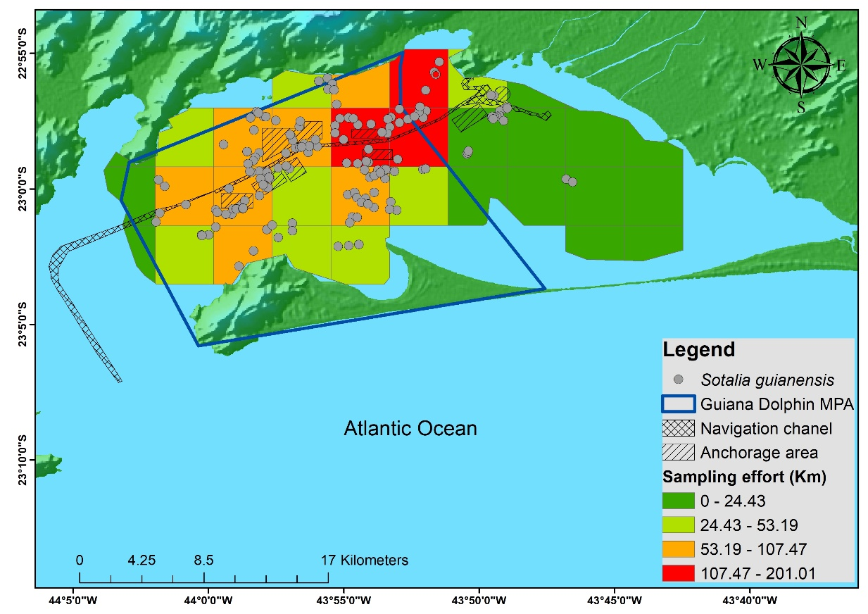
Supplement 3. Map of occurrence of the Guiana dolphin (Sotalia guianensis) in Sepetiba Bay, Southeastern Brazil between the years 2015 and 2018. The color scale in grids represents the sampling effort in kilometers traveled. The green color represents the lowest effort values, and the red color represents the highest effort values. Blue dots represent each Guiana dolphin group sighted.

Supplement 4. Moran Test for spatial autocorrelation of response variables.

Variables | Moran I | p
Whistle rate | 1,31 | 0,09
Duration | -0,72 | 0,76
Max frequency | -0,49 | 0,69
Min frequency | -0,97 | 0,84
Delta frequency | 0,19 | 0,42
Occurence | 0,37 | 0,36

Supplement 5. Models were used to test the influence of noise on the occurrence and acoustic parameters of the Guiana dolphin in Sepetiba Bay, Southeastern Brazil. In bold the most parsimonious model selected is highlighted for each response variable. SEL = Sound Exposure Level, and SST = Sea Surface Temperature.
Model |  | Deviance | GCV | AIC | Significant Variables
Whistle rate | Whistle rate ~ SEL + SST + Depth + Bottom heterogeneity + Bottom | 74.50% | 17.02 | 44.82 | Bottom and Depth
Whistle rate | Whistle rate ~ SEL + Depth + Bottom | 74.00% | 9.88 | 41.29 | All
Whistle rate | Whistle rate ~ Depth + Bottom | 69.50% | 9.18 | 43.28 | All
Whistle rate | Whistle rate ~ SEL | 68.90% | 8.09 | 42.37 | None
Duration | Duration ~ SEL + SST + Depth + Bottom heterogeneity + Bottom | 33.00% | 5.35 | -3.96 | None
Duration | Duration ~ SEL + Depth | 24.60% | 1.04 | -6.86 | None
Duration | Duration ~ SEL | 12.00% | 0.73 | -7.39 | None
Max Frequency | Max Frequency ~ SEL + SST + Depth + Bottom heterogeneity + Bottom | 41.40% | 3.89 | 76.64 | None
Max Frequency | Max Frequency ~ SEL + Depth + Bottom heterogeneity | 37.80% | 1.43 | 75,20 | None
Max Frequency | Max Frequency ~ SEL | 18.30% | 0.57 | 73.75 | None
Max Frequency | Max Frequency ~ SST + Depth + Bottom heterogeneity | 65.60% | 1.5 | 71.06 | None
Min Frequency | Min Frequency ~ SEL + SST + Depth + Bottom heterogeneity + Bottom | 48.20% | 4.33 | 68.35 | None
Min Frequency | Min Frequency ~ SEL + Bottom heterogeneity | 37.80% | 0.9 | 66.06 | None
Min Frequency | Min Frequency ~ SEL | 11.50% | 0.77 | 67.39 | None
Min Frequency | Min Frequency ~ SST + Depth + Bottom heterogeneity | 81.30% | 1.22 | 58.62 | Bottom heterogeneity
Min Frequency | Min Frequency ~ Bottom heterogeneity | 49.20% | 0.57 | 63.24 | None
Delta frequency | Delta frequency ~ SEL + SST + Depth + Bottom heterogeneity + Bottom | 35.80% | 4.55 | 60.33 | None
Delta frequency | Delta frequency ~ SEL + SST + Depth | 33.60% | 0.82 | 56.65 | None
Delta frequency | Delta frequency ~ SEL | 23.8% | 0.56 | 55.94 | None
Delta frequency | Delta frequency ~ SST + Depth + Bottom heterogeneity + Bottom | 4.11% | 2.35 | 62.11 | None
Occurrence | Occurrence ~ SEL + SST + Depth + Bottom heterogeneity + Bottom | 76.20% | 0.26 | 72.5 | SST
Occurrence | Occurrence ~ SST + Depth + Bottom heterogeneity + Bottom | 76.10% | 0.15 | 70.5 | SST
Occurrence | Occurrence ~ SST | 39.50% | 0.05 | 68.89 | SST
Occurrence | Occurrence ~ SEL | 58.10% | 0.02 | 68.69 | SEL
Occurrence | Occurrence ~ SEL + SST | 63.90% | 0.05 | 68.82 | None

