Supporting Information

Breadcrumb-inspired Construction of LM@BN Core-shell Microparticles for Highly Thermal Conductive Elastomeric Composites with Excellent Flexibility and Stability

Zhijian Wang ª, Jingchao Li ^{a, b *}, Neng Ye ª, Huan Zhang ª, Dan Yang ª,Yonglai Lu ^{a, c *}

a State Key Laboratory of Organic-Inorganic Composites, Beijing University of Chemical Technology, Beijing 100029, China
b Beijing Key Laboratory of Wood Science and Engineering & MOE Key Laboratory of Wooden Material Science and Application, Beijing Forestry University, Beijing 100083, China
c Engineering Research Center of Elastomer Materials Energy Conservation and Resources, Ministry of Education, Beijing University of Chemical Technology, Beijing, 100029, China
*Corresponding Authors, E-mail: lijingchao@bjfu.edu.cn; luyonglai@mail.buct.edu.cn

Characterization
The structures of h-BN, BN-S, and BN@LM were characterized by Fourier transform spectrometer (FT-IR, model: TENSOR 27, from BRUKER company in Germany) and X-ray photoelectron spectroscopy (X-ray photoelectron spectroscopy) (XPS, model: ESCALAB 250, from Thermo Electron company). Thermogravimetric analysis Thermal Gravimetric Analyzer (TGA) is tested by the TGA/DSC3+ instrument of METTLER-TOLEDO company in Switzerland. The test conditions are nitrogen atmosphere, room temperature to 900℃, and heating rate of 10 ℃/min. The differential scanning calorimeter DSC is tested by the DSC3 instrument of METTLER-TOLEDO company in Switzerland. The test conditions are as follows: Cool down from room temperature to -120°C, hold for 5 minutes, and then heat up to 80°C, heating rate and cooling rate are 10 ℃/min. The microstructure of h-BN, LMMP, BN@LM, and composites were observed by optical microscope (model: Axiolab5, from ZEISS company in Germany) and scanning electron microscope (SEM, model: SMUE 4800, from HITACHI company in Japan). The orientation structure of BN formed in the tensile process of the composites was characterized by an X-ray diffractometer (XRD, model: XRD-6000, from Shimadzu Company, Japan). A broadband dielectric spectrometer (Model: Concept50, from Novocontrol, Germany) measured the relative permittivity (εr), dissipation factor (tanδ), and specific conductance (S) of the composite material in the frequency range of 10-1-106Hz, The temperature range is -80-100℃. The stress-strain curve of the material was measured by the M5-5 testing machine of Mark-10 Company in the United States. The two ends of the sample were connected by conductive tape. An electrochemical workstation (model: PGSTAT302N, from Metrohm, Switzerland) was used to apply a voltage to the sample and read it. Currently, the size of the sample working area is 30mm*10mm*0.5mm. The test conditions are a tensile speed of 100mm/min and an applied voltage of 1-5V. The in-plane thermal conductivity and out-of-plane thermal conductivity of elastomers and elastomer composites were calculated according to the formula k=ρ×C×D, where k, r, C, and D represent the thermal conductivity (W·m-1·K-1), density (g·cm-3), specific heat capacity (J·g-1·K-1) and thermal diffusivity (mm2·s-1). The thermal diffusivities of the specimens were measured with an LFA-467 instrument from NETZSCH, Germany. The voltage and test temperatures were 500-550V and 25°C, respectively. The density of the samples was tested by the drainage method at room temperature. The specific heat capacity of the samples was measured by the DSC sapphire method. The infrared images of composites under a polyimide heater(PI heater) were recorded with a FLIRE30 infrared thermal imager from FLIR Corporation, and the heating power was 2W. The contact thermal resistance tester produced by Guilin Hemei Company was used to apply different pressures to the composite material and test its corresponding contact thermal resistance. The thickness of the test sample is 0.6mm and the diameter is 20mm. The test time for each sample is 20 minutes, and the heating power of the instrument is 0.50W.

Figures
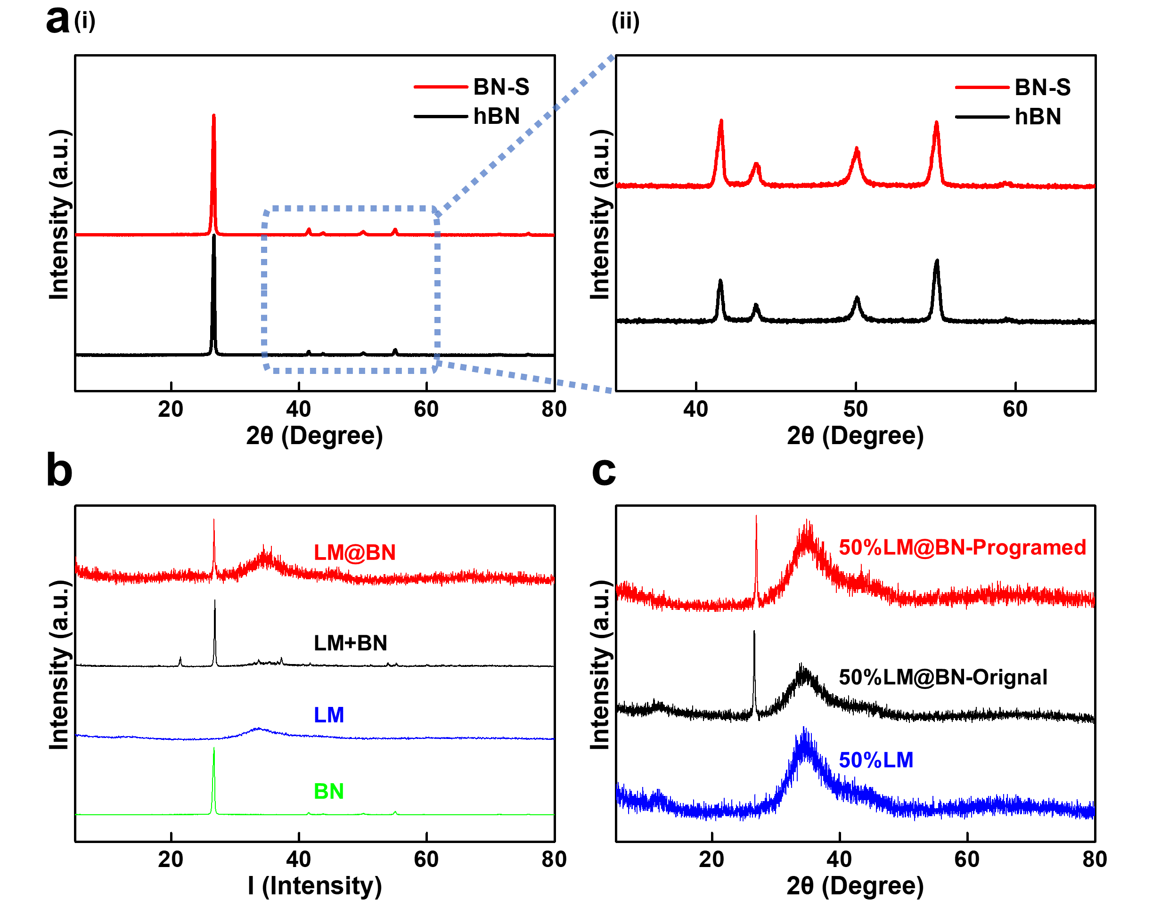
Fig. S1. (a) XRD diffraction spectra of h-BN and BN-S; (b) XRD diffraction spectra of unmodified BN+LM fillers and LM@BN hybrid fillers; and (c) XRD diffraction spectra of LM/PDMS, LM@BN/PDMS and mechanically trained composites with a filling amount of 50%.

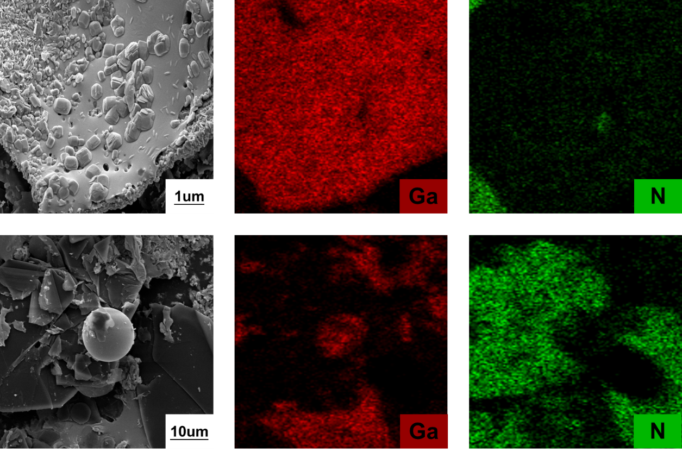
Fig. S2. SEM and EDS images of Ga and N elements were obtained by direct mixing of liquid metal and boron nitride. (a) The wrapping of BN layers by LM (b) Free LM particles.

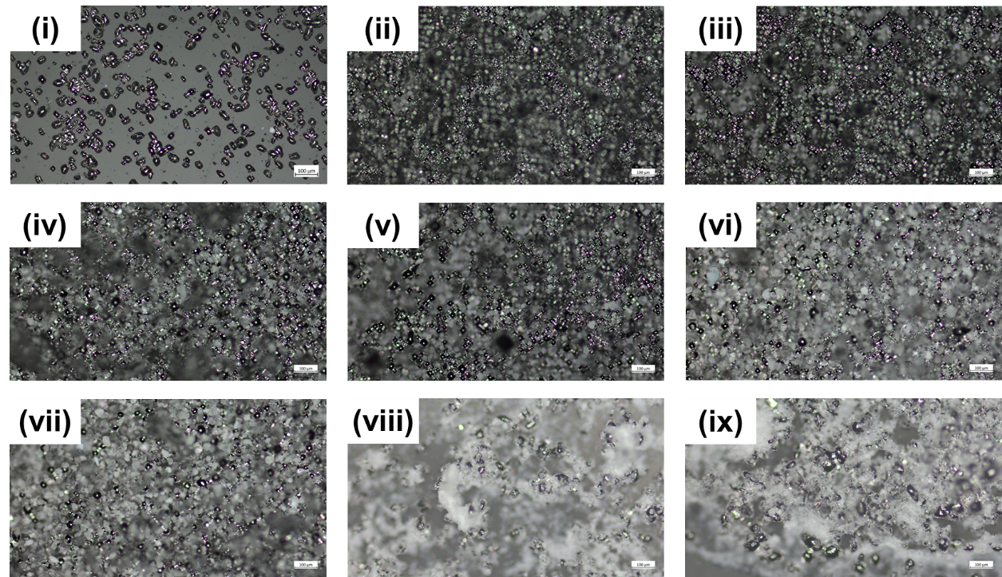
Fig. S3. The optical microscope images of LM@BN hybrid fillers were formed by different amounts of BN-S. (I) LM:BN=100:1; (ii-iii) LM:BN=70:1; (iv-v) LM:BN=50:1; (vi-vii) LM:BN=30:1; (vii-ix) LM:BN=1:1.

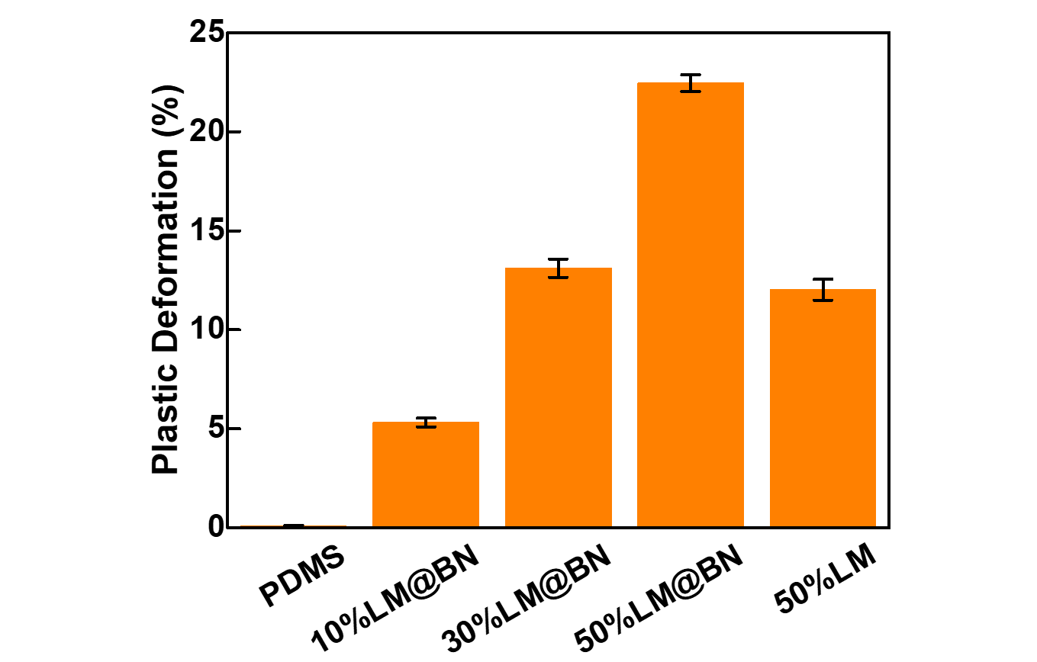
Fig. S4. Plastic deformation of the material after tensile programming.

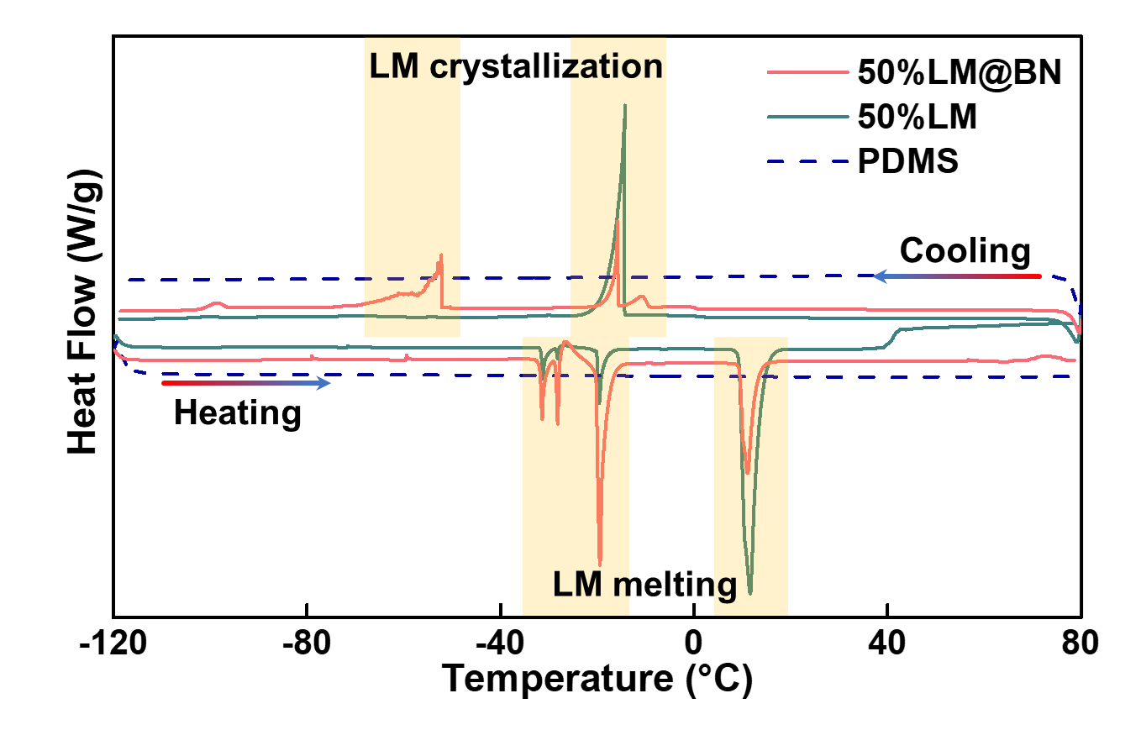
Fig. S5. DSC curves of LM/PDMS, LM@BN/PDMS, and PDMS.

