SUPPLEMENTARY MATERIAL

METHODS

Index of multiple deprivation
As an estimation of socio-economic status, patients’ postcodes were used to assign a deprivation rank according to the English Index of Multiple Deprivation (IMD). Briefly, in England, the IMD scores identifies areas of poverty, inequality and decreased opportunity based on income, employment, education attainment and other attributes. IMD divides England into 32,844 small areas, ranging from 1 (most deprived) to 32,844 (least deprived). IMD and related single domains were analysed as continuous variable (median of IMD and single domains) as well as categorical variable (percentage of patients into terciles of IMD and single domains).

Descriptive statistics
Univariate analysis was carried out using Mann-Whitney for continuous, and chi‐square test for categorical variables respectively. Kruskal-Wallis or ANOVA with post-hoc corrections was used for comparison between multiple groups. Receiver operating characteristic (ROC) curves were used to assess the diagnostic performance of the derived formula compared to traditional screening methods for fibrosis assessment. Areas under ROC curve (AUROC) with 95% confidence intervals were calculated under nonparametric (distribution free) assumption. Optimal cut‐off values were calculated to maximise sensitivity and specificity, while positive predictive value (PPV) and negative predictive value (NPV) were reported based upon the observed prevalence of liver disease within the population. Finally, pairwise statistical comparison of AUROCs was performed using the DeLong method between the derived score and traditional screening methods.
All tests were two‐sided and a P value 0.05 was considered significant. Statistical analysis was performed using SPSS© (version 24.0; SPSS Inc Chicago, IL).

RESULTS

Internal validation

In the validation cohort, the BIMAST score showed a Hosmer‐Lemeshow test and Brier score of 0.89 and 0.13, confirming that the derived model fitted well the validation cohort well and had good calibration. In this cohort, the BIMAST score was able to predict the presence of significant fibrosis (LSM≥8.1 kPa, n=17) accurately, with an AUROC 0.91 (95%CI: 0.82-0.99, p<0.0001) (Supplementary figure 2A). A cut-off of 0.063 gave 70% sensitivity and 90% specificity, with PPV 63% and NPV 94% for significant fibrosis. Similarly, the BIMAST score predicted the presence of advanced fibrosis (LSM≥12.1 kPa, n=14) accurately, with an AUROC 0.908 (95%CI: 0.81-0.99, p<0.0001) (Supplementary figure 2B). A cut-off of 0.102 carried sensitivity 63%, specificity 95%, PPV 66% and NPV 99% for advanced fibrosis.
TABLES
Publication, journal, year | Intervention | Comparator (standard of care) | Population | Country | Setting | Model | Cost-effectiveness results | Key cost-effectiveness drivers | Ref
Tanajewski, BMJ Open, 2017 | Transient elastography (TE) | Liver function tests (LFTs) and referral | Adults with risk factors for NAFLD¹ | UK | Primary care | Decision tree and Markov model | Intervention cost-effective compared to SOC | fibrosis progression rate, treatment effect of screening | ¹
Srivastava, Gastroenterology, 2019 | FIB-4; enhanced liver fibrosis test; fibroscan | Liver function tests & abdominal ultrasound | Patients with a confirmed NAFLD diagnosis | UK | Primary care | Probabilistic decision model | All interventions cost-saving | NALFD screening test sensitivity and specificity | ²
Noureddin, Gastroenterology, 2020 | Ultrasound, noninvasive tests. LFTs | No screening | Patients with type 2 diabetes and NAFLD | US | n/a | Markov model | ICER ~$36,000/QALY | Initial age | ⁴
Serra-Burriel, Journal of Hepatology, 2019 | TE, confirmed by liver biopsy | Aminotransferase activities | General population (observational) | UK and EU | Primary care | diagnostic algorithm with conditional inference trees | Variable across countries, but TE always cost-effective vs. SOC | Liver disease risk factors (diabetes, alcohol consumption) | ⁵
Tapper, Am Journal of Gastroenterology 2015 | vibration controlled TE (VCTE), NAFLD fibrosis score (NFS) | Liver biopsy | Adult patients with NAFLD aged 50 years | US | Specialty care (gastroenterologist) | Monte Carlo microsimulation state-transition model | Both interventions cost-effective | Liver biopsy and screening costs | ⁶
Tapper, PLoS One, 2016 | VCTE, NFS, combination screening | Liver biopsy | Adult patients with NAFLD | US | Primary care | Monte Carlo microsimulation state-transition model | All interventions cost-effective | Setting (screening in GP office most cost-effective) | ⁷
Vilar-Gomez, Clinical Gastroenterol Hepatol, 2020 | 2-test combinations of: FIB-4, VCTE, magnetic resonance elastography (MRE), liver biopsy | No screening | Middle-aged patients with NAFLD | US | Specialty care clinic or tertiary referral centre | Decision tree and microsimulation model | FIB-4 + VCTE most cost-effective, all other interventions also cost-effective | Cirrhosis prevalence, screening costs | ⁸
Phisalprapa, Medicine Baltimore 2017 | Ultrasonography & weight reduction programme | No screening | Patients with metabolic syndrome | Thailand | n/a | Decision tree and Markov model | $958/QALY | Age, transition probabilities, weight reduction | ⁹
Eddowes, Aliment Pharmacol Ther, 2018 | TE, multiparametric MRI, TE + MRI | Liver biopsy | Patients with diagnosed NAFLD | UK | Clinical trial | Cost analysis | Multiparametric MRI cost-saving | n/a | ¹⁰
Crossan, Health Technol Assess. 2015 | Non-invasive liver tests | Liver biopsy | Patients with chronic liver disease | UK | n/a | Decision tree and Markov model | Intervention cost-effective compared to SOC | Treatment effect of screening on mild fibrosis patients | ¹¹
Blake, BMJ Open. 2016 | TE, multiparametric MRI, TE + MRI | Liver biopsy | Patients with diagnosed NAFLD | UK | Clinical trial | Simple decision tree (cost analysis) | Multiparametric MRI cost-saving | TE sensitivity and specificity, MRI price & failure rate | ¹²
Crossan, Liver Int. 2019 | Sequential noninvasive tests (FIB-4, fibroscan) | Liver biopsy; refer all (fibrosis stages) | Patients with diagnosed NAFLD | UK | Primary care screening; secondary care referral | n/a (decision curve analysis) | Greatest net benefit with two-tier sequential screening | Advanced fibrosis prevalence, referral rates, direct medical costs | ¹³
Zhang, Eur Radiol. 2015 | NIT sequential algorithm with NFS, TE, CK-18 | No screening | Patients with type 2 diabetes or obesity | Canada | Primary care | Markov model | MRE more cost-effective than liver biopsy | TE cost, transition probabilities, surveillance age | ¹⁴
Corey, Dig Dis Sci. 2016 | Ultrasound for all patients | No screening | Type 2 diabetes population  aged 50 years | US | n/a | Markov model | Screening dominated by no screening | Utility decrement for treatment due to side effects, screening costs | ¹⁵
Congly, PLoS One. 2021 | NFS, FIB-4, TE, shear wave elastography (SWE); screening combinations | n/a (pairwise comparison of all screening interventions) | Patients with NAFLD at increased risk of advanced fibrosis | Canada | Primary care | Decision tree | FIB-4/SWE cost-effective or dominant for all patient subgroups | NAFLD prevalence, negative predictive value of each screening test | ¹⁶
Steadman, Can J Gastroenterol. 2013 | TE | Liver biopsy | Adult patients with NAFLD, liver transplant, hepatitis B or C | Canada | Primary care | Decision tree | $1,427 to $7,030 / correct diagnosis  needed for livery biopsy versus TE | TE sensitivity and specificity, fibrosis prevalence | ¹⁷
Saokaew, Medicine Baltimore 2020 | fatty liver index, hepatic steatosis index, lipid accumulation product index | No screening | Patients with type 2 diabetes | Thailand | n/a | Simple cost comparison | Total cost reduction $4,000-14,000 with screening compared to no screening | Costs and diagnostic accuracy of screening | ¹⁸
Moolla, Frontline Gastroenterol. 2019 | TE, NFS, FIB-4, lifestyle and weight management | No clinic attendance | Patients with NAFLD and type 2 diabetes | UK | Hospital (secondary/tertiary care) | UK Prospective Diabetes Study Outcomes Model | All screening strategies cost-effective ICER £6,100/QALY | Degree of type 2 diabetes control (greater impact for poorly controlled) | ¹⁹
Thavorn, Ont Health Technol Assess Ser. 2015 | TE with(out) controlled  attenuation parameter (CAP) | Liver biopsy | Patients with chronic liver disease | Canada | Primary care | Decision tree | TE cost-effective compared to liver biopsy | TE amd liver biopsy costs, TE specificity, severity of liver fibrosis | ²⁰
¹ Risk factors include type 2 diabetes and excessive alcohol use.
Supplementary table 1. Literature review of economic evaluations of NAFLD screening strategies.

Input parameter | Base-case value |  | Ranges and probability distributions | Reference
I Transition probabilities
MLD to SLD | 0.06-0.17 |  |  |  | Tanajewski, et al.
SLD to CC | 0.06-0.17 |  | Dirichlet and Beta |  | Tanajewski, et al.
CC to DC | 0.0735 |  | Dirichlet and Beta |  | Tanajewski, et al.
CC to HCC | 0.03 |  | Dirichlet and Beta |  | Tanajewski, et al.
DC to HCC  <70 years  ≥70 years | 0.05  0.00 |  | Dirichlet and Beta |  | Tanajewski, et al.
HCC to LT  <65 years  ≥65 years | 0.04  0.00 |  |  |  | Tanajewski, et al.
All-cause mortality¹  MLD to death  SLD to death  CC to death  DC to death  HCC to death  LT to death | 0.019  0.019  0.0705  0.2275  0.133-0.53  0.029-0.166 |  | Dirichlet and Beta |  | Srivastava, et al.
Risk ratio for diagnosed versus undiagnosed  MLD and SLD  CC | 0.63  0.67 |  | Log-normal  95% CI: 0.06-6.45  95% CI: 0.21-2.07 |  | Tanajewski, et al.
II NAFLD screening |  | 20, 40, 60, 80, 100
Standard of care  mild liver disease (specificity²), %  Severe liver disease (sensitivity²), %  FIB-4,  No/mild liver disease (specificity), %  Severe liver disease (sensitivity), %  NAFLD fibrosis score  No/mild liver disease (specificity), %  Severe liver disease (sensitivity), %  Fibroscan  No/mild liver disease (specificity), %  Severe liver disease (sensitivity), % | 65.00  35.00  83.65  62.75  62.68  62.00  21.63  98.04  100.00  100.00 |  |  |  | Srivastava, et al.  Primary care cohort  Primary care cohort  Primary care cohort
III Health state utilities |  | Gamma, ±50%
MLD, SLD, CC  DC  HCC  LT  Death | 0.895  0.66  0.65  0.69  0.00 |  |  |  | Tanajewski, et al.
IV Costs³ (2020 GBP) |  | Gamma, ±50%, ±200%
Direct medical costs (SOC strategy), first/subsequent year  MLD-  MLD+  False negatives  SLD+  CC  DC  HCC  LT  Direct medical costs (screening strategies), first/subsequent years  MLD-  MLD+  False negatives  SLD+  CC  DC  HCC  LT  Screening test unit costs  FIB-4  NAFLD fibrosis score  Fibroscan | 0/0  1,400/74  0/0  1,400/421  1,975/1,012  7,639/8,823  22,228/20,806  102,223/23,686  0/0  171/171  0/0  805/605  1,179/1,179  7,639/8,823  22,228/20,806  102,223/23,686  4.24  4.72  125.00 |  |  |  | Tanajewski, et al.  Tanajewski, et al.  Primary care cohort
V Other input parameters
Initial age, years  Discount rate for benefits and costs, %  Time horizon, years  NAFLD population prevalence, % | 61  3.5  40 (lifetime)  64 |  | 54-66  0-5  1, 5, 10, 20 |  | Primary care cohort  NICE guidelines  Tanajewski, Srivastava  Primary care cohort

¹Adjusted by excess death rate due to diabetes from Tanajewski, et al.
² Sensitivity=true positives/(true positives+false negatives); specificity=true negatives/(true negatives+false positives)
³ Direct medical costs include GP consultations, specialist and dietician appointments, medications and treatments associated with
each liver disease stage. Detailed cost components are reported in supplementary table 5.

Supplementary table 2. Model input parameters for the cost-effectiveness analysis of 5 NAFLD screening strategies compared to the standard of care, with data sources and ranges used in sensitivity analyses.
Abbreviations: MLD: mild liver disease (no NAFLD or NAFLD with LSM≤8 kPa); SLD: significant liver disease (NAFLD with LSM≥8.1 kPa); CC: compensated cirrhosis; False negatives: undiagnosed liver disease (NAFLD with LSM ≥8.1 kPa who were false negatives at screening); DC: decompensated cirrhosis; HCC: hepatocellular carcinoma

Input parameter | Value (2020 GBP) | Reference
I Annual direct medical costs: first year

MLD  FIB-4  GP appointment  Dietician appointment  Medications  TOTAL | 4.24  53.00  92.00  22.00  171.24 | Tanajewski, et al.
SLD  Follow-up tests (fibroscan, ultrasound)  GP appointment  1st referral to NAFLD clinic  Dietician appointment  Medications  TOTAL | 438.48  53.00  200.00  92.00  22.00  805.48 | Tanajewski, et al.
CC  Follow-up tests (ultrasound, EEG, OGD)  GP appointment  Dietician appointment  Medications  TOTAL | 900.57  53.00  92.00  134.00  1,179.57 | Tanajewski, et al.
DC  HCC  Liver transplant | 7,639.00  22,228.00  102,223.00 | Tanajewski, et al.
II Annual direct medical costs: subsequent years
MLD  FIB-4  GP appointment  Dietician appointment  Medications  TOTAL | 4.24  53.00  92.00  22.00  171.24 | Tanajewski, et al.
SLD  Follow-up tests (fibroscan, ultrasound)  GP appointment  Dietician appointment  Medications  TOTAL | 438.48  53.00  92.00  22.00  605.48 | Tanajewski, et al.
CC  Follow-up tests (ultrasound, EEG, OGD)  GP appointment  Dietician appointment  Medications  TOTAL | 900.57  53.00  92.00  134.00  1,179.57 | Tanajewski, et al.
DC  HCC  Liver transplant | 8,823.00  20,806.00  23,686.00 | Tanajewski, et al.

Supplementary table 3. Comprehensive overview of unit costs by health state, used to calculate direct medical costs for screening strategies.
Abbreviations: MLD: mild liver disease (no NAFLD or NAFLD with LSM≤8 kPa); SLD: significant liver disease (NAFLD with LSM≥8.1 kPa); CC: compensated cirrhosis; False negatives: undiagnosed liver disease (NAFLD with LSM ≥8.1 kPa who were false negatives at screening); DC: decompensated cirrhosis; HCC: hepatocellular carcinoma; GP: general practitioner; EEG: electroencephalography; OGD: oesophago-gastro-duodenoscopy.

Value of parameter varied | HIV testing strategy | Discounted QALYs per person (years) | Discounted lifetime cost per person (£) | % change in correct diagnoses compared to baseline screening | ICER  (£/YLS)
Base case (scenario 1)
-- | Baseline | 12.29 | 12,295 | -- | --
-- | Screening | 12.89 | 13,543 | 30.41% | £2,338
Parameter varied: risk ratio (for diagnosed compared to undiagnosed)
lower bound | Baseline | 13.68 | 5,627 | -- | --
lower bound | Screening | 14.10 | 5,783 | 30.41% | £371
upper bound | Baseline | 9.38 | 24,351 | -- | --
upper bound | Screening | 9.39 | 27,312 | 30.41% | £799,213
Parameter varied: time horizon
5 years | Baseline | 3.81 | 1,300 | -- | --
5 years | Screening | 3.82 | 1,599 | 30.41% | £70,351
10 years | Baseline | 6.67 | 2,513 | -- | --
10 years | Screening | 6.71 | 2,820 | 30.41% | £7,536
Parameter varied: health state utilities
lower bound | Baseline | 11.98 | 12,295 | -- | --
lower bound | Screening | 12.49 | 13,543 | 30.41% | £2,412
upper bound | Baseline | 12.60 | 12,295 | -- | --
upper bound | Screening | 13.15 | 13,543 | 30.41% | £2,268
Parameter varied: direct medical costs
50% | Baseline | 12.29 | 6,148 | -- | --
50% | Screening | 12.82 | 6,771 | 30.41% | £1,169
200% | Baseline | 12.29 | 24,591 | -- | --
200% | Screening | 12.82 | 27,086 | 30.41% | £4,676
Parameter varied: screening sensitivity and specificity
20% | Baseline | 12.29 | 12,295 | -- | --
20% | Screening | 12.59 | 13,265 | -68.34% | £3,257
40% | Baseline | 12.29 | 12,295 | -- | --
40% | Screening | 12.73 | 13,221 | -36.67% | £2,076
60% | Baseline | 12.29 | 12,295 | -- | --
60% | Screening | 12.80 | 13,341 | -5.01% | £2,040
80% | Baseline | 12.29 | 12,295 | -- | --
80% | Screening | 12.84 | 13,516 | 26.65% | £2,220
100% | Baseline | 12.29 | 12,295 | -- | --
100% | Screening | 12.86 | 13,718 | 58.31% | £2,477
Parameter varied: discount rate
1% | Baseline | 16.80 | 20,733 | -- | --
1% | Screening | 17.76 | 22,995 | 30.41% | £2,353
5% | Baseline | 10.47 | 9,325 | -- | --
5% | Screening | 10.85 | 10,248 | 30.41% | £2,393

Supplementary table 4. Results of the univariate sensitivity analyses showing the impact of uncertainty in model input parameters on the clinical outcomes and ICER: scenario 1 (US + LFTs).

Value of parameter varied | NAFLD screening | Discounted QALYs per person (years) | Discounted lifetime cost per person (£) | % change in correct diagnoses compared to baseline screening | ICER  (£/YLS)

Value of parameter varied | NAFLD screening | Discounted QALYs per person (years) | Discounted lifetime cost per person (£) | % change in correct diagnoses compared to baseline screening | ICER  (£/YLS)
Base case (scenario 2)
-- | Baseline | 12.29 | 12,295 | -- | --
-- | Screening | 12.81 | 13,362 | 1.66% | £2,060
Parameter varied: risk ratio (for diagnosed compared to undiagnosed)
lower bound | Baseline | 13.68 | 5,627 | -- | --
lower bound | Screening | 14.08 | 5,714 | -0.83% | £215
upper bound | Baseline | 12.60 | 12,295 | -- | --
upper bound | Screening | 13.14 | 13,362 | 1.66% | £1,994
Parameter varied: time horizon
5 years | Baseline | 3.81 | 1,300 | -- | --
5 years | Screening | 3.82 | 1,335 | 1.66% | £8,350
10 years | Baseline | 6.67 | 2,513 | -- | --
10 years | Screening | 6.71 | 2,581 | 1.66% | £1,718
Parameter varied: health state utilities
lower bound | Baseline | 11.98 | 12,295 | -- | --
lower bound | Screening | 12.48 | 13,362 | 1.66% | £2,130
upper bound | Baseline | 12.60 | 12,295 | -- | --
upper bound | Screening | 13.14 | 13,362 | 1.66% | £1,994
Parameter varied: direct medical costs
50% | Baseline | 12.29 | 6,148 | -- | --
50% | Screening | 12.81 | 6,681 | 1.66% | £1,030
200% | Baseline | 12.29 | 24,591 | -- | --
200% | Screening | 12.81 | 26,724 | 1.66% | £4,120
Parameter varied: screening sensitivity and specificity
20% | Baseline | 12.29 | 12,295 | -- | --
20% | Screening | 12.59 | 13,265 | -68.34% | £3,257
40% | Baseline | 12.29 | 12,295 | -- | --
40% | Screening | 12.73 | 13,221 | -36.67% | £2,076
60% | Baseline | 12.29 | 12,295 | -- | --
60% | Screening | 12.80 | 13,341 | -5.01% | £2,040
80% | Baseline | 12.29 | 12,295 | -- | --
80% | Screening | 12.84 | 13,516 | 26.65% | £2,220
100% | Baseline | 12.29 | 12,295 | -- | --
100% | Screening | 12.86 | 13,718 | 58.31% | £2,477
Parameter varied: discount rate
1% | Baseline | 16.80 | 20,733 | -- | --
1% | Screening | 17.73 | 22,841 | 1.66% | £2,259
5% | Baseline | 10.47 | 9,325 | -- | --
5% | Screening | 10.84 | 10,055 | 30.41% | £1,953

Supplementary table 5. Results of the univariate sensitivity analyses showing the impact of uncertainty in model input parameters on the clinical outcomes and ICER: scenario 1 (FIB-4).
Abbreviations: ICER: incremental cost-effectiveness ratio; QALY: quality-adjusted year.

Value of parameter varied | NAFLD screening | Discounted QALYs per person (years) | Discounted lifetime cost per person (£) | % change in correct diagnoses compared to baseline screening | ICER  (£/YLS)
Base case (scenario 3)
-- | Baseline | 12.29 | 12,295 | -- | --
-- | Screening | 12.76 | 13,275 | -58.36% | £2,092
Parameter varied: risk ratio (for diagnosed compared to undiagnosed)
lower bound | Baseline | 13.68 | 5,627 | -- | --
lower bound | Screening | 14.08 | 5,960 | -58.36% | £827
upper bound | Baseline | 9.39 | 24,351 | -- | --
upper bound | Screening | 9.59 | 25,558 | -58.36% | £6,016
Parameter varied: time horizon
5 years | Baseline | 3.81 | 1,300 | -- | --
5 years | Screening | 3.82 | 830 | -58.36% | -£109,221
10 years | Baseline | 6.67 | 2,513 | -- | --
10 years | Screening | 6.70 | 2,160 | -58.36% | -£9,080
Parameter varied: health state utilities
lower bound | Baseline | 11.98 | 12,295 | -- | --
lower bound | Screening | 12.42 | 13,275 | -58.36% | £2,184
upper bound | Baseline | 12.60 | 12,295 | -- | --
upper bound | Screening | 13.09 | 13,275 | -58.36% | £2,008
Parameter varied: direct medical costs
50% | Baseline | 12.29 | 6,148 | -- | --
50% | Screening | 12.76 | 6,638 | -58.36% | £1,046
200% | Baseline | 12.29 | 24,591 | -- | --
200% | Screening | 12.76 | 26,550 | 30.41% | £4,185
Parameter varied: screening sensitivity and specificity
20% | Baseline | 12.29 | 12,295 | -- | --
20% | Screening | 12.59 | 13,265 | -68.34% | £3,257
40% | Baseline | 12.29 | 12,295 | -- | --
40% | Screening | 12.73 | 13,221 | -36.67% | £2,076
60% | Baseline | 12.29 | 12,295 | -- | --
60% | Screening | 12.80 | 13,341 | -5.01% | £2,040
80% | Baseline | 12.29 | 12,295 | -- | --
80% | Screening | 12.84 | 13,516 | 26.65% | £2,220
100% | Baseline | 12.29 | 12,295 | -- | --
100% | Screening | 12.86 | 13,718 | 58.31% | £2,477
Parameter varied: discount rate
1% | Baseline | 16.80 | 20,733 | -- | --
1% | Screening | 17.64 | 22,948 | 58.31% | £2,636
5% | Baseline | 10.47 | 9,325 | -- | --
5% | Screening | 10.80 | 9,891 | 30.41% | £1,669

Supplementary table 6. Results of the univariate sensitivity analyses showing the impact of uncertainty in model input parameters on the clinical outcomes and ICER: scenario 2 (NAFLD fibrosis score).
Abbreviations: ICER: incremental cost-effectiveness ratio; QALY: quality-adjusted year.

Value of parameter varied | NAFLD screening | Discounted QALYs per person (years) | Discounted lifetime cost per person (£) | % change in correct diagnoses compared to baseline screening | ICER  (£/YLS)
Base case (scenario 4)
-- | Baseline | 12.29 | 12,295 | -- | --
-- | Screening | 12.83 | 13,366 | 10.76% | £1,967
Parameter varied: risk ratio (for diagnosed compared to undiagnosed)
lower bound | Baseline | 13.68 | 5,627 | -- | --
lower bound | Screening | 14.14 | 5,545 | 7.96% | -£176
upper bound | Baseline | 9.38 | 24,351 | -- | --
upper bound | Screening | 9.32 | 27,366 | 4.86% | -£46,796
Parameter varied: time horizon
5 years | Baseline | 3.81 | 1,300 | -- | --
5 years | Screening | 3.82 | 1,368 | 4.55% | £15,368
10 years | Baseline | 6.67 | 2,513 | -- | --
10 years | Screening | 6.71 | 2,614 | 6.03% | £2,428
Parameter varied: health state utilities
lower bound | Baseline | 11.98 | 12,295 | -- | --
lower bound | Screening | 12.50 | 13,366 | 10.76% | £2,027
upper bound | Baseline | 12.60 | 12,295 | -- | --
upper bound | Screening | 13.16 | 13,366 | 10.76% | £1,910
Parameter varied: direct medical costs
50% | Baseline | 12.29 | 6,148 | -- | --
50% | Screening | 12.83 | 6,683 | 10.76% | £984
200% | Baseline | 12.29 | 24,591 | -- | --
200% | Screening | 12.83 | 26,733 | 10.76% | £3,934
Parameter varied: screening sensitivity and specificity
20% | Baseline | 12.29 | 12,295 | -- | --
20% | Screening | 12.59 | 13,265 | -68.34% | £3,257
40% | Baseline | 12.29 | 12,295 | -- | --
40% | Screening | 12.73 | 13,221 | -36.67% | £2,076
60% | Baseline | 12.29 | 12,295 | -- | --
60% | Screening | 12.80 | 13,341 | -5.01% | £2,040
80% | Baseline | 12.29 | 12,295 | -- | --
80% | Screening | 12.84 | 13,516 | 26.65% | £2,220
100% | Baseline | 12.29 | 12,295 | -- | --
100% | Screening | 12.86 | 13,718 | 58.31% | £2,477
Parameter varied: discount rate
1% | Baseline | 16.80 | 20,733 | -- | --
1% | Screening | 17.78 | 22,837 | 10.76% | £2,144
5% | Baseline | 10.47 | 9,325 | -- | --
5% | Screening | 10.86 | 10,065 | 10.76% | £1,879

Supplementary table 7. Results of the univariate sensitivity analyses showing the impact of uncertainty in model input parameters on the clinical outcomes and ICER: scenario 4 (BIMAST).

Value of parameter varied | NAFLD screening | Discounted QALYs per person (years) | Discounted lifetime cost per person (£) | % change in correct diagnoses compared to baseline screening | ICER  (£/YLS)
Base case (scenario 5)
-- | Baseline | 12.29 | 12,289 | -- | --
-- | Screening | 12.86 | 13,718 | 15.05% | £2,478
Parameter varied: risk ratio (for diagnosed compared to undiagnosed)
lower bound | Baseline | 13.68 | 5,627 | -- | --
lower bound | Screening | 14.17 | 5,701 | 11.05% | £149
upper bound | Baseline | 9.38 | 24,351 | -- | --
upper bound | Screening | 9.21 | 28,442 | 10.43% | -£23,192
Parameter varied: time horizon
5 years | Baseline | 3.81 | 1,300 | -- | --
5 years | Screening | 3.82 | 1,854 | 18.96% | £120,487
10 years | Baseline | 6.67 | 2,513 | -- | --
10 years | Screening | 6.71 | 3,062 | 13.85% | £12,441
Parameter varied: health state utilities
lower bound | Baseline | 11.98 | 12,295 | -- | --
lower bound | Screening | 12.54 | 13,718 | 15.05% | £2,543
upper bound | Baseline | 12.60 | 12,295 | -- | --
upper bound | Screening | 13.19 | 13,718 | 15.05% | £2,413
Parameter varied: direct medical costs
50% | Baseline | 12.29 | 6,148 | -- | --
50% | Screening | 12.86 | 6,859 | 15.05% | £1,238
200% | Baseline | 12.29 | 24,591 | -- | --
200% | Screening | 12.86 | 27,435 | 15.05% | £4,953
Parameter varied: screening sensitivity and specificity
20% | Baseline | 12.29 | 12,295 | -- | --
20% | Screening | 12.59 | 13,265 | -68.34% | £3,257
40% | Baseline | 12.29 | 12,295 | -- | --
40% | Screening | 12.73 | 13,221 | -36.67% | £2,076
60% | Baseline | 12.29 | 12,295 | -- | --
60% | Screening | 12.80 | 13,341 | -5.01% | £2,040
80% | Baseline | 12.29 | 12,295 | -- | --
80% | Screening | 12.84 | 13,516 | 26.65% | £2,220
100% | Baseline | 12.29 | 12,295 | -- | --
100% | Screening | 12.86 | 13,718 | 58.31% | £2,477
Parameter varied: discount rate
1% | Baseline | 16.80 | 20,733 | -- | --
1% | Screening | 17.84 | 23,144 | 15.05% | £2,332
5% | Baseline | 10.47 | 9,325 | -- | --
5% | Screening | 10.88 | 10,433 | 15.05% | £2,670

Supplementary table 8. Results of the univariate sensitivity analyses showing the impact of uncertainty in model input parameters on the clinical outcomes and ICER: scenario 3 (Fibroscan).
Abbreviations: ICER: incremental cost-effectiveness ratio; QALY: quality-adjusted year.

 | NAFLD, elevated LSM  N=50 | NAFLD, normal LSM  N=136
 | Median (IQR) | Median (IQR) | P value*
Overall IMD | 10043  (4098-18528) | 11858  (4851-21254) | 0.1
Income rank | 6767  (1872-16991) | 8336  (3218-20084) | 0.19
Employment rank | 8171  (3109-19674) | 10511  (3110-24241) | 0.22
Education rank | 18789  (13721-26362) | 23148  (14665-28792) | 0.03
Health and disability rank | 16806  (9800-27198) | 20105  (12063-29788) | 0.13
Crime rank | 14692  (7268-20746) | 16118  (8228-22680) | 0.63
Barriers to housing services rank | 11292  (8067-13945) | 11728  (9393-14434) | 0.29
Living environment rank | 5923  (2769-9394) | 5599  (3289-8107) | 0.99
 | N (%) | N (%) | P value*
Overall IMD  1st tertile  3rd tertile | 27 (54)  7 (14) | 56 (41)  29 (21) | 0.2
Income rank  1st tertile  3rd tertile | 27 (54)  36 (51) | 73 (53)  27 (20) | 0.06
Employment rank  1st tertile  3rd tertile | 27 (54)  9 (16) | 66 (48)  37 (27) | 0.42
Education rank  1st tertile  3rd tertile | 6 (12)  18 (36) | 13 (10)  71 (52) | 0.08
Health and disability rank  1st tertile  3rd tertile | 13 (25)  15 (30) | 21 (15)  61 (44) | 0.54
Crime rank  1st tertile  3rd tertile | 17 (34)  10 (20) | 38 (27)  33 (24) | 0.71
Barriers to housing services rank  1st tertile  3rd tertile | 18 (36)  0 (0) | 35 (25)  1 (0) | 0.65
Living environment rank  1st tertile  3rd tertile | 38 (76)  1 (2) | 114 (83)  0 (0) | 0.73

Supplementary table 9. Differences in socio-economic status between NAFLD patients stratified per liver stiffness measurement greater than 8.1 kPa. Socio-economic status is expressed as Index of multiple deprivation and relative single domains. The table shows the differences between patients with NAFLD with elevated (n=50) and normal (n=136) LSM. Variables are expressed as median and IQR or relative percentages. * p-value: differences between patients with NAFLD with elevated LSM and normal LSM.
Abbreviations: NAFLD: non-alcoholic fatty liver disease, LSM: liver stiffness measurement, IQR: interquartile range, IMD: index of multiple deprivation.

 | Derivation cohort  N=194 | Validation cohort  N=93
 | Median (IQR) | Median (IQR) | P value*
Age, years | 60 (54-66) | 61 (54-65) | 0.46
Waist circum, cm | 106 (98-116) | 106 (100-107) | 0.38
Hip circum, cm | 109 (102-118) | 112 (105-121) | 0.16
BMI, kg/m² | 30 (26.7-34.4) | 31.1 (28.1-34.4) | 0.39
PLT, x 10⁹/uL | 254 (212-292) | 234 (192-275) | 0.055
ALT, IU/L | 28 (20-43) | 32 (26-48) | 0.07
AST, IU/L | 27 (22-34) | 28 (23-39) | 0.18
GGT, IU/L | 27 (18-46) | 31 (19-59) | 0.31
ALP, IU/L | 83 (69-100) | 85 (23-39) | 0.1
Total Cholesterol, mmol/l | 4.1 (3.5-4.7) | 4.1 (3.4-4.8) | 0.9
TRG, mmol/l | 1.3 (1-2) | 1.4 (1-2) | 0.93
HDL, mmol/l | 1.1 (0.9-1.3) | 1.1 (0.9-1.3) | 0.69
LDL, mmol/l | 2.1 (1.2-2.7) | 2.1 (1.5-2.8) | 0.77
Ferritin, ng/ml | 81 (40-155) | 108 (46-156) | 0.37
LSM, kPa | 5.6 (4.4-7.3) | 5.5 (4-7.5) | 0.56
CAP score, dB/m | 309 (255-292) | 308 (260-347) | 0.81
Diabetes characteristics
 | Median (IQR) | Median (IQR) | P value*
Fasting glucose, mmol/l | 6.8 (5.2-9.4) | 6.9 (5.8-9.9) | 0.07
HbA1c, mmol/mol | 57 (49-70) | 59 (47-71) | 0.75
Insulin, µU/ml | 14 (9-27) | 12.4 (7.4-22) | 0.17
Homa index | 4.1 (2.1-8.4) | 3.2 (1.8-9.6) | 0.47
Duration DM, years | 10 (4-18) | 10 (4-15) | 0.055

Supplementary table 10. Differences between derivation and internal validation cohort. The table shows the differences between patients from the validation vs internal derivation cohort. Variables are expressed as median and IQR or relative percentages.
* p-value: differences between patients from the derivation vs internal validation cohort.
Abbreviations: IQR: interquartile range, BMI: Body mass index, PLT: platelet, ALT: alanine aminotransferase, AST: aspartate aminotransferase, GGT: gamma-glutamyl transferase, ALP: alkaline phosphatase, TRG: triglycerides, HDL: high density lipoprotein, LDL: low density lipoprotein, HbA1c: glycated haemoglobin.

 | Derivation cohort  N=287 | Validation cohort  Royal Free  N=218 | Validation cohort  Sicily  N=168
 | Median (IQR) | Median (IQR) | Median (IQR) | P value* | P value**
Age, years | 61 (54-66) | 61 (53-68) | 56 (50-63) | 0.58 | 0.0001
Waist circum, cm | 106 (98-116) | 111 (100-120) | 109 (100-118) | 0.006 | 0.09
BMI, kg/m² | 30.4 (26.9-34.4) | 32.4 (28.1-37.7) | 31.8 (28.9-35.5) | 0.0001 | 0.004
PLT, x 10⁹/uL | 243 (202-290) | 230 (181-276) | 229 (178-267) | 0.001 | 0.01
ALT, IU/L | 30 (22-45) | 49 (33-68) | 56 (37-82) | 0.0001 | 0.0001
AST, IU/L | 27 (22-35) | 34 (24-48) | 38 (28-51) | 0.0001 | 0.0001
LSM, kPa | 5.6 (4.4-7.3) | 7.9 (5.4-14) | 11 (7.8-16.8) | 0.0001 | 0.0001

Supplementary table 11. Differences between the derivation cohort and the validation cohorts. The table shows the differences between the primary care cohort (derivation cohort) and cohorts from Royal Free Hospital and Sicily. Variables are expressed as median and IQR.
* p-value for difference between derivation cohort and validation cohort from Royal Free.
** p-value for difference between derivation cohort and validation cohort from Sicily.

FIGURES

Supplementary figure 1. Flowchart showing the patients enrolled in the study.
The flowchart of the study illustrates the total number (n=300) of patients enrolled in the study and the breakdown of the overall prevalence of NAFLD (64%) and other liver disease (9%) in the population. Patients with NAFLD were stratified according to LSM in those with elevated LSM (LSM≥8.1 kPa, n=50) and those with normal LSM (LSM < 8 kPa, n=136).

Supplementary figure 2. Diagnostic performance of the BIMAST score for predicting significant and advanced fibrosis in the internal validation cohort (diabetes primary care). The figure illustrates the receiver operating characteristic curve of the BIMAST score for predicting LSM ≥ 8.1 kPa (Figure 2A) and for predicting LSM ≥ 12.1 kPa (Figure 2B) in the internal validation cohort (diabetes primary care).
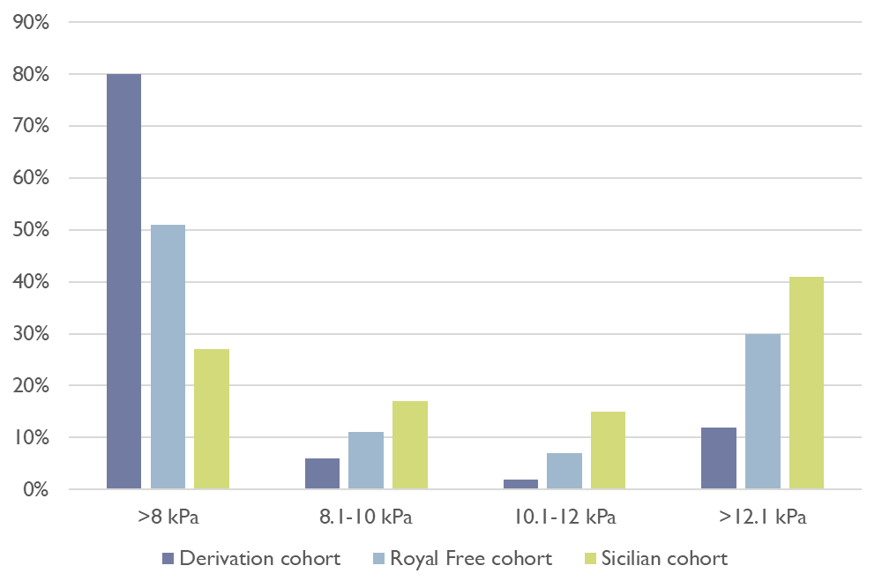
Supplementary figure 3. Study population versus external validation cohorts stratified per LSM ranges.
The bar chart illustrates the prevalence of patients with different ranges of LSM in the three groups: derivation cohort, Royal free cohort and Sicilian cohort.

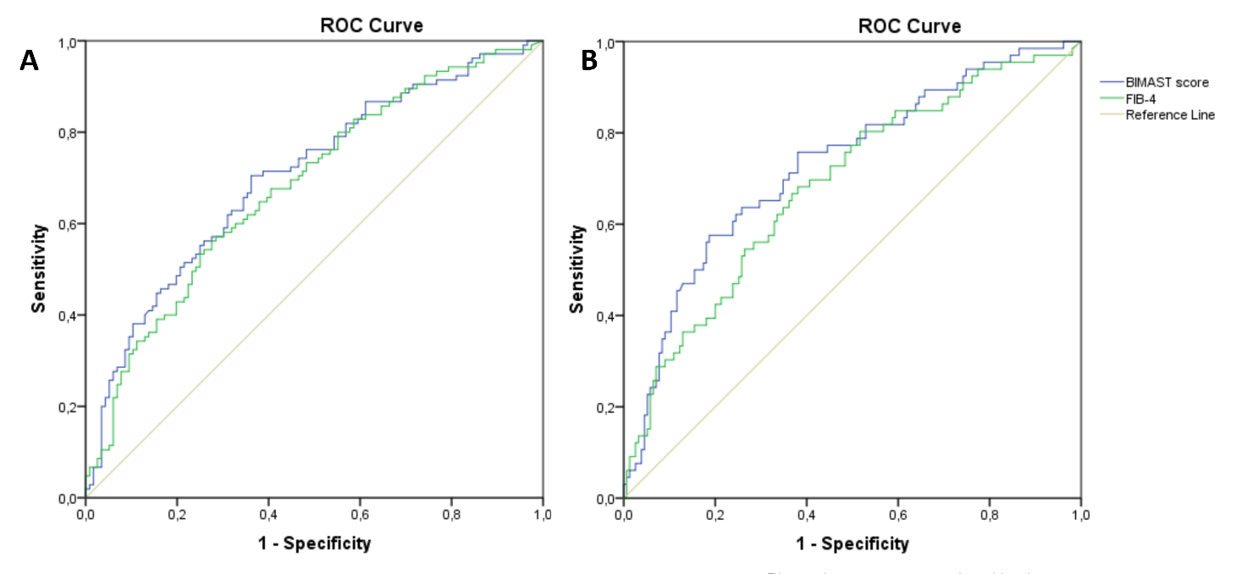
Supplementary Figure 4. BIMAST score vs FIB-4 for predicting significant and advanced fibrosis in the Royal Free cohort.
The figure shows the receiver operating characteristic curve of BIMAST score vs FIB-4 for predicting LSM≥ 8.1 kPa (Supplementary Figure 4A) and LSM ≥12.1 kPa (Supplementary Figure 4B) in the Royal Free cohort.

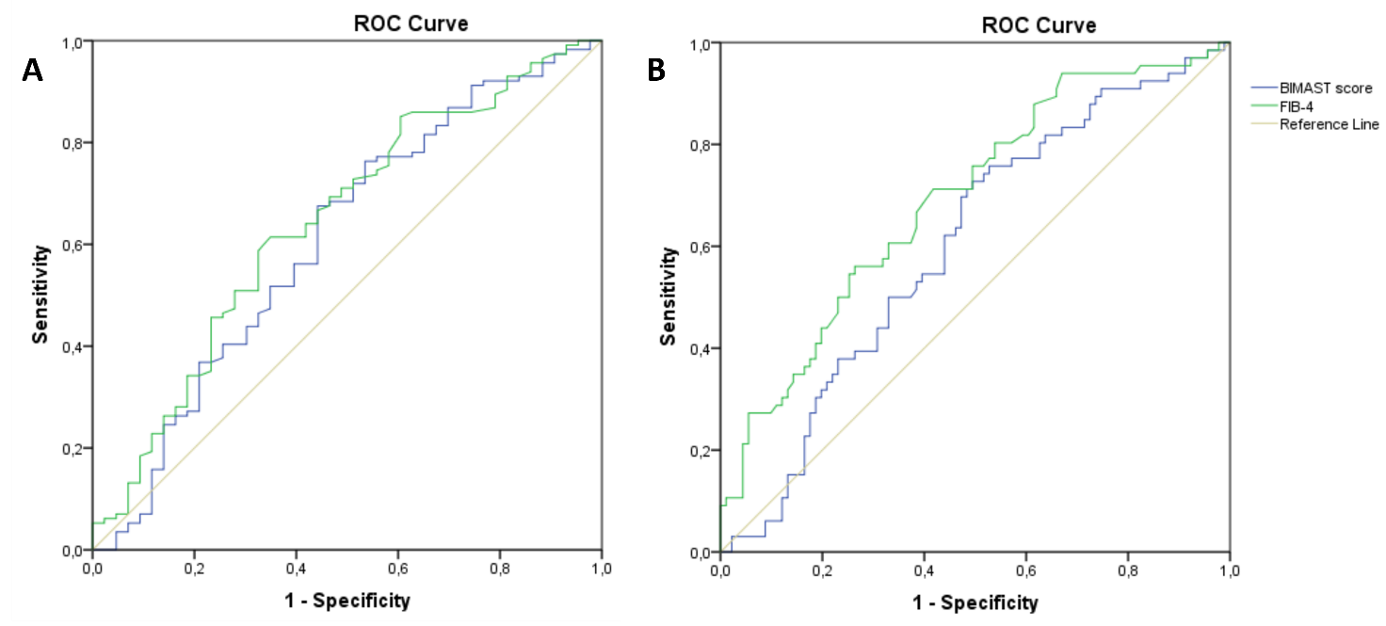

Supplementary Figure 5. BIMAST score vs FIB-4 for predicting significant and advanced fibrosis in the Sicilian cohort.
The figure shows the receiver operating characteristic curve of BIMAST score vs FIB-4 for predicting LSM≥ 8.1 kPa (Supplementary Figure 5A) and LSM ≥12.1 kPa (Supplementary Figure 5B) in the Sicilian cohort.

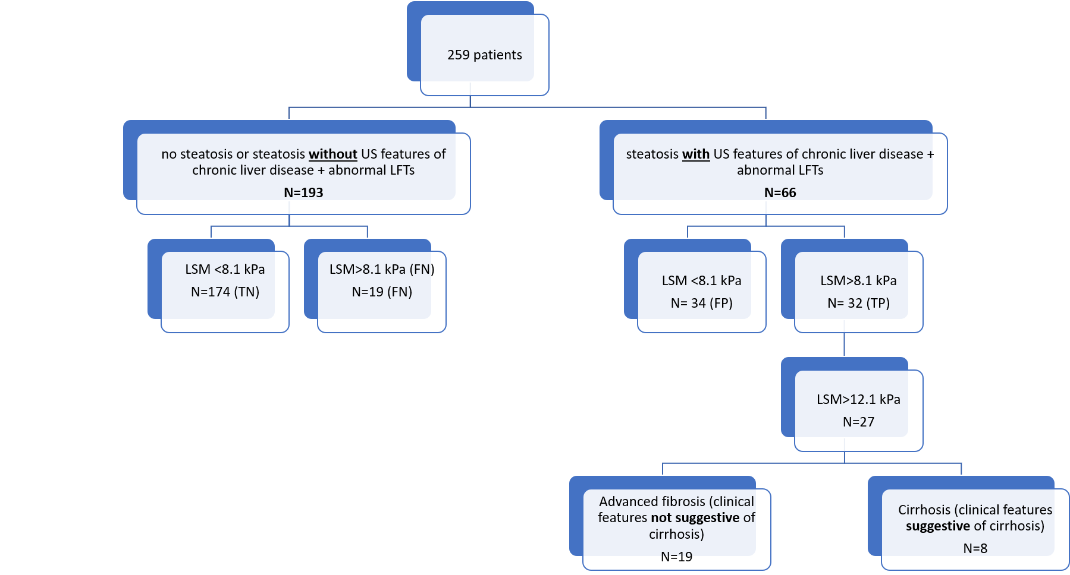

Supplementary figure 6. Identification rates for significant and advanced liver disease due to NAFLD among diabetic patients in primary care using US and LFTs.
Abbreviations: NAFLD: non-alcoholic fatty liver disease, LSM: liver stiffness measurement, TP: true positive, TN: true negative, FP: false positive, FN: false negative, US: ultrasound, LFT: liver function test

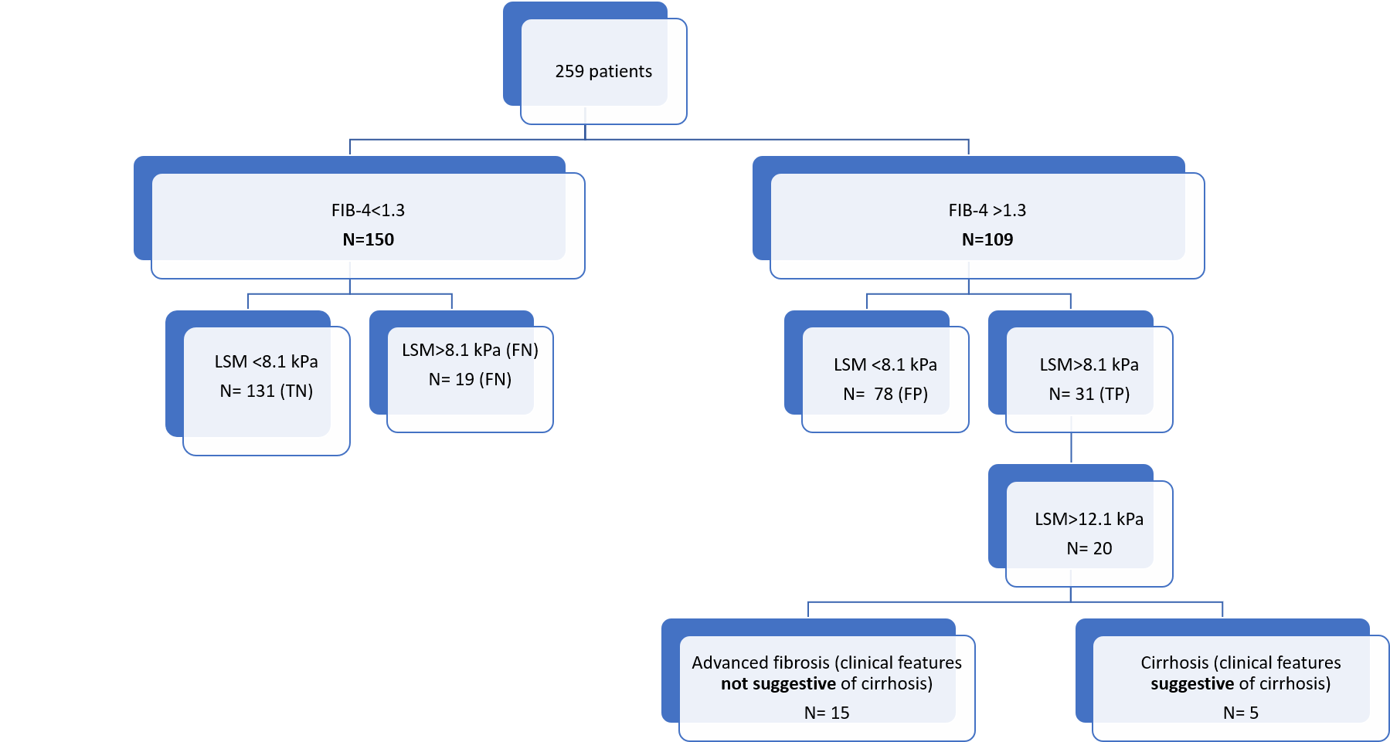
Supplementary figure 7. Identification rates for significant and advanced liver disease due to NAFLD among diabetic patients in primary care using FIB-4.
Abbreviations: NAFLD: non-alcoholic fatty liver disease, LSM: liver stiffness measurement, TP: true positive, TN: true negative, FP: false positive, FN: false negative, FIB-4: fibrosis score-4

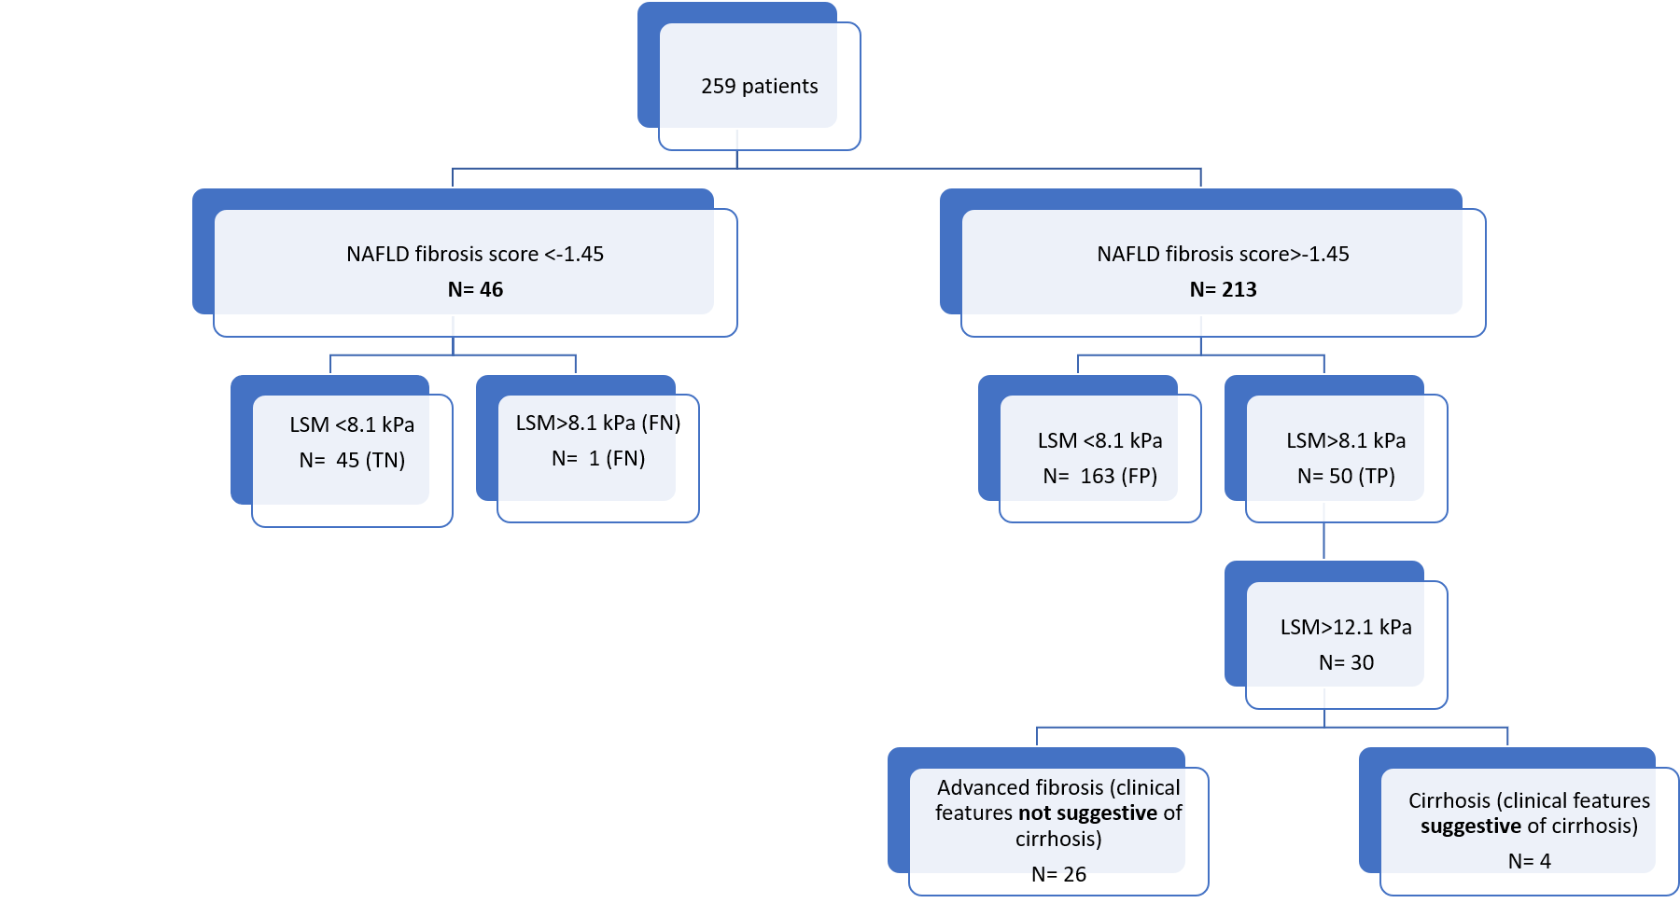

Supplementary figure 8. Identification rates for significant and advanced liver disease due to NAFLD among diabetic patients in primary care using the NAFLD fibrosis score.
Abbreviations: NAFLD: non-alcoholic fatty liver disease, LSM: liver stiffness measurement, TP: true positive, TN: true negative, FP: false positive, FN: false negative.
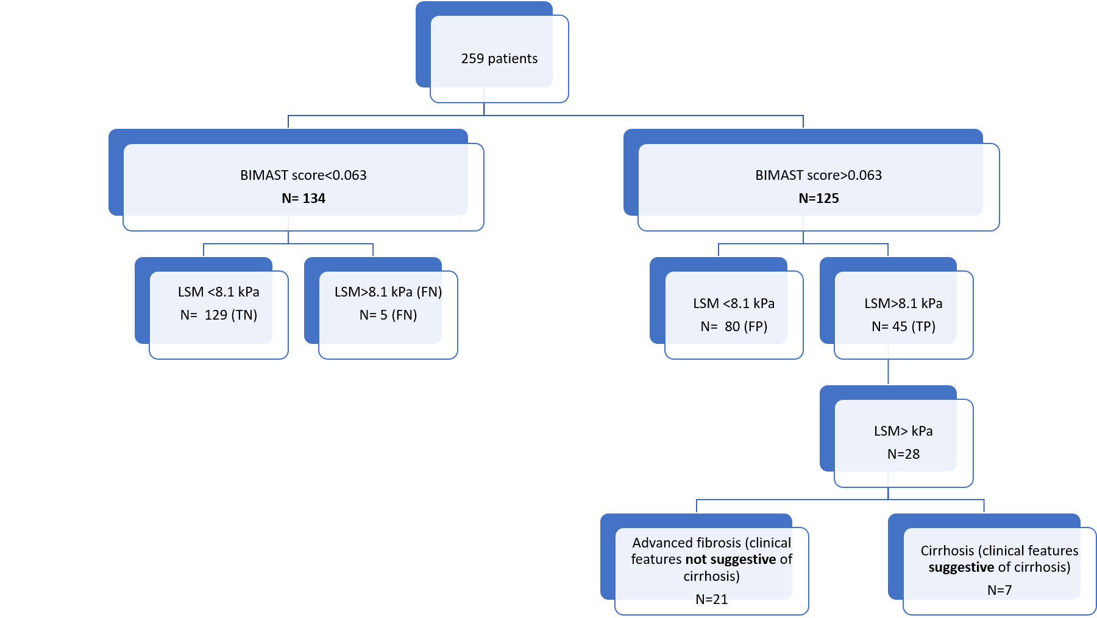
Supplementary figure 9. Identification rates for significant and advanced liver disease due to NAFLD among diabetic patients in primary care using the BIMAST score.
Abbreviations: NAFLD: non-alcoholic fatty liver disease, LSM: liver stiffness measurement, TP: true positive, TN: true negative, FP: false positive, FN: false negative.
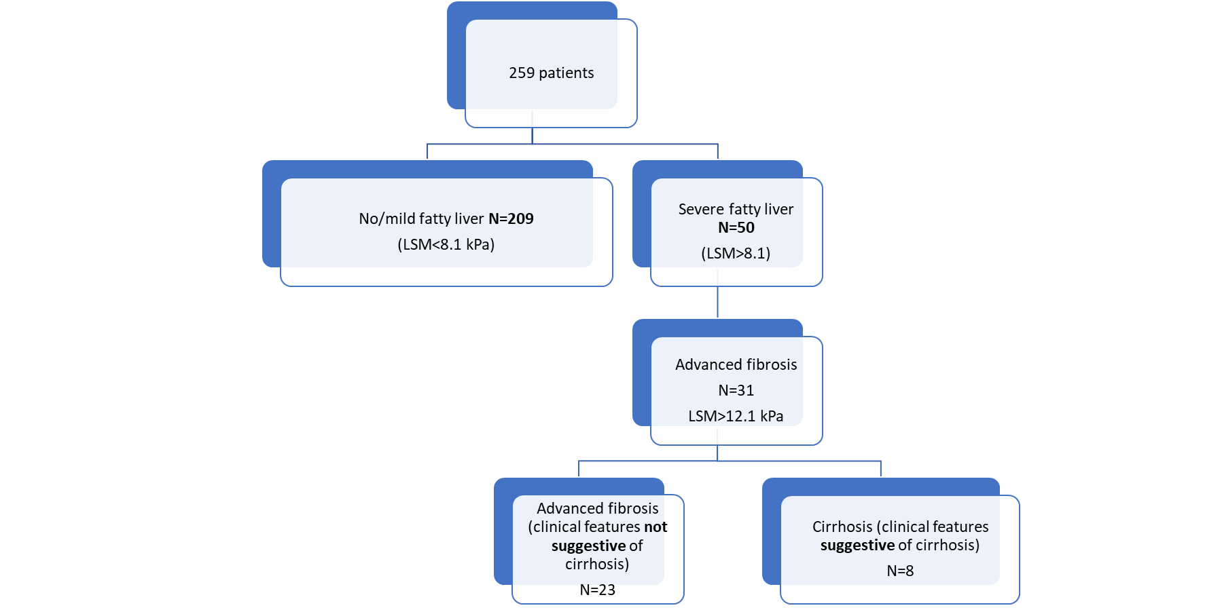
Supplementary figure 10. Identification rates for significant and advanced liver disease due to NAFLD among diabetic patients in primary care using the liver stiffness measurements.
Abbreviations: NAFLD: non-alcoholic fatty liver disease, LSM: liver stiffness measurement, TP: true positive, TN: true negative, FP: false positive, FN: false negative.

SUPPLEMENTARY REFERENCES
1. Tanajewski L, Harris R, Harman DJ, et al. Economic evaluation of a community-based diagnostic pathway to stratify adults for non-alcoholic fatty liver disease: a Markov model informed by a feasibility study. BMJ Open. 2017;7(6):e015659.
2. Srivastava A, Jong S, Gola A, et al. Cost-comparison analysis of FIB-4, ELF and fibroscan in community pathways for non-alcoholic fatty liver disease. BMC Gastroenterol. 2019;19(1):122.
3. Estes C, Razavi H, Loomba R, Younossi Z, Sanyal AJ. Modeling the epidemic of nonalcoholic fatty liver disease demonstrates an exponential increase in burden of disease. Hepatology. 2018;67(1):123-133.
4. Noureddin M, Jones C, Alkhouri N, et al. Screening for nonalcoholic fatty liver disease in persons with type 2 diabetes in the United States is cost-effective: A comprehensive cost-utility analysis. Gastroenterology. 2020;159(5):1985-1987.e4.
5. Serra-Burriel M, Graupera I, Torán P, et al. Transient elastography for screening of liver fibrosis: Cost-effectiveness analysis from six prospective cohorts in Europe and Asia. J Hepatol. 2019;71(6):1141-1151.
6. Tapper EB, Sengupta N, Hunink MG, Afdhal NH, Lai M. Cost-effective evaluation of nonalcoholic fatty liver disease with NAFLD fibrosis score and vibration controlled transient elastography. Am J Gastroenterol. 2015;110(9):1298-1304.
7. Tapper EB, Hunink MG, Afdhal NH, Lai M, Sengupta N. Cost-effectiveness analysis: risk stratification of nonalcoholic fatty liver disease (NAFLD) by the primary care physician using the NAFLD fibrosis score. PLoS One. 2016;11(2):e0147237.
8. Vilar-Gomez E, Lou Z, Kong N, Vuppalanchi R, Imperiale TF, Chalasani N. Cost effectiveness of different strategies for detecting cirrhosis in patients with nonalcoholic fatty liver disease based on united states health care system. Clin Gastroenterol Hepatol. 2020;18(10):2305-2314.e12.
9. Phisalprapa P, Supakankunti S, Charatcharoenwitthaya P, et al. Cost-effectiveness analysis of ultrasonography screening for nonalcoholic fatty liver disease in metabolic syndrome patients. Medicine (Baltimore). 2017;96(17):e6585.
10. Eddowes PJ, McDonald N, Davies N, et al. Utility and cost evaluation of multiparametric magnetic resonance imaging for the assessment of non-alcoholic fatty liver disease. Aliment Pharmacol Ther. 2018;47(5):631-644.
11. Crossan C, Tsochatzis EA, Longworth L, et al. Cost-effectiveness of non-invasive methods for assessment and monitoring of liver fibrosis and cirrhosis in patients with chronic liver disease: systematic review and economic evaluation. Health Technol Assess. 2015;19(9):1-409, v-vi.
12. Blake L, Duarte RV, Cummins C. Decision analytic model of the diagnostic pathways for patients with suspected non-alcoholic fatty liver disease using non-invasive transient elastography and multiparametric magnetic resonance imaging. BMJ Open. 2016;6(9):e010507.
13. Crossan C, Majumdar A, Srivastava A, et al. Referral pathways for patients with NAFLD based on non-invasive fibrosis tests: Diagnostic accuracy and cost analysis. Liver Int. 2019;39(11):2052-2060.
14. Zhang E, Wartelle-Bladou C, Lepanto L, Lachaine J, Cloutier G, Tang A. Cost-utility analysis of nonalcoholic steatohepatitis screening. Eur Radiol. 2015;25(11):3282-3294.
15. Corey KE, Klebanoff MJ, Tramontano AC, Chung RT, Hur C. Screening for nonalcoholic steatohepatitis in individuals with type 2 diabetes: A cost-effectiveness analysis. Dig Dis Sci. 2016;61(7):2108-2117.
16. Congly SE, Shaheen AA, Swain MG. Modelling the cost effectiveness of non-alcoholic fatty liver disease risk stratification strategies in the community setting. PLoS One. 2021;16(5):e0251741.
17. Steadman R, Myers RP, Leggett L, et al. A health technology assessment of transient elastography in adult liver disease. Can J Gastroenterol. 2013;27(3):149-158.
18. Saokaew S, Kositamongkol C, Charatcharoenwitthaya P, et al. Comparison of noninvasive scoring systems for the prediction of nonalcoholic fatty liver disease in metabolic syndrome patients. Medicine (Baltimore). 2020;99(50):e23619.
19. Moolla A, Motohashi K, Marjot T, et al. A multidisciplinary approach to the management of NAFLD is associated with improvement in markers of liver and cardio-metabolic health. Frontline Gastroenterol. 2019;10(4):337-346.
20. Thavorn K, Coyle D. Transient elastography and controlled attenuation parameter for diagnosing liver fibrosis and steatosis in Ontario: An economic analysis. Ont Health Technol Assess Ser. 2015;15(19):1-58.

