`

Synthesis, characterization and evaluation the performance of some novel pyridinone derivatives as corrosion inhibitors for various industrial applications

Gehad Sª, , Yousry.A. Ammar^{b}. S , Al-Sharbasy ª M. A. Migahed ^{c*}
ª Department of Chemistry, Faculty of Science (girls), Al-Azhar University, Cairo, Egypt, Salwa.elsharabasy@ azhar.edu.eg.^{b}
^{b} Department of Chemistry, Faculty of Science (boys), Al-Azhar University, Cairo, Egypt, yossry@azhar.edu.eg,^{c} ^{c*}Egyptian Petroleum Research Institute (EPRI), Nasr City 11727, Cairo, Egypt.

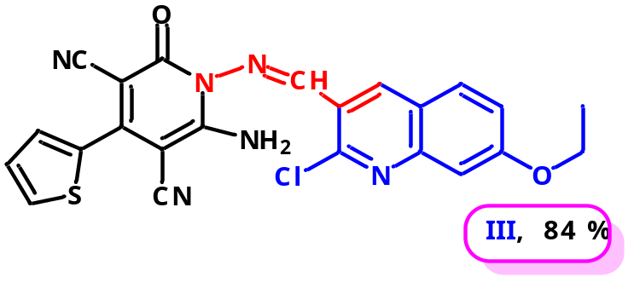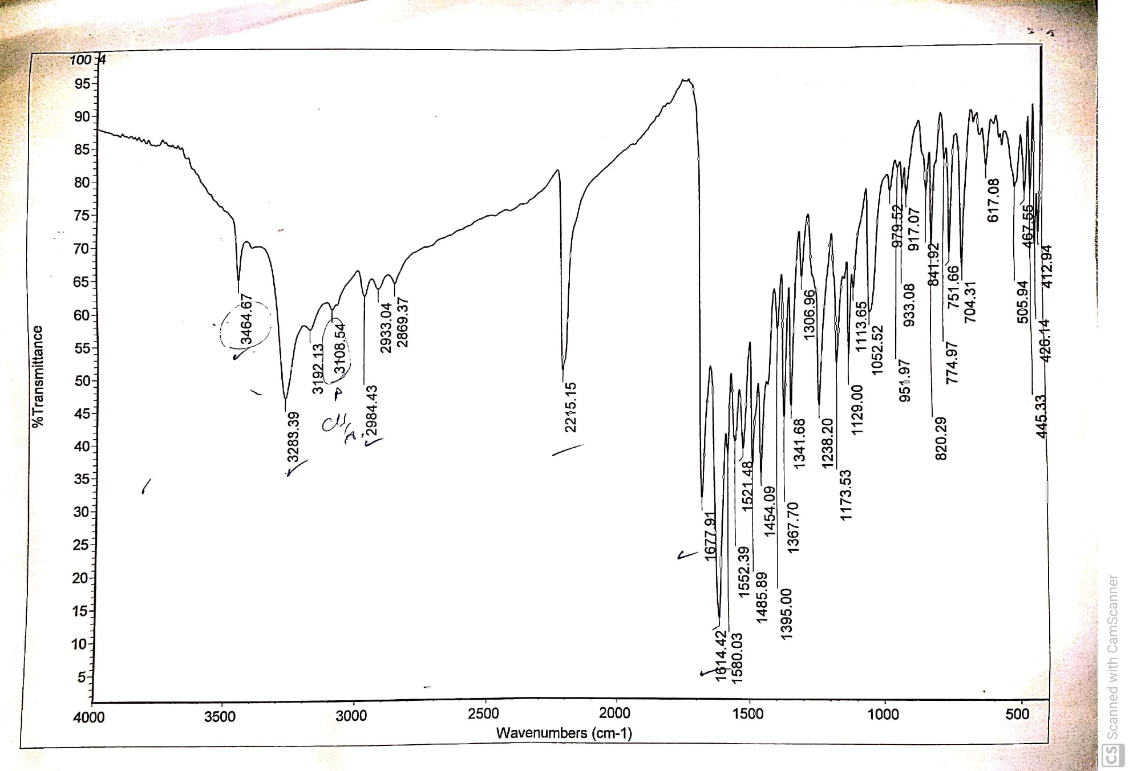
S1: FTIR spectrum of the prepared inhibitor (III).
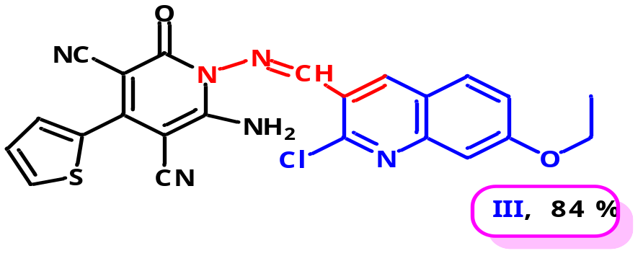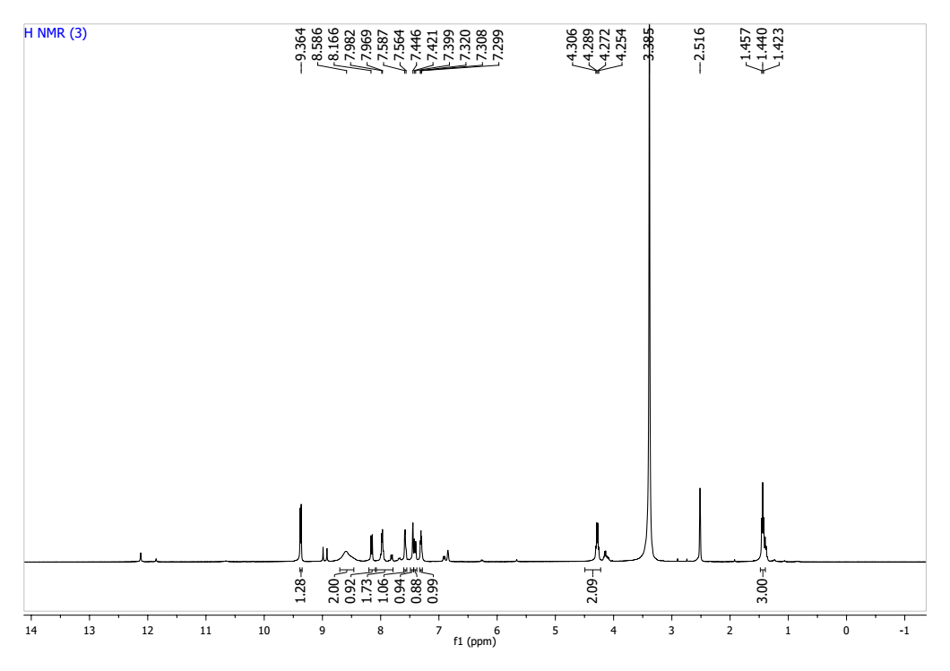S2: ¹H-NMR spectrum of the prepared inhibitor (III).
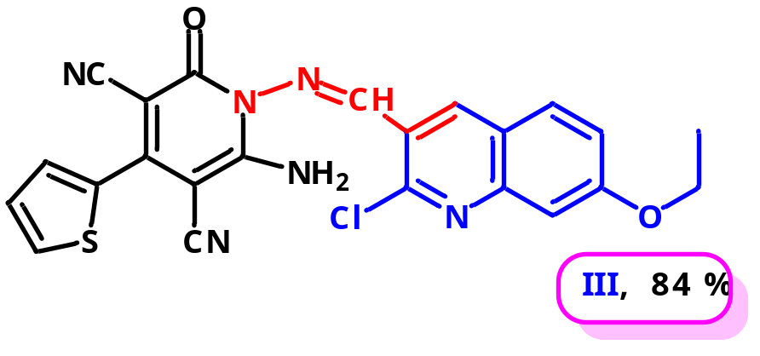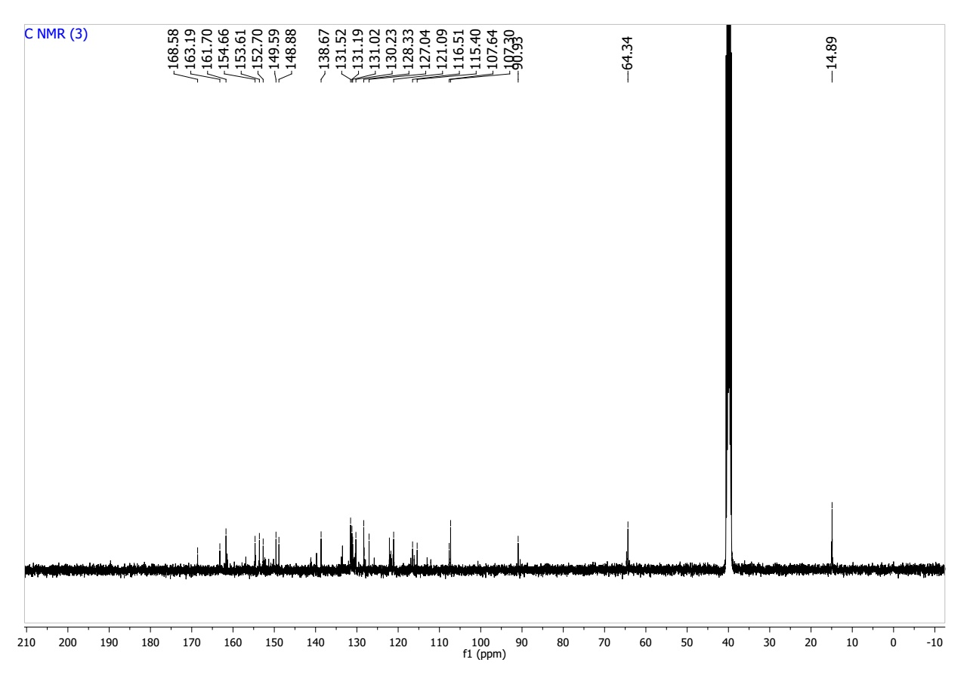
S3: ¹³C-NMR spectrum of the prepared inhibitor (III).

