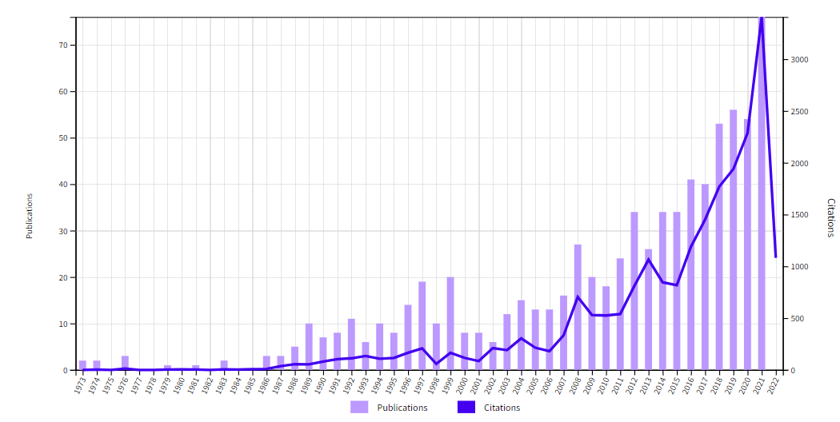
Graphic 1. Number of articles and citations between 1970 and 2021.

